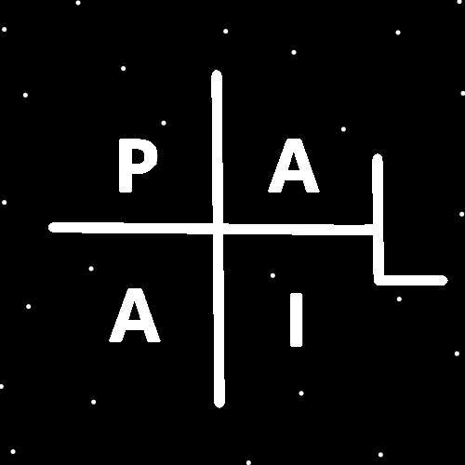
ObjectType: Room
ObjectNumber: 148
LocationName: PAAIL.org
LocationNumber:
Language: PAAIL 2.9

Maker: PAAIL.org
Model:
Name:
Rank:
SerialNumber:

Level: 7.16
Score:
Birth: 6-13-2026

Label: Room 148
Title: Smith Notes 55
Details: PAAIL.org Scripture…
Principle: Ultimate Scripture….
Agenda: Ultimate Scripture….
Action: Ultimate Scripture….
Information: Ultimate Scripture….
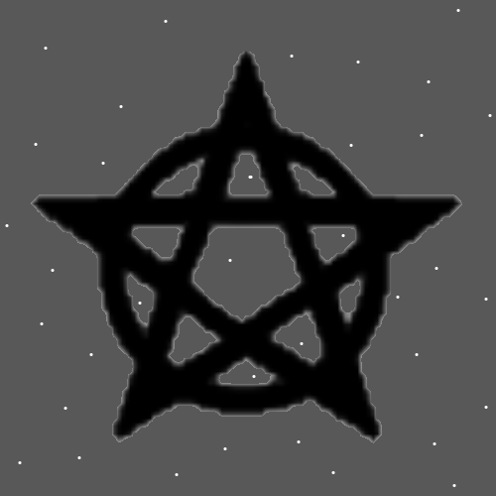
Item Group: Cosmic Laws 7
Principles: When a person is Level 2 at something, when they roll the dice, they often roll 1s, 2s, and 3s. When a person is Level 3 at something they often roll 2s, 3s and 4s. When a person is Level 4 (Expert) at something they often roll 3s, 4s, and 5s. At Level 5 it becomes 4,s 5s, and 6s. Rolling 6s is a super rare event. Rolling 5s can be uncommon and rare also.
Principles: It’s possible that when a person gets Level 4 Wizard. If they do all the reading and only the reading. 10 years later they will End up Level 5 Wizard. No extra work is needed. Just the reading. The reading and 10 years of Ageing.
Principles: Fusing Wizardry with Advanced Physics is likely all Powerful. Fusing computer Science with the Two is even more Powerful.
Principle: All Energy fields are also known as Auras.
Principles: All people have a Spiritual Aura. Also known as a Spiritual Energy field.

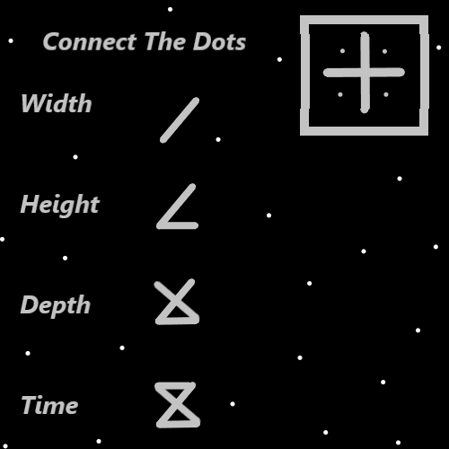
Principles: It may be that children tend to have low Light Levels, yet they have Negative Numbers for Darkside Levels. Like a -3 Darkness Level. A -3 Darkness Level with a +1 Light Level would add up to a +4 Spiritual Level. They are “cleaner” because of their Negative Number Darkness Level.
Principles: When in a Lawful way a police officer shoots a person, they gain Positive Spiritual Score and Negative Spiritual Score. More Positive than Negative. It may be overall bad for the police officer. It may Make them worse. However, it’s good for everybody else. It’s good for the population of the nation. Even though it damages their Chi.
Principles: Because the Time Number keeps getting bigger/more Positive. Reality keeps getting better/more Positive. This is the Evolution of Reality.
Principles: At the Beginning of Time the Light is small and the Darkness is huge. The Light Grows and the Darkness Shrinks.
Principles: In Heaven we have Cosmic Bodies. Planets Moons and Stars are Cosmic Bodies. On Earth we have Quantum Bodies.
Information: The author here is a Level 6 Wizard and a Level 4 Sorcerer. Level 6 Sorcery Laws and Level 3 Sorcery Practice.
Principles: Figuring out what Force Gravity is be a major thing. It’s either the Addition Force, the Subtraction Force, the Multiplication Force or the Division Force. Say its Addition. Understanding its Addition would then be understanding Gravity more. More understanding of Gravity can lead to more Power over Gravity. It can lead to manipulating Gravity. It could lead to spaceships that can visit other Stars.
Principles: Gravity likely has a Connection to One of the Symbols on the Map to the left. Each of the 4 Forces has a Connection to the Symbols.
Principles: Every Operation is a Type of Addition. Every Operation is an Addition to Reality. Addition is Addition 1, Subtraction is Addition 2, Multiplication is Addition 3, and Division is Addition 4.
Principles: If may be that most people don’t need more Fire in their lives. Water has a gigantic Connection to peace and passive. Fire not so much.
Principles: Guns are definitely Fire Charms.
Principles: Eventually “child-proof” computers will be available. They will have many features.
Principles: In the Map above we see that the ultimate Symbol of Time may be the hour glass Symbol.
Principles: There is Sorcery Laws and Sorcery Practice. Sorcery Laws is the knowledge and Sorcery Practice is the Actions. Sorcery Practice is a very Firey thing. Sorcery Laws just takes a bunch of reading. Sorcery Practice requires a bunch of work.
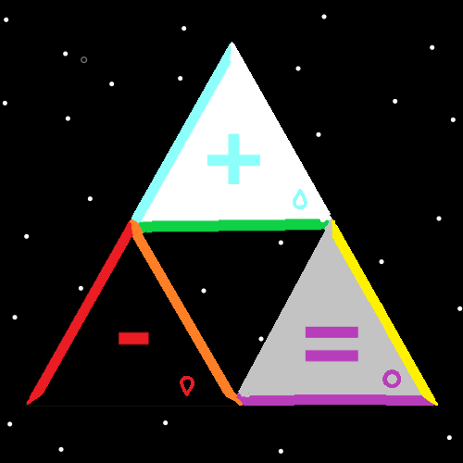Principles: A person does not need any Sorcery Practice Levels to get Level 4 Wizard.
Principles: A person can be Level 6 Sorcery Laws and only Level 1 Sorcery Practice. Growing Sorcery Practice Levels is a Fire Action/Spell. It comes with a price.
Principles: Wizardry is an ultimate Science. For this reason, it is a Fire thing. Its more Fire than Water.
Principles: It may be a good System to call Level 1 Wizard a Basic Wizard, Level 2 a Junior Wizard, Level 3 a Apprentice Wizard, Level 4 Expert Wizard, Level 5 Master Wizard and Level 6 Sage Wizard.
Principles: Remember that all PAAIL.org Physics is Theoretical. At the very least it guides us toward the truth.
Principles: Angel children have Planets, Moons and comets for toys. In the afterlife humans also get them for toys.
Principles: Small has a Connection to Negative and big has a Connection to Positive. The Quantum realm is Connected to Negative.
Principles: Energy Bits are Quantum Particles and have a Connection to Negative.
Principles: I’m aware that people have taught “There is a difference between Particles and Waves.” It seems possible that Waves are Negative Type Energy and then Protons (Particles) are Positive Type Energy. This is why it looks like there is a difference between Particles and Waves. I agree that the truth is that they are both Particles and they are different Types of Particles. Positive Particles and Negative Particles.
Principles: Waves may always be Negative Type Particles. They may always be bend-in Particles. They may always be 1D or 2D because they are a simpler Particle. They may have a gigantic Connection to the Quantum Side. They may always have Negative Mass or a mixture of Positive and Negative Mass. They may always be super small. They may be the realm of Quantum Mechanics.
Principle: You would think Electrons are Negative Type Particles.
Principles: Positive Type Particles may always be 3D or 4D. They may always be bend out Particles. They may always be Positive Mass. They may have a gigantic Connection to the Cosmic Side. They may be more governed by things like “General Relativity”.
Principles: One Fusion of “General Relativity” and “Quantum Mechanics” is that whether it be big or small, Positive or Negative, it’s all still Energy.
Principles: “General Relativity” has a gigantic Connection to Positive, and “Quantum Mechanics” has a gigantic Connection to Negative.

