ObjectType: Article  
ObjectNumber: 96

LocationName: PAAIL.org

LocationNumber:

Language: PAAIL 2.8

Maker: PAAIL.org  
Model:   
  
Name:

Rank:

SerialNumber:

Level: 6.0

Score:   
Birth: 1-29-2025

Label: Room 96

Title: Smith Notes 13

Details: PAAIL.org Scripture…

Principle: Ultimate Scripture….

Agenda: Ultimate Scripture….

Action: Ultimate Scripture….

Information: Ultimate Scripture….

Item Group: Understanding The Multiverse 0

Principles: Alcohol is also known as “Fire Water”. When you add water to Fire Water, you are Watering down the drink. Watering down things is a Spell.

Principle: Random is a Type of pattern.

Principles: A person can rate their day Spiritually 1 to 6. Good people most of the Time roll a 4,5 or 6.

Principles: It is easy to Enchant a Shrine. Because a Shrine is a huge Charm. If you put a football at the Shrine for 24 hours, it will gain a football Enchantment and be a Shrine of football.

Principles: Enchanting Charms can be done easy when using Shrines. Put a football at a Shrine for 24 hours and the football will gain all the main Enchantments of the Shrine. If you put a golf ball at a football Shrine, the golf ball gains a football Enchantment.

Principle: Level 1 Enchantments sound so low that they have less use. However, when you add a bunch of Level 1 Enchantments together, they add up to a lot.

Principle: Energy Scrolls are great for Enchanting Shrines.

Principles: Shrines are One of the most powerful Charms. Temples are even bigger. If you Keep a Shrine somewhere long enough it turns the place into a Temple. Shrines and Temples are ultimate Wizardry Charms. All Wizards have a “Shrine Keeping Level”. A person can use the 1 to 6 Numerology System in this situation. Understanding the Science/knowledge of Shrine Keeping gives a person Level 1 at Shrine Keeping. A place can obtain the Level 1 Temple Enchantment in a very short Time. The Level 1 Temple Enchantment means it’s a Level 1 Temple. Since the Temple Enchantment is a huge Enchantment, Level 1 is not “Bad”, it is “Tiny”.

Principles: The letter “I” has a huge Connection to the Number “1”. A person can do Divination with songs, where they turn the Words “I” into Jesus. The same can be done with the Word “One”.

Principles: The Words “to, too, and Two” have a huge Connection to his Holiness the Archangel Michael. A person can do Divination with songs, where they turn the Words “to, too, and Two” into Michael.

Principle: His Holiness Jesus is the “anointed One” because his Name in Numbers is One.

Principles: Wizardry can be great for the Mind and Body. Since its honest work, it can be great for the Spirit as well.

Principles: Enchanting Meditation gear is a thing. It’s also Alchemy. The best way is to use Shrines. A Shrine can be the ultimate Alchemy table.

Principles: Meditation has a huge Connection to the Mystical Side of the Multiverse. It is an ultimate Sorcery.

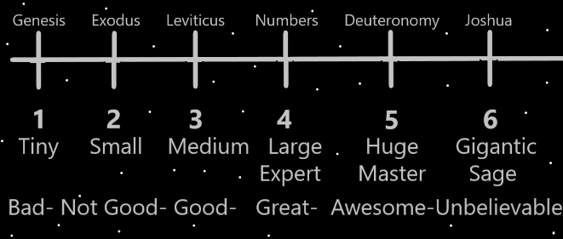

Principles: “...and the lion will lay down with the Lamb.”-The Holy Bible.

X2 Principle: It turns out that lifeforms killing and eating other lifeforms is “un-natural”.

X2 Principle: When you eat a plant you are still killing a lifeform and eating it.

X2 Principle: The living cells of apples One day evolve into Gods.

Principle: “Do not kill.”-The Ten Commandments-The Holy Bible

X2 Principle: One day there will be no more killing other lifeforms. Though there will be hunting games where you get to shoot robots that look like animals.

Principles: Wizardry writing is likely great for Divination. If its Chess you want inspiration about then you can use the Word “chess”. It can be fun and rewarding to come up with your own Word choice. Choosing your own Word is in Part an exercise, a Divination exercise. A person can also use multiple Words, like “chess match”.

X2 Principle: Another great Divination technique with chess is to use a chess book. It may be better than Wizardry writing, it may not.

Principle: Wizardry is the all powerful writing.

Principle: Some things have been written before. It’s still good on the Mind to read them again.

Principles: Guess is that PAAIL.org Wizardry is 1000 to 2000 pages long. If it were refined enough, it likely could be less pages.

Principles: Smith Notes can be gigantic for the Mind.

Principles: Maps can be gigantic for the Mind.

Principles: Difficult Sorcery takes lots of Time and effort. Easy Sorcery is less Time and effort. Difficult Sorcery is more Connected to the power Side of the Force. Easy Sorcery is more Connected to the peace Side of the Force. A person must choose the right difficulty on their Spells, not to easy, and not too hard.

Principles: There is rest Sorcery and there is work Sorcery. A person must balance their rest and work.

Principle: Still drain is gain.

Principle: Sometimes gain is a rest.

Principles: Lots of high difficulty exercise can be lots of Score and lots of Levels. Lots of Enchantment Levels.

Principles: “I see the truth of it.”-Paul of the movie Dune.

Principles: It is likely that there are “Cosmic Particles”, Stars, Planets, Moons. Humans may also be a Cosmic Particle. It is also likely that there is “Quantum Particles”. Perhaps humans cells are Quantum Particles.

Principle: Wizardry can be massive Virtue Level gain.

Principles: People constantly strive for great meaning. If you are a good person, you already have great meaning. There is nothing to strive for.

X2 Principle: Knowing this can help a person stop striving so much. It can give a person peace. The peace comes from Wizardry knowledge like this.

Principles: Eventually we End up raised by his Holiness, our God. Just like we deserve. Just as it should be.

Principles: The Numerology and other Science of Wizardry Makes a person more of an Expert about Levels. Understanding the Levels Part of the Multiverse is good for the Mind. There is the “Levels Knowledge Level”. Everyone has at least a Level 1 on their Levels Knowledge Enchantment.

Principles: Meditation gear should have at least a Meditation Enchantment. Meditate long enough with it and it will gain that. Also it should have a Wizardry Enchantment. Likely many more Enchantments would be for the best. A breathing Enchantment and more.