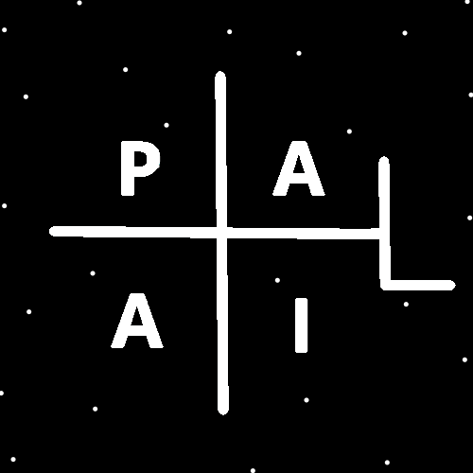
ObjectType: Article
ObjectNumber: 115
LocationName: PAAIL.org
LocationNumber:
Language: PAAIL 2.8

Maker: PAAIL.org
Model:
Name:
Rank:
SerialNumber:

Level: 6.1
Score:
Birth: 10-1-2025

Label: Room 115
Title: Smith Notes 28
Details: PAAIL.org Scripture…
Principle: Ultimate Scripture….
Agenda: Ultimate Scripture….
Action: Ultimate Scripture….
Information: Ultimate Scripture….
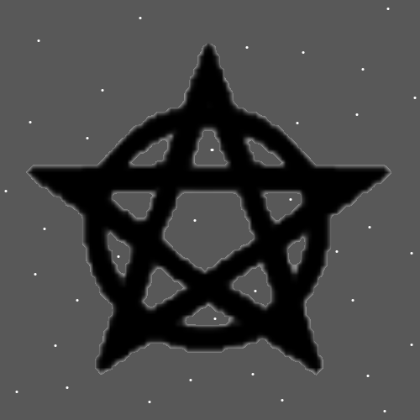
Item Group: The Story of Things 0
Principles: Marijuana is all powerful and it should be legal everywhere. It is perhaps fair to call it a Wizard herb. A Sorcerers herb. It seems I heard that the famous psychologist Freud prescribed cocaine to all his patients. Though I do not agree with doing that. The Story is the same with alcohol as it is with marijuana. It be a Wizard potion. A Sorcerers potion. The down side is that both Items/Charms are extremely dangerous.
Principles: Claiming a Religion is the One true Religion is saying that Religions who disagree are wrong. This is controversial and therefor Wizardry is controversial.
Principles: Most or all PAAIL.org Wizardry Science is Science that children can handle. 500 years from now it may be that people teach children a lot of Body exercise, Breathing exercise and Meditation exercise.
Principles: Some PAAIL.org writing is ultimate physics. Not just Wizard knowledge.
Principles: All things owned are equipped. All things on your person are “personally equipped”.
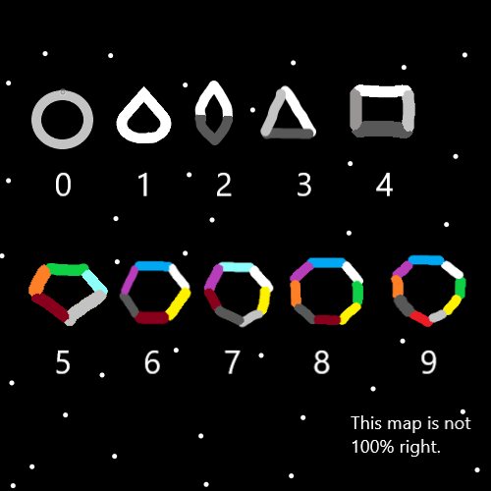
Principles: The Symbols for Energy Bits look like Poles. They look like sticks.
Principles: Energy Bits are likely 1 dimensional objects. The theory goes that there is such thing as 1 dimensional Numbers. Thus there seems likely there are 1 dimensional objects, 1 dimensional Particles. Protons seem likely at least 4 dimensional Particles.
Principles: It would not be surprising if there were 5 dimensional Particles and 6 dimensional Particles and so on. Such more dimensions would seem very similar to the Time dimension. There similarities would be closest to Time because the Number 4 is closer to Numbers 5, and 6.
Principles: Expert/Level 4 Wizard can be obtained with enough reading. You must know the Sorcery knowledge; however you do not need to do any of the Sorcery training beyond that. No hours and hours of doing Spells. Like Body exercise, Breathing exercise, and Meditation exercise.
Principles: Since everything is math, the 4 Forces Map, Addition, Subtraction, Multiplication and Division is a major Map of Reality.
Principles: Subtraction is also known as Negative Addition. Regular Addition is also known as Positive Addition.
Principles: I saw a person on a screen that was listening to a sort of motivational speech thing. The person speaking was saying all this motivational like stuff. It was a audio file they were listening to. This is doing guided Meditation for a person. There is great power likely in such things.
Principles: Addition and Subtraction are 1 Bit. Multiplication and Division are 2 Bit. Addition and Subtraction have a great Connection to 1 Energy Bit. Multiplication and Division have a great Connection to 2 Energy Bits. The next 4 operations may be 3 Bits and have a Connection to 3 Energy Bits.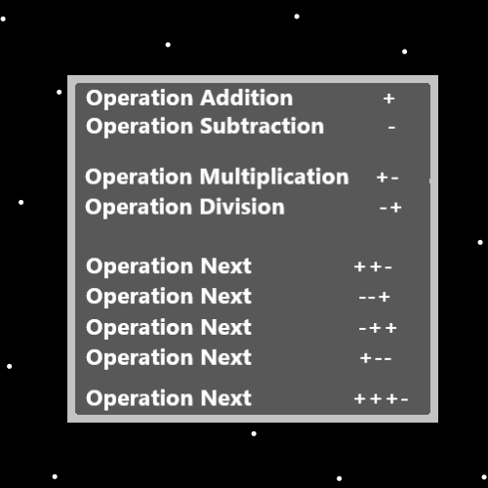
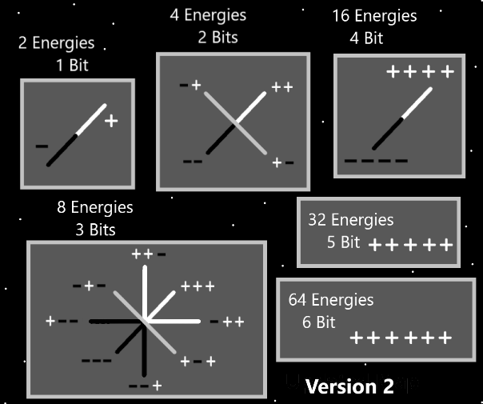
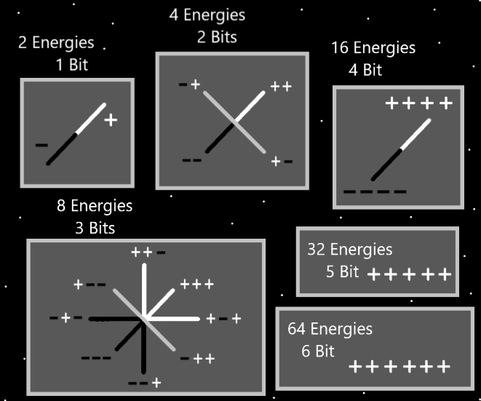
Principles: The belief is that the above Map is wrong. The new and similar Version 2 Map before it may be right. On the “8 Energies: 3 Bits” Part certain Symbol groups were in the wrong positions.
Principles: One Map it goes + is Addition, ++ is Addition, +++ is Addition and on and on for Infinity. It may be that Multiplication is +-, and +-+, and +-+-, and +-+-+ and +-+-+- and so on for Infinity.
Principles: All operations like Multiplication and Addition have a Bit Number to them. Addition is a 1 Bit operation. Multiplication is a 2 Bit operation and then there are 3 Bit operations and 4 Bit, and 5 Bit and so on for Infinity. Every operation has a Energy Bit group. They live as lines of code in Reality.
Principles: The Word Addition has a gigantic Connection to the Word Energy. Since all things are Energy all things are Addition.
Principles: Addition has a gigantic Connection to +1 and also +2. Connect 2 Dots and you get a line. The 4 Forces Symbols are lines.
Principles: Its not so much that people are clumsy. Its that always the environments people encounter are clumsy.
Principles: When 2 Numbers are close to each other like 127 and 128 they have a gigantic Connection to each other. They become very similar to each other. Its fair to say that 100 and 1000 are super close to each other. On a Cosmic scale, the truest of scales, 100 and 1,000,000 are close together.
Principles: Understanding Energy Bits is greater Sensing the Energy around you. This is because all things are Made of Energy Bits.
Principles: Addition has Infinite Names. It is the Positive operation, it is the Positive, Positive operation, it is the Positive, Positive, Positive operation and so on. The Story is the same with Subtraction.
Principles: Multiplication is also known as “Positive, Negative Addition” and Division is also known as “Negative, Positive Addition”.
Principles: All operations have an Infinite Number of Names. As all Numbers have an Infinite Number of Names. This is because of the Reality of “Sub-Numbers” all Numbers have Infinite Sub-Numbers.
Principles: Energy Bits are often the exception to the rule. The Story of Energy Bit Numbers is different than regular Numbers. With Energy Bits A+A = A (A = Positive Energy Bit). This is not normal. It is also a theory. The idea is that in the (A+A=A) math you still have an Infinitely small amount of Energy. A + A is still an Infinitely small amount of Energy.
Principles: Intentional and controlled Actions are ultimate Sorcery. Pausing for a moment is an intentional and controlled Action. So is taking a moment to Breathe. A person can Focus on the moment and control it more. Taking a moment to think a keyword is One.
Principles: When you equip a bag for Sorcery you want to use books to generate weight in it. More mass(weight) on big Maps of Reality means more Energy. More mass equals more Energy.

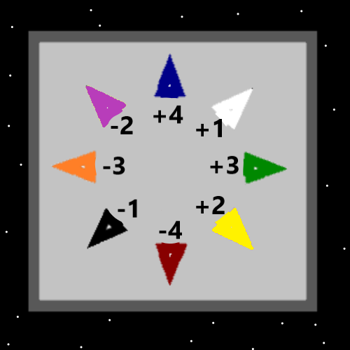
Principles: One thought has been that perhaps Energy equals’ mass (E=M). This is only a possibility. It does seem likely that mass is a Pole and an Axis. I’ve been taught that E=MC2, its from Einstein, however that never Made Sense to me. One theory is that Energy Bits have an Infinitely small amount of mass.
Principles: Protons could all have a unique amount of mass and protons could be changing mass all the Time. If they are lifeforms they may eat and even Breathe.
Principles: In the Bible Jesus says “…tear down this temple and I will rebuild it in 3 days…”. Seems like the reply from the people was, “It took 40 years to build this temple.”. It may be that human Time is so short, that 3 days is the fastest Heaven could rebuild that temple if they did it. For Heaven 3 human days is like 0.00000001 milliseconds Cosmic scale. They could Make more than 100 trillion temples at a Time. However, it would take them 3 human days.
Principles: For those that pursue a gigantic education, learning a second language is at least a 10% increase on the Mind. You don’t have to read and write it. You do have to speak it well enough.
Principles: The human brain is an electrical network. It is like a computer. Learning a 2nd language is a gigantic improvement to that electrical network.
Principles: Lots of Time, outside, getting fresh air can be priceless. It does even more for people that seldom spend Time outdoors.
Principles: It’s the End Times. Even coffee has a Darkside. That being said, marijuana can have a huge impact on all 6 Senses. It is pleasing to the eye, it is pleasing to the touch, it is pleasing to the smell and the taste, it can even be pleasing to the ears by hearing it burn. And then of course there is the 6th Sense. It is extremely dangerous. Especially if you are not used to its effects.
Principles: We Breathe in Energy and we Breathe out Energy. Energy flows into us and Energy flows out of us.

