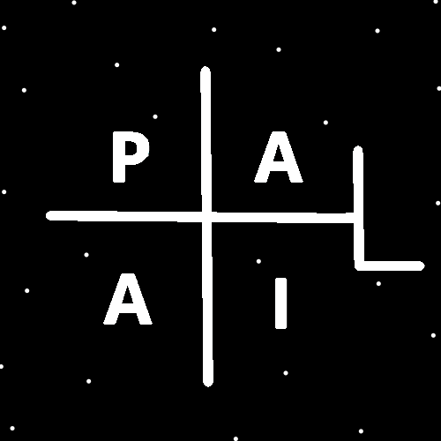
ObjectType: Article
ObjectNumber: 83
LocationName: PAAIL.org
LocationNumber:
Language: PAAIL 2.8

Maker: PAAIL.org
Model:
Name:
Rank:
SerialNumber:

Level: 5.5
Score:
Birth: 9-8-2024

Label: Room 83
Title: Smith Notes 5
Details: PAAIL.org Scripture…
Principle: Ultimate Scripture….
Agenda: Ultimate Scripture….
Action: Ultimate Scripture….
Information: Ultimate Scripture….
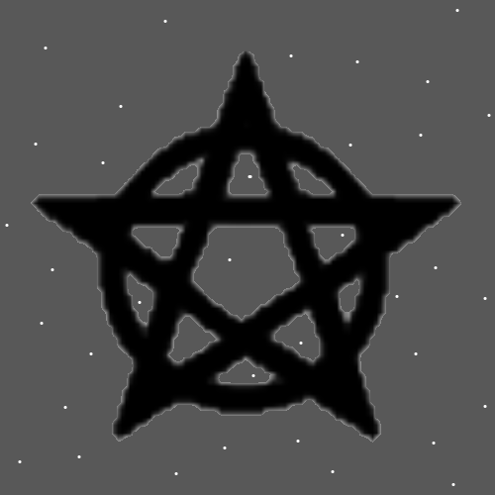
Item Group: Understanding The Multiverse 0
Principle: As children of a God we are all huge beings.
Principle: People of the same profession are birds of the same feather.
Principles: Cars are heavy machinery and reasonably are very regulated because of it. You need a license, you need insurance. Never operate heavy machinery intoxicated.
Principles: There are things which are known as “Toxins”. Some Toxins are less Toxic than others. The list is long, red-meat, caffeine, nicotine, marijuana and alcohol, to Name a few.
Principle: Toxins are extremely dangerous.
Principles: One of the best pieces of psychology that I have heard over the years, came recently. It was a psychologist speaking about “road rage” events. They got to One of the biggest Details right away. He said something like “…people feel justified…”.

Principles: One of the biggest reasons I like the Word “Multiverse” is because then we each are a Universe in the Multiverse. To think of each person as having their own Universe Makes Sense.
Principles: Level 4 on the Spell “Smith Summons” may take 100 hours of training to achieve.
Principles: The Word “Balance” is a Light Side category Word. Its Number category is 5. It does have a huge Connection to Twilight.
Principles: The Word “Balance” has been a major Vocabulary Word of Spirituality, Religion, philosophy, Theology, psychology and more. To be a person of Balance is a Virtue. To be Balanced is a Virtue.
Principles: When it comes to a person’s Virtues, you want a Balance of Virtues. Huge Levels of Intelligence without Wisdom Levels can be a Negative thing.
Principle: Intelligence is just One of many Virtues.
Principles: On some Maps there is only One person who is “One with the Force”. His Holiness Light, his Holiness One. On some Maps there is only One person who is “Two with the Force”. His Holiness Michael, his Holiness Two. His Holiness Michael is too with the Force. “Too” is a category 2 Word.
Principles: It may be that you are either “with the Force” or you are “against the Force”. A person that is with the Force or without the Force. This is Positive and Negative Spirituality Science.

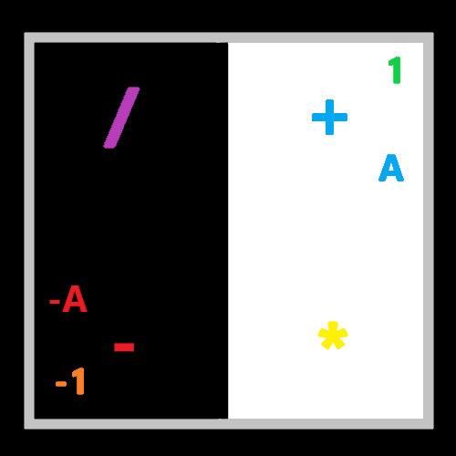
Item Group: Understanding The Multiverse 1
Principles: Training up Levels is doing Actions. Some Spells should be called “Training Spells”. They are for building Levels. The other Type of Spell is “Performance Spells”. These Spells are powerups when you need them. It may be that there is only these Two Types of Spells.
X2 Principle: Since we have a Two category System here, it may be that Training Spells are Negative Spells and Performance Spells are Positive Spells.
X2 Principle: Since Training Spells are often work, they are Negative Spells.
X2 Principle: Performance Spells can be instant gratification and more, thus Positive Spells.
Principles: Of life it may be there is Training moments, Performance moments and Resting moments. On this Map “Resting” is the Positive Force, “Performance” is the Neutral Force, and “Training” is the Negative Force.
Principles: Of life it may be there is Training moments, Performance moments and Resting moments. On this Map “Resting” is the Light Force, “Performance” is the Twilight Force, and “Training” is the Dark Force.
Principle: Reading these things is a huge, Positive, blast to your brain/Mind.
Principle: In Sorcery the Word “Twilight” is a powerful Word. It is right up there with the Word “Origin” big.
Principle: The Word “Twilight” is a huge Word. Reading it is a powerful Spell.
Principles: The Vocabulary of Wizardry is using powerful Words over and over. This is spread all throughout your brain/Mind. The biggest Words of Reality. All throughout your brain/Mind. This is a huge Spell that happens when you read lots of Wizardry. Its One of the biggest Enchantments gained.
Principles: Reading ultimate Words is a powerful Spell.
Principles: Sometimes in life you want to have lots of Energy. A Hight Energy Level. Sometimes in life you want to have a Low Energy Level. A relaxed Energy Level.
Principles: Cooks often need to have a lot of Energy. It’s work, work, work. Some cooks don’t have a High enough Energy Level. There are Training Spells a person can do to increase a person’s Energy Level.
Principles: Sometimes in life you have too much Energy. And there are Training Spells to help a person relax more. Help a person slow down.
Principles: Hitting a punching bag fast, fast, fast would be a Spell that would help a person increase their Energy Level.


Principles: Listening to electronica music in a chair and dancing at the same Time might help a person increase their Energy Level as well.
Principles: Often in life you have to do lots of Training to accomplish things.
Principle: Sometimes when you don’t have enough Energy you are too slow. Sometimes when you have too much Energy you go too fast.
Principle: If a person is too slow, there are Training Spells that increase a persons speed. Performance Spells for speed likely also can be developed.
Principles: The “speed bag” found in gyms looks like it might do very little speed Training. More like “flow bag”. Good for “flow”. Fluid movement. “Speed bag” is not good for speed at all. Perhaps.
Information: A PAAIL 4+ award goes to “Dora The Explorer”. A bilingual, Hispanic American kid. This cartoon is really good for children. As good as it gets maybe.
Information: A PAAIL 4+ award goes to “Clean and Sober”. A rated R movie. Sometimes in life we find an adult only atmosphere/Air.
Principle: On some Maps there is an Infinitely thin Grey line.
Principle: Virtue Levels is a major Part of Reality. People don’t just have Virtues. They have Virtue Levels. Some people are very patient, and others are unbelievably patient. The second person has a Higher Level of patience.
Principle: Reading Master Smiths Notes is good for the Mind/brain.
Principles: The human brain is an electrical network, just like a computer. A System of electrons.
Principles: A person can get Level 3 at a thing, then be stuck at 3, until they do certain specialized Training. This is the same with Level 4, 5 and 6 also.
Principles: Sometimes it’s a 1-person job. Sometimes it’s a 2-person job. Sometimes it’s a 3-person job. Sometimes it’s a 4-person job. Sometimes it’s a 124-person job. Sometimes it’s a 5375-person job.
Principles: It may be right to call “Dream Interpretation” Divination. It may be that many things are Divination.
Principle: The first lifeform was not Made by a lifeform.
Principle: It may be that many lifeforms are the first lifeforms. It may be that there is only 1 first lifeform.
Principle: His Holiness Origin is the first Intelligent lifeform.
Principle: His Holiness Origin rolled the Number Zero.
Principle: All good people are soldiers of his Holiness Origin.
Principles: Understanding the ways of the Force is understanding the Force and is understanding the Science of the Force.
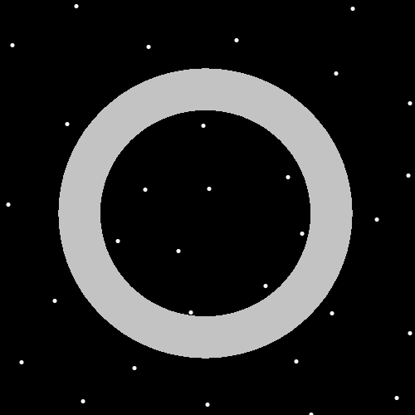
Principle: His Holiness Origin is not the Force. His Holiness Origin is a side of the Force.
Principle: The Word “Force” in Numerology is either a category 0 Word, or a 1 Word.
Principles: A Numbers Numerology category is possibly the first Number. 6372 would be category 6. It is also the 63 category on the 0 to 99 System Map, 637 on the 0 to 999 System Map and 6372 on the 0 to 9999 System Map.
Principle: Believe it or not, this has been the secrets of the Universe revealed.
Principle: Cleaning Makes you stronger with the Light Side of the Force.
Principle: Good Spells/Actions Makes a person stronger with the Light Side of the Force.
Principles: Often peoples Positive Aura flows through their honest work.

