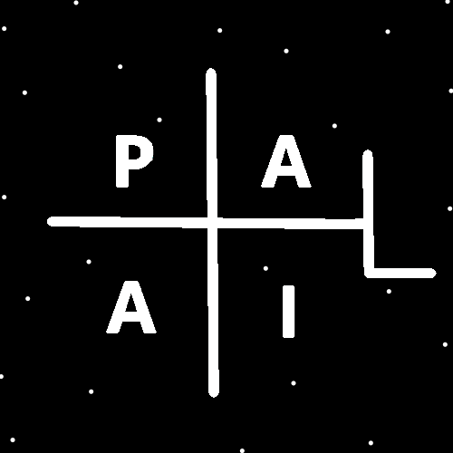
ObjectType: Article
ObjectNumber: 135
LocationName: PAAIL.org
LocationNumber:
Language: PAAIL 2.8

Maker: PAAIL.org
Model:
Name:
Rank:
SerialNumber:

Level: 7.0
Score:
Birth: 1-4-2025

Label: Room 135
Title: Smith Notes 43
Details: PAAIL.org Scripture…
Principle: Ultimate Scripture….
Agenda: Ultimate Scripture….
Action: Ultimate Scripture….
Information: Ultimate Scripture….
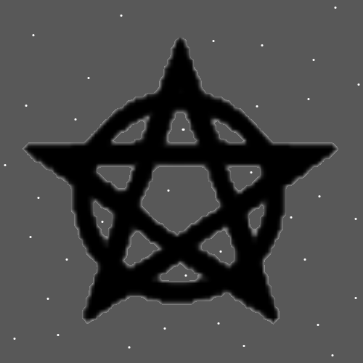
Item Group: More View Of The Multiverse
Principles: With the development of the personal Wizard book, bag and more I have Changed the Level of Wizardry to 7. The Level On this Room is 7. The last Room was 6.5.
Principles: If all the writing of PAAIL.org is under 2000 pages that is a major Detail. 2000 pages does not take much Time to read.
Principles: Best God like portrayal goes to South Park the cartoon. It be the personality of God. Best Jesus portrayal also goes to South Park, the cartoon. It be the personality of Jesus. I have mentioned God before. I have not mentioned Jesus. Until now.
Principles: God has been known as “the creator”. We are like God we are all creators.
Principles: With all the Wizardry Physics we are at Level 7 Cosmic Laws/knowledge. Energy Bits, Axis Groups, massive 4 Forces knowledge and such. On PAAIL.org can be found enough knowledge to get Cosmic Knowledge 7. Also known as Cosmic Laws 7.
Principles: To get Level 7 Cosmic Laws you have to learn a lot of Physics.
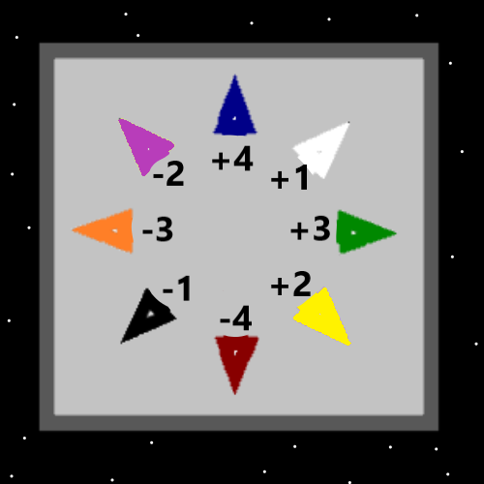
Principles: A person’s most important Number is their Spiritual Score. How much good they’ve done. How much they have helped God. Good helps God.
Principles: It may be sometimes or all Times that to Recharge a Battery you must Drain a different Battery. It is a famous teaching that you cannot create or destroy Energy, you can only transfer it from One place to another.
Principles: Sometimes an Action comes with massive Energy Recharge, and also massive Energy Drain. As much as you would think eating food is only Recharge on a person’s Batteries, it’s not. It can Drain other Batteries in a person and have Negative Side effects. A person can need a rest after eating. Or some other Negative thing.
Principles: Recharge found in eating comes from the Battery that is the food. Likely the Science Reality is that we consume “Life Force” as we eat. An unnatural thing, as life should not consume other life. When God designed man, he designed him to survive on “Life Force”.
Principles: If you have read all PAAIL.org then you’re a 7.0 Wizard. Date of this Item January 6th 2026.
Principles: Cosmic Laws 5, mixed with Sorcery Laws 4, would probably be enough to get Expert Wizard. Wizardry Physics is a Part of Cosmic Laws. Because of Wizardry Physics and more a person can now achieve Cosmic Laws 7.
Principles: It is a new Detail to use the Word “Laws” instead of “knowledge”. Cosmic Laws 5 seems better than Cosmic knowledge 5. Laws is a major Vocabulary Word.
Principles: A person can know Sorcery Laws 6 and not use much of it. Knowing it does have a gigantic impact on a person though. Right now, I would say we are at Sorcery Laws 6. The author is Sorcery Laws 6.
Principles: As for knowledge in Wizardry there may be only the Two Types. Cosmic knowledge and Sorcery knowledge. Also known as Cosmic Laws and Sorcery Laws. They combined are the knowledge of Wizardry. The Laws of Wizardry.
Principles: Right now, current Wizardry is Level 7 Cosmic Laws and Level 6 Sorcery Laws.
Principles: It seems right to say that there is also Sorcery Training. Which Makes for 3 things. Cosmic Laws, Sorcery Laws and Sorcery Training.
X2 Principles: With some Divination. I would say Cosmic Laws are the Water Light Side. Sorcery Training is the Firey Darkside and Sorcery Laws the Twilight Side, Earth/Air. Since there is 3 of them the Divination is One is the Light/Water. One is the Darkness/Fire and One is the Twilight/Earth/Air.
X3 Principles: Knowing Cosmic Laws is a Positive Water experience. While doing Sorcery Training is this Negative Fire Draining experience.
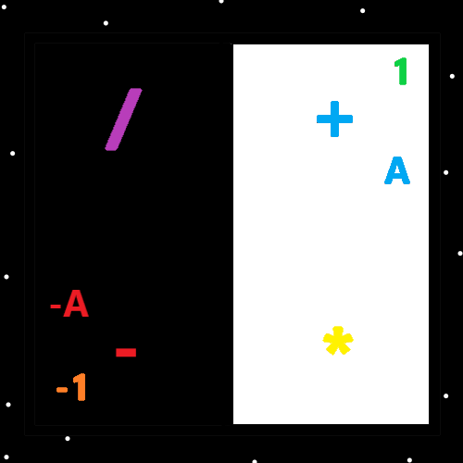
Principles: When you find a System with 3 Types often One is the Positive/Light, One is the Negative/Darkness and One is the Neutral/Twilight. When its Systems of 2 often it’s just a Positive Type and a Negative Type.
Principles: “The sins of the father fall unto the son up to the 7th generation.”-The Holy Bible.
Principles: In the Map above, I removed the Grey border. It does not seem like an improvement and will not be published in the Maps area of PAAIL.org.
Principles: I Highly recommend going to PAAIL.org, Land 2 and looking at all the pictures in the pictures section. It takes a tiny amount of Time and its all these major Maps at once on your brain and more. I Highly recommend it. For lots of reasons it’s a ultimate Spell.
Principles: Wizardry 6 Ended with “personal Wizardry books” and “Wizardry bags” along with many other things. From now on it will be Wizardry 7.
Principles: The latest is to think it might be right to say Wizardry is Cosmic Laws, Sorcery Laws, Sorcery Training, and Sorcery Use.
Principles: It may be right to say Cosmic Laws are Water. Sorcery Training is Fire. Sorcery Laws is Earth and Sorcery Use is Air.
Principles: Understanding the Water Force is the Positive, Positive Force is understanding the Water Force. This is both Wizardry and Physics.
Principles: A person could build a Divination section into their personal Wizardry book. Many different Systems are possible. A person could have 100 Words, each with a Number from 0 to 99. Then role 2x ten Sided dice which give a Number when rolled. The dice would have Numbers 0 to 9 on their ten Sides. Other dice Systems can be designed as well. Custom Divination Systems are not a bad thing.
Principles: In Physics you learn that it may be accurate to say that generally speaking “more Mass tends to equal more Energy”. Mass and weight are very similar. When it comes to a personal Wizardry book you want lots of weight. Lots of Mass.
Principles: Sometimes you find a System of 2 where there is Black and White, with no Grey area.
Principles: The Theory is that there is at least Six Senses. Just being able to predict the future seems like another Sense. Like predicting a chess move during a chess match. Or predicting what something is going to taste like from smelling it. Everyone predicts things all the Time. Basic Mind Power can result in predictions.
Principles: Using a personal Wizardry book is Connecting to things you want to Connect to. It should have at least a little Scripture in it. From books like the Bible, Koran, or Torah. Theres lots of Scripture options.

