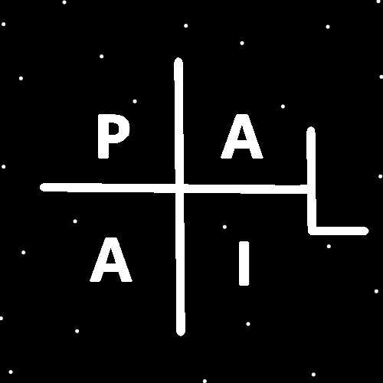
ObjectType: Room
ObjectNumber: 156
LocationName: PAAIL.org
LocationNumber:
Language: PAAIL 2.9

Maker: PAAIL.org
Model:
Name:
Rank:
SerialNumber:

Level: 7.2
Score:
Birth: 9-13-2026

Label: Room 156
Title: Smith Notes 62
Details: PAAIL.org Scripture…
Principle: Ultimate Scripture….
Agenda: Ultimate Scripture….
Action: Ultimate Scripture….
Information: Ultimate Scripture….
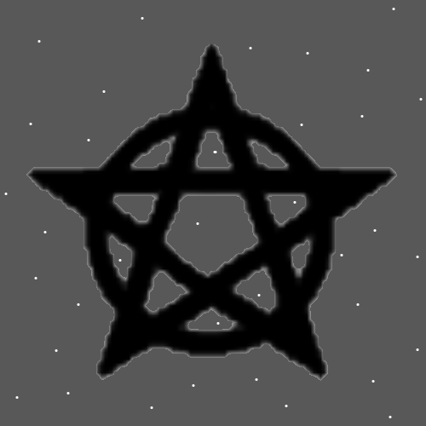
Item Group: Multiverse Laws
Principles: Everything is Science and Science is everything!
Principles: All Details are Laws of the Multiverse.
Principles: This is Apocalypse 6. 5500 to 5999 area. 6 is the Number for Change. Things are Changing all the Time around us. Life is full of Change.
Principles: The Number eleven is not a major Vocabulary Word of Wizardry. The Number Nine is.
Principles: A person can think they are an Expert Wizard when in truth they are a Master. It doesn’t take much to get from Expert to Master. Once a person gets to Expert they will likely Grow into Master when they have a been an Expert for 5 years. No Sorcery Practice needed. No training needed. Just reading. If you do want Level 5 quickly, you do Sorcery Practice. Then you can get Level 5 Wizard in six months. Level 6 Wizard in another 3 months. This is all guessing at the Math of it. Once you get to Expert, you’re likely going to End of Master after a few years. You don’t even have to try. This is Ageing.
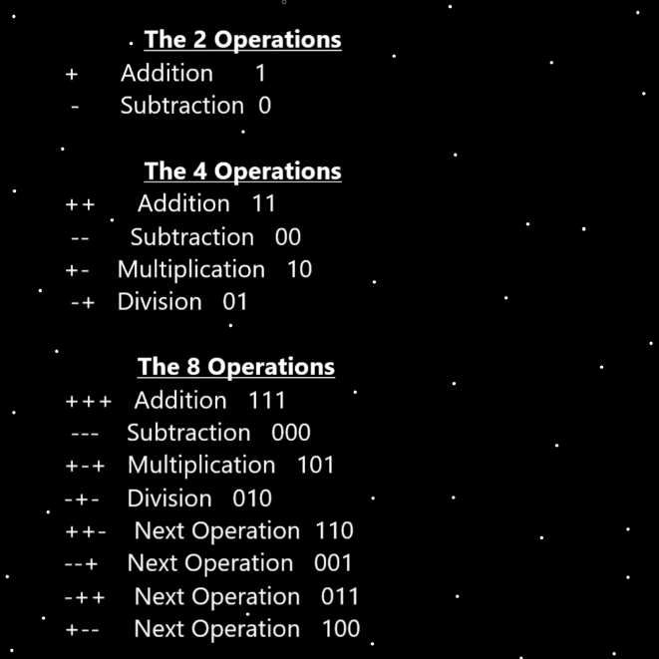
Principles: Wizardry is a super easy Doctorate. 1, 2 or 3 years. When a full-Time student. My guess is 1 or 2 years. Wizardry Level 0 to Wizardry Doctor in 2 years.
Principles: Energy Bits may always be sticks. With One Property. They are either Positive sticks or Negative sticks.
Principles: The Multiverse may be sticks Made of sticks.
Principles: The history of peoples across Planet Earth may be full of Prophecies about the Messiah. “One who will come” this, and “a king who will come” that. All of these Prophecies before Jesus visited Earth. If the Buddha is the Messiah, then the Buddhist Religions predates the Jesus visit. It seems I learned somewhere that “Messiah” and “Christ” mean the same thing, “anointed One”.
Principles: Good people don’t always know it, however they help God fight the Darkness a lot.
Principle: Humans are both tiny and gigantic.

Principles: God and Heaven know what Protons are Made of. They also know what those are Made of and then what those are Made of and then what those are Made of and so On. This goes on and on more than 1000 Levels deep. The advanced Microscope of God and Heaven is something like 1 trillion Times more Powerful than humans most Powerful Microscope. Because of the nature of “decimal points”, there is always a smaller Number and thus a smaller Particle. Exception to Energy Bits.
Principles: “..and on the 7th day God rested…”-The Holy Bible. This is Prophecy. This day of rest has not yet come.
Principle: Before there was the Light Side of the Force and the Dark Side of the Force, there was the Twilight Side of the Force.
Principle: The Zero moment resembles what happens in a “Particle accelerator”. Fittingly also known as a “collider”. Where Particles are slammed into each other.
Principles: The latest Theory is that “all things are Made of Energy Bits” is accurate. However more accurate is that “all things are Made of 1 Dimensional Energy Bits”. A new Theory is that there is such thing as 2D Energy Bits, 3D Energy Bits, 4D Energy Bits, and so forth. Furthermore, 4D Energy Bits are Made of 4, 1D Energy Bits. 3D Energy Bits are Made of 3 1D Energy Bits. This means there are Energy Bit strands. +++- is a Energy Bit strand.
Principles: Its note worthy to state that a 4D Energy Bit is Made of 4 1D Energy Bits. However, accurate is also to say it is Made of Two 2D Energy Bits.
Principles: Tons of Body exercise equals Sorcery Practice Level 2.5. Even if you have trained Zero Wizardry. You would be Level 1 Sorcery or Level 0 Sorcery, still 2.5 Sorcery Practice.

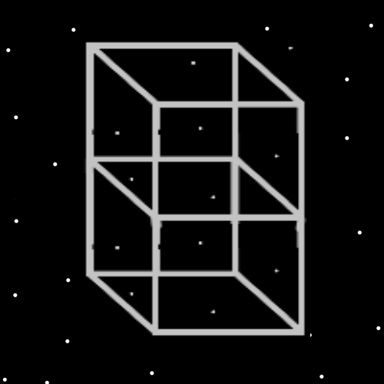
Principles: Go to put your shirt On… say after a shower or bath. Pick it up. Then wait a few seconds. Pause for a few seconds (maybe 3) before you put it On. You have now done a “Pause” Spell. This Spell is found in Smith Spells. It is also an all-Powerful Spell. Use this Spell once and awhile while using your computer.
Principles: Ultimate Science may be that there are “Energy Strands”, Made of Energy Bits. The Theory is that all Energy Strands are still an Infinitely small amount of Energy, except when you Fuse an Infinite amount of them. There for they all equal an “A” amount of Energy. It is right to call Energy Strands a line of code.
Principles: The next layer after a 1D Energy Bit is Energy Strands. Made of at least 2 Energy Bits.
Principles: Likely a person’s cloths and other gear have a gigantic impact on a person’s Chi.

Information: If the author could afford it, they would likely desire around the house gear that they would call “well stoned, precious metal bracers”. Worth at least 100k would be nice. I wouldn’t wear in public. They would likely be Powerful conduits through which Energy flows. Energy would flow through them to me, and from me, through them, unto the world.
Principles: What gear to go with is something a person has to figure out.

