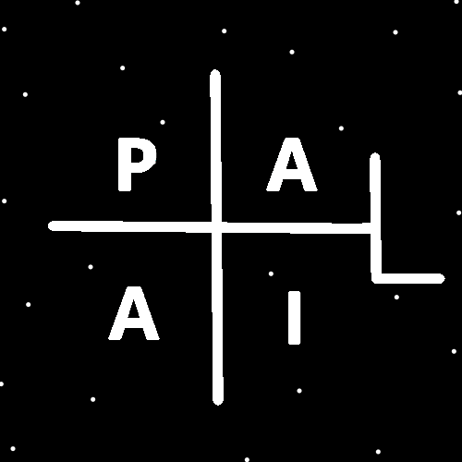
ObjectType: Article
ObjectNumber: 107
LocationName: PAAIL.org
LocationNumber:
Language: PAAIL 2.8

Maker: PAAIL.org
Model:
Name:
Rank:
SerialNumber:

Level: 6.1
Score:
Birth: 7-18-2025

Label: Room 107
Title: Smith Notes 21
Details: PAAIL.org Scripture…
Principle: Ultimate Scripture….
Agenda: Ultimate Scripture….
Action: Ultimate Scripture….
Information: Ultimate Scripture….
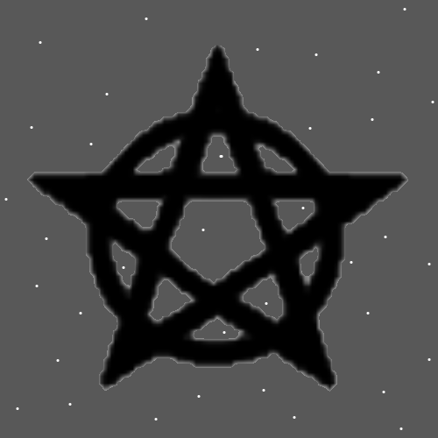
Item Group: Understanding The Multiverse 0
Principles: 1 is the Number for addition and subtraction. 2 is the Number of multiplication and division. There be the Two operations for all 1-Dimensional Numbers. 3, 4, 5 and so forth.
Principles: People have grown Levels at things without knowing it. Such as tarot card people, phones psychics and so forth.
Principles: “Books will be opened, and the dead will be judged.”- The Holy Bible
Principles: “Multitudes will rise from the dust of the Earth.”-The Holy Bible
Principles: “…holy, holy is God almighty, who is and was, and is yet to come.”-The Holy Bible. This is One of my favorites.
X2 Principle: One reasonable translation is “…Wholey, Holy is God almighty, who is and was and is yet to come.”.

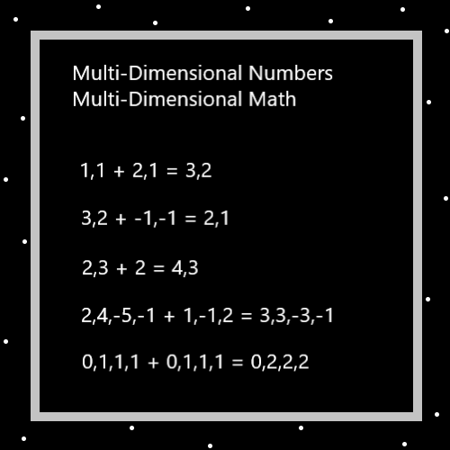
Principles: In PAAIL Science people have Agendas. People have Principles. People have Agendas. People have Actions. People have access to Information and know Information as well.
Principles: Wizards have a gigantic Connection to music from movies like the Harry Potter series. Jedi is like a Type of Wizard, and thus Wizards have a gigantic Connection to the Star Wars music and movies.
Principles: Of the Four Forces, gravity, electromagnetism, strong-nuclear and weak-nuclear…. Two of them are more fundamental than the others. Two of them are addition and subtraction. The Four Forces are Made of the Two Forces. Multiplication and division are Made of the Two Forces. In some ways the truth is that it’s not all about the Four Forces, gravity, electromagnetism, strong-nuclear, weak-nuclear. It’s about the Two Forces, maybe gravity is One of them. Multiplication and division are mixtures of addition and subtraction. Multiplication is the addition, subtraction Force, and division is the subtraction, addition Force.

Principles: The ultimate Story is that it’s all about the 2 Forces. Not the 4 Forces. Gravity is One the 4, maybe One of the 2. The ultimate physics may be that it’s all about the 2 Forces, gravity and electromagnetism.
Principles: Generally, women benefit from weightlifting exercise more than men. Generally, men benefit from stretching exercise more than women.
X2 Principles: Some practical application of this Information is that women underate weightlifting, and men underate stretching.
X2 Principles: This knowledge is likely useful in athletic Science.
X2 Principles: A combination of stretching and weightlifting is likely a great design for Body exercise.
Principles: Likely the Story is that men don’t stretch enough, and women don’t lift weights enough. This is likely a common disaster on the Planet.
Principles: The more recent theory is that there are Axis Groups, Pole Groups, Axis’s and Poles. All things sort into One of these 4 categories. The new theory is that it may be when you Zoom in on a Pole, you get a new Axis. The Pole is Made of an Axis. A Two Parts Axis. It may be that all Poles are also Axis’s.
Principles: The pattern is that all Axis’s are Made of Two Poles, and all Poles are Made of an Axis.
Principles: Gravity is likely a Pole and an Axis. Zoomed out it’s a Pole. Zoomed In its an Axis Made of Two Poles.
Principles: PAAIL.org Meditation headgear reduces the amount of Light on your eyes. The reduced light can be outright therapy. It gives a great peace to the eyes and Mind. Closing your eyes while using it is wrong.
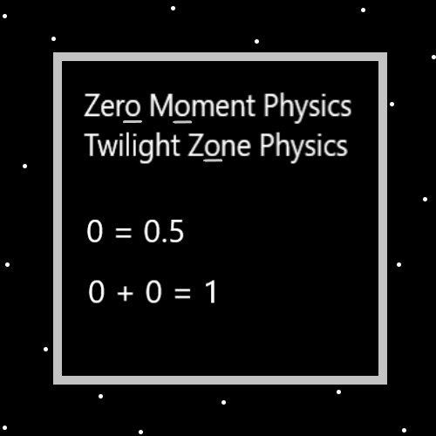
Principles: PAAIL.org Meditation headgear is all powerful for Fire and Water Meditation. Don’t close your eyes while using.
Principles: PAAIL.org Meditation headgear does many things. It Makes a person more Balanced during their Meditation.
Principles: In the past PAAIL.org Meditation headgear was described as “at least a 10%” enhancement. It be greater than that. Much greater. PAAIL.org Meditation headgear is ultimate Wizard technology.
Principles: His Holiness Jesus had the Apostles call him “teacher”. He was likely a teacher, a Wizard, and at least a Expert carpenter. One of the greatest professions of Reality is the “teacher”. All parents teach things to their children. Teaching is One of the bigger Parts of the Multiverse. The Bible teaches us things. People have “teachings”. Religions have their “teachings”. Our God would teach things to us.
Principles: The Bible speaks of his Holiness Jesus drawing in the dirt. He was likely doing Divination. I’ve never tried drawing in the dirt. I suppose some dirt’s work better than others. Maybe use your finger is the ultimate Spell Part. Maybe use a stick.
Principles: Often when a person has work, their Spiritual Energy flows through the work. If a person has no real work in life, it flows through other things.
Principles: The Scripture of the Bible that supports PAAIL.org Science is great Scripture.
Principles: The Scripture of the world that supports PAAIL.org Science is great Scripture.
Principles: Ultimate Cosmic knowledge is more supreme being like. Level 4 Wizard is more Connected to the supreme being existence.
Principles: When using the Word “Wizardry” for Divination, you skip the letter “z”. That letter seldom shows up. Instead you use the letters “Wi-ardry”.
Principles: PAAIL.org Meditation headgear rests the eyes while using. It does this and many other things.
Principles: His Holiness Jesus has a gigantic Connection to 1%. His Holiness Origin has a gigantic Connection to 0%. His Holiness 100 has a gigantic Connection to 100% and a gigantic Connection to the Word “maximum”. In Numerology the Number 100 has a gigantic Connection to the Word “maximum”. It could be a Name of Angel 100. We all have Infinite Numbers and Infinite Names. We all have 1 core Number, and 1 core Name. His Holiness Jesus owns Numbers 1 to 1.999(repeating 9’s). His core Number is 1.0. His core Name may be Light. His Holiness Origin may have Twilight as his core Name. His Holiness Twilight. It may be the true Name of God.
Principles: People really don’t know the gravity of their lives. Here at the beginning of Time.

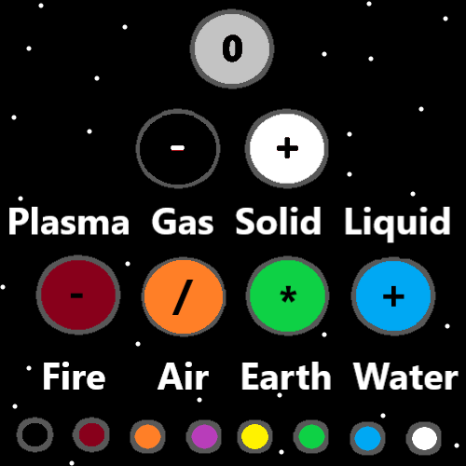
Principles: “People have entertained Angels without knowing it.”. – The Holy Bible.
X2 Principles: As in people have had guests who were Angels without knowing it.
X2 Principles: Perhaps Heaven is watching and people have entertained Angels in that way as well.
Principles: Often a person can get to Level 3 at something just by doing it over and over, like chess. Often getting Level 4 takes specialized training. Often getting Level 5 takes specialized training. Often getting Level 6 takes specialized training.
Principles: Any movie or book with a Wizard in it has a gigantic Connection to Wizards. The music also. Sometimes the Word is not “Wizard”, sometimes its witch or jedi. These books and movies as well. I think in the cartoon sleeping beauty there are the 3 fairy’s maybe, they know magical Words like “bibbity, bobbity, boo.”.
Principles: The PAAIL.org Meditation headgear decreases power using your eyes, and increases power on your ESP Sense. It is also rest on the eyes.
Principles: In the cartoon “Tiny Toons”, there be the students and the teachers. On some Maps there are Two Types of people, “teachers” and “students”. Training Wizardry turns student people into teacher people.
Principles: One of the teachers in the cartoon “Tiny Toons”- “Its short!”. A certain film is declared the winner of the student films. One teacher shouts “Its short!”.
Principles: They say “Don’t text and drive.”. It’s don’t text and operate heavy machinery. Which is what a car is. Always be super safe when operating heavy machinery.
Principles: Never operate heavy machinery while under the influence of a drug.

