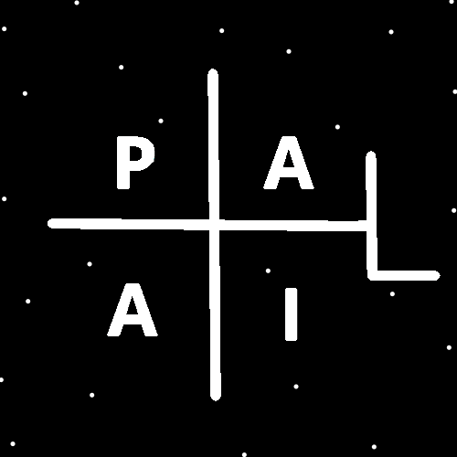
ObjectType: Article
ObjectNumber: 139
LocationName: PAAIL.org
LocationNumber:
Language: PAAIL 2.8

Maker: PAAIL.org
Model:
Name:
Rank:
SerialNumber:

Level: 7.03
Score:
Birth: 1-29-2026

Label: Room 139
Title: Smith Notes 46
Details: PAAIL.org Scripture…
Principle: Ultimate Scripture….
Agenda: Ultimate Scripture….
Action: Ultimate Scripture….
Information: Ultimate Scripture….
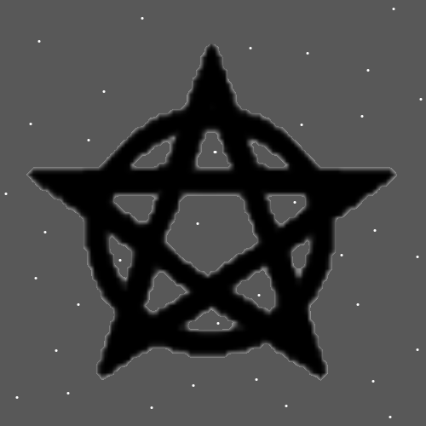
Item Group: More Wizardry 7
Principles: Its not really a Wizard staff until it hits Level 4 Wizard.
Principles: Charms of a Level 5 Wizard Age to Level 5 Wizard faster than a person at Level 4 Wizard. A person’s main Wizard Level influences their Enchanting/Ageing/Keeping.
Principles: A staff at Level 5 Wizard is still Named a Wizard staff. Like the Level 4 staff. This shows us sometimes there is not much difference between 4 and 5.
Principles: Religions have always been mutating/changing/Evolving.
Principles: The “Old Testament”, (the first half of the Bible) largely tells the Story of the Israelites. It is common of Scripture to tell the Story of a people.
Principles: Wizardry was a real Science all along.
Principles: The Force Made his Holiness the living God Origin.
Principles: Reality is Made of Energy Bit Code and all lines of Code each equal 1 Energy Bit of Energy. +--+-+-++ = 1 Energy Bit of Energy. The Theory is that +--+-+-++ is Infinitely small.
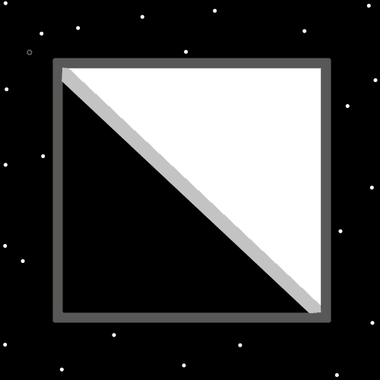
Principles: When it comes to computers there is no smaller than “1 Bit”. Not a surprise, Reality is the same. The smallest things are Energy Bits. The smallest thing is an Energy Bit.
Principles: Greater understanding of Energy Bits can be learned by understanding computer Science. Things like Bits and so forth. The author here does not know much about such things.
Principles: The amount of Energy in a Energy Bit may equal the “absolute value” of the Energy Bit. The amount of Energy in A and -A is A.
Principles: There is a lot of Stress across the Land. For children and adults alike.
Principles: Reality may have been 2D at the Zero moment. It also could be 1D or 0D or On some Maps 0D, other Maps 2D and so forth.
Principles: One of his Holiness Jesus’s Names is On. Notably similar to the Word “One”.
Principles: Likely height, width and depth are gigantic Particles. Time may also be a gigantic Particle.
Principles: When a person’s Positive Spiritual Aura does not flow through their work it flows through their rest. When it does not flow through their rest it flows through their work. Mostly it flows through both.
Principles: We are experiencing Paranormal Levels of technology on Earth these days.
Principles: When you understand nuclear Power plants you know they work by having the right mix of Water and Fire. The heat heats up the Water. The Water turns to steam/Gas/Air. The steam/gas/Air turns a Turbine. The Turbine Makes electricity. People are Power plants.
Principles: In a nuclear Power plant, you can see the Water, Fire, Earth and Air. The Earth is the Uranium fuel. The Air is the Water steam. The Water is the Water, and the nuclear explosion is the Fire.
Information: I’m always surprised that there is such thing as “cold Fission”. Which is what nuclear Power plants look like to me. They only have a tiny amount of Fission happening.
Principles: 0 and 1 are the “singular Numbers”. 2 and Higher is not.
Principles: The Mass of a Particle may be the same as its size. A 1 inch cube of Gold looks smaller than a 2 inch cube of light wood. But if you measure the surface of each gold atom and wood atom there is more surface with the gold cube. The gold cube is in some ways larger. It has more surface.
Principles: Waves are recognized as string shaped Particles. Energy Bits may be string shaped Particles. My Theory is that Waves are a Type of Particle.
Principles: Right now, we are on something like internet 10.0. It will take 20 years to adapt to it. Unfortunately, then there will be internet 15.0 and it will take 20 years to adapt to that.
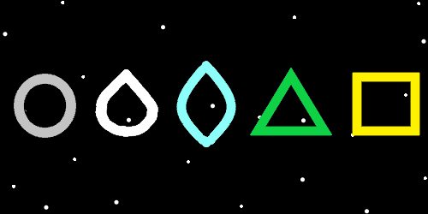
Principles: If you wanted to start using Sorcery throughout your day…. A great start might be to use the Keyword Sorcery. Thinking “Sorcery” three Times encourages a person to do Sorcery. Also, the Keyword Sorcery can be used to focus on Sorcery.
Information: Authors Levels
Wizardry 5
Cosmic Laws 7
Sorcery Laws 6
Sorcery Training 3
Divination 4
Cleaning 2
Body Training 2
Breathing 4
Meditation 5
Tarot Cards 2
Astrology 2
Alchemy/Enchanting 5
Principles: Pretty sure it’s been written. It’s worth writing again. Divination is Meditation. A Type of Meditation may be right. There are Types of Meditation.
Principles: Using your off hand is a all-Powerful exercise. It also increases the chances of making a mistake. A error. And you should always use caution when doing so.
Principles: The Zero moment (Zero Object) existed before the Force. The Zero Object Made the Force.
Principles: The Force Made God.
Principles: Having High Levels in Sorcery Makes the Spell “think a Word 3 Times” a more Powerful Spell. High Levels of Sorcery have a huge impact On a person’s Spells.
Principles: Its been written before and its worth writing again. Body exercise, Breathing exercise and Meditation exercise is ultimate Sorcery.
Principles: Right now, in most ways, there are no waterfalls in Heaven. Eventually after something like 1 million Cosmic years there will be. The waterfalls will be bigger than the people, just like they are now. Angels may still look like Energy Balls or perhaps dice with many Sides. People will be able to craft the waterfalls. They will be able to take every waterfall painting done on Earth and Make One that looks the same. All existing waterfall paintings have a gigantic Connection to a real waterfall that will One day exist.
Principles: Stars may be like dice with many Sides. The future evolution of the Body may always be Growing another Side.
Principles: Just as some random Theory… if Photons have Negative Mass perhaps Negative Mass Particles can travel the speed of Light and/or faster.
Principles: Another random like Theory… It may be that Photons have both Positive Mass and Negative Mass. This would Make them look like they have no Mass.
Principles: Vibrations and Frequencies are major Parts of the Multiverse. All coins Vibrate on a certain Frequency.

