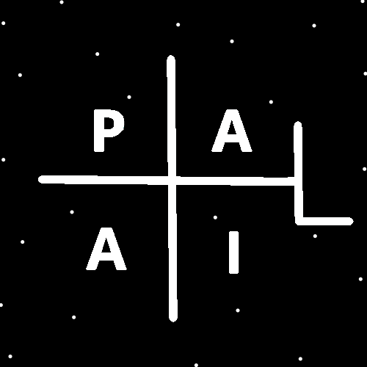
ObjectType: Article
ObjectNumber: 127
LocationName: PAAIL.org
LocationNumber:
Language: PAAIL 2.8

Maker: PAAIL.org
Model:
Name:
Rank:
SerialNumber:

Level: 6.5
Score:
Birth: 12-6-2025

Label: Room 127
Title: Smith Notes 36
Details: PAAIL.org Scripture…
Principle: Ultimate Scripture….
Agenda: Ultimate Scripture….
Action: Ultimate Scripture….
Information: Ultimate Scripture….
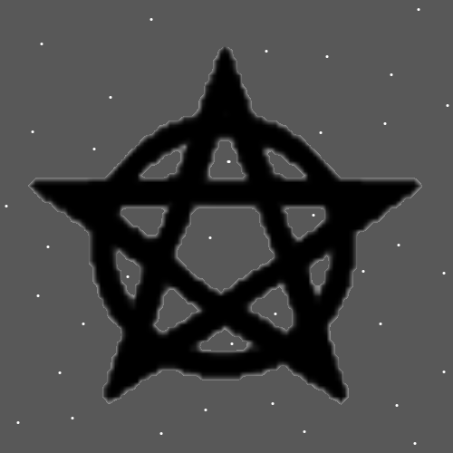
Item Group: More Story of Things 0
Principles: A better example of long Titles. His Holiness, Chess Master, Math Expert, Teaching Expert, Writing Expert and Olympian Fencer, “name here”.
Principles: A bunch of tiny Items equals a small Item. A bunch of small Items equals a Medium Item. A bunch of Medium Items equals a large Item. A bunch of large Items equals a huge Item. A bunch of huge Items equals a gigantic Item. You can replace the Words “Item/Items” with many other Words. Example you can use the Words “Charm”, “Spell” or “Action”. A bunch of tiny Spells equals a small Spell. A bunch of tiny Charms equals a small Charm. A bunch of tiny Actions equals a small Action. A bunch of small Actions equals a Medium amount of Action. A bunch of Medium Actions equals a large amount of Action. A bunch of large Actions equal a huge amount of Action. A bunch of huge Actions equals a gigantic Action.
Principles: Often to get to a gigantic Action you must do a bunch of tiny Actions. Often gigantic Actions are Made of tiny Actions.
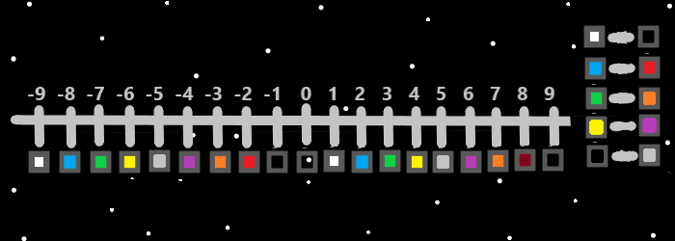
Principles: The theory is that One day we will be the size of marbles, and yet as Powerful as God is right now.
X2 Principles: This could be a million Cosmic years of Evolution, or even a trillion years. It could be 10 thousand Cosmic years for all I know.
Principles: Likely space can be converted into other Energy. Example space converted into Protons. A loss of space for a gain of Protons. At the Beginning of Time space converted into the God Body.
Principles: Perhaps space is often converting into other Energies all the Time. Perhaps it happens with Black holes.
Principles: Space may have mass. Space is possibly bend in Particles that have mass. We travel along the surface of the bend in Particles. We surf space. Like Water can be surfed space is surfed. Space may have Negative mass.
Principles: There may be Two Types of Energy On some Maps. Space and another Type. Space may be the Negative Type On this Map, and the other is the Positive Type. The Two Types of Energy may be known On some Maps as “bend out Energy” and “bend in Energy”.
Principles: Space is likely another Particle and we travel along the surface of it. 4 Particles to be exact.
Principles: Space likely resembles a tapestry. Instead of a 2D tapestry it’s a 4D One. There may be space Particles, and they have a size. It’s possible that space is Made out of many space Particles. They may have a certain size and mass.
Principles: It may be that all Particles have Mass. Positive or Negative Mass maybe. Still Mass. Exception to the Zero Particles at the Zero Moment. They likely had no Mass. Even Energy Bits look like they have Mass. Positive Energy Bits a “A” worth of Mass, and Negative Bits a “-A” amount of Mass.
Principles: The amount of Energy in a Particle may equal its Mass. Include its speed in the measurement and then its more. Include the heat and there is even more Energy.
Principles: One Law God gave the Israelites is no work on the Sabbath. He commanded no work for everyone, including servants and slaves. On Gods Sabbath (Resurrection Day), it will be a crime to dig a hole, if you don’t enjoy doing it.
Principles: The PAAIL.org teachings regarding the Sabbath are that it can be good to have at least 1 rest day a week. It need not be on Sunday or Saturday. Its wrong to go to church on your Sabbath if you don’t like going to church. If you are going to church on Sundays because Forces compel you, and you don’t like it, Make your Sabbath some other day of the week, while you go to church on Sundays.
Principles: 1 draw of marijuana can get a person super Intoxicated. 1 drink of alcohol can have no impact at all. 4-6 drinks of alcohol can get a person so Intoxicated that marijuana is a tiny Intoxicate compared to alcohol.
Principles: As a Toxin, caffeine is a 2, marijuana is a 4, and alcohol is a 6. These Toxins get people Intoxicated. Toxins/Toxic things can be super dangerous.
Principles: It may be there are bend in Particles, bend out Particles and the only flat Particles were the Zero Energy Bit Particles at the Zero Moment.
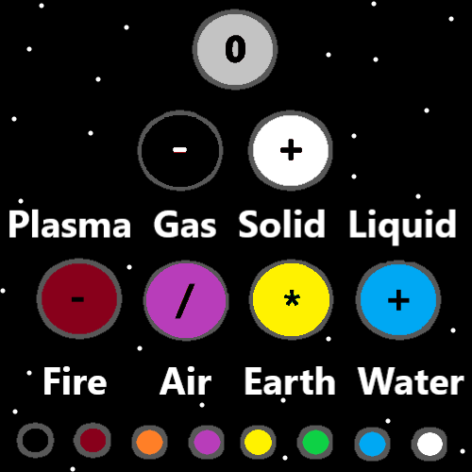
Principles: Since bend out Particles all look similar, then likely all bend in Particles look the similar. Likely all bend in Particles look like space. Space is a bunch of bend in Particles, and all bend in Particles look like them.
Principles: Bend in Particles may resemble mini-empty Universes. All of space may be Made of mini-empty Universes. 1D, 2D, 3D or 4D Particles.
Principles: There seems possible that there are 1D Particles, 2D Particles, 3D Particles, 4D Particles and maybe more. It may be that as Reality Evolves new 100D Particles will appear.
Principles: Good news. Theres lots of good news. Bad news. Theres lots of bad news.
Principles: The Water Colors are White and Blue. The Earth Colors are Green and Yellow. The Air Colors are Purple and Orange. The Fire Colors are Red and Black. The Map above Details this. These 8 Colors are the 8 Colors of the 8 Operations. Addition is White, Subtraction is Black, Multiplication is Yellow, and Division is Purple. The other 4 Colors belong to the other 4 Operations. I do not know what the other 4 Operations are.
Principles: Because Energy Bits are Particles, it Makes Sense to say all Energies are Particles. It Makes Sense to say space is a Particle or space is a group of Particles. Height, width, depth and Time are Particles with a surface and we travel along the surface.
Principle: All things are Physics. There is no beyond Physics.
Principle: Lots of PAAIL.org is Theoretical Science.
Principles: All things are math. However, before all things are math all things are 1’s and 0’s. All things are Positives and Negatives. For every Number (except 0) is Positive or Negative.
Principles: On some Maps there may be 8 “states of Matter”. Not just Liquid, Solid, Gas and Plasma.
Principles: One may find ultimate measuring Systems by examining the difference between Solid and Liquid, Liquid and Gas, Gas and Plasma. Each has a heat Level. Perhaps Solid is 1, Liquid is 2, Gas is 3 and Plasma is 4.
Action: Force a Vision of God. Picture his Energy Ball Body Off in the distance. See him at the center of his Universe. See him and this Universe going around him. On a Cosmic scale God is a small distance away.
Principles: If the amount of Mass in an “A” Energy Bit is “A”. Then likely Energy = Mass.
Principles: These days all Scientists know there is always new more Powerful technology to be invented. Because of this and more technology is Evolving super-fast. It’s worth noting that new technology is something humans have to adapt to. The bigger the technology the more destructive it is at its Beginning.

