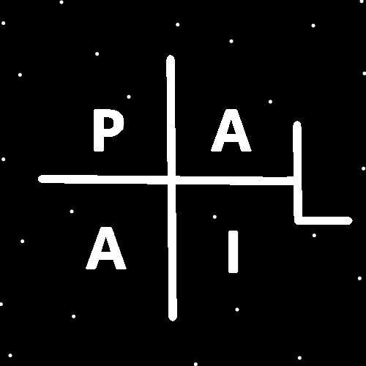
ObjectType: Room
ObjectNumber: 149
LocationName: PAAIL.org
LocationNumber:
Language: PAAIL 2.9

Maker: PAAIL.org
Model:
Name:
Rank:
SerialNumber:

Level: 7.18
Score:
Birth: 6-19-2026

Label: Room 149
Title: Smith Notes 56
Details: PAAIL.org Scripture…
Principle: Ultimate Scripture….
Agenda: Ultimate Scripture….
Action: Ultimate Scripture….
Information: Ultimate Scripture….
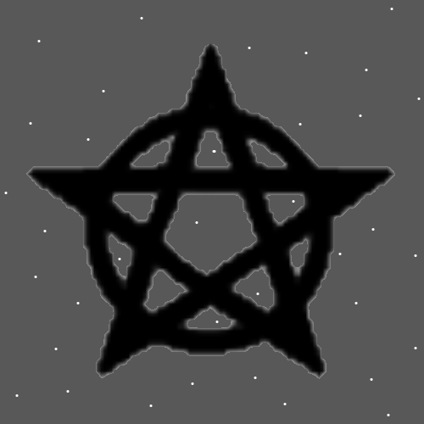
Item Group: Wizardry Laws 7+
Principles: Music can induce experiences. These experiences count as Visions.
Principles: Experiencing Visions likely Drains a person’s Mana.
Principles: There may be Negative Type Particles that push away from Galaxies when they come near them. These Particles would mainly live in between Galaxies.
Principle: Divination is listening to the Four winds.
Principles: Knowing the Four Forces are the Addition Force, the Subtraction Force, the Multiplication Force and the Division Force will likely lead to greater technology. It’s the same Story with Energy Bits and other PAAIL.org Science. It will likely lead to greater technology.
Principles: His Holiness the living God Jehova is like us. He is a Part of the Force, a Side of the Force, a Dimension of the Force.
Principles: Because we are family to God, all the good peoples Stories are Scripture to God.

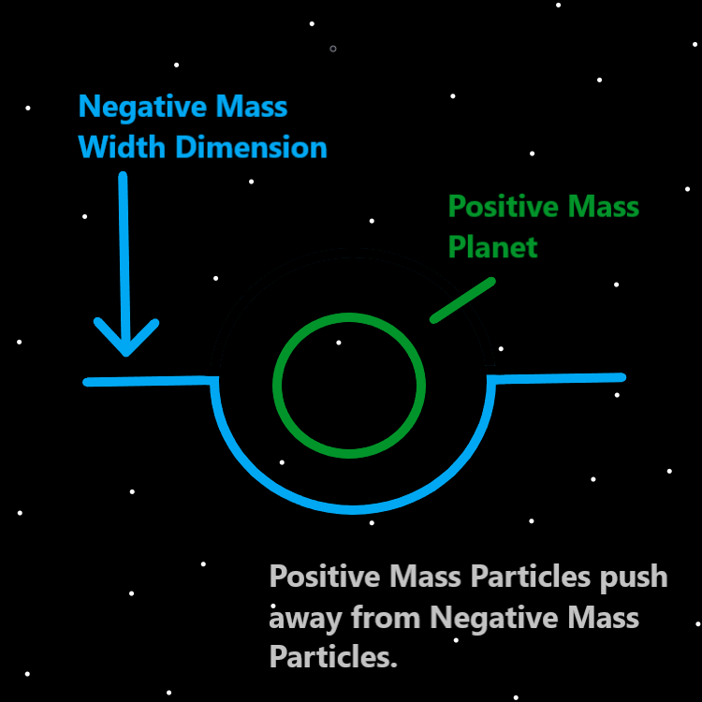
Principles: In the afterlife all children will gain at least Level 4 Wizard by 10 years old. Likely Level 5 or Higher.
Principles: It seems possible that Energy Bits have Mass. If they do then likely all Particles have Mass. It may be the Mass of a +A Energy Bit is +A. If so then Mass may be the ultimate Number of a Particle. A Particle with 10 Mass would be the 10 Particle. Also -A Energy Bits likely have Negative Mass. If true, then there may be other Particles with Negative Mass.
Principles: Its an old teaching that you cannot create or destroy Energy, that you can only transfer it. When you Recharge Mana you Drain from other Batteries. Sometimes when you eat food you Recharge, however there is also a Drain.
Principles: It seems likely all Particles have Mass if Energy Bits have Mass.
Principles: It seems right to call Waves a Type of Particle since Energy Bits are called Particles. It may be Energy Bits are Wave Type.

Principles: Everyone has a Chess Aura. Sometimes that Aura is very small. If you have never played Chess it would be Level 0. All Auras have Parts. Auras have Sub-Auras. Part of our Spiritual Aura is our Spiritual Level. Another Part of our Spiritual Aura is our Spiritual Score. Our Spiritual Story is yet another.
Principles: Rigorous exercise where you sweat is more ultimate Body exercise. There are other sweating exercises also. Some are extremely dangerous, like a sweat lodge. People have died sometimes.
Principles: If Negative Mass Particles do exist some of them may push away from Positive Mass Particles. In regards to the Width Dimension we call this effect Gravity. It may be Width generates Negative Gravity and Protons generate Positive Gravity.
Principles: It may be Energy Bits are 1D.
Principles: Negative Mass Particles may be hard to find because of their Physics. Exception to things like the Width Dimension and possibly Electrons. Photons may also be Negative Type and have Negative Mass.
Principles: It’s no surprise the End of Particle Physics is Energy Bits. Reality is just like computers.
Principles: 1000 Cosmic years is the Beginning. 99 Cosmic years is the Beginning of the Beginning.
Principles: All things are Made of Energy Bit Code.
Information: Holy cow!! The secrets of the Universe revealed!!
Principles: All of Reality is Surfaces Making contact with other Surfaces.
Principles: Like reading and basic math Wizardry is a Science everyone would learn.
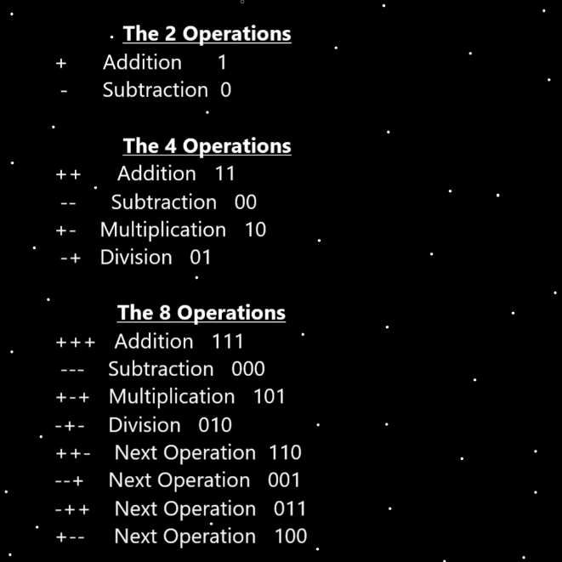
Principles: 1 Spell is “Symbol Write 1x”. Another is Symbol Write 10x. Another is Symbol Write 100x and yet another is Symbol Write 1000x. If you were to write them in a book you Enchant the book and Gain Symbol Write Levels. Wizardry books are worth Enchanting in this way. Not all books are. If it damages the book or lowers its value, then it should not be done. The Symbols drawn ideally improve the appearance of the book.
Principles: When you achieve Level 4 Wizard movies can reveal the truth of things.
Principles: It seems all the Angels can interact with each other, even across the great distances. All galaxies are in contact with all other Galaxies. This Makes it seem like there may be Particles traveling faster than the speed of Light. Some how these Galaxies interact. Perhaps portals are involved. Perhaps Quantum Entanglement is involved.
Principles: It may be a telepathy existence in the Heavens. I give it 50, 50. 50% is not very likely. I wouldn’t want to bet on it at all.
Principles: The Stars are tiny things to God. They are tiny on a Cosmic scale. Like little Particles.
Principles: It may be that Stars are so small they qualify as Quantum sized Objects. It seems likely that the God Body does not qualify.
Actions: Force a Vision of having a Vision into your Mind.
Principles: Gravity may be governed by Positive and Quantum Mechanics is governed by Negative. Their Laws may be the opposite of each other and they may contradict each other. Gravity may be the Water Force and Quantum Mechanics the Fire Force. Gravity could also be the Addition Force and Quantum Mechanics the Subtraction Force.
Principles: The ultimate Science Fused with other Science is a all-Powerful thing. Especially these days when Wizardry is at Cosmic Laws 7. Wizardry was much less Advanced at the End of “Tome Of The Yellow Wizard”. Wizardry is much more Advanced now than it was at the End of “Tome of the Yellow Wizard”.
Principles: 2D Particles may have “0” Depth. Then again, it may be they have “-1” Depth, or -0.1 or something. They could have “A” Depth or “-A” Depth. “A” is referring to Energy Bits.
Principle: The Light forever Grows and the Darkness forever shrinks.
Principles: It may be right to say space is a 4 Dimensional Object. That or 3 Dimensional Object. Its Made of 3 or 4 1 Dimensional Objects. It may be that it is a 3 Dimensional Wave Type Object. Likely space is a Negative Type Object.
Principles: It may be at the End of the day a persons Mana Battery is Drained and sleep Recharges it.
Principles: Famous Symbols are ultimate Symbols. The Christian cross is a famous Symbol.
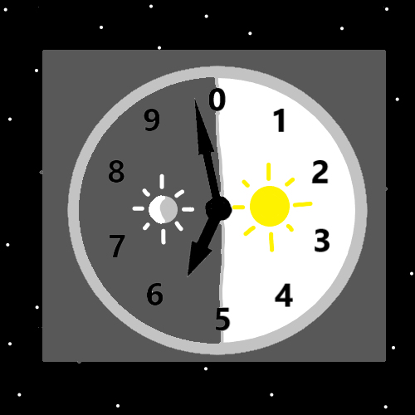
Principle: Famous sound clips are ultimate sound clips. Often, they are short tunes lasting a handful of seconds.
Principle: Famous music is ultimate music.
Principle: Famous things are ultimate things.
Principles: Famous video clips are ultimate video clips. Often, they only last a handful of seconds. Sometimes you find them right before a movie starts.
Principles: Famous movies are ultimate movies.
Principles: The first half of an age (1000 years) is the day. The second half is the night.
Principles: Wizardry is seldom cryptic Words. It is specific Scientific Statistics.

