ObjectType: Article  
ObjectNumber: 108

LocationName: PAAIL.org

LocationNumber:

Language: PAAIL 2.8

Maker: PAAIL.org  
Model:   
  
Name:

Rank:

SerialNumber:

Level: 6.1

Score:   
Birth: 8-2-2025

Label: Room 108

Title: Smith Notes 22

Details: PAAIL.org Scripture…

Principle: Ultimate Scripture….

Agenda: Ultimate Scripture….

Action: Ultimate Scripture….

Information: Ultimate Scripture….

Item Group: Understanding The Multiverse 0

Principles: PAAIL.org Wizard technology in many ways is new technology. Since it hasn’t been readily available until now. Humans have not yet adapted to Wizardry. For this reason many Wizards will encounter a rocky Path. The trailblazers of early Wizardry will be their Stories. They be 1st generation Wizards.

Principles: Reality is an Infinite series of “big bang” events. There are the biggest 4 big bangs though. The first, an empty Universe. The 2nd the Birth of the God Body. The 3rd the Birth of Heaven, and the 4th the Birth of the Jesus Body.

X2 Principle: When Two Planets collide it is a “big bang” event.

Principles: Hats like the baseball cap reduce the amount of light on the eyes. These hats are priceless because they reduce light, and because seeing less objects is a good thing.

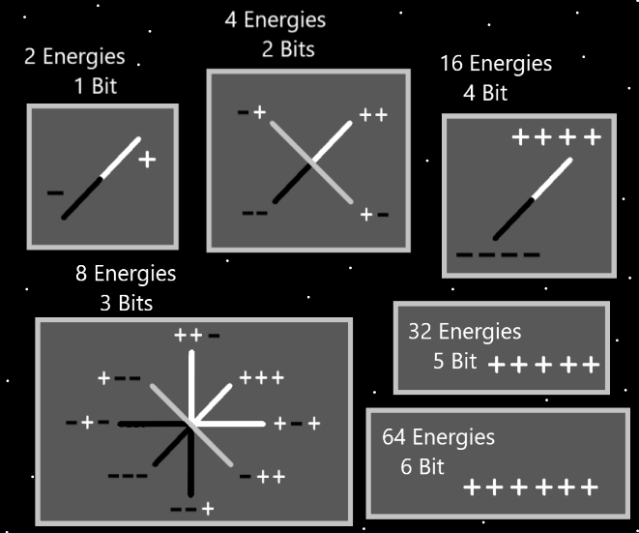

Principles: If you have ever held your hand over a flashlight in the dark, you see the light travels through your hand, and Makes your hand glow. This is important because we want to notice how closing your eyes reduces light, however tons of light still passes through your eye lids. Closing your eyes does not do as much as PAAIL.org Meditation headgear. Also, closing your eyes off-balances a person, and does other Negative things.

Principles: The PAAIL.org Meditation headgear diverts power from your eyes to your other Senses. A lot of power to.

Principles: Because the letter “A” is the first letter of the alphabet it has a gigantic Connection to his Holiness Jesus. This is because his Number is “1”. His Holiness Two has a gigantic Connection to the letter “B”. Because it’s the 2nd letter in the alphabet.

Principles: His Holiness Jesus has a gigantic Connection to the letter “I”, because in roman numerals “I” means “One”.

Principles: It seems like there is write in sand Meditation. A person might be able to do a Divination Meditation writing in sand also.

Principles: “…the great I am!”-The Holy Bible. I believe the Bible is referring to his Holiness Twilight. He be “the great I am!”.

Principles: Divination is listening to the 4 Winds. Communing with the Force.

Principles: Every cell in the human Body is alive and they all will evolve into Gods someday.

Principles: The theory is that some pain and discomfort is caused by cells experiencing pain and/or discomfort.

Principles: PAAIL.org Meditation headgear is ultimate technology. Once again, you should be able to see your chest and lower Body with it. This lets in a little light, as is desired.

Principles: Gravity is a Pole. One of the 4 Forces. And its an Axis with Positive and Negative Gravity.

Principles: Of the 8 core operations, gravity may be Two of them. Positive gravity is One operation and Negative gravity another. 4 of the 8 core operations are addition, subtraction, multiplication and division.

Principle: Wizardry is the ultimate training for a person’s Chi.

Principles: All Wizardry is the Science of God. The Numerology of the 1 to 6 Numerology System is a System God uses.

Principle: Our Gods grandchildren in Heaven have Planets and Moons for toys.

Principles: Before there was Light and Darkness there was Twilight. Light and Darkness are Made of Twilight.

Principles: The Origin moment is the source of all things. Note the letter “o” in the Word “source”. One Name that belongs to his Holiness Twilight may be “source”.

Principles: The most Scientific Word for Reality may be “Multiverse”.

Principles: The Multiverse is Made of Infinite Universes.

Principle: Lots of Light on the eyes bombards a person in a Negative way.

Principles: Sunglasses when used correctly are likely ultimate power. They are likely a very underrated thing.

Principles: The One thing all medical Experts seem to agree on is that people need to intake the right amount of Water each day.

Principles: Ideally you want the right Balance and amount of Fire and Water in life. To much Water tends to not be so Negative. To much Fire can be a disaster. Never play with Fire.

Principle: A person can Make their fasting easier by eating a lot the day before they fast. Its likely the best practice to fast One day a month. Some people are too busy for fasting. It can be to difficult to fast for some people and it is not mandatory to do so.

Principle: Often people get Expert at a thing and never get a higher Level, because they don’t need a higher Level.

Principle: The best PAAIL.org Meditation headgear would be headgear that’s also designed to look awesome. The latest thought is that it should be called a “Meditation Helmet”. I have a Vision of a helmet that has a face mask like piece which points out like baseball cap and folds down in front of the face. You can fold it down (when using) and you can fold it up, where then you can see the Room around you.

Principles: Making up Systems that use the 1 to 6 Numerology invention is a powerful thing.

Principle: A person might use a Numerology System that is 1 to 5, because in the situation there is no better than “Masterful”. This System is not as good as the 1 to 6. However it is a great Map sometimes in life.

Principles: Divination can Force a person to think. Thinking can be good for the Mind. Thinking is Meditation. It may be accurate to say that Divination is a Type of Meditation.

Principles: The Zero moment is the source code of all things.

Principles: Wizardry is the 100% accurate Religion. The all-knowing Religion.

Principles: On some Maps trained Wizards are first generation Wizards. On another Map I be the first-generation Wizard and everyone else is 2nd generation or later.

Principles: One of his Holiness Jesus’s Names is “Genesis”. He be his Holiness Genesis. As for his Holiness Michael, another of his Names is Exodus. His Holiness Exodus.

Principles: While using PAAIL.org Meditation Helmets…. Since you can only see your chest and lower Body it helps you to better Connect to yourself. It helps you Disconnect from the outer world and better Connect to yourself. Improvement of self is the core focus in life. Focus on thyself is Level gain. People tend to have more power over their own Chi than other Chi out there.

Principles: The best Meditation Helmet may have a “visor”. Possibly a visor that folds up and down. I always End up thinking about a scene in Star Wars, where Yoda is teaching a bunch of children, they all have training helmets.