Ian Corbett
Specialist Oral Surgeon
Sedation

Sedation makes you feel drowsy and helps reduce anxiety, it may also make you forgetful and you may remember very little of your treatment. You will not be asleep. At your consultation appointment we will discuss if this is suitable for you, which may depend on your health, medicines and home circumstances. Sedation is not suitable for patients with moderate-severe breathing problems, sleep apnoea, or during pregnancy. The type of sedation we offer is called intravenous sedation, using a single drug called midazolam. This is given by injection into a vein in the back of your hand or in your arm through a small plastic tube or cannula. It is normal to feel a sharp scratch when the tube is placed and once it is in place the sedation drug can be given without using any more needles. The tube stays in place until you are ready to go home.
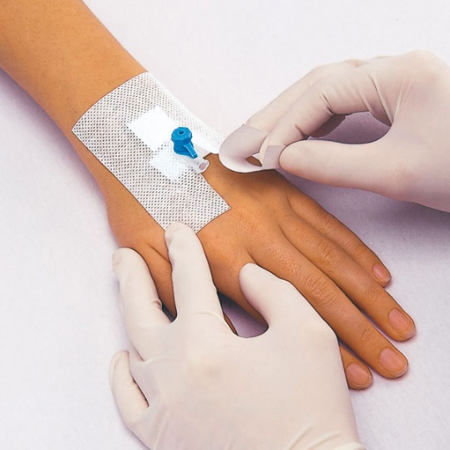

Each patient needs a different amount of sedation drug and we will give you a little at a time until you are happy to start treatment. Before and during sedation we will take your blood pressure, measure your pulse and the amount of oxygen in your blood. Oxygen is measure by placing a small soft clip on your finger, which is why we might ask you to remove nail polish or false nails before sedation. These measurements help use to ensure your safety. Sedation can affect your breathing and we may ask you to take some deep breaths during your procedure. Sometimes we give you a little oxygen through a small tube placed under your nose. We will also keep reminding you to ‘open wide’ as you may have forgotten why you are with us.
Your treatment will be the same whether you are having sedation or numbing alone. Once you are sedated, we will give you the usual numbing injections before we start your surgery. As we carry out your treatment your sedation will slowly wear off and you will become more aware of your surroundings. Sedation lasts around 45 minutes, and this is usually more than enough to finish your treatment comfortably. Once we have finished, we will sit you upright and you will begin to feel more awake. You will still be unsteady on your feet and we will move you to a comfortable seated recovery area. We will continue to check your blood pressure, pulse and oxygen while you recover. Once fully recovered, usually around one hour after sedation was started you may go home accompanied.
Because of the effects of sedation, we ask that some one comes with you to your appointment, your escort. This person should be responsible for looking after you only and you should not bring children with you to your appointment. Unfortunately, if you do not have someone with you at your appointment who will be able to look after you, we will not be able to give you sedation. This person should drive you home or arrange for someone or a taxi to collect you. You should not travel home on public transport. Once home you should take it easy, stay seated, watch television or you may wish to nap. Your escort should stay with you and look after you for 24 hours after your sedation as you should not drive, go to work, look after children or make any decisions for 24 hours.
You may feel fully recovered before 24 hours are up, but you should continue to follow the instructions. Where the tube was in your hand or arm may have a small bruise. Side effects of this type of sedation are uncommon but we will provide you with a contact number should you or your care have any concerns.

