One Nation Under God Ministries (www.onug.us)
How Could A Holy God Ever Love A Sinner Like Me?
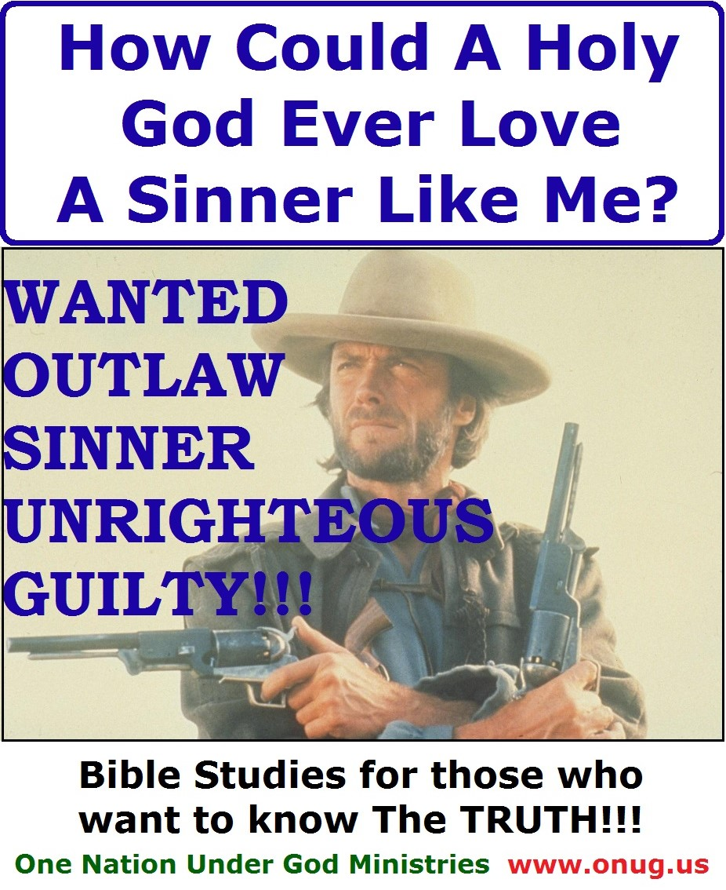
One Nation Under God Ministries (www.onug.us)
How Could A Holy God Ever Love A Sinner Like Me?
God the Father and Jesus Christ have lived together since eternity, yet the Bible is crystal clear on this one point; that God the Father loves you and I – right now - every bit as much as He loves His Son Jesus! But just how is something as amazingly awesome as that even possible?
Video Link: https://youtu.be/-tALFOADf5M
Bible Study Instructions: One Nation Under God Ministries (www.onug.us) publishes and distributes weekly Bible Studies, worldwide – free of charge, to anyone who requests them, in both printed and electronic formats. Our Studies are intended to be a simple and fun way to learn the Scriptures, and are very easy to follow! We adhere to Jesus Christ’s Biblical instructions to teach and feed the flock of God portions of meat in due season, on weekly Sabbaths, and on the seven annual Holy Days throughout each calendar year (Luke 12:42 / Isaiah 28:9-10 / Matthew 13:52). Using both the Old and New Testaments, our Bible Studies are designed to present a premise, make a statement, or ask a question – followed by one or more Scriptural references. Just look up and read from your Bible the Scriptures listed. Comments following questions elaborate on the Scriptures you just read. Pray always before beginning any study of God’s Word, asking God to open both your eyes and your mind to His Truth; then Prove everything you read, is in fact the Truth, by comparing it to The Word of God (1 Thessalonians 5:21 / 2 Timothy 3:15-17). Then use the Biblical System of Checks and Balances, and SEE if both Jesus Christ, and the First Century Church of God Apostles – also Did, Said, and Taught these SAME THINGS (Galatians 1:1-12, 5:25 / 1 Peter 2:21, 25 / 1 John 2:3-6)! That’s all there is to it! Our Bible Studies are based on the King James Version, unless otherwise stated. We will be praying for your eyes to “see” (Matthew 13:11-17); and we are always available to answer any of your questions! Be Blessed, in Jesus’ Name! - One Nation Under God Ministries is Preparing this world for The Return of Jesus Christ; One Bible Study At A Time! (www.onug.us) JESUS IS LORD!!!
In order for us to begin to understand God’s love for the sinful humans living on this planet, we must first understand why Satan hates us so; and we must also comprehend the deep hatred Satan’s harbors in the core of his being, for his own Divine Creators; God the Father, and Jesus Christ, Themselves (John 1:1-3)! www.onug.us
The Bible tells us that Lucifer was the wisest, the most perfect, and the most powerful of all the angels. He was the most beautiful Living Being of all that God created; he was even adorned with EVERY precious stone, the perfection of perfection – according to how Almighty God sees it, and records it in Scripture!!! Lucifer was in the Garden of Eden, after the Creation, as a Holy Angel of God! Long before he became the devil, Lucifer watched God create man, and afterwards watched God create Eden. Lucifer kept the first Sabbath ever, with Jesus Christ and Adam; he fellowshipped with Adam, and worshipped God the Father with Adam on that first Sabbath Day (Ezekiel 28:12-13 / Genesis 1:1-5, 26-28, 31, 2:1-9)!
What are Tabrets and Pipes according to the Bible?
In Ezekiel 28:12-13, we just read, “the workmanship of thy tabrets and of thy pipes was prepared in thee in the day that thou wast created.” What does this mean? Let’s see!
King David, a man after God’s own heart (Acts 13:22) continually Praised God in both word and music. I believe God originally created Lucifer to do the same thing; God made Lucifer’s perfect spiritual body with the Divine talent and ability to play music in and of himself! www.onug.us
In every Scripture that I could find, but two; “tabrets and pipes” refer to musical instruments: (Tabret) Genesis 31:27 / 1 Samuel 10:5, 18:6 / Job 17:6 / Isaiah 5:12, 24:8, 30:32 / Jeremiah 31:4 / Ezekiel 28:13 and (Pipes) 1 Samuel 10:5 / 1 Kings 1:40 / Isaiah 5:12, 30:29 / Jeremiah 48:36 / Ezekiel 28:13 / Matthew 11:17 / Luke 7:32 / 1 Corinthians 14:7 / Revelation 18:22. The two exceptions, are in Zechariah, where the pipes they are speaking about are part of the lamp stand (Zechariah 4:2, 12).
Man was created with just one “pipe”; the wind pipe! Lucifer on the other hand has multiple “pipes” created IN HIM, as well as multiple “tabrets” or small drums / timbrells! He was created by God to be a Vocalist, a Spiritual Organ, and a living musical instrument of sorts! Today, we are finding a renewed interest in “a cappella” singing groups; a modern variation of the classic Barbershop Quartets! The phrase “a cappella” is actually Italian for “in the manner of the church” or “in the manner of the chapel”. Although a capella is technically defined as singing without instrumental accompaniment, some groups today use their voices to emulate the sounds of instruments. When we understand that “church” in the Bible means “ekklesia” or ASSEMBLY / CONGREGATION, then God giving Lucifer tabrets (drums) and pipes (vocals and wind instruments) would make him a one angel orchestra – which God intended to play for the Body of Christ / The Congregation of the Saints – (a capella) in the manner of the church!!! I think this is some pretty cool stuff about Lucifer that most people today are ignorant about! Hopefully, this study will give you a lot more to think about in your future Bible Studies too! All the Scriptures we have read so far, makes me wonder; what kind of music did Lucifer play for God, on that First Sabbath morning, in the Garden of Eden, with Jesus Christ, Adam, and all the other angels present?
Yes! God created music and song for both man and angel to worship Him with (Revelation 5:8-10)! We can see from Scripture that His Saints will not only be Kings and Priests on the earth; but they will be “Singing Saints”, with a band of angels playing music to accompany them!!! When Satan fell, and was disfigured / transformed into a dragon; his musical ability – still spiritually derived, was twisted and perverted along with him! www.onug.us
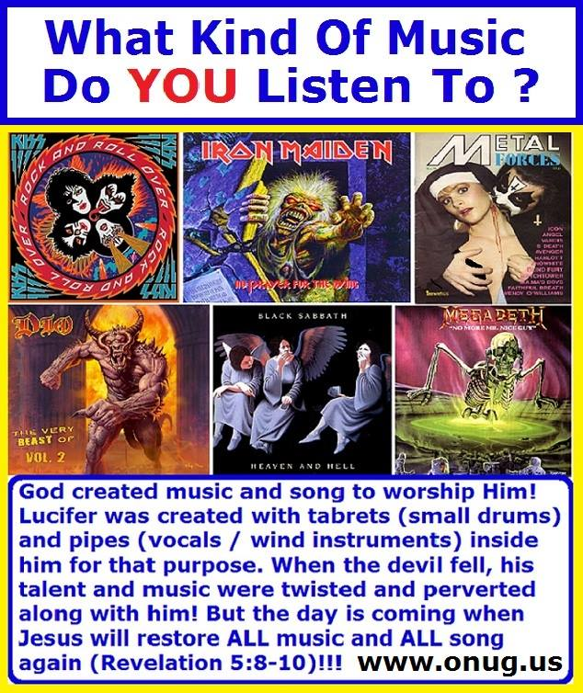
Once you possess God’s Holy Spirit in your mortal flesh; you will begin to “see” and “hear” the devil himself in most of today’s rock and roll, heavy metal, and rap music! Even the pure music that stands apart, and that which is called Gospel or Christian Music, can be polluted with un-Scriptural lyrics that promote a lie rather than the Truth of God (John 8:44)! I think of the song, “Onward Christian Soldiers”, and wonder how Satan must have perverted that theme, as he played his War Drums and convicted more than 50 million angels to reject their created purpose and seek to overthrow the God who made them!
We invited you to watch our YouTube video: “Onward Christians Soldiers” (at www.onug.us) and experience one of the many pure songs that do Glorify God!
Video Link: http://youtu.be/cOroaaI5JQo
Why Did Satan Sin (Ezekiel 28:11, 14-17)? www.onug.us
There is a “hierarchy” among the angels of God. The word itself comes to us in the modern English, from the Greek words “hierarchia” which means “rule of a high priest”; and from “hierarkhes” which means “leader of sacred rites. We can simply summarize it as “Heir Order”, or how God will structure the Kingdom of God under His Heirs, in the very near future! This is KEY to understanding why Satan fell (Revelation 5:7-10)!
Under Lucifer, God had originally set four living creatures, and twenty four angelic elders. These Angelic Elders rule over the legions of angels, and each Elder holds a harp and golden bowls in their hands (Revelation 5:8). These Elders also wear crowns denoting their “hierarchy” in the Angelic Legions (Revelation 4:9-11); they are not, nor were they ever human, as this would violate John 3:13 / Daniel 12:1-3 / Revelation 20:4-6, and many other Scriptures about the fate of the dead! Also, Elders are NOT redeemed by Christ’s Blood (Revelation 5:9); the words, “And they sung a new song”, refers only to the Saints who come up in the First Resurrection!
Zoon and Therion: Do You Know The Difference between ZOON (Living Creatures) and THERION (Beasts)? Most people do not! Some Bible Translations, like the KJV, translate the four living creatures as “Beasts”, but this is not accurate! The word here is actually, “Zoon” in the Greek, and should be translated as "LIVING CREATURES". www.onug.us
Zoon used in Revelation 4:9, 5:8, 6:1-7 means “living being” or “living creature”; it is distinctly different from the Greek word, “Therion” also translated as “Beast” in Revelation 6:8, 11:7, 13:1-4, 17:1-3 (See also Daniel 7:11-12). Therion appropriately means “a wild, untamed animal”; so BEAST would be a good modern translation and analogy for us to use when referring to Satan and his lot! Satan and his demons are still composed of spirit, but they no longer are filled with the “Holy Spirit” of God (Ezekiel 10:17)! They are defective and empty spirits, bent on opposing everything God had ordained!!!
The Biblically Revealed Hierarchy of God’s Creation:
1) God the Father (Eternal, Always Existing! Revelation 22:1-3)
2) Jesus Christ (Eternal – Always Existing!) Sits as a separate God Being, at the Father’s Right Hand (John 1:1 / Acts 7:55-56)
3) The Four Zoon (Created as Immortal – they can never die!) They are the four “Living Creatures” in front of God’s Throne. We call them Seraphim (Revelation 4:9, 5:8 / Isaiah 6:2, 6). They are NOT human-like angelic beings as we shall see!
4) Twenty Four (24) Angelic Elders (Created as Immortal – they can never die!). These are also called Cherubim; they are the chiefs among the angelic legions; however, they also are NOT human-like angelic beings as we shall soon discover! The Cherubim that are assigned to The Throne Room wear crowns, have a harp, and carry bowls in their hands (Revelation 4:10, 5:8). There are other Cherubim (Cherub – singular) too that God uses for other functions in the Bible; such as arch angels (Genesis 3:22-24 / Ezekiel 28:14). Cherubim, along with the Seraphim, are both Biblically defined as two different kinds of Divine “Living Creatures” (Ezekiel 1:13, 10:20). www.onug.us
5) Then there are the millions of Holy Angels (Created as Immortal – they can never die!) whom God has created to be servants, or ministering spirits, to those of us who are HEIRS of Salvation (Revelation 5:11-12 / Hebrews 1:13-14 / 1 Kings 22:19 / Psalm 91:11, 103:20 / Daniel 6:22, 7:10 / Matthew 4:11).
5a) A sub-category to Level 5 consists of the devil (a Cherub), now fallen, and his demons (mostly comprised of Angels, however there is some Biblical evidence to suggest that some of the demons may also be fallen Cherubim); these although “fallen” in nature and stature, and dwelling on the earth, are still above the creatures on level 6 below. www.onug.us
Let’s pause here for a moment and answer one of the questions we touched on above:
How many Angels does God have in Heaven, really?
Well, of the Holy Angels, at the time the earth is restored under Christ’s Authority; there will be ten thousand times ten thousand (100,000,000 or a hundred million Holy Angels), and thousands of thousands (plus a few million more!); according to Revelation 5:11! This is the two-thirds remnant, after the angelic rebellion when Satan drew a third of the stars away from God (Revelation 12:4). So originally there were more than 150 million angels at Creation (Genesis 2:1-3); and right now the Devil has more than 50 Million very powerful demons working for him on the earth! When Christ returns - the Bottomless Pit; then later on, the Lake of Fire, are going to be “Crowded as Hell”, with more than 50 million demons in them!!! :o) www.onug.us
6) Every Creature on earth, under the earth, and in the sea. This also includes humans (Created as Mortal, Terrestrial Bodies – they will wear out and die; and were NOT created with immortal souls!) Genesis 3:22 shows us that you must eat of the Tree of Life in order to have Eternal Life; and God forbids the disobedient from eating of this Tree! The Tree of Life is a PRIVILEGE; it is a RIGHT which is GRANTED, by Jesus Himself, and is ONLY given to those who QUALIFY To enter into God’s Kingdom (John 10:1-3 / Revelation 22:14-16 / Matthew 7:20-21). All mortal creatures (humans included) were originally created to VERBALLY Praise and Honor God; and one day soon, ALL of them will again (Revelation 5:13-14)! But God made mankind, in His image, in His Likeness; we are in a much different category than the rest of the created creatures (Genesis 1:25-27)! www.onug.us
The REAL Reason YOU Were Created (Deuteronomy 30:19-20)!
God’s Gospel Plan is that we choose Life over death, Blessing over cursing; and most of all, that you and I choose to grow up to become like our Father, and inherit our portion of our inheritance, as HEIRS of Eternal Life in His Kingdom (Matthew 25:34 / Mark 10:17 / Romans 8:17, 11:14-36)!!! God’s Gospel Plan is to take the lowest form of life (carnal Human flesh), and elevate it to the very Highest Form of Life there is… Divine Spirit Beings, Sons of God; Higher in Stature then ANY Angel, in the Kingdom of our Father God (Revelation 22:3-7)!!! Our Potential, Your Potential - to be a Very SON of God, and a Brother to Christ, in the Family of God – above all other creatures, even the Light Bringer himself; this is what sent Lucifer flying off the handle, “Mad as Hell”, more than anything else!!! And one third of all the angels sympathized with him, and felt slighted by God! They were no longer content with their assigned positions, chosen for them by Christ (Ezekiel 28:17)!!!
Lucifer was created to be The Head Angel (The Head Cherub of ALL Cherubim, and of ALL the Holy Angels). Lucifer was originally assigned, at one time, to stand in the very presence of God the Father and Jesus Christ, to cover both of Them with his wings (Ezekiel 28:14-15)! Lucifer stood above the two other Cherubim that were assigned to flank God’s Holy Throne. Think of our concept of an ancient king; with the royal servants assigned to cover him with a large fan blade or palm leave, providing shade from the sun, or fanning the royal king to keep him cool in warm weather (Exodus 25:17-22, 26:1, 31-32 / 1 Samuel 4:4 / Isaiah 37:16 / Psalm 80:1, 99:1)! This is where we humans derived that concept from! The devil, before he fell, served in such a role – walking up and down on the stones of fire (Now you also know who introduced Fire Walking on hot coals to humans - as a means to show others, our mastery and our greatness)! Lucifer had access to the Highest Throne in the Universe, and the very presence of The Father and The Son! He was Created and Anointed by God for that office, and was PERFECT in ALL his ways (as measured by God’s Exact Heavenly Standards, which are far superior than the most stringent human standards could ever be. See Isaiah 55:8-9)! www.onug.us
Lucifer was Created as the third most powerful being in existence, diminished in power only to God the Father and Jesus Christ (he is not a god, but in the next lower class: an angel – and is, right now, the most powerful angel there is! Today, Satan has usurped the role of a god (John 12:31-32 / 2 Corinthians 4:3-6 / Ephesians 2:1-2 / Colossians 1:12-14 / 2 Timothy 2:24-26). And yet, Satan is so very JEALOUS of both YOU and I!!! Why? Lucifer began to realize that God’s intention was for humans to become His Sons, and Lucifer – as magnificent as he was – would NEVER become a god or a son of the Most High God (Genesis 3:5 / Psalm 82:6 / John 10:33-36 / 1 Corinthians 6:1-3 / Hebrew 2:9-10 / 1 John 3:1-3 / Revelation 1:11-19)!!!
What is your idea of what an angel looks like?
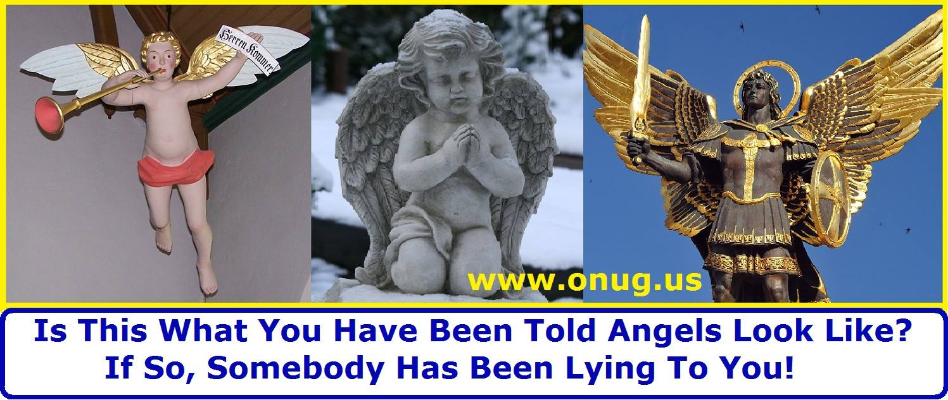
Let’s read about Lucifer’s first job, and the role of Cherubim today (Ezekiel 10:1-22). Considering how magnificent the cherubim are, Lucifer had to be absolutely and amazingly perfect, in order to give perfect Glory to a Perfect God, in the very Throne Room of Heaven; and he was exactly that… until Lucifer sinned and was cast down (Ezekiel 28:12-17 / Luke 10:17-19 / Revelation 12:10)!!
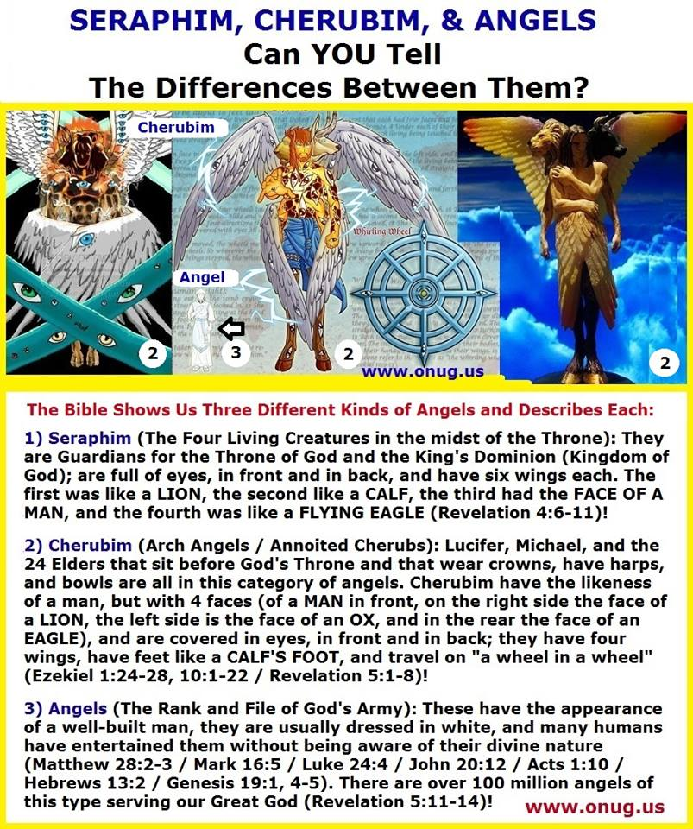
What did Lucifer do, in order to commit sin? How did he become Satan? How did he convince a third of all the angels to follow him and to rebel against God? Let’s look at some more scriptures that will help us to understand more clearly (Isaiah 14:12-17 / Matthew 4:10-11 / Hebrews 1:1-14, 2:1-18 / Revelation 12:3-13 / 2 Thessalonians 2:3-12 / Genesis 3:1-24 / Ezekiel 28:1-10).
What we have seen and proven so far from the Word of God, is that Lucifer, before he became Satan, walked up and down amongst the stones of fire, at the very throne of God, as the most perfect of created beings! He was one who made “three” at God’s throne; although he never sat upon it – he wanted to! Ponder that for a moment… this is where the false Trinity doctrine got its start – from the Pride of Satan!!! Lucifer was the greatest spirit being that God ever put together! Lucifer was “the supreme one” in terms of all the abilities that God created in him, with all power of intelligence and wisdom existing within him! But something got to him - something which all his wisdom, and all his power, and all his intelligence couldn’t save him from; Lucifer the angel whom God had made to be perfect, sinned against the Most High God by rejecting the position God had created him for!
It was “PRIDE” within; the Light Bringer wanted more than God had allotted for him! It began to wear away at him, until Lucifer did not trust God anymore. Finally it made Lucifer HATE the loving Creator God that made him!!! Satan convinced himself he was the victim, and he shared this concept of victimization with the rest of the Holy Angels! Satan used it to whittle away at one third of the angels, until they too did not trust God anymore; until they too hated their God!!! We see that same “something” being used on humans today! Satan still uses it on us humans; to get us humans not to trust God, to doubt that He has our best interest at heart. Finally, if we are not carefully guarding against it; it will makes us hate God too – just as Satan hates God!!!
Satan felt victimized by God! He felt that God did not love him as much as these new humans He had created! Resentment grew! Lucifer had been created to be the head servant angel of God (in charge of more than 150 million other angels), and although he was given the tremendous responsibility of ministering to the future children of the Most High God; that wasn’t enough!!! Satan would never become a Son of the Living God, as humans are destined to become (1 John 3:1-3)!!! His power and glory combined with pride, led Lucifer to think that he deserved something more, something better, than what God intended to give to those little frail and weak, flesh and blood human beings! Lucifer forgot his place in the Kingdom of God (1 Corinthians 15:38-58)! Let’s make sure we don’t make the same mistake Satan did; KNOW YOUR PLACE in The Kingdom of God!!! www.onug.us
Over time, maybe as long as a hundred years after the very first day was created; God’s Gospel plan - to bring many sons to glory (Hebrews 2:9-18 / Revelation 20:4-6, 21:1-8) – this created tremendous dissatisfaction in Lucifer, which he justified by telling himself, “God doesn’t love me anymore!” and “God doesn’t have my best interest at heart, therefore I must take matters into my own hands!”
Here is a lesson for us to learn! If we ever find ourselves thinking that we are victims of fate, and we find ourselves complaining about our lot in life, our circumstances, and “oh woe is me!” … Stop It! Because whether we realize it or not, we are playing right into Satan’s hand, and following his very example! When we lose faith that God is in charge, and lose sight of the truth – that God has nothing but the very best in store for us; we are “accusing God” just as Satan does! Satan wants us to believe that “God could never love a nasty sinner like you and me!” But that just isn’t true, and the Bible Proves It (Ephesians 3:14-21 / John 14:1-4, 6-7, 12-21 / Jeremiah 29:11 / Matthew 6:25-34)!
A truth in this world - is that we respond to people who love us. We move toward pleasure and away from pain; we gravitate to those who are nice to us, and away from those who act unkind. If Satan can makes us believe that God doesn’t love us, spreading little seeds of doubt here and there; if he can hide God’s True Plan to redeem both this world and us, and get us to think we can’t rely on God any more, that we can’t trust Him anymore – then we will most assuredly turn on God! Trust depends on a belief that the other person loves us, that they have our own self-interest at heart. We trust people who love us; and we distrust anyone we believe doesn’t love us – eventually making them our enemy! www.onug.us
God wants us to know that He loves us more than we can presently imagine, He wants us to Trust in Him that His Ways, and His Laws, are the best ways for us to live; God loves us so much that He is going to send His Son back again to restore this whole world, and to prepare this earth and all of us, to live here forever (Matthew 5:5) – with both Jesus and God the Father (Revelation 21:1-7, 22:1-5). That my friends is the Gospel Truth (John 14:23-24)! God so LOVES us, a world full of sinners; that He has Chosen to Call the weak of the world – to Save the rest of the world - Through Us (1 Corinthians 1:25-27 / Psalm 8:2)! It is a Pretty Amazing Proposition God is Offering To Us (1 Peter 2:9-10)!!! We are The Called, The Chosen, The Redeemed, The Saints, Wise Virgins, The Bride of Christ, The Very Sons of God, Citizens of The Kingdom of Heaven, The Israel of God, Heirs to The Promises, The Very Body of Christ, A Treasure to God, The Beloved of God, The Branches of The True Vine, The Church of God, The Fold of the Sheppard, Kings and Priests, and The Very First Fruits of God! Remember THAT the next time you are feeling down!!! www.onug.us :o)
Before Jesus ascended up into heaven, he prayed for His disciples – those He had trained during His earthly ministry; but He also prayed for YOU and ME too (John 17:20-23). Jesus is asking God the Father, here on our behalf, that He would make it possible for you and I to understand – today, NOW, in our lifetime – to Know, to Really Comprehend, THAT WE ARE LOVED BY GOD – EVERY BIT AS MUCH AS GOD LOVES CHRIST!!! Think about that for a moment, let it sink in… GOD LOVES YOU and I EVERY BIT AS MUCH AS THE ONE HE HAS SPENT ETERNITY WITH!!!
God loves You and I AS MUCH as He LOVES His Son!!! www.onug.us
Why is that? Because we ARE also His Sons, soon to be born into God’s Family, at Christ’s Return (1 John 3:1-10)!!!
THIS IS THE MOST AWESOME PROMISE OF GOD, IN THE ENTIRE BIBLE!!! NOTHING COMPARES WITH THE LOVE GOD HAS FOR US, YOU AND I – RIGHT NOW!!!
The Truth that sent Lucifer off the deep end, that caused him to become Satan the Great Dragon, and to hate God… is that God LOVES You and I just as much as He loves His Son… no more, no less… with Equal LOVE!!! That is the LOVE The Father has for His SONS… ALL of them (Hebrews 2:9-10)!!! If we Love God we will OBEY Him (John 14:15,21-25, 15:10-16), but if we want to make that LOVE PERFECT, we must realize and absolutely embrace the concept that JUST AS CHRIST IS LOVED (by the Father), SO ARE WE LOVED – RIGHT NOW, in this world (we are loved JUST AS MUCH as Jesus is)!!! www.onug.us
“Herein is our love made perfect, that we may have boldness in the day of judgment: because AS HE IS, SO ARE WE in this world” (1 John 4:17).
Now that’s a TRUTH we will PREACH!!! It’s a TRUTH Satan hates too! Sadly, it’s a TRUTH almost nobody in this world currently knows about either!
There were many times in my life, that I have forgotten this simple Truth! Depending upon what I was going through, a trial, some pain, or persecution, either because of a sin I committed, or something somebody else did to me; my focus shifted away from my ability to love God perfectly. I forgot or couldn’t imagine that God still loves me, right now, in the flesh, in this world, just as much as He loves His Son!!! But there was never a prayer that Christ prayed that the Father did not answer! John 17:20-23 is no exception! So on the Authority of Jesus Christ (Matthew 28:18 / John 3:35 / 1 Corinthians 15:27 /Ephesians 1:20), God the Father loves YOU right now, just as much as He has ever loved His Son (Matthew 3:16-17)!!! YOU are part of God’s Creation, and although you were not made perfect as Lucifer was, you were made to become perfect, as Christ is perfect - because God loves YOU just as much as He loves Jesus! God really is LOVE!!!
God LOVES what He made YOU to be, and what YOU are, right at this very moment – human frailties and all! God also LOVES what He is going to make you to Become: a Glorified Son of the Most High God!!! He is looking forward to that time when You and I will SHARE Eternal Life with Him, and with His Son; on His level of existence! Now that’s AMAZING!!! God has made that promise to us, and He is going to keep it!!! God will bring us into His Kingdom at the Return of Christ (John 3:16-21, 17:20-23 / 1 John 2:25, 4:17)!!! www.onug.us
Jesus came to Reveal this Truth to us: That the Father loves US just as much as He loves Him! He told us not to lose heart, not to ever forget this TRUTH (Luke 18:1). Satan forgot how much God loved him, he began to imagine God abandoned him, slighted him, and neglected him in favor of you and I!!! This led Satan to resent God, then to hate God – AND THAT’S WHY Satan hates us!!! Jesus does not want this to happen to us; He does not want us to forget that God has a custom made Plan for you and me, and to stop having faith in God; that even though things will get really rough in the end times (Matthew 24:21-22), The Father loves us as Just as much as He loves Jesus (Luke 18:7-8 / Hebrews 11:6 / Romans 10:17)!!! Now we have heard the Word of God, now we have heard the Words of Christ! God wants us to have the Full Knowledge of His Will and His Plans; with the Spiritual Understanding to Discern it, Live it, and Walk in it! But we must do this by FAITH (Galatians 4:1-7)!!!
Fear Not! For from the first day you set your heart to understand and follow God, your words were heard by Him (Daniel 10:12)!!!
YOU are Blessed and Greatly Beloved (BE-LOVED) by God – just as much as He loves the King of Kings (Daniel 10:11)!!
Now you KNOW, and have PROVEN from The Bible, EXACTLY what God Intends to DO; now YOU Know what The Gospel, that Jesus came to bring us, Really Is!!! Now you Know the Truth that Jesus Christ came to Reveal to ALL of mankind; and If we reject that TRUTH, as Satan did, God will also Reject us (Hosea 4:6 / John 8:31-32)!!! www.onug.us
Satan had his crown and his glory; and he REJECTED it! He is so full of RAGE against God – and HATE for you and I, that he will do everything in his power to keep us from realizing our Glory! And the GLORY that Almighty God has in store for you and I, is a MILLION TIMES GREATER than anything Satan has ever had, even back in the good old days, when he commanded 150 million angels as the Perfect Angel of Light!!!
We pray that all those whom God is Calling, Understand The WORDS that God is Speaking to us – and Those Same Words, that we must also SPEAK, to do The Job that God has called us to DO (Matthew 28:18-20 / Mark 16:15-20)!!!
Stand Up TALL, and Be BOLD in our LORD, Jesus Christ, because a Holy God LOVES sinners - just like - exactly LIKE - YOU and I!!! We are BELOVED BY GOD!!! Amen!!! We all have a Father in Heaven and an Elder Brother; Who Both LOVE US, VERY, VERY, VERY MUCH!!! Praise God!!! :o)
We are Honored that you joined us today, in the Study of God’s Word! We hope that you will join us again next week, and that you will continue to share what you have learned here, with others – at home, at work, and in your neighborhood (Matthew 28:18-20 / Mark 16:15-20)! May our Great God, Bless you and keep you, until then – in Jesus’ Name!!!
- Submitted by Pastor R.C. Brown III
One Nation Under God Ministries is Preparing this world for The Return of Jesus Christ; One Bible Study At A Time!!! JESUS IS LORD!!! www.onug.us
---------------------------------------------------------
God is calling YOU to be a follower of Jesus Christ, and the first century church, can you hear His Voice (1 John 2:6 / Matthew 11:29)? The Sabbath and Holy Days show us God’s Plan. When we keep these Holy Days we become the very Voice of God to this fallen world; we are in effect saying, by our actions on each Feast Day, “Come LORD Jesus, Come” (Revelation 22:12, 17, 20-21)!!! We are actually confessing Christ before men (Matthew 10:32-33)!
The faithful and obedient in Christ will always keep God’s True Holy Days and Sabbath; and will reject the pagan lies and substitutions of God’s TRUTH (Revelation 22:11-15)! God’s Holy Days are meant for Christians to ENJOY! They truly are FEAST DAYS, meant to be enjoyed by God’s elect everywhere, throughout time, FOREVER!!!
If you have never faithfully kept God’s seventh day Sabbath holy or God’s Holy Days, the way Jesus Christ did – in the flesh, and in the fellowship of other followers of the Son of Man; we invite you to obediently enter into God’s rest today, and to keep the Feasts of the LORD (Hebrews 4:1-11 / Leviticus 23:1-44)! Contact us to find out where we fellowship and worship God, in your area, on His Sabbath Days (Exodus 31:12-18). We would love to hear from you and help get you started! :o)
Join us on-line every Sabbath and Holy Day at www.onug.us ! You can download our Bible Studies, or join us on facebook and “listen in” to our webinar Bible Study each week!
Our Mailing Address is:
One Nation Under God Ministries
P.O. Box 111960
Naples, Florida 34108 U.S.A.
Telephone: (239) 353 – 1303
e-Mail us at: one_nation_under_god_usa@msn.com
---------------------------------------------------------
”But ye believe not, because ye are not of my sheep, as I said unto you. My sheep hear my voice, and I know them, and they follow me: And I give unto them eternal life; and they shall never perish, neither shall any man pluck them out of my hand. My Father, which gave them me, is greater than all; and no man is able to pluck them out of my Father's hand. I and my Father are one” (John 10:26-30).
Christians must learn to read the Bible, interpret the scriptures according to Biblical principles (Isaiah 28:9-10, / Matthew 13:52), and begin to apply the precepts they learn in their walk with God. Individual study is essential; coupled with fellowship times of group study, worship, and discussions of personal insights and observations.
We strive, each Saturday, to foster an open and welcoming atmosphere where Spirit led confirmation, clarification, questions, and correction can be made in the fellowship of other students of God’s Word.
One Nation Under God Ministries (www.onug.us) is working to unify the body of Christ in the worship of God the Father, in the way Jesus showed us to - in Spirit and in Truth! We strive to promote rediscovery of American History, and renew in current generations the Vision and the Covenant of our Founding Fathers.
One Nation Under God Ministries (www.onug.us)
------------------------------------------------
NEVER A COST - Our Bible Studies are mailed FREE, worldwide to anyone that asks.
“And when He had called unto Him His twelve disciples, He gave them power against unclean spirits, to cast them out, and to heal all manner of sickness and all manner of disease… And as ye go, preach, saying, The kingdom of heaven is at hand. Heal the sick, cleanse the lepers, raise the dead, cast out devils: freely ye have received, freely give. Provide neither gold, nor silver, nor brass in your purses, Nor scrip for your journey, neither two coats, neither shoes, nor yet staves: for the workman is worthy of his meat” – Jesus Christ (Matthew 10:1, 7-10).
PRISON MINISTRY - Is there anyone you know in jail or in prison who may like to begin receiving our FREE weekly Bible Studies? Please let us know, we would be happy to share the Good News of God’s Coming Kingdom with them!
TITHES, OFFERINGS, DONATIONS – We gratefully acknowledge and thank those led by God, to support this ministry! We Pray Daily for all of you who continue to support this work, and for all those to whom God’s Word will be sent! Please pray with us and for us!
- In the United States, checks and money orders may be made payable to: One Nation Under God U.S.A. Ministries
- From outside the U.S.A., payments may be made to:
The Church of One Nation Under God International, P.O. Box 111960, Naples, Florida 34108, U.S.A.
Notes:

Feeling Down? Join Us for one of the MOST Uplifting Bible Studies YOU have EVER read! Just CLICK the link below!!!
God wants us to know that He loves us more than we can presently imagine, He wants us to Trust in Him that His Ways, and His Laws, are the BEST Ways for us to live; God LOVES us so much that He is going to send His Son back again to restore this whole world, and to prepare this earth and all of us, to live here forever (Matthew 5:5) – with both Jesus and God the Father (Revelation 21:1-7, 22:1-5)!!! That my friends is the Gospel Truth (John 14:23-24)! God so LOVES us, a world full of sinners; that He has Chosen to Call the weak of the world – to Save the rest of the world - Through Us (1 Corinthians 1:25-27 / Psalm 8:2)! It is a Pretty Amazing Proposition God is Offering To Us (1 Peter 2:9-10)!!! We are The Called, The Chosen, The Redeemed, The Saints, Wise Virgins, The Bride of Christ, The Very Sons of God, Citizens of The Kingdom of Heaven, The Israel of God, Heirs to The Promises, The Very Body of Christ, A Treasure to God, The Beloved of God, The Branches of The True Vine, The Church of God, The Fold of the Sheppard, Kings and Priests, and The Very First Fruits of God! Remember THAT the next time you are feeling down!!! www.onug.us :o)
http://www.onug.us/sites/default/files/BIBLE%20STUDY%20How%20Could%20A%20Holy%20God%20Ever%20Love%20A%20Sinner%20Like%20Me%2002%20June%202018.pdf

