One Nation Under God Ministries www.onug.us
BIBLE STUDY: Golgotha - The Place of Both Goliath of Gath’s Skull, and The Death of Jesus Christ (Part I)!!!
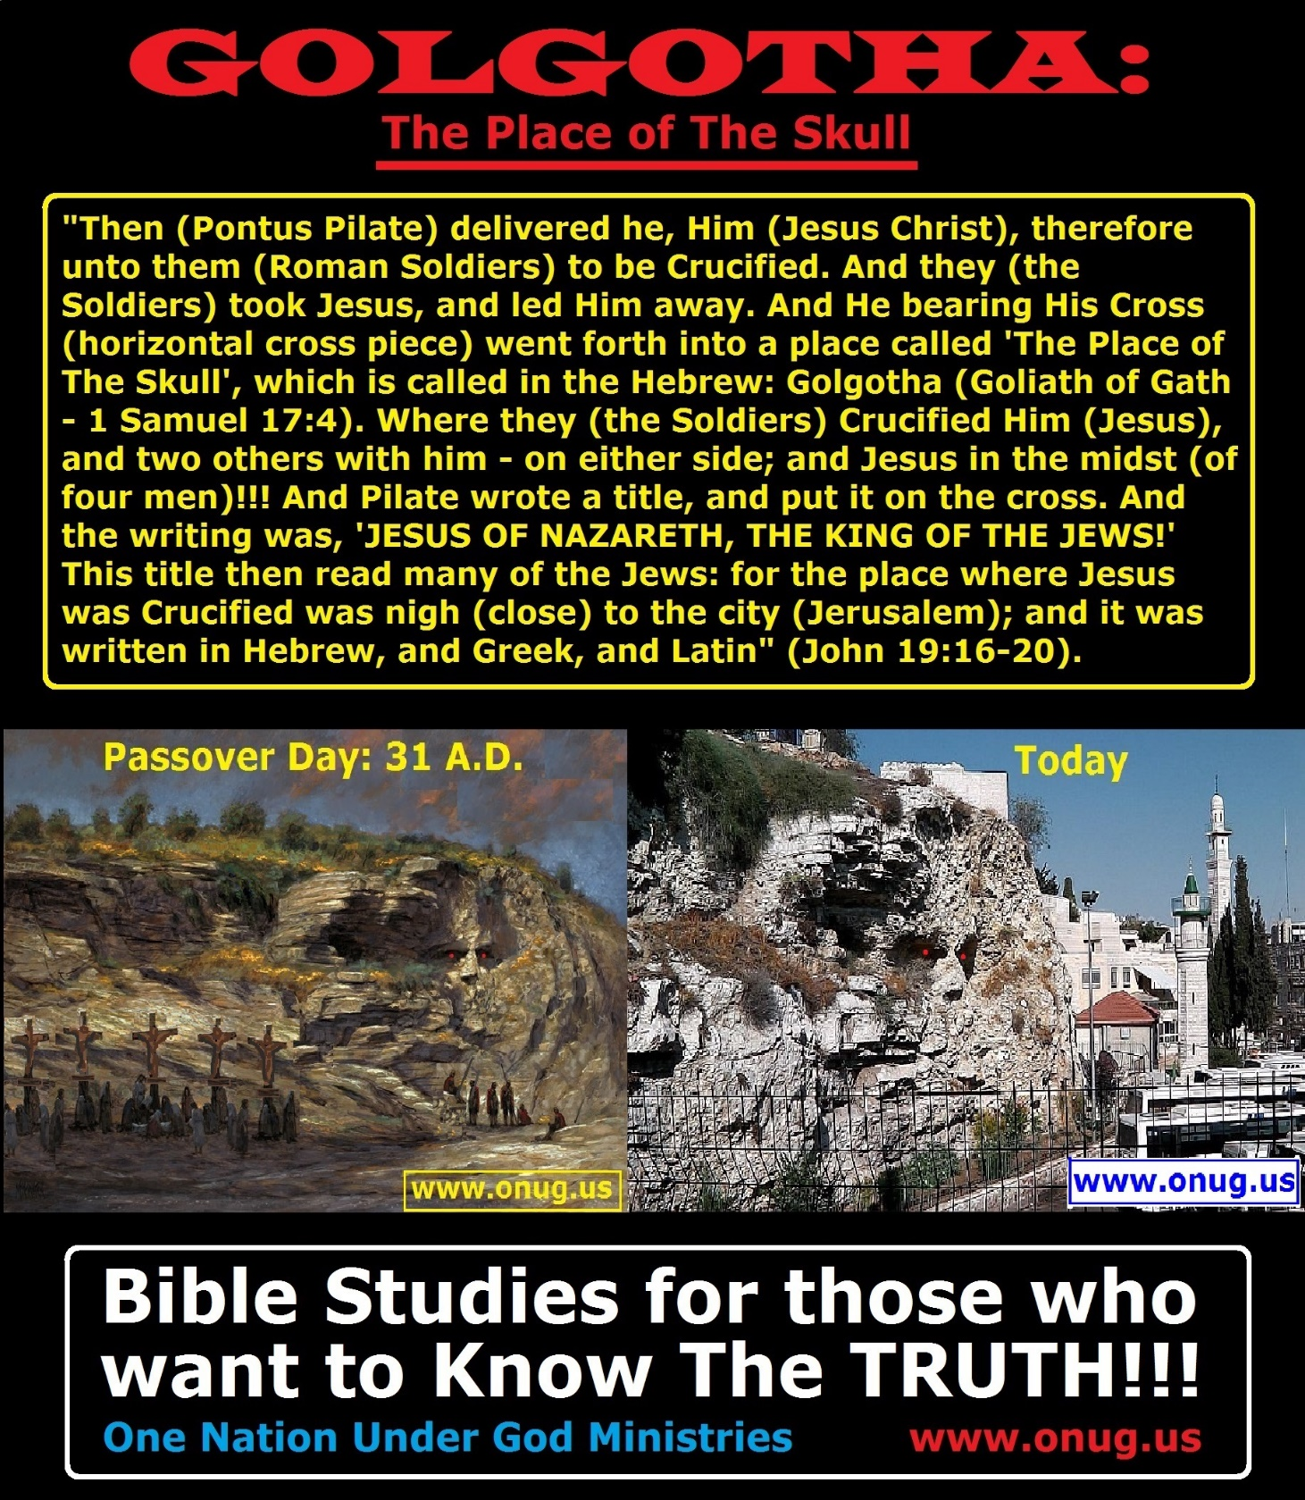
One Nation Under God Ministries www.onug.us
BIBLE STUDY: Golgotha - The Place of Both Goliath of Gath’s Skull, and The Death of Jesus Christ (Part I)!!!
Imagine, if YOU could travel back in time to Passover Day, 31 A.D.! Imagine, if YOU could personally witness the Mocking and the Taunting of Jesus Christ, as He stumbled through the streets, to the place of His Public Execution! Imagine, YOU being an Eyewitness to EVERYTHING that was Said, and Done, the morning after Jesus ate His Last Supper with His Disciples, in the Upper Room; and Broke Bread as His Body, Gave Wine as His Blood, and Washed His Disciples’ Feet – Establishing The Annual New Testament Passover in His Church - FOREVER (John 13:12-17)! If YOU could actually Witness, as Jesus Christ’s Disciples did - The Crucifixion of The Passover Lamb of God (John 1:29); WHAT WOULD YOU REPORT BACK? WHAT WOULD YOU WRITE DOWN? WHAT WOULD YOU PASS ON to your children, and future generations, so as to Preserve History, and to Prepare Humanity - for The Future Return of The Son of Man? www.onug.us
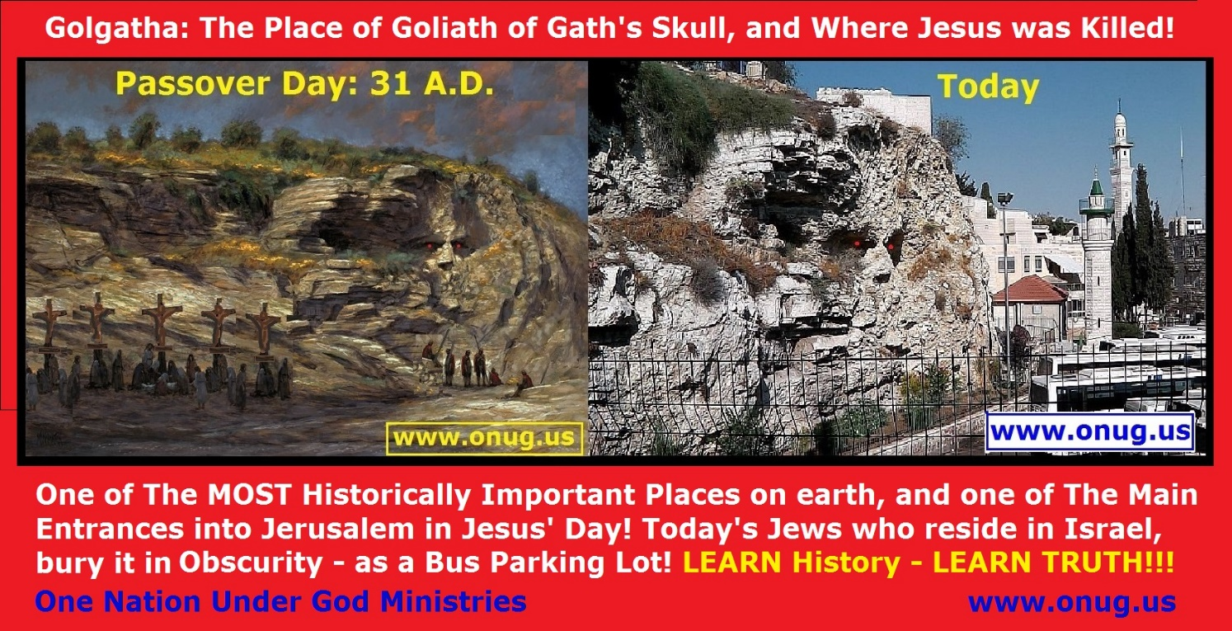
Let us open up our Bibles today, and go Back in Time! Let us READ, and DISCOVER, and PROVE - These Remarkable TRUTHs for ourselves; from Actual EYEWITNESS accounts of those who were Really There!!! www.onug.us
Bible Study Instructions: One Nation Under God Ministries (www.onug.us) publishes and distributes weekly Bible Studies, worldwide – FREE of charge, to anyone who requests them, in both printed and electronic formats. Our Studies are intended to be a simple and fun way to Learn The Scriptures, and are very easy to follow! We adhere to Jesus Christ’s Biblical Instructions to Teach and Feed The Flock of God (John 10:16) portions of Meat in Due Season, on weekly Sabbaths, and on The Seven annual Holy Days (Leviticus 23:1-44) throughout each calendar year (Luke 12:42 / Isaiah 28:9-10 / Matthew 13:52). Using both The Old and New Testaments, our Bible Studies are designed to present a premise, make a statement, or ask a question – followed by one or more Scriptural References. Just look up and read from your Bible The Scriptures listed. Comments following questions elaborate on The Scriptures you just read. Pray always BEFORE beginning any Study of God’s Word, Asking God to OPEN both your eyes and your mind to His Truth (Matthew 7:7-8); then Prove EVERYTHING you read, is in fact the Truth, by comparing it to The Word of God (1 Thessalonians 5:21 / 2 Timothy 3:15-17). Then use The Biblical System of Checks and Balances, and SEE if both Jesus Christ, and The First Century Church of God Apostles – also Did, Said, and Taught These SAME THINGS (Galatians 1:1-12, 5:25 / 1 Peter 2:21, 25 / 1 John 2:3-6)! That’s all there is to it! Our Bible Studies are based on the King James Version, unless otherwise stated. We will be Praying for your eyes to “SEE” (Matthew 13:11-17); and we are always available to answer any of your questions! Be Blessed, in Jesus’ Name! - One Nation Under God Ministries, and their FREE Online College of Biblical Knowledge, are Preparing The Brides of Christ (Matthew 25:1-13), and this world (Mark 16:15-20), for The Return of Jesus (John 10:16); One Bible Study (Matthew 11:28-30) At A Time! Join Them at www.onug.us!!! JESUS IS LORD!!!
PART 1: Deuteronomy 29:22-29
“So that the generation to come of your children that shall rise up after you, and the stranger that shall come from a far land, shall say, when they see the plagues of that land, and the sicknesses which The LORD hath laid upon it; And that the whole land thereof is brimstone, and salt, and burning, that it is not sown, nor beareth, nor any grass groweth therein, like the overthrow of Sodom, and Gomorrah, Admah, and Zeboim, which The LORD overthrew in His Anger, and in His Wrath: Even all nations shall say, Wherefore hath The LORD done thus unto this land? What meaneth the heat of This Great Anger? Then men shall say, Because they have forsaken The Covenant of The LORD God of their fathers, which He Made with them when He brought them forth out of the land of Egypt: For they went and served other gods (Molech - Christmas, Ashtoreth – Easter, Sun god day – Satan) and worshipped them, gods whom they knew not, and whom He had NOT Given unto them: And The Anger of The LORD was Kindled Against this land, to bring upon it ALL the Curses that are Written in This Book: And The LORD Rooted Them Out of their land In Anger, and In Wrath, and In Great Indignation, and Cast Them into another land, as it is this day!!!”
“The Secret Things Belong unto The LORD our God: but Those Things which are Revealed (John 15:15), Belong unto US, and to our children, For Ever, that we may DO ALL The Words of This Law” (Deuteronomy 29:22-29)!!!
Your American and Biblical Histories Have Been HIDDEN From YOU, For So Long, That Now, When Someone Shows You The TRUTH of God (John 17:17), And From Real History (1 Thessalonians 5:21); YOU Think That “They” Are The Crazy Ones Who Have Been Deceived! www.onug.us
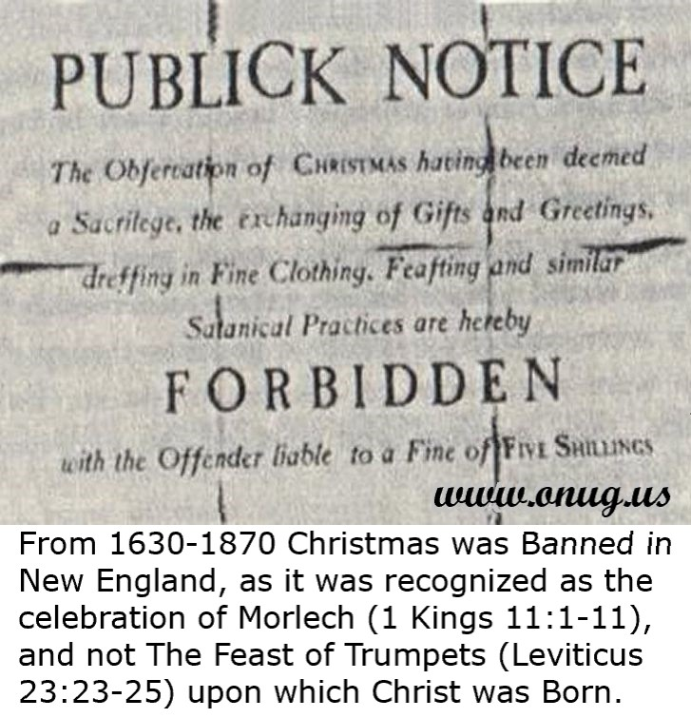
Christmas Was Banned in Boston!
It took the Catholic church, until 1582 A.D. to legitimize the child sacriifces to the fire god, Molech (or Morlech), as the Catholic “Christ Mass” (Dueteronomy 12:1-4, 28-32 / Jeremiah 10:1-10); thus dividing up Europe into the Catholics (Pagan Christians) and Protestants (Those Who Still Kept The Holy Days of Christ in Leviticus 23:1-44). By the early 1600’s, The Church of England had fallen to the pressure of Rome, and also began keeping Sunday, Christmas, and Easter. The Church of England then began to persecute The True Disciples of Christ, driving the Pilgrims to flee to the New World, or New England, in 1630 A.D. where they could Worship God AS Christ DID!!!
Were The Pilgrims “Kill Joys” or “Harsh Puritans”, as we have been led to believe; or did They LOVE God’s Word SO MUCH, that they REFUSED to allow it to be Changed and PERVERTED as both Rome, and now The Church of England had allowed (Deuteronomy 12:32 / Revelation 22:18-19 / Malachi 3:6 / Hebrews 13:8)?
Yet few Americans know that Christmas was, for a generation in the Massachusetts Bay Colony (now Boston), and for centuries the people in Massachusetts, ALL went to school and to work as usual, on most Christmas days; BECAUSE THEY WERE STILL KEEPING GOD’S ORIGINAL WEEKLY SABBATH AND HIS HOLY DAYS!!!
Many of the English settlers who left the British Isles, some because of religious persecution, to found the Plymouth and Massachusetts Bay Colonies brought with them a Biblical Attitude towards the Pagan and Forbidden Christmas. These sober-minded Christians KNEW that Christ was born on The Feast of Trumpets, in the Fall, they did NOT believe in the FALSE Trinity Lie from Rome, and they could ALSO PROVE from their Bibles, that Their Savior, Jesus Christ, was ONE of FIVE men condemned to die at Golgotha, ON a Wednesday Passover Day, in 31 A.D.!!!
The Pilgrims grew up Knowing that the Ancient Roman worshippers of the Persian son-god Mithras, celebrated his birth on December 25th; and that Rome had OUTLAWED True Christianity in 1582 A.D., by papal decree. The Pilgrims fled England in 1630 A.D., because now their country was also MURDERING Christians, who refused to use “a Black Sabbath dedicated to Child Sacrifices to Morlech”, as the Birthday of Jesus Christ!!!
In 1870 A.D., America’s Federal Government gave in to The Great Whore that sits upon The Beast, and officially made The Biblically FORBIDDEN Black Sabbath of “Christmas”, a Federal Holiday! Americans could now get PAID to take Christmas off from work; and engage in this Abomination to God (Dueteronomy 12:28-32) with their friends, family, and children too (Proverbs 22:6)!!!
“Those who cannot remember the past are condemned to repeat it!” - American philosopher George Santayana
The Jewish Sin of The Crucifixion of Christ (John 19:11), and the Total Destruction of Jerusalem: www.onug.us
“His Blood Be Upon Us, And On Our Children!!!” (Matthew 27:25).
Do NOT Ever Forget, that God Wiped Jerusalem Off the face of the earth, in 70 A.D., with the exception of Only ONE Structure; because of the Crucifixion of His Son, by the Jews in 31 A.D. (John 19:12-15 / Matthew 27:19-31). Every single manmade structure of wood was burned; and every single stone or brick building was COMPLETELY dismantled, overturned, and carried away, from the top of the Mount of Olives – in every direction – for 10 miles; EXCEPT for the Old Roman Fort!!! EVERYTHING you can see in the city of Jerusalem today, is newer than 70 A.D. – EXCEPT the Wailing Wall, and the foundational stones of that Old Roman Fort!!! www.onug.us
Question: What will happen to Judah and Jerusalem just before Christ Returns (Luke 21:20-24)? The modern English of the Moffatt translation may be a bit easier to understand here: "For Sore Anguish will come upon the land, and Wrath on this people!" Let’s also visit the parallel account in Matthew 24:15-20. Do you SEE God Showing YOU a time of Great Tribulation coming upon the whole world (Matthew 24:21 / Zechariah 14:1-5)?
What would happen if Jesus did NOT Return and Intervene in the affairs of men (Matthew 24:22)?
Do you SEE How God is shortly going to make it Impossible for anyone NOT to Believe in God? They will either Praise Him or Curse Him, as These Days approach!!! And ONLY those who are IN The Body of Christ will be SPARED; AND ONLY those within That Body, who are FOLLOWING Christ’s Instructions (Psalm 91:1-16 / Luke 21:34-38 / Zechariah 14:6-15)!!! Let Him that Readeth UNDERSTAND!!! www.onug.us
Do YOU Believe The Words Of Jesus Over Your History Books? I DO!!!
The Wailing Wall in Jerusalem is NOT the remains of the Ancient Jewish Temple! If it is, then Jesus Christ is a Liar; and that CANNOT possibly happen!!! www.onug.us
"And Jesus went out, and departed from the temple: and His disciples came to Him for to shew Him the buildings of The Temple. And Jesus Said unto them, 'See ye not all These Things (the temple complex)? Verily I Say unto you, There shall NOT be left here ONE STONE UPON ANOTHER, that shall not be Thrown Down!!!'" (Matthew 24:1-2). www.onug.us
The Wailing Wall is the remains of Antonia Fortress, which was a military barracks in the time of Christ, and was Pontius Pilot's Headquarters, located next to, and NORTH of the Jewish Temple!
The Roman Fort, built over the old Hasmonean Baris (a citadel constructed north of Jerusalem's Temple Mount, during the Hasmonean period); was built by Herod the Great, and named for his patron, Mark Antony! A pre 31 B.C. date is certain for the Fort as Mark Anthony was defeated by Octavius at the sea battle of Actium on September 2, 31 B.C.
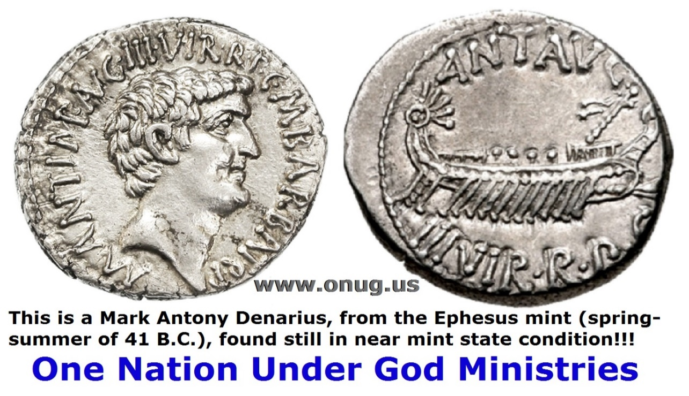
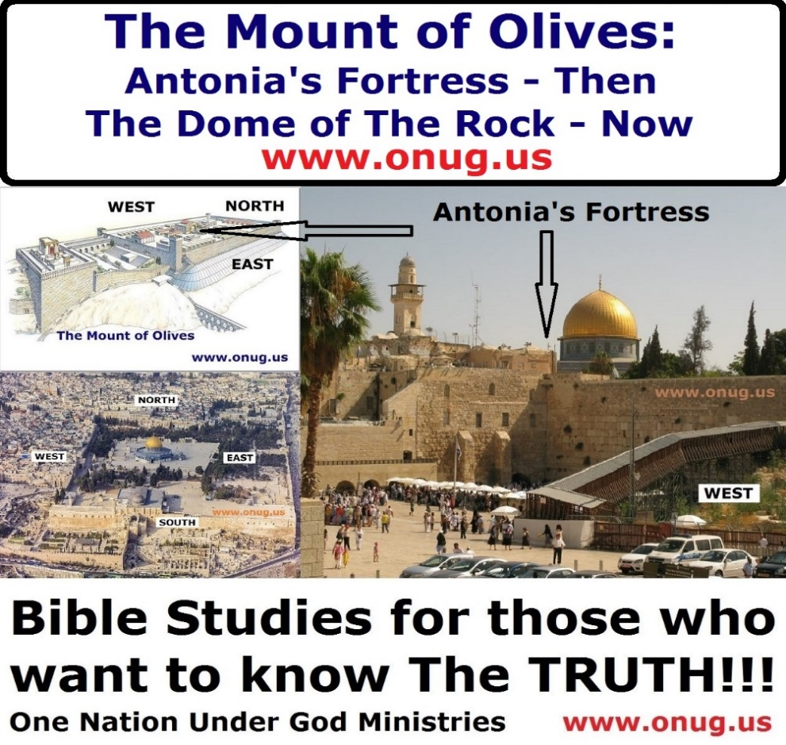

The leaders of the modern Jewish State, known today as Israel, DO Understand This; otherwise they would NOT have given the site of the Dome, to the Arabs!!! However, keeping this knowledge hidden from the Arabs, appeases them in a false victory; and serves to bring in LOTS and LOTS of tourist dollars for modern Israel today too (1 Timothy 6:10)!!! :o)

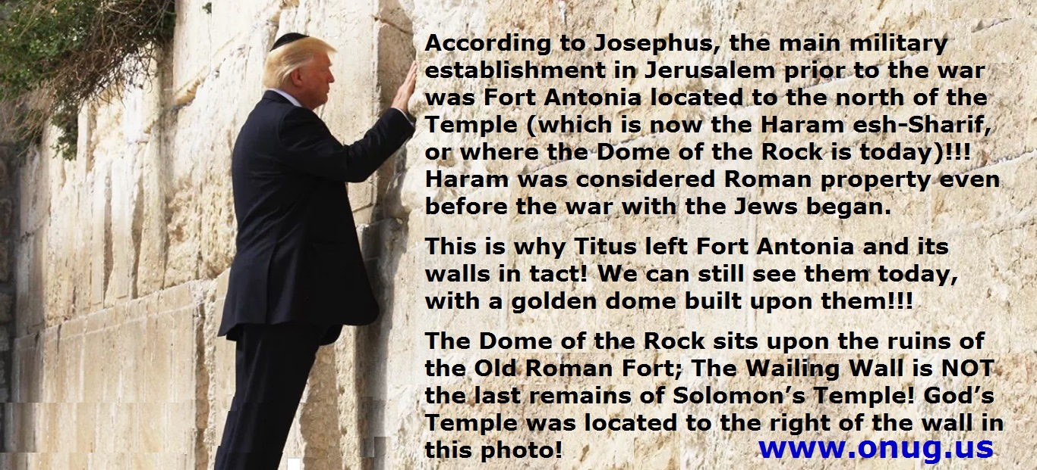

0n Monday, May 22, 2017, President Donald Trump became the first U.S. President to visit the Western Wall, also known as the Wailing Wall, located on the Westside of The Mount of Olives in Jerusalem. During his brief visit, President Trump, wearing a yarmulke, put his hand against one of the most sacred sites in Judaism; then placed what appeared to be a written prayer or note between its stones - as has become the modern day custom at the Wailing Wall.

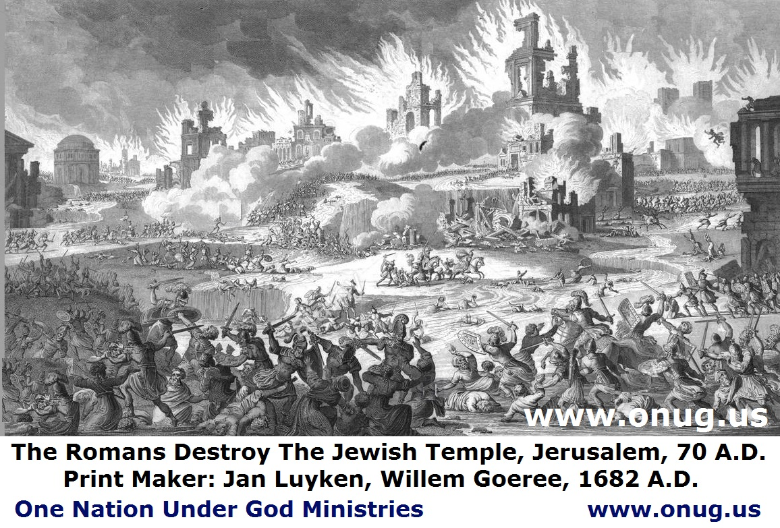
Jerusalem is a city that has been fought over 16 times, it has been destroyed twice, besieged 23 times, attacked in major offensives 52 times, and captured and recaptured 44 times, as of 2023! The Bible predicts there is MORE DESTRUCTION to come in the near future as well (Luke 21:24 / Matthew 24:15-16 / Mark 13:14 / Daniel 9:26-27 (Dual fulfillment), 12:7 / Revelation 11:2-3,13, 12:14, 13:5 / Zechariah 14:1-21)!!! www.onug.us
The Destruction of Jerusalem in 70 A.D.:
In 63 B.C., Roman General Pompey desecrated the Temple by brazenly entering the Holy of Holies to see the image of the Jewish God, and found it empty of any idols. He did not plunder the Temple furnishings or treasury; and the next day ordered the temple cleansed, and the Jewish rituals to resume! The “Abomination of Desolation” spoken of by Jesus (Matthew 24:15) is the desecration of the Temple and the destruction of Jerusalem by the Roman armies in 70 A.D., after the Jews rebelled. This time, the Temple was completely destroyed by the Roman legions, and not one stone was left on another, as Jesus prophesied (Matthew 24:2 / Luke 19:43-44). But Jesus intended yet another fulfilment of Daniel’s prophecy in the Time of The End!!!
The Destruction of The Temple – The Eyewitness Accounts of Josephus and Titus Agree With Jesus!!! www.onug.us
Let’s review some background on the Dome of the Rock, as it is today; and the Mount of Olives of yesteryear – when Jesus walked this earth, in the flesh.
Titus Flavius Josephus (37–100 A.D.), was born Joseph Ben Matityahu, and was a first-century Romano-Jewish scholar, historian and hagiographer, who was born in Jerusalem (which was at that time part of Roman Judea). His father was of priestly descent, and his mother claimed royal ancestry.
Josephus initially fought against the Romans during the First Jewish–Roman War as head of Jewish forces in Galilee, until surrendering in 67 A.D. to Roman forces led by Vespasian after the six-week siege of Jotapata. Josephus claimed that the Jewish Messianic prophecies had initiated the First Roman-Jewish War, and made reference to Vespasian becoming Emperor of Rome! In response, Vespasian decided to keep Josephus as a slave and as his Jewish Hebrew interpreter. After Vespasian became Emperor in 69 A.D., he granted Josephus his freedom, at which time Josephus assumed the emperor's family name of Flavius.
Flavius Josephus fully defected to the Roman side, and was granted Roman citizenship. He became an advisor and friend of Vespasian's son Titus, serving as his translator when Titus led the Siege of Jerusalem in 70 A.D., which resulted (when the Jewish revolt did not surrender) in the city's destruction; and in the looting and destruction of Herod's Temple (the Second Temple). See Matthew 24:1-2. www.onug.us
Josephus recorded Jewish history, with special emphasis on the first century A.D., and the First Jewish–Roman War, including the Siege of Masada. His most important works were The Jewish War (75 A.D.) and Antiquities of the Jews (94 A.D.). The Jewish War recounts the Jewish revolt against Roman occupation (66–70 A.D.). The Antiquities of the Jews recounts the history of the world, from a Jewish perspective, for an ostensibly Roman audience. These works now provide valuable insight into first century Judaism, and of course, the background of Early Christianity that we will be looking at today!
Josephus describes Antonia's fortress as pictured (on pages 9 and 23-24, of our Golgatha Bible Study - Part One, at www.onug.us). Josephus' dimensions of the fort are: 115 m from East to West, Western side 35 m and Eastern side 42 m, with four towers. The rock on which the fortress was built was 50 cubits high (22-31 m). The height of the fortress itself was 40 cubits (18-25 m.) and it had 4 towers, one in each corner. The height of three of the towers was 50 cubits and the fourth tower was 70 cubits: "Now, as to the tower of Antonia, it was situated at the corner of two cloisters of the court of the temple; of that on the west, and that on the north; it was erected upon a rock, of fifty cubits in height, and was on a great precipice; it was the work of king Herod, wherein he demonstrated his natural magnanimity.
(239) In the first place, the rock itself was covered over with smooth pieces of stone, from its foundation, both for ornament, and that anyone who would either try to get up or to go down it, might not be able to hold his feet upon it.
(240) Next to this, and before you come to the edifice of the tower itself, there was a wall three cubits high; but within that wall all the space of the tower of Antonia itself was built upon, to the height, of forty cubits.
(241) The inward parts had the largeness and form of a palace, it being parted into all kinds of rooms and other conveniences, such as courts, and places for bathing, and broad spaces for camps; insomuch that, by having all conveniences that cities wanted, it might seem to be composed of several cities, but by its magnificence, it seemed a palace;
(242) and as the entire structure resembled that of a tower, it contained also four other distinct towers at its four corners; whereof the others were but fifty cubits high; whereas that which lay upon the southeast corner was seventy cubits high, that from thence the whole temple might be viewed;
(243) but on the corner where it joined to the two cloisters of the temple, it had passages down to them both, through which the guard
(244) (for there always lay in this tower a Roman legion [that would be about 6,000 soldiers with a support crew of 3-4,000 additional people]) went several ways among the cloisters, with their arms, on the Jewish festivals, in order to watch the people, that they might not there attempt to make any innovations; www.onug.us
(245) for the temple was a fortress that guarded the city, as was the tower of Antonia a guard to the temple; and in that tower were the guards of those three. There was also a peculiar fortress belonging to the upper city, which was Herod's palace;
(246) but for the hill Bezetha, it was divided from the tower of Antonia, as we have already told you; and as that hill on which the tower of Antonia stood, was the highest of these three, so did it adjoin to the new city, and was the only place that hindered the sight of the temple on the north.
(247) And this shall suffice at present to have spoken about the city and the walls about it, because I have proposed to myself to make a more accurate description of it elsewhere." (Josephus, Wars 5.238-247).
Then Came The Absolute and Totally Complete Destruction in 70 A.D.!!! www.onug.us
"It [Jerusalem with its walls] was so thoroughly laid even with the ground by those that dug it up to the foundation, that there was left nothing to make those that came thither believe it [Jerusalem] had ever been inhabited" (The Jewish War VII. 1,1).
“They had cut down all the trees, that were in the country that adjoined to the city, and that for ninety stadia round about [for nearly ten miles], as I have already related. And truly, the very view itself was a melancholy thing. Those places that were before adorned with trees and pleasant gardens were now become a desolate country in every way, and its trees were all cut down. Nor could any foreigner that had formerly seen Judaea and the most beautiful suburbs of the city, and now saw it as a desert, but lament and mourn sadly at so great a change. For the war had laid all signs of beauty quite waste. Nor, if any one that had known the place before, and had come on a sudden to it now, would he have known it again. But though he were at the city itself, yet would he have inquired for it notwithstanding" (The Jewish War VI. 1,1, the Whiston translation). www.onug.us
The Wailing Wall of today is NOT part of the original Temple!!!
President Donald Trump visited the Wailing Wall on 22 May 2017. He was the first U.S. President ever to do so; and while he was there, he placed a written prayer between the cracks of the bricks, as has become a recent custom at this location. What message is he sending by these actions? Does he know The Truth about the Temple Mount? www.onug.us
After A.D.70, people would have seen utter desolation in all directions. Every stone of every building and wall, in Jerusalem, was dislodged from its original position and thrown down to the ground. Josephus provides reasonable accounts of later events after the war was over to show how this complete destruction was accomplished. Much of the destruction came after the war had ceased. For six months after the war, Josephus tells us that the Tenth Legion "dug up" the ruins of the houses, buildings and walls looking for plunder. They systematically excavated beneath the foundations of the ruined buildings and houses (they had many of the Jewish captives do the work for them). They also had the whole area turned upside down looking for gold and other precious metals that became molten when the fires were raging. This caused the precious metals to melt and flow into the lower crevices of the stones. Even the foundation stones contained melted gold from the great fires that devoured Jerusalem. This plundering of every former building or wall in the municipality of Jerusalem resulted in the troops overturning (or having the remaining Jewish captives overturn for them) and displacing every stone within the city of Jerusalem!!! www.onug.us
This continual digging up of the city occurred over a period of several months after the war. History records that after an absence of about four months, Titus returned to Jerusalem from Antioch, and once again viewed the ruined city. Josephus records what Titus saw:
"As he came to Jerusalem in his progress [in returning from Antioch to Egypt], and compared the melancholy condition he saw it then in, with the ancient glory of the city [compared] with the greatness of its present ruins (as well as its ancient splendor). He could not but pity the destruction of the city…. Yet there was no small quantity of the riches that had been in that city still found among the ruins, a great deal of which the Romans dug up; but the greatest part was discovered by those who were captives [Jewish captives were forced by the Roman troops to dig up the stones of their own city looking for gold], and so they [the Romans] carried it away; I mean the gold and the silver, and the rest of that most precious furniture which the Jews had, and which the owners had treasured up under ground against the uncertainties of war."
The Wailing Wall of today is NOT part of the original Temple Buildings, or of the Temple Complex, spoken of BY Jesus Christ, in Matthew 24:1-2!!! www.onug.us
Three Years After The War That Leveled EVERY Stone - Another Account Of The Complete Desolation of Jerusalem:
Eleazar, the Last Jewish commander at Masada, related what happened to Jerusalem, three years after the war was finished. His eyewitness account of how the Romans preserved Fort Antonia (the Haram) among the ruins of the city is remarkable, and virtually unknown today by those who visit the Holy Lands today!!! www.onug.us!
“Masada” is one of Israel’s most popular tourist attractions. The name itself helps make our point here today. Masada is the Modern Hebrew word for “Metzada” or “Metsad” (another ancient fortress or fortification in the Southern District of Israel, situated on top of an isolated rock plateau, akin to a mesa, on the eastern edge of the Judaean Desert, overlooking the Dead Sea). Herod the Great built palaces for himself on the mountain and fortified Masada between 37 and 31 B.C. According to Josephus, the Siege of Masada by troops of the Roman Empire towards the end of the First Jewish–Roman War, ended in the mass suicide of the 960 Sicarii rebels and their families who were hiding there. Masada is located 20 kilometers (12 miles) east of Arad. www.onug.us
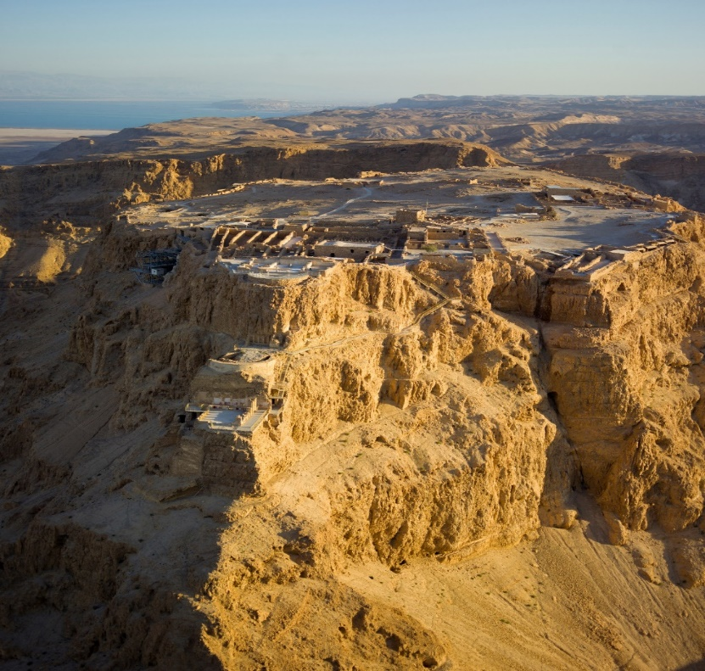
This is what Fortress Masada looks like in Israel today!
Remember, it was Eleazar who spoke to the 960 Jewish people who were going to commit suicide rather than fall into the hands of General Silva; who was on the verge of capturing the Fortress of Masada. Commander Eleazar lamented over the sad state of affairs that everyone present had witnessed now that the war with the Romans was over. Jerusalem was to him a disastrous spectacle of utter ruin. There was only one thing that was still standing; this was the Camp of the Romans that Titus had permitted to remain - as a monument of humiliation over the Mother City of the Jews!
Eleazar acknowledged that this military encampment had been in Jerusalem before the war, and that Titus let it continue after the war! The retention of this single Camp of the Romans, according to Eleazar, was a symbol of the victory that Rome had achieved over the Jewish people. Let’s read some of his words which are recorded for all to see in The Jewish War VII. 8, 7!!! www.onug.us
“And where is now that great city [Jerusalem], the metropolis of the Jewish nation, which was fortified by so many walls round about, which had so many fortresses and large towers to defend it, which could hardly contain the instruments prepared for the war, and which had so many ten thousands of men to fight for it? Where is this city that was believed to have God himself inhabiting therein? It is now demolished to the very foundations, and hath nothing left but that monument of it preserved, I mean the camp of those [the Romans] that hath destroyed it, which still dwells upon its ruins; some unfortunate old men also lie ashes upon the Temple [the Temple was then in total ruins — all of it had been burnt to ashes], and a few women are there preserved alive by the enemy, for our bitter shame and reproach."
What Eleazar saw and wrote about is an eyewitness account of the state of Jerusalem in the year A.D. 73. His words are of critical importance to Followers of Christ today – that is WHY God Has Preserved them!!! Commander Eleazar wrote that the City of Jerusalem and all its Jewish fortresses had indeed been demolished "to the very foundations"!!! There was nothing left of the City or the Temple! This is Exactly what Jesus Prophesied would happen; and is Exactly what is going to happen AGAIN (Zechariah 14:1-2)!!! www.onug.us
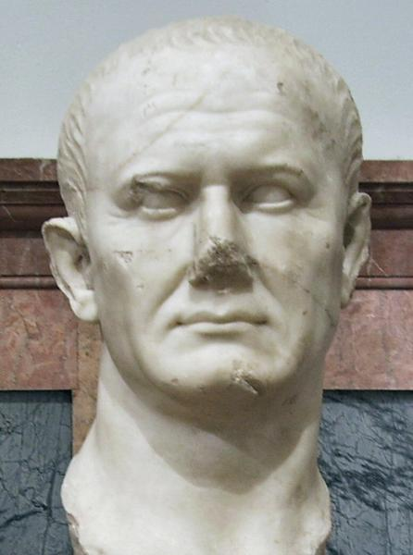
A Marble Bust of the Roman General Lucius Flavius Silva
Lucius Flavius Silva Nonius Bassus was a late-1st-century Roman general, governor of the province of Iudaea (Judea) and consul. Silva was the commander of the army, composed mainly of the Legio X Fretensis, in 72 AD which laid siege to the near-impregnable mountain fortress of Masada, occupied by a group of Jewish rebels called the Sicarii. The siege ended in 73 AD with Silva's forces breaching the defenses of the Masada plateau and the mass suicide of the Sicarii, who preferred death to defeat or capture. Silva's actions are documented by 1st-century Jewish-Roman historian Josephus, the remains of a 1st-century Roman victory arch identified in Jerusalem in 2005 A.D., and the extensive earthworks at the Masada site, a monument to the high-water mark of Roman siege warfare.
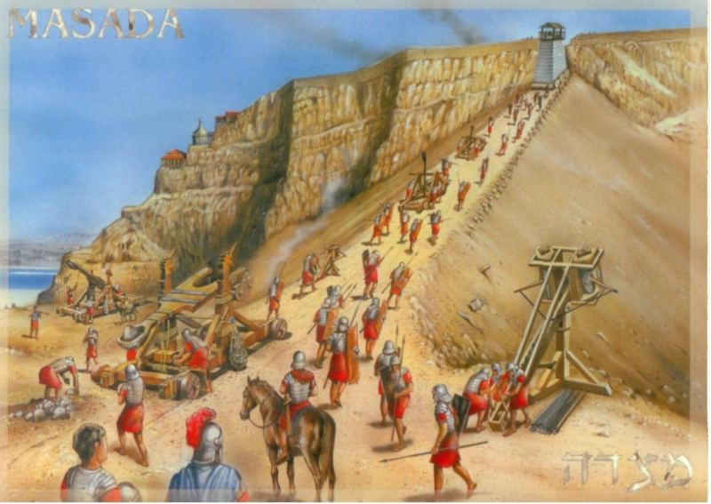
Now YOU know that the very foundation stones that comprised the Temple complex (including its walls) had been uprooted and demolished. They were then "dug up" and not even the lower courses of base stones were left in place. According to Eleazar, the only thing left in the Jerusalem area was a single Roman Camp (or Fortress) that still hovered (higher elevation) triumphantly over the ruins of the City and the Temple. He said that Jewish Jerusalem "hath nothing left"!!! The only thing continuing to exist was the "monument" (a single monument) preserved by Titus – “the camp of those that destroyed it [Jerusalem], which still dwells upon its ruins.” www.onug.us
The Jews had the Greater Sin of The Crucifixion of Christ (John 19:11), and the Total Destruction of Jerusalem was the result!!!
“His Blood Be Upon Us, And On Our Children!!!” (Matthew 27:25).
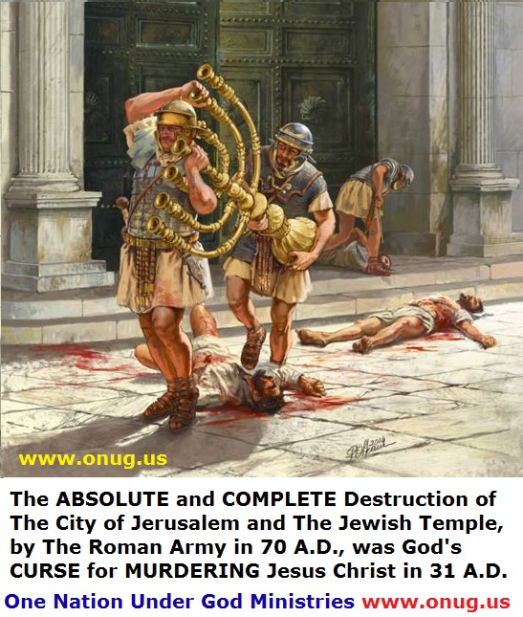
Jerusalem is a city that has been fought over 16 times, it has been destroyed twice, besieged 23 times, attacked in major offensives 52 times, and captured and recaptured 44 times, as of 2023! The Bible predicts there is MORE DESTRUCTION to come in the near future as well (Luke 21:24 / Matthew 24:15-16 / Mark 13:14 / Daniel 9:26-27 (Dual fulfillment), 12:7 / Revelation 11:2-3,13, 12:14, 13:5 / Zechariah 14:1-21)!!! www.onug.us
Eleazar mentions the "wholesale destruction" of the city. He said that God had "abandoned His most holy city to be burnt and razed to the ground" (The Jewish War VII. 8,6 Loeb translation). Commander Eleazar concludes his eyewitness account by stating: "I cannot but wish that we had all died before we had seen that holy city demolished by the hands of our enemies, or the foundations of our Holy Temple dug up, after so profane a manner!!!" (The Jewish War VII.8, 7).
“And Jesus Said unto them, ‘See ye not all these things (the Temple Complex)? Verily I Say unto you, There shall NOT be left here ONE STONE UPON ANOTHER, that shall NOT be Thrown Down!!!” (Matthew 24:2).
Now YOU Know… that the very foundation stones that comprised the Temple complex (including its walls) had been uprooted and demolished. They were then "dug up", and not even the lower courses of base stones were left in place!!! According to Eleazar, the only thing left in the Jerusalem area was a single Roman Camp (or Fortress) that still hovered (higher elevation) triumphantly over the ruins of the City and of the Temple. He said that Jewish Jerusalem "hath nothing left"!!! www.onug.us
The only thing continuing to exist was the "monument" (a single monument) preserved by Titus – the camp of those that destroyed it [Jerusalem], which still dwells upon its ruins.” www.onug.us
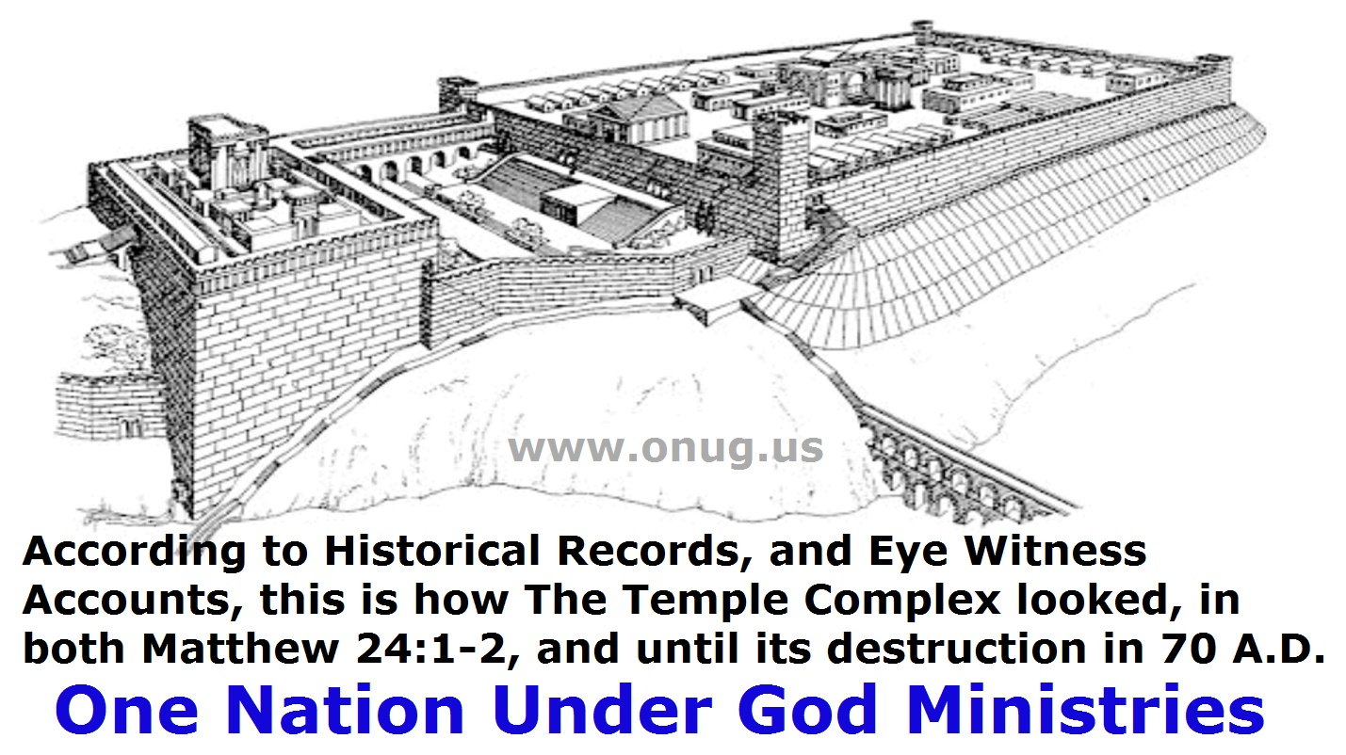
According to Josephus, the main military establishment in Jerusalem prior to the war was Fort Antonia located to the north of the Temple (which is now the Haram esh-Sharif – or where the Dome of the Rock is today)!!! Haram was considered Roman property even before the war with the Jews began!!!
Because Antonia was the property of Rome, they had no reason to destroy something that already was theirs! This is where Pilate was when Jesus was brought from the Temple to appear before him! This is why Titus left Fort Antonia (the Haram esh-Sharif / the sanctuary fortress or sanctuary of strength) and its walls in tact! We can still see them today, with a golden dome built upon them!!! www.onug.us
The Dome of the Rock sits upon the ruins of the Old Roman Fort; The Wailing Wall is NOT the last remains of Solomon’s Temple! God’s Temple was located to the right of the wall on the photo below.
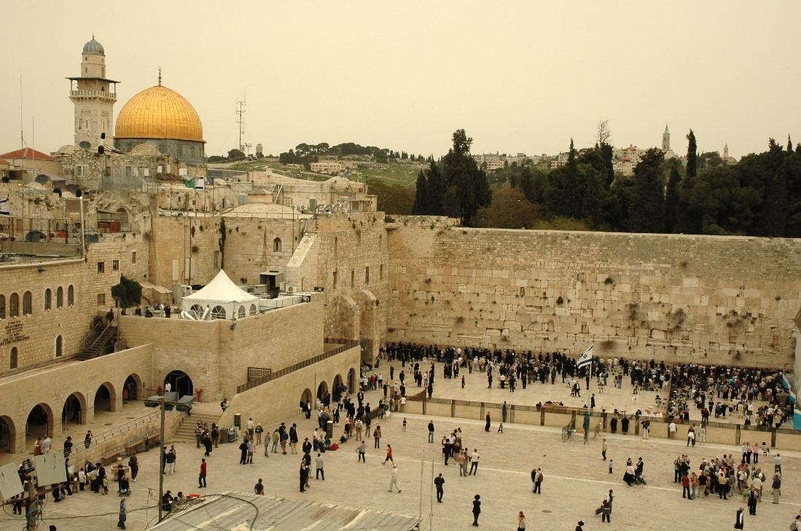
History Will Repeat Itself, Yet Again!!! www.onug.us
A short time before Christ Returns, armies will once again surround Jerusalem and an “abomination” will be done on the Temple Mount. As Matthew 24:21 says, this act inaugurates the time of Great Tribulation. At that time, The Saints in Jerusalem are told to flee to the mountains for safety (Matthew 24:16; Luke 21:20-21). Invading armies will again perform a blasphemous rite, and an idol will be erected in the Temple precincts, as in the former desolation. In the Old Testament, "abomination" is often synonymous with an "idol" (Daniel 11:45 / Revelation 13:11-18). So we can see here that the Beast will build a temple to himself on the Mount of Olives, after stopping the twice daily sacrifices (that have not even started yet, as of this writing) and defiling the altar; once this temple is completed, the false prophet who can call down fire from heaven, will convince the world to make an image to the beast – this image placed in the temple will have supernatural abilities to both speak and kill those who do not worship the Beast (2 Thessalonians 2:1-12)!!! www.onug.us
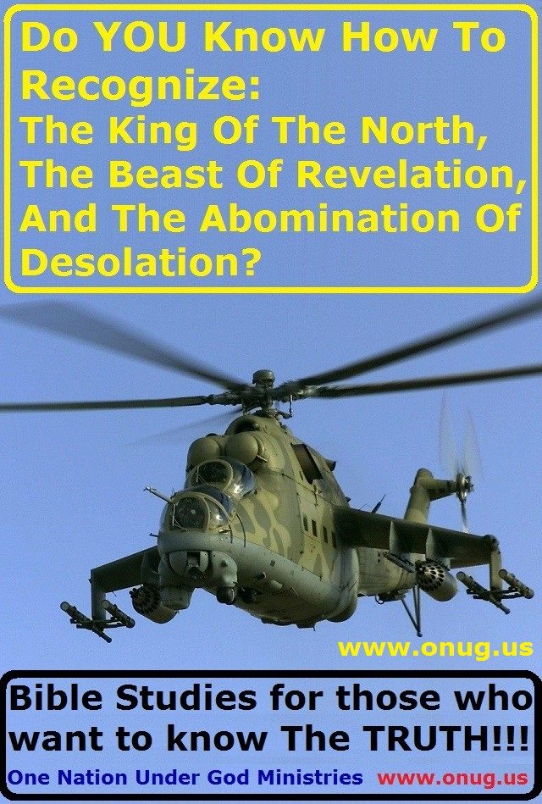
Please see our “King Of The North” Bible Study series, at www.onug.us for much more about this End Times ‘Man of Perdition’!!!
The Jews DO intend to START sacrificing on the Temple Mount again, and in OUR VERY NEAR FUTURE - so Says Jesus Christ; but NOT where the Dome of the Rock is; and NOT where the Old Roman Fort - where Christ was scourged (John 1:29) - was!!!
When the sacrifices do begin, it will be where the old temple really was!!! www.onug.us

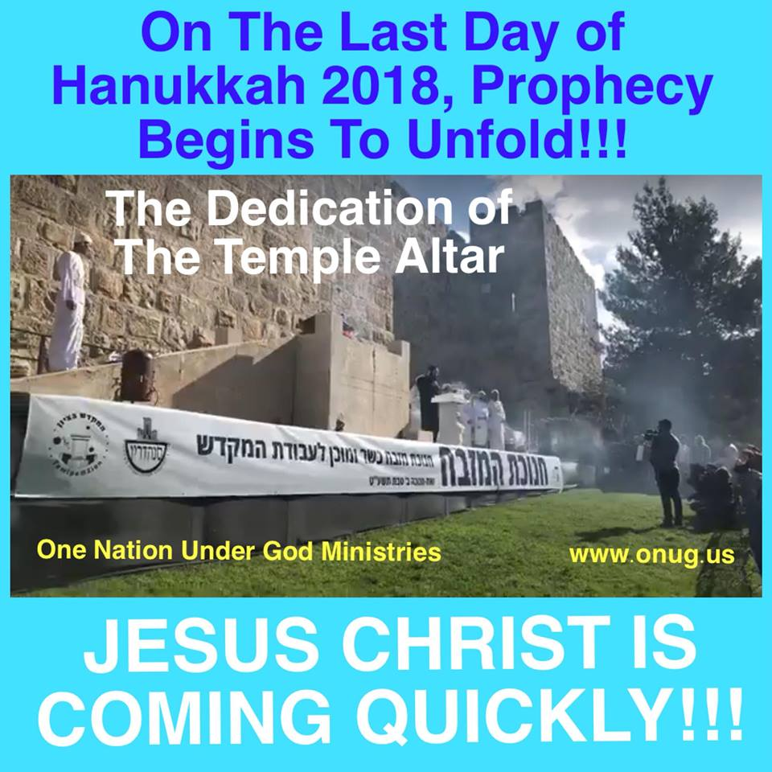
---------------------------------------------------------------------
NOW YOU KNOW…
That what MOST people believe to be the location, and the Remains, of the Old Jewish Temple – is NOT!!! Churches, the tourist industry, and the modern Nation of Israel, all continue to give this LIE life; and they teach, and re-teach it to each generation! We MUST Believe The Bible, FIRST and FOREMOST; then the history books, BUT ONLY WHEN AND IF, they agree with The Bible!!! www.onug.us
Let us now continue on, and SEE MORE of what the world always seems to get WRONG, about the Crucifixion of Jesus Christ!!!
Hopefully, you have already read our 3 Part - Passover Bible Study series; if so YOU now Know and have Proven that Jesus Christ was our Passover Lamb, and that He died on a Wednesday afternoon, on a Passover Day, and that He Rose from His Tomb on a Saturday afternoon, as our First Fruits - BEFORE sunset! Easter Sunday is a pagan LIE (1 Kings 11:1-11)!!!
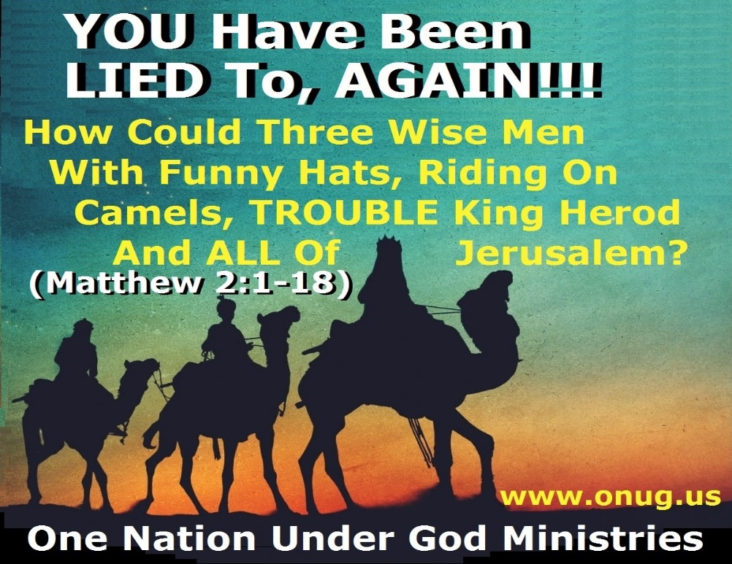
Just as human tradition has led us to believe, incorrectly, that three wise men came to see Jesus when He was born (See our Feast of Trumpets Bible Study for much more on this); we have also been led to believe that Jesus was Crucified in between two thieves! This IS NOT SO!!!
Our, “Why Was Christ Crucified?” Bible Study would also have Proven to YOU the 3 Biblical Reasons that Christ was killed; and also that Jesus was One of FIVE people that died on a cross that day. Please go back and READ these Very Important Bible Studies, if you have not already done so!!! www.onug.us
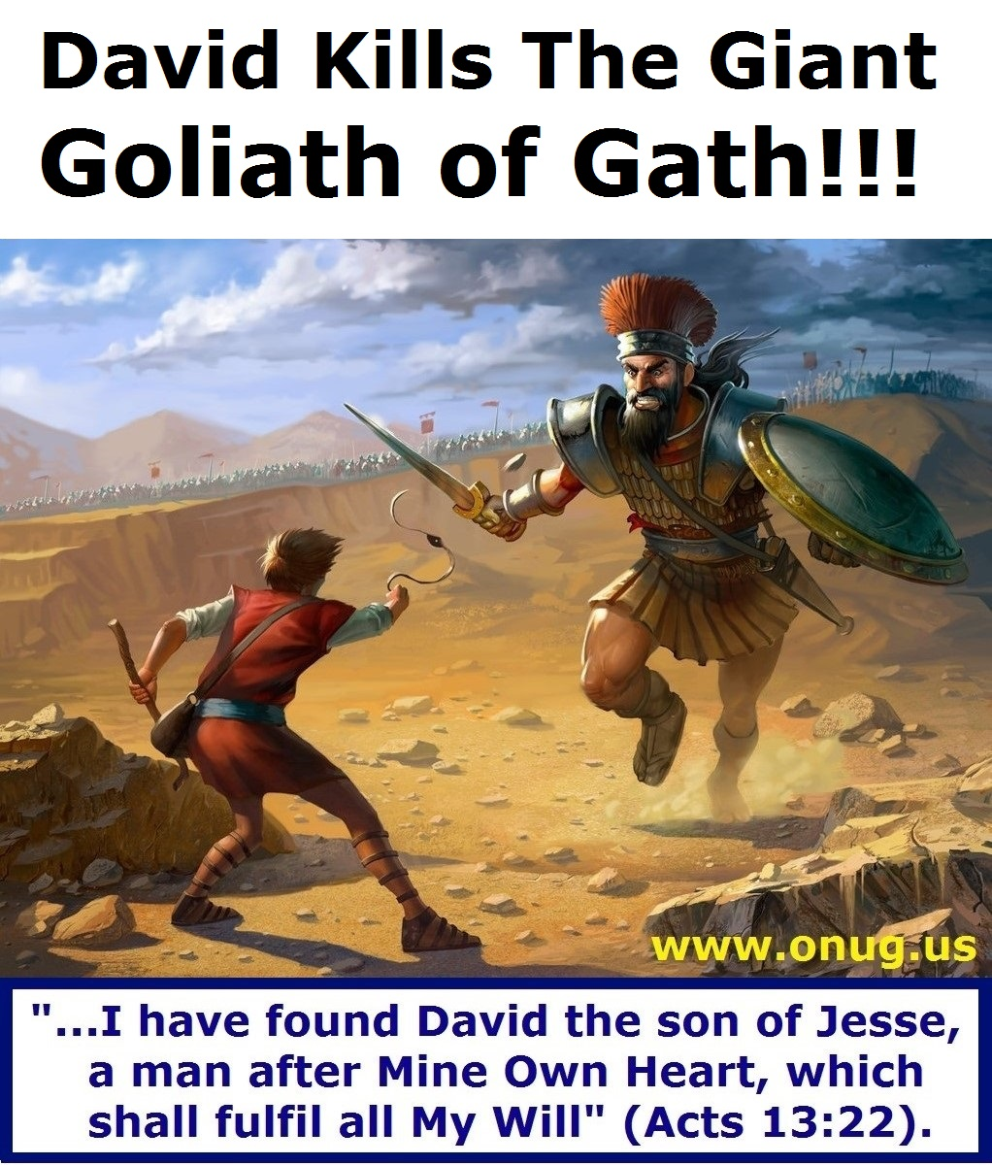
WHAT Is WRONG With This Picture (or Painting)? Serious Students of God’s Infallible Word Will KNOW!!!
Strangely, our Study today on The Place of Christ’s Crucifixion, would NOT be complete if we didn’t first begin with David’s Epic Battle against a Very Big Man - Goliath of Gath!!! www.onug.us
Let’s Read 1 Samuel 17:1-11
Are YOUR Beliefs Based On TRUTH (John 17:17); Or Are They Based On Lies, Traditions, And What Other Men Have Told You?
A Song About “David And Goliath”, By M. Kibble:

David was a young blood. David was a stripling
But he looked like the jungle boy. That was talked about by Kipling
Well, he looked like a jungle boy and he sang like a bird
(But he fought like the devil when his temper got stirred)
When David was attending sheep for his pa
Somebody hollered, I think it was his ma
She said "Hurry to the field with this little-bitty sack
I want you to take it to your Brothers, but hurry right back"
Now David took his lunch box, and off he hurried
And there he saw the Israelites lookin' right worried
When he asked them what the problem was
They pointed to the prairie
There he saw a sight to make an elephant scary
Oh, there he saw Goliath, champion of Gath
He roared in his anger, howled in his wrath
Oh, he was stronger than a lion
He was taller than a tree
Little David had to tiptoe just to reach up to his knee
"Come on!" said the giant, raging and striding
"Bring out your strongmen from where y' got 'em hiding
Drag out your champions from under their bunks
I'll feed 'em to the buzzards, the lizards and the skunks"
Now David heard him bragging, and said, "I declare
That giant's got an awful lot of mouth up there"
So he strolled to the brook, and he picked up a pebble
It was smooth as ice, but hard as a devil
He starts out for the giant, dancing on his toes
He was whirling away with his slingshot
He was singing a song like so... goes:
"Rock of ages, cleft for me" – like so
The giant looks at David and lets out a laugh
He laughs like a tiger being sassed by a cat
He laughs like a hyena, grins from ear to ear
Ba-Ba-Ba-Bangin' on his armor with his ten-foot spear
He stars (starts) out for David, bangin' and a-clankin'
He said, "Come here, Junior! I'm gonna give you a spankin'!"
David took his slingshot, and swung it 'round his head
Out flew that pebble and the giant dropped
(He dropped dead) – dead!
(You know little David made a – good shot!)

Another "David And Goliath" Song, By Barry McGuire:

Well, there stood a giant 'bout 40 feet tall
He was lookin' down hard on me
He was lookin' for trouble, gonna gobble me up
That was plain enough for me to see
He said, "Na, na, na, na, na, na, na, na"
"Na, na, na, na, na, na, na"
"Na, na, na, na, na, na"
"Na, na, na, na, na, na"
"Na, na, na, na, na, na, na"

Yeah, I thought about runnin' but where could I go?
Wherever I went, he’d take me
Well, I'd be running forever, every corner I'd turn
That freak be waitin' for me
He'd say, "Na, na, na, na, na, na, na, na"
"Na, na, na, na, na, na, na"
"Na, na, na, na, na, na"
"Na, na, na, na, na, na"
"Na, na, na, na, na, na, na"

Well, I got down on my knees
Reached down for The Rock
I reared back and let him fly
I caught him smack in the head
That monster fell down dead
Now I know that I'll never die
I said, "Na, na, na, na, na, na, na, na"
"Na, na, na, na, na, na, na"
"Na, na, na, na, na, na"
"Na, na, na, na, na, na"
"Na, na, na, na, na, na, na"

So if you got a monster livin' in your head
There's only one thing to do
Reach out to God 'n grab His rock of truth
And let Him have His way with you
Then you can say, "Na, na, na, na, na, na, na, na"
"Na, na, na, na, na, na, na"
"Na, na, na, na, na, na"
"Na, na, na, na, na, na"
"Na, na, na, na, na, na, na", yeah!

"Na, na, na, na, na, na, na, na"
"Na, na, na, na, na, na, na"
"Na, na, na, na, na, na"
"Na, na, na, na, na, na"
"Na, na, na, na, na, na, na"...

It is EASY to be MISLED, by Powerful lyrics combined with Great music, in a hymn or a song! A Smooth-Talking orator, can WOW You so much with the Quality of his speech, that YOU Don’t recognize the Lies, Deception, or Perverted Truths that you are being fed! Sometimes an artist can deceive us, just by his skill, so that we are so amazed by what we see, our emotions are stirred; so that we MISS COMPLETELY, our “DELIBERATE, FOCUSED, and GRADUAL Redirection, AWAY FROM God’s Holy Word!!!” www.onug.us

Let’s Read 1 Samuel 17:4-7, 40-51. Did YOU SEE that Goliath wore a helmet of brass? And that he carried a large SPEAR into battle; NOT a sword, which was still in its sheath when David defeated him? Goliath did NOT carry his own shield either!
David was an ADULT of the same stature as King Saul; he was a youth (which can also be translated as “Young Man”) – in his 20’s! David was a soldier in The Kings Army, a MAN or War, The King’s Armor Bearer, and a Royal Musician (1 Samuel 16:10-23) – David was living in the King’s Palace; and David had his own chariot and chariot driver too! David was NOT a child (1 Samuel 17:12-22, 26-40)! www.onug.us
Look at our painting on page 29 AGAIN! Most of us see nothing WRONG with it, UNTIL GOD EDUCATES them with Scriptures like The Ones YOU just Read! We will Teach you MANY MORE HIDDEN TRUTHS about this epic battle, in this Golgotha Bible Study Series! So Stay Tuned!!!

“Now the Philistines gathered together their armies to battle, and were gathered together at Shochoh, which belongeth to Judah, and pitched between Shochoh and Azekah, in Ephesdammim. And Saul and the men of Israel were gathered together, and pitched by the valley of Elah, and set the battle in array against the Philistines. And the Philistines stood on a mountain on the one side, and Israel stood on a mountain on the other side: and there was a valley between them. And there went out a champion out of the camp of the Philistines, named Goliath, of Gath, whose height was six cubits and a span.” (1 Samuel 17:1-4).
NOTE: 1 Samuel 17:4 / KJV translation would put Goliath’s height at about Nine Feet, Nine Inches (SIX CUBITS AND A SPAN) – or 2.972 Meters! Jerome’s fourth century A.D. Latin translation (the Vulgate), which appears to follow the Hebrew proto-MT faithfully, likewise puts Goliath at six cubits and a span. The Vulgate gradually grew in popularity in the West and eventually became the “received text” for the Western churches, thus codifying the 9’9” giant into Western culture.
HOWEVER, the textual evidence for the variant reading of “FOUR CUBITS AND A SPAN” (Six Feet, Nine Inches) – or 2.057 Meters, IS SIGNIFICANTLY STRONGER, as we shall soon SEE! www.onug.us
The textual witnesses for the variant that cites Goliath’s height at four cubits and a span (6’9”) include:
- 4QSama, the oldest extant Hebrew manuscript for this text.
- Vaticanus, the oldest complete Greek codex of The Bible.
- Josephus (whom we allotted much time to above, in order to validate his historical accounts), is a non-Biblical first-century ad reference. As a first-century Jewish historian though; Josephus’ account demonstrates to us Convincingly, that Goliath’s shorter height was Well Established in The Hebrew Bible of His day!!!
- The Lucian Greek recension, a third-century ad witness; and
- Other early codices such as Alexandrinus (Commonly known as the “Septuaginta” (LXXII) or shortened “Septuagint”(LXX) – a Greek translation of The Old Testament, completed no later than the mid second-century B.C. AMAZINGLY, one of the Hebrew copies of the Book of Samuel found among the Dead Sea Scrolls, contains text from 1 and 2 Samuel. Although parts of the text are damaged, 1 Samuel 17:3-6 is not!!! This text dates to around 50 B.C., and THIS IS The Oldest Hebrew Copy of this part of 1 Samuel; so it is Significant that it has the Shorter Height of Goliath as Four cubits and a span or Six Feet, Nine Inches (2.057 Meters)! www.onug.us
A 6’9” tall Goliath (2.057 Meters), would have been at least 20 centimeters taller than the heroes found in Iron Age Mycenaen tombs, and 30-40 centimeters taller than the average Iron Age man. This indicates that even the heroes of that time period, were only 10-15 centimeters taller than the average man; and a man 30 centimeters taller than these heroes (as Goliath was), would have been a real Post Flood Giant, on the shrinking scales of human sizes following the days of Noah! Goliath at 6’9” was almost 40 centimeters taller than the average man.
King Saul needed not to have been more than 6 feet tall to be head and shoulders above all of Israel! Remember, King Saul is more concerned with Goliath’s Fighting Ability and Experience; than with Goliath’s Height (1 Samuel 17:31-40)! Neither David, nor Saul, are overly concerned about Goliath’s Height; and David having already watched Goliath in battle (1 Samuel 17:19-29), has already formulated a battle strategy to defeat him!!!
At 6’9”, Goliath of Gath, was still a Big, Man; but it was Goliath’s muscular girth, and fierceness, that dismayed most – but NOT David!!! www.onug.us
Let’s Continue with our text in 1 Samuel 17:5-11
“And he had an helmet of brass upon his head, and he was armed with a coat of mail; and the weight of the coat was five thousand shekels of brass.
NOTE: Surviving brass shekels from this time period, contained only a fourth part of an ounce; and so 5,000 shekels of brass would weigh in at 1,250 ounces, or exactly at 78 pounds. A coat of Mail of this weight would not be unsuitable for a man of such stature and strength, as the Scriptures suggest Goliath possessed! Even if we went with the more modern, one half ounce weight to the shekel of brass; that would put Goliath’s armor coat at 156 pounds, 4 ounces.
How much weight can a Very Tall, Very Muscular Philistine Warrior carry into Battle? www.onug.us
(1 Samuel 17:6-11) “And he had greaves of brass upon his legs, and a target of brass between his shoulders. And the staff of his spear was like a weaver's beam (with a rope loop handle to help him wield it!); and his spear's head weighed six hundred shekels of iron (about 15 pounds).
NOTE: A normal spear head from this time period would have been eight inches, maybe a foot long, and weigh in at about a pound, roughly half a kilogram at most! In 1962 near Kfar Monash, a settlement in the plain of Sharon, near the Coast of Israel; a cache of early Bronze age weapons and tools were found. Among these were several Giant copper spearheads 66 cm long (26 inches) weighing 2.05 kg (4.5 lbs). These would be about the same size as Goliath’s Spear head, and if they were made of Iron instead of Copper – they would weigh in at close to the same 15 pounds as Goliath’s Spearhead!!! Also found in the 1962 dig, were 800 copper plates, 5 cm x 11 cm, (2 inches wide by 4 1/3 inches long) which may have been used for scale armor, for rather large warriors!!! www.onug.us
WHAT IS A WEAVER’S BEAM?
1 Samuel 17:7 “…The shaft of his spear was like a weaver's beam…”
In the time period of David and Goliath, the warp weighted loom was typically used to make woven materials. A weavers beam was a strong, long rounded wooden pole used at the top of a loom to hold the warp, or vertical threads. The warp threads were kept taut by means of weights tied to the bottom of them. The weaver’s beam kept the warp threads separated and could be turned to roll up the material as the weaving progressed. With the warp threads taut and in place, filling threads, called the weft, are woven through the warp threads from side to side. This was often done by two women. Weaving was typically done from the top of the loom to the bottom, and the strands of filling thread were beaten upwards. Looms were adapted to the size of the material being made. Based off the looms used in that time period, it would be common for a weaver’s beam to be 2 to 2 1/2" inches thick and more than 5 feet long.
The Biblical reference of a weaver’s beam is most likely in respect to the unusual thickness and strength of the shaft, rather than the length!!! The weaver’s beam reference contrasts the normal smaller, thinner spear that would be handled by an average size man. There are 4 verses in Scripture that mention a weaver’s beam like spear, 2 of which refer to Goliath’s Spear. One refers Goliath’s brother’s spear; who was most likely close to Goliath’s size. The 4th verse refers to a giant size Egyptian, Even BIGGER than Goliath; who lived in that day, who would measure over 7 foot 6 in tall!!! www.onug.us
1 Samuel 17:7 - “And the staff of his spear was like a weaver's beam; and his spear's head weighed six hundred shekels of iron: and one bearing a shield went before him.”
2 Samuel 21:19 – “And there was again a battle in Gob with the Philistines, where Elhanan the son of Jaareoregim, a Bethlehemite, slew the brother of Goliath the Gittite, the staff of whose spear was like a weaver's beam.”

1 Chronicles 11:23 – “And he slew an Egyptian, a man of great stature, five cubits high; and in the Egyptian's hand was a spear like a weaver's beam; and he went down to him with a staff, and plucked the spear out of the Egyptian's hand, and slew him with his own spear.”
1 Chronicles 20:5 – “And there was war again with the Philistines; and Elhanan the son of Jair slew Lahmi, the brother of Goliath the Gittite, whose spear staff was like a weaver's beam.”
For the physics of our Goliath’s spear beam to work properly with a 15 - 16lb, 11oz spear head, and the height of Goliath (6 feet, 9 inches), we choose a 10’ length 2in diameter pole, including a 6lb 1.2oz counterweight, giving our spear a total length of 12 ft 7in. This is not to say the spear could not have been even longer, and thicker!!! The Biblical Concept being relayed to us here, is the Impressiveness of HOW THICK Goliath’s Spear really was! A normal sized man could not grasp such a THICK Pole, and Effectively Use It in Battle!!! Goliath had VERY BIG HANDS!!! The Bible doesn’t give us the exact length. However, the length we calculated for our replica would allow Goliath to have a center of balance to hold the spear easily with one hand about 62 inches from the tip. This would allow him to thrust it directly at the enemy to achieve the best leverage and killing force. A spear of much longer length would cause the weight of the head to become overwhelming to wield and bend the shaft making it too flexible and cumbersome for effective hand to hand battle. At the time of David and Goliath, around 1020 BC, spears were a normal battle weapon. There was also another known weapon that was too long to be used in hand-to-hand combat. It was the ancient Sarissa, that was up to 20 feet long. It would be used as a stationary defensive weapon, simply held in place to keep enemies from crossing battle lines. The head of the Sarissa was lighter and wasn’t known to be used widely, until the Macedonian times of around 359 B.C.

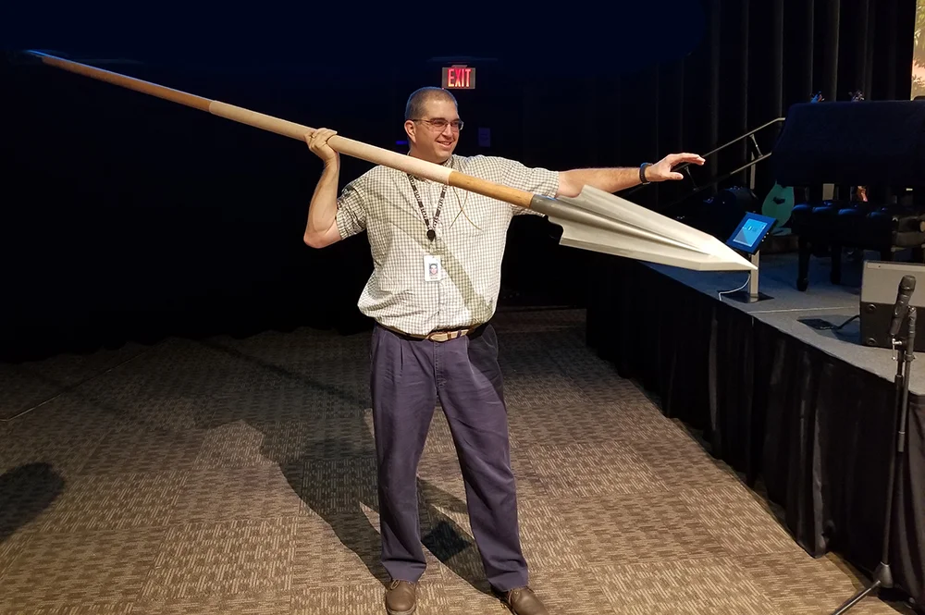
5-6 foot tall humans may be able to hold a Giant’s Spear; but they could NEVER wield one in battle effectively!
(Continuing in verse :7) “and one bearing a shield went before him (Do YOU SEE The Scriptural ERRORS in the preceding drawing of Goliath fighting David? Goliath was NOT holding his shield when he fought David!!!). And he stood and cried unto the armies of Israel, and said unto them, Why are ye come out to set your battle in array? Am not I a Philistine, and ye servants to Saul? Choose you a man for you, and let him come down to me!!! If he be able to fight with me, and to kill me, then will we be your servants: but if I prevail against him, and kill him, then shall ye be our servants, and serve us!!! And the Philistine said, I defy the armies of Israel this day; give me a man, that we may fight together!!! When Saul and all Israel heard those words of the Philistine, they were dismayed, and greatly afraid!!!” (1 Samuel 17:7-11).

Studying the above Scriptures, critically: 78 pounds (low end) to 156 pounds (high end) for armor, and maybe another 30-40 pounds for helmet, spear, sword, and leggings (200 pounds maximum) isn’t a lot of weight, for a slow moving, but very muscular and mesomorphic, 6’9” warrior (1 Samuel 17:44).
Goliath did NOT run into battle as our previous painting showed us! Goliath had to lumber slowly forward; while David was very quick, agile, and nimble on his feet! Let’s now use a Hulk of a man to help us Understand this more fully!
The Incredible Hulk:
Louis (Lou) Jude Ferrigno, born in 1951, was a very popular and widely known body builder in the 1970’s through the 1990’s. He is probably best known as the star of the Incredible Hulk T.V. series, where most people got their first look at his Massive Physique! Lou, at the height of his career, was 6 feet, 5 inches tall (195.5 cm), and weighed in between 285-295 pounds (129.3-133.8 kg). His biceps were 22.5” (inches), chest 59”, waist 34”, thighs 29”. If Hollywood was going to cast someone to be Goliath in an upcoming movie, Lou Ferrigno would be my choice! Looking at photographs of Lou; it is easy to see why other men of war would fear Goliath! Add in Goliath’s documented Violent behavior, and war fighting history; and you would have a True Menace on your hands!!! At 6’5”, 295 pounds; Lou could handle a lot of battle gear. At 6’9”, and even heavier; Goliath could easily carry his Biblically Recorded Battle Load too! www.onug.us
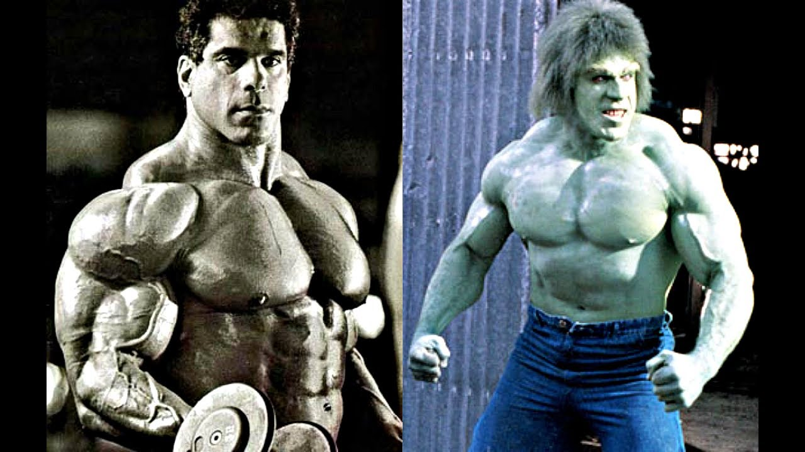
Lou Ferrigno: As A Body Builder And As The Incredible Hulk!!!
How much weight can an average American Soldier, with military conditioning and strength training, carry into Battle? www.onug.us
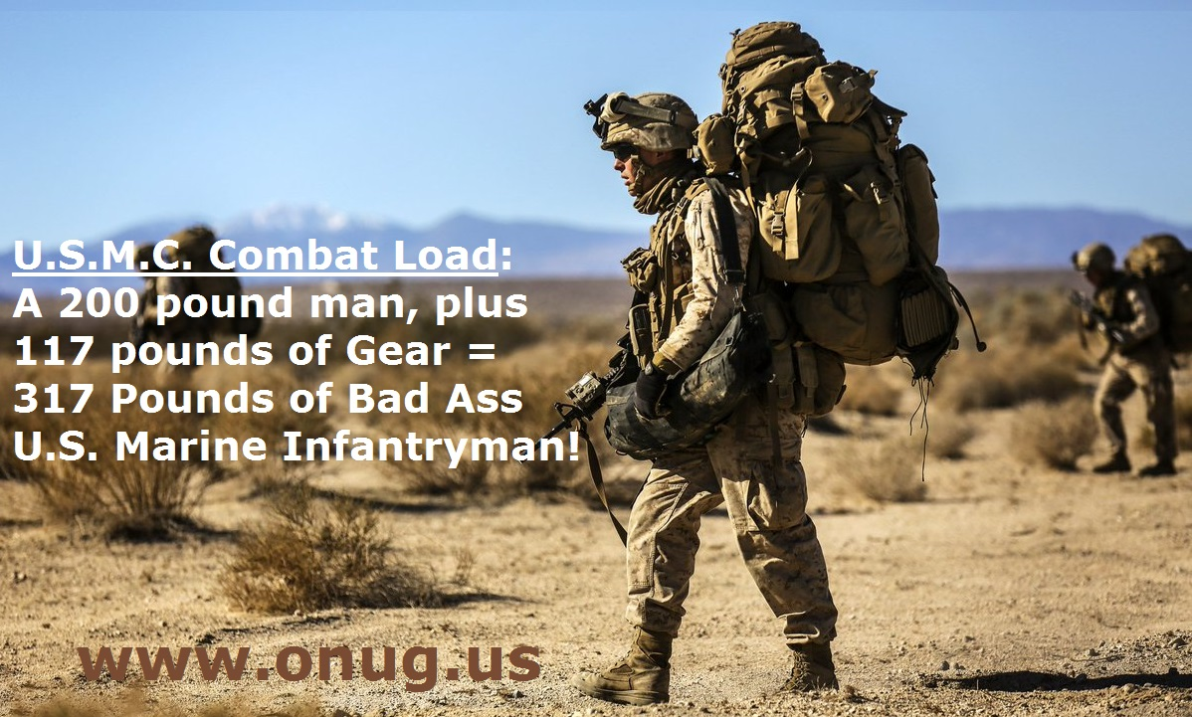
While I was in the U.S. Marine Corps (1982-1988), and during my years as a Law Enforcement S.W.A.T. Cadre and Riot Control Instructor (1995-2017); I cannot ever recall weighing myself in my battle or entry gear, to see how much my gear, my weapons, and myself weighed. We just trained Hard, and Lifted Heavy; so we could put a 200 pounds-plus man, into lots of armor, weapons, and ammunition, and get the job done! We weren’t going to go running after anyone in a fight (we had 40MM Less Than Lethal rounds to go after the runners); but wearing all that heavy gear, and carrying all of our toys, we dominated every place we walked into!!!
But in 2003, Colonel Charles Dean; a military equipment expert, decided to study the weight worn of Combat Soldiers in Eastern Afghanistan – specifically that of an infantry soldier. His team joined with the 82nd Airborne Division, collecting data, and weighing more than 750 soldiers with a range of different jobs. When soldiers headed out on foot patrols, their average load ranged from 87 pounds to 127 pounds. When they came under attack and dropped their rucksacks, most of their fighting loads still exceeded 60 pounds!!!
Lightening The Load!!! www.onug.us
Light and Quick: Marines in Uganda used AR-15’s, Uzi Sub-Guns, and 870P 12 Gauge Shotguns, to move about the countryside.
In his final report, Colonel Dean sounded an alarm. “If an aggressive weight loss program is not undertaken by the U.S. Army, the soldier’s combat load will continue to increase, and his physical performance will continue to be even more severely degraded!!!”
King David understood, as would the later Roman Legions, what The U.S. Marines and U.S. Army Colonel Dean would in recent times – “rediscover”; that lighter troops can move and fight faster – especially when using projectile based weaponry! There is a time to fight heavy, and there is a time to fight light! There is a time to fight up close and personal; and there is a time to fight at a distance (Psalm 144:1-2)!!! www.onug.us
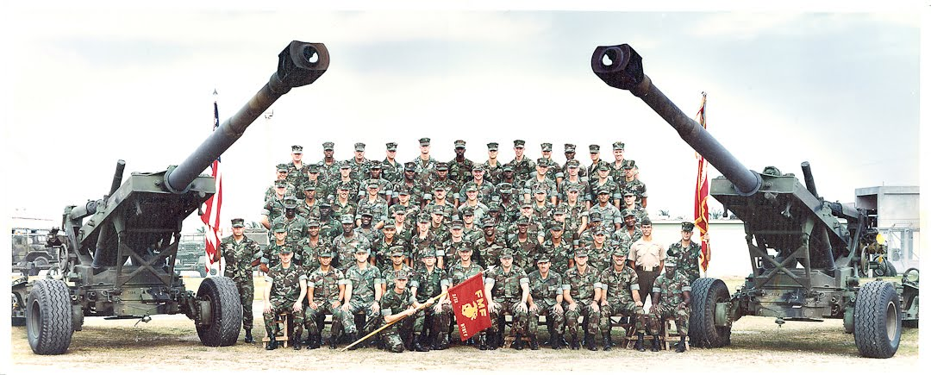
My Dad, Robert C. Brown Jr., worked for the Phone Company from the time he got out of The U.S. Air Force in the 1950’s thru the 1980’s. In the 1960’s thru the 1970’s, The Bell (Phone) System had a catchy commercial slogan that I can still remember to this day: “Long Distance. It’s the next best thing to being there.” By the time I was stationed in Japan (1983-1984), our U.S. Marine Field Artillery had changed that slogan to: “Death By Long Distance; The Next Best Thing To Being There!” Photo: "F" Battery, 2nd Battalion / 12th Marines; Okinawa, Japan (1986).

David Defeats Goliath In Battle (1 Samuel 17:41-54)
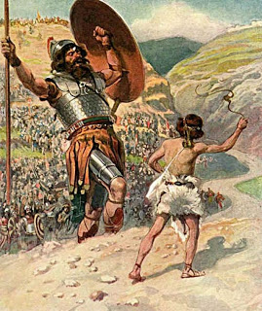
Although Goliath is Biblically Correct, in carrying a spear, in this painting; he is also INCORRECTLY carrying his shield!!! David is still pictured as a youth, or shepherd boy; NOT as the adult, 6 foot tall, Warrior and SOLDIER - THAT HE WAS, when he engaged Goliath in mortal combat!!! www.onug.us
The Bible Recounts how King Saul wanted to reward David for his victory over the Philistines. The reward had been previously stated by the king, and all the army of Israel knew what King Saul would grant to the one who defeated Goliath (1 Samuel 17:25)! Saul at this time, knew who he had sent out into battle against Goliath (verse :32, 37-38); but he did not know who David’s father was, so as to make his house, and his estate, tax free, from this point forward (1 Samuel 17:55-58)!!!
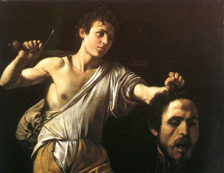
David does sever Goliath’s head with the giant’s own sword – TRUE! But David was an Adult Soldier, an an Accomplished Warrior – Most Likely in Uniform, during this encounter!!! www.onug.us
David Becomes A National Hero!!!
David keeps the Giant’s armor, and probably the sword, shield, and spear too; as trophies of war (1 Samuel 17:54)! He gives Saul the head of his enemy; but then what?
What did King Saul do with the Giant’s Head, after he received it? Most people, outside of Jeffery Dahmer (The Milwaukee Cannibal, who murdered and dismembered 17 men and boys, between the years of 1978 to 1991) would NOT keep severed body parts in their refrigerator!
Where did The BIG Giant Head Go? The Bible DOES Tell Us!!!

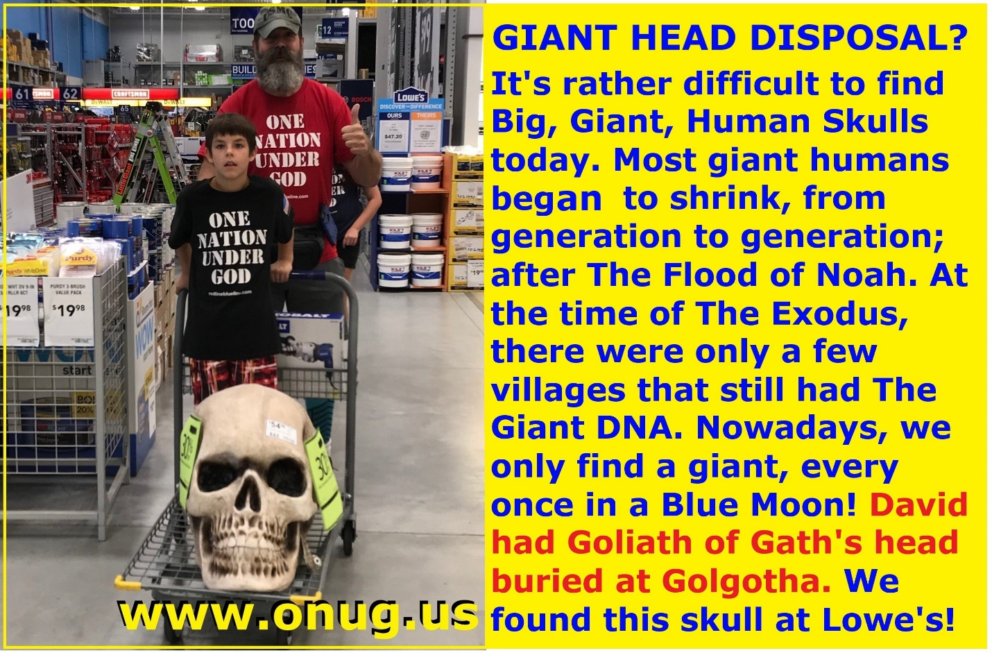
“Fe, Fi, Fo, Fum; I Smell The Blood Of An Englishman!!!”
Are Human Giants REAL (1 Thessalonians 5:21)?
Giant Humans? God’s Word Says, “YES, There Once Were, Giant People In This World!!!” (Genesis 6:1-8). www.onug.us
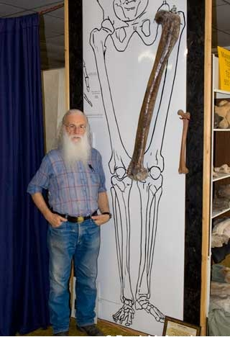
In the late 1950’s, during road construction in the Euphrates Valley of south-east Turkey, many tombs containing the remains of giants were uncovered. At the sites, some of the leg bones were measured to be 120 cm (47.24 inches). Joe Taylor, Director of Mt. Blanco Fossil Museum, was commissioned to sculpt the human femur (seen above), to be a replica of the actual human leg bone found in the Turkish tombs. This giant stood some 14-16 feet tall!!! Likely this was a skeleton of a pre-flood person, a time when human giants were known to live for several centuries! But even after The Great Flood, Genesis 6:4 claims: “There were giants in the earth in those days.” Deuteronomy 3:11 states that the bed of Og, king of Bashan, was 9 cubits by 4 cubits (approximately 14 feet long, by 6 feet wide)! In Numbers 13:28-33, the Israelite spies investigated the land of Canaan in preparation for an invasion. They reported a race of giants that made them feel like mere grasshoppers! www.onug.us
Are Human Giants REAL (1 Thessalonians 5:21)?
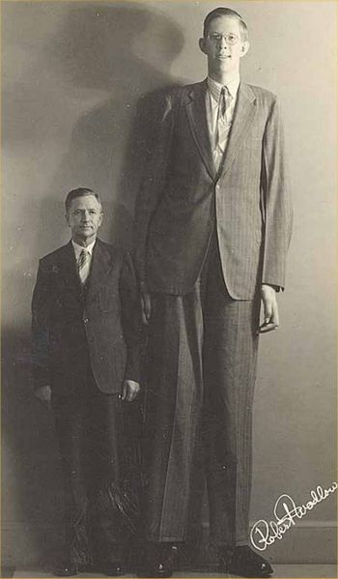
The tallest person in our recently recorded history, was Robert Wadlow of Alton, IL (seen above). Wadlow was born on February 22, 1918 and grew to be 2.72 m (just under 9 feet tall). He died in 1940 at just 22 years of age, and was buried in a 10-foot long, half-ton coffin that required twelve pall bearers! According to the Guinness record keepers, the tallest man alive today is Sultan Kösen of Turkey. He was born in 1982 and stood at 8 ft 3 in 2011. . . . .
“All the people that we saw in it are men of a great stature. And there we saw the giants, the sons of Anak, which come of the giants: and we were in our own sight as grasshoppers, and so we were in their sight!!!” (Numbers 13:32-33). www.onug.us
A 6’9” tall Goliath (2.057 Meters), would have been at least 20 centimeters taller than the heroes found in Iron Age Mycenaen tombs, and 30-40 centimeters taller than the average Iron Age man. This indicates that even the heroes of that time period, were only 10-15 centimeters taller than the average man; and a man 30 centimeters taller than these heroes (as Goliath was), would have been a real Post Flood Giant, on the shrinking scales of human sizes following the days of Noah! Goliath at 6’9” was almost 40 centimeters taller than the average man. King Saul needed not to have been more than 6 feet tall to be head and shoulders above all of Israel! Remember, King Saul is more concerned with Goliath’s Fighting Ability and Experience; than with Goliath’s Height (1 Samuel 17:31-40)! Neither David, nor Saul, are overly concerned about Goliath’s Height; and David having already watched Goliath in battle (1 Samuel 17:19-29), has already formulated a battle strategy to defeat him!!!
At 6”9”, Goliath of Gath, was still a Big, Man; but it was Goliath’s muscular girth, and fierceness, that dismayed most – but NOT David!!!
Goliath of Gath is often referred to in Bible Studies as a Giant; but he was far from being the biggest man, post flood! www.onug.us
The REAL GIANTS of The Bible were our own human ancestors, who lived from the time of Adam until The Great Flood of Noah! Everything was BIGGER before The Flood; including Humans! Yes; There Once were Giants who walked the earth; and they were the same animals and people whose descendants, yet smaller, are alive today!

The Bible Says: That Noah and his family, and the whole world; were completely 100 percent (Just Like Adam and Eve were) - Human Giants BEFORE and AFTER The Great Flood (READ Genesis 6:1-8 and SEE)!!! Humans did NOT begin to get smaller until YEARS AFTER The Flood!!!

One Nation Under God Ministries www.onug.us
A 64 pound sledge hammer was found in Great Orme Mines in Wales. One would need to be 12-15 feet tall, to wield this hammer safely and efficiently!!! www.onug.us
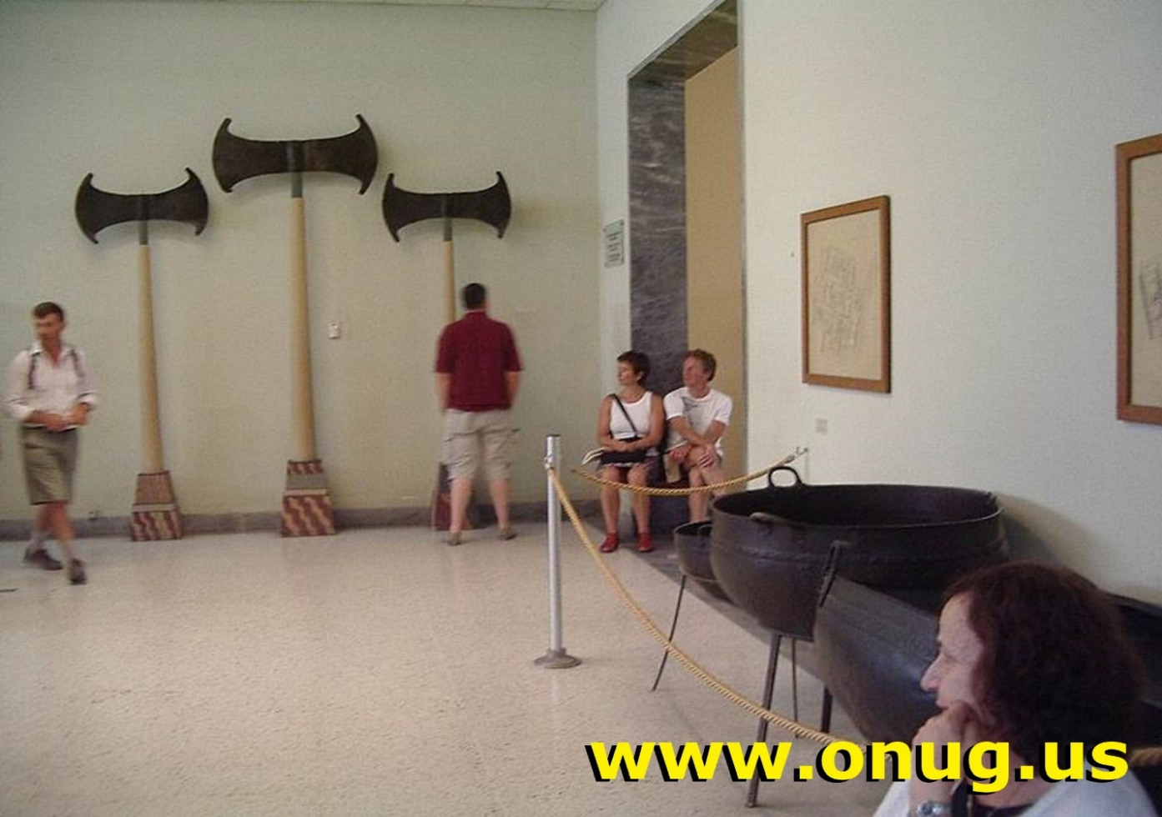
Battle Axes that ONLY a Giant Could Wield: Ancient Minoan and Cretan Axes That Weigh 100 Pounds Each!!! Our History Books now teach Satan’s LIE of Evolution!!!
If today’s Heavy Sledge Hammer Heads, weigh in at 10 pounds for a 5-6 foot man, and you would need a 12-15 foot tall man to wield the 64 pound Sledge Hammer above; and today’s doubled-headed axes are 4-5 pounds in weight… then How BIG, and How STRONG would YOU need to be, in order to swing the 100 pound, Double-Headed Axes, above? YES, There Really Were Giants on the earth! Unfortunately, Goliath of Gath was a LITTLE Giant by God’s Biblical Standards; but he was still much BIGGER than the 6 foot Soldier, Warrior, and soon to be King, David!!! www.onug.us
For Much More on GIANT Animals and Humans - in The Bible; Read our Bible Study Series on “The Book of Job”! It is ALWAYS available in One Nation Under God Ministries’ “Online College of Biblical Knowledge”!!!
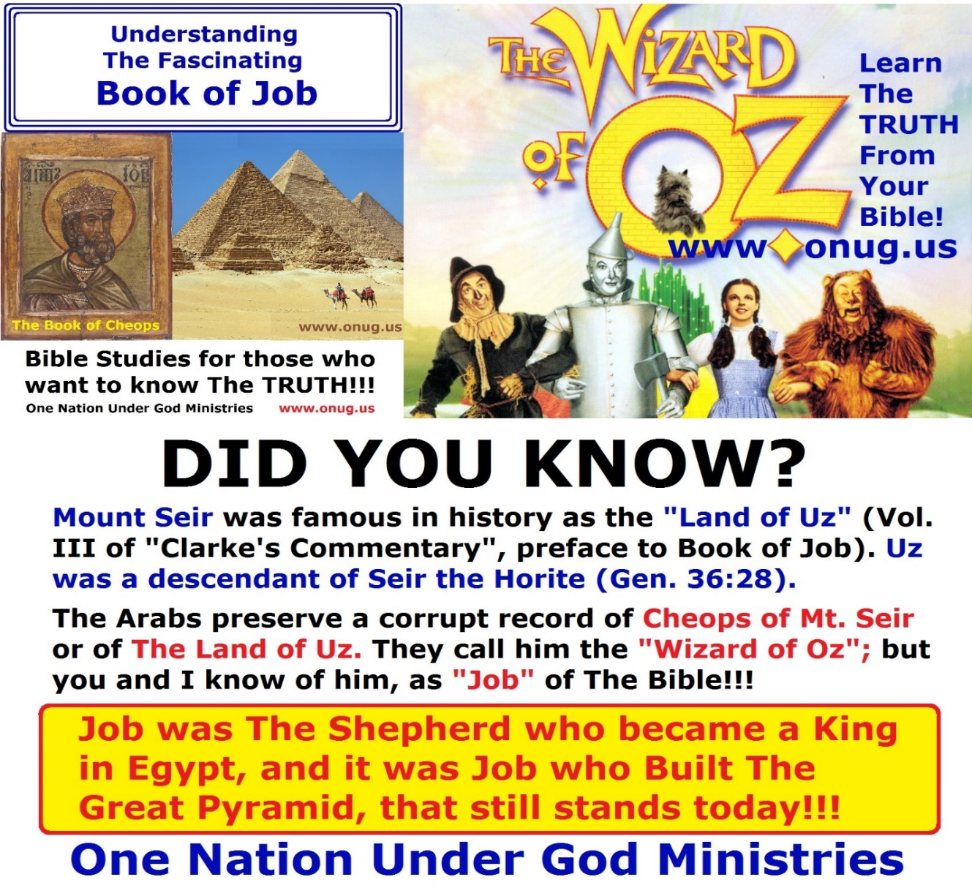
God’s Mighty And Eternal TRUTH (John 17:17), Really Is Stranger Than Fiction, Or The Perverted Lie Of Evolution!!!
The Place Of The Skull? www.onug.us
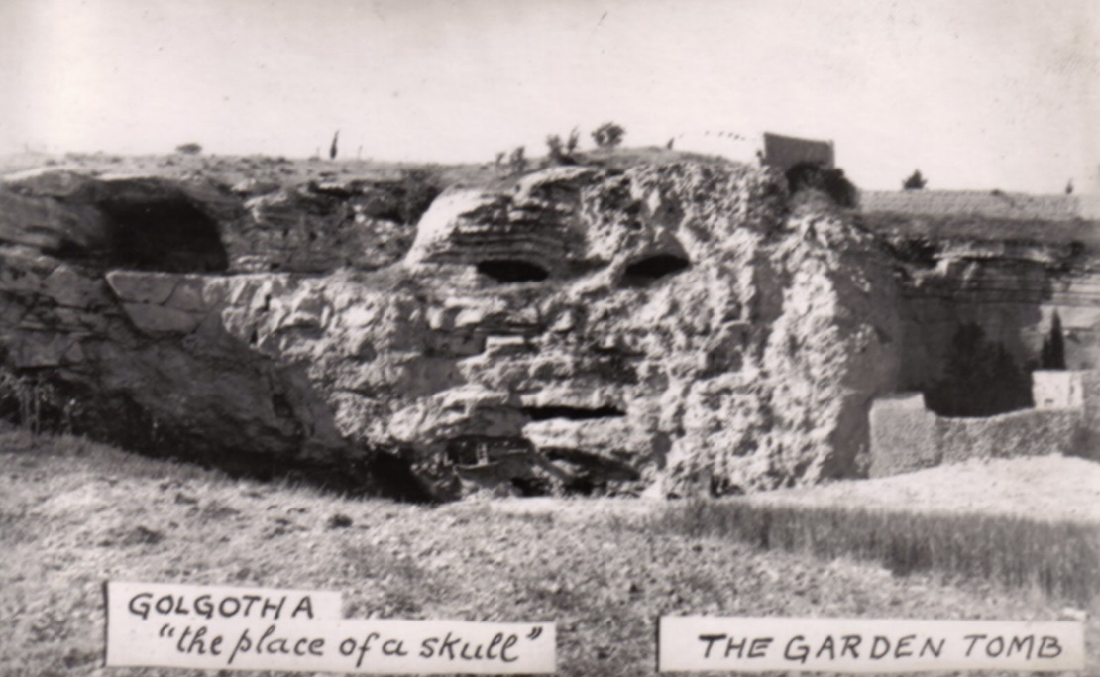
“The Place of The Skull” is a very strange natural rock formation with caves carved into it. It also has a very interesting history! The above photograph is from the turn of the century, before much of the presently existing structures were built. Below, is how it looks today! www.onug.us
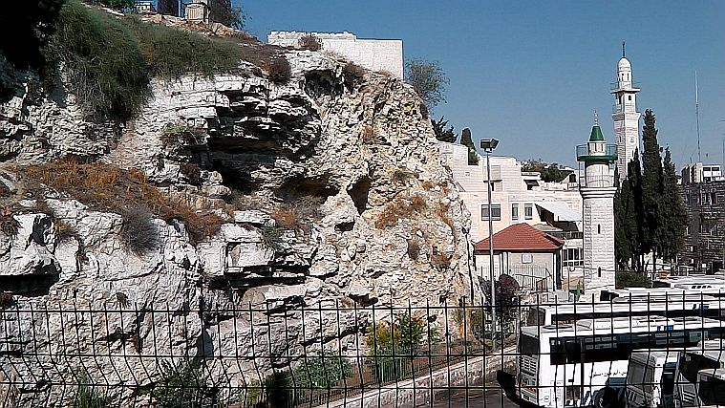
Calvary Today:
The location of Jesus Christ’s Crucifixion is known today as both Calvary (skull) and Golgotha (The Place of The Skull).
Not only Did David bury the Philistine’s head, outside the city, “Goliath of Gath”, “Gol- Gath”, “Golgotha”; which is CALLED (Pay CLOSE ATTENTION to the WORDS John uses in John 19:17) “The Place of The Skull”, which is called in Hebrew “Golgotha”!!! The Very Place ACTUALLY Resembles a Giant Human Skull (See the photos above)!!! Everyone in Jerusalem, at that time, knew this place was where David placed Goliath’s Head! That’s HOW it got it’s Name!!! www.onug.us
- The Late Latin word, Calvāria, where we get our modern word, Calvary from; literally means skull.
- The Greek word, κρανίον (kran-ee-on), translated as Cranium, means skull, or the head of a skeletal frame. Cranium, is commonly used in English today, as a medical term for skull. Golgatha in Greek today, means place of The Skull!
- The Modern Hebrew word, Gulgolet , means Skull (or Poll). It is derived from the English word Golgotha, meaning “The Place of The Skull” (or in Hebrew “Gulgolth”).
- The Aramaic word, Gulgaltha, has the same meaning as the Hebrew word “Gulgoleth” above (Place of The Skull).
It seems everybody, in the old days, knew where the Big, Giant, Head was! Now to Teach this Truth to today’s generation!!! www.onug.us
Counting Polls or Skulls?
Numbers 1:2, 1:18 / 1 Chronicles 23:3, 24 / 2 Kings 9:35
As you can see from the above scriptures, golgolet is used in the context of taking a census, or “a poll” by counting the "heads", "skulls", or “polls” - of the individuals over age twenty. By the time the first century rolled along, Poll (or skull) became Golgolet, and was called Golgotha in Greek; and became associated with an actual place where they counted people (or skulls – polls), as they entered Jerusalem from the Mount of Olives! In first-century Jerusalem, that place was “The Place of The Skull”!!!
Now YOU know why a voting place, is called a “polling” place or the polls! www.onug.us
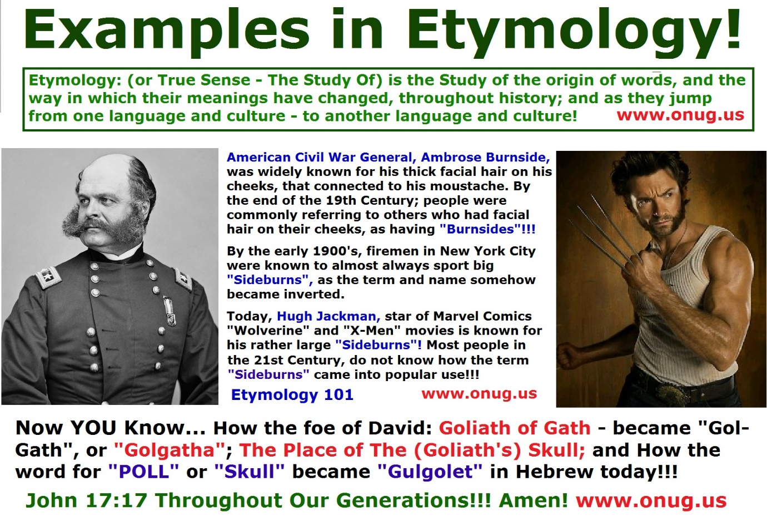
Golgotha was on, and bordered one of the major roads that led into Jerusalem. This place was a bottleneck for people coming into the city from the east, and so was a station point for the "counting of the skulls," or the "lifting up of the heads." It is also why the Romans crucified criminals at this location, to deter any who were coming into the city with nefarious intentions that this would be their destiny. This is another reason why it was called Golgotha; and this is why the Romans would write the Criminal charges, on the cross of a condemned man – not just for Jesus; BUT FOR ALL THAT HUNG ON THE CROSS – TO DETER THAT CRIME IN THE FUTURE (John 19:17-22)!!!
Jesus was NOT Crucified on top of Golgotha; but rather next to it – ALONG THE ROADWAY – So people passing by could MOCK, TAUNT, READ THE CHARGES OF EACH CONDEMNED POSTED BELOW THEIR FEET, and BE WARNED NOT TO COMIT THE SAME OFFENSE!!! www.onug.us
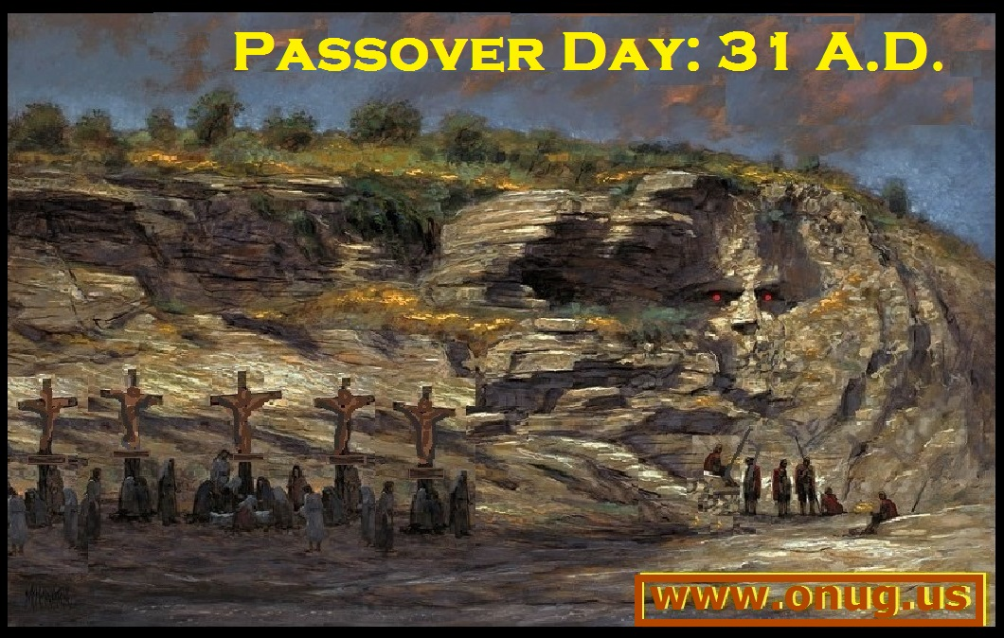
Those who were entering Jerusalem from the East had to pass right by Golgotha. It was a natural bottleneck, and would allow soldiers or officials, to climb up on the rocks, and look down on the road’s traffic, to monitor and count visitors to the city. The condemned were placed next to the roadway, so MANY people (John 19:20), as John would write; could read the charges or crimes of the dying men – posted on their crosses (Pilate would write extra, beyond the charge of “Malfactor” or Rebel for Jesus’ Cross).
- John 19:19 “put it on the cross”. This does NOT say WHERE on the cross it was posted!!!
- Matthew 27:36-37 “and SITTING DOWN they watched him there; and set up over His Head (His Poll) His Accusation written”.
A Charge or Accusation, directed at you, over you, or toward you – DOES NOT have to mean literally nailed to the cross ABOVE his Head; but that the charge was directed AT or OVER his head or poll! Have you ever heard the expression, “He has that hanging over his head”, in reference to a past sin or crime that someone else committed? The focus is on the head, skull, or poll; and the CHARGES levied at it (Isaiah 28:9-10 / 1 Thessalonians 5:21). www.onug.us
- Mark 15:26 “And the ‘superscription’ of His Accusation was written ‘over’ (or Pilate had OVERWRITTEN His Charge of Malfactor / Rebel with the additional: ‘The KING of The Jews!’, OVER the Original Charge! This in NO WAY says the sign with the charges was nailed to the cross above Jesus’ Head!!!
- Luke 23:38 “And a ‘Superscription’ ALSO (in addition to the Original charge of Malfactor) was written over Him (as pronouncing a charge or curse, Over or Against someone), in letters of Greek, and Latin, and Hebrew, ‘THIS IS THE KING OF THE JEWS!’”. Again, this DOES NOT say the sign was nailed or posted above Christ’s Head; only that it was pronounced over him – figuratively and legally!!! www.onug.us
Remember: Blessings and Curses in The Bible, are ascribed by placing hands on the Head (or Poll / Skull) of the person who is to receive them (Genesis 48:12-20 / Leviticus 1:4, 16:21 / 1 Corinthians 6:3 / Revelation 20:10)!!!
This is a great place to stop today! We will continue on next Sabbath, with Part Two of our Golgotha Bible Study!!!
We hope this Bible Study will make YOU PROVE or re-PROVE all the things you think you know about God, Jesus, and The Coming Kingdom of God – for God The Father’s Exceeding Great GLORY!!!
One Nation Under God Ministries www.onug.us
The First Century Church of God is still alive and well; and we are still about our Father’s Business! We would like to Thank You for joining One Nation Under God Ministries (www.onug.us) today in The Study of God’s Word! JOIN US Next Sabbath, as we continue to Learn Much More about The Place of Jesus Christ’s Crucifixion, and Manner of Death – that MOST indoctrinated by Mainstream Christianity, simply REFUSE to acknowledge and Accept! We do hope that you will continue to SHARE what you have Learned here, with others – at home, at work, and in your neighborhood (Matthew 28:18-20 / Mark 16:15-20)! May our Great God, Bless you and Keep you, until then – in Jesus’ Mighty Name!!!
- Submitted by Pastor R.C. Brown III
One Nation Under God Ministries is Preparing The Brides of Christ (Matthew 25:1-13), and this world (Mark 16:15-20), for The Return of Jesus (John 10:16); One Bible Study At A Time (Matthew 11:28-30)! Join Them!
JESUS IS LORD!!! www.onug.us
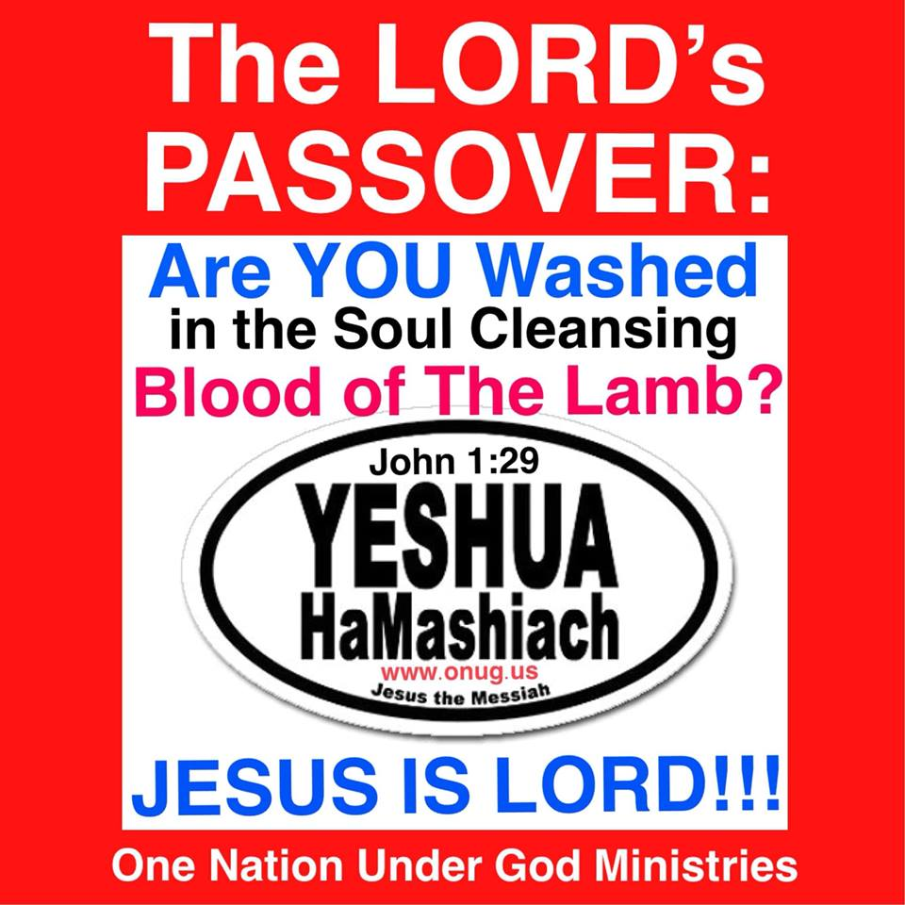
Learn How To KEEP The Lord’s Passover With Us This Year!
PRINT yourself a FREE Holy Day Calendar (below) and Never Again MISS One of God’s Holy Feast Days!!!
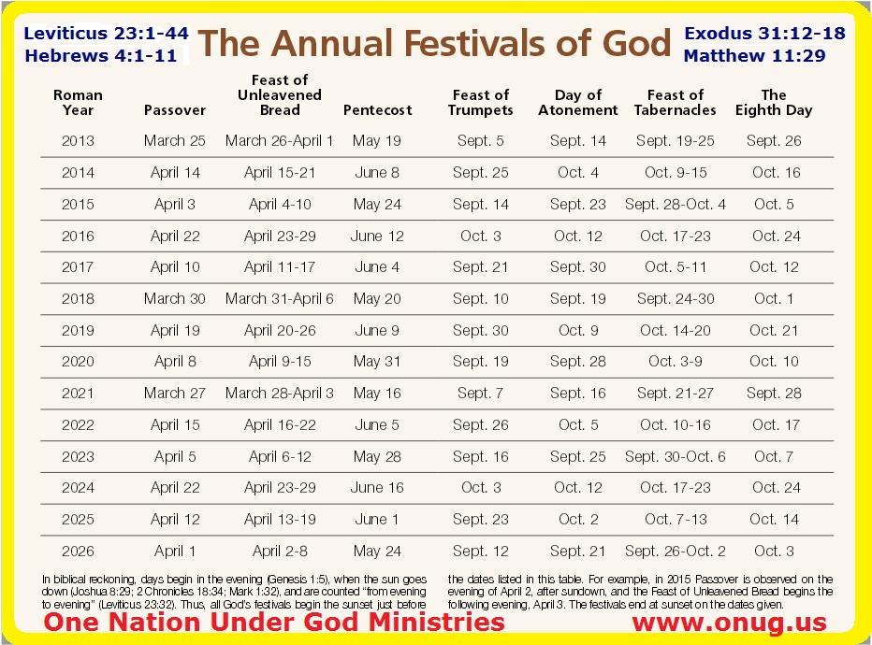
ONE NATION UNDER GOD MINISTRIES (WWW.ONUG.US), WHO WE ARE; HOW AND WHY WE TEACH AND PREACH:
”But ye believe not, because ye are NOT of My Sheep, as I Said unto you. My Sheep Hear My Voice, and I Know them, and they Follow Me: And I Give unto them Eternal Life; and they shall Never Perish, Neither shall any man pluck them out of My Hand!!! My Father, Who Gave them Me, is Greater than all; and no man is able to pluck them out of My Father's Hand!!! I and my Father are One” (John 10:26-30).
Christians must Learn to Read The Bible, interpret The Scriptures according to Biblical Principles (1 Thessalonians 5:21 / Isaiah 28:9-10 / Psalm 111:10), and begin to Apply The Precepts they Learn in their Walk with God. Individual Study is Essential; coupled with Fellowship times of Group Study, Worship, and discussions of personal insights and observations.
We strive, each Saturday, to foster an open and welcoming atmosphere where Spirit led confirmation, clarification, questions, and correction can be made, in the Fellowship of other students of God’s Word.
One Nation Under God Ministries (www.onug.us) is working to unify The Body of Christ in The Worship of God The Father, in The Way that Jesus Showed us to - in Spirit and in Truth!
Rediscover Biblical and American History, and Help us Renew, in this Generation, The Vision and The Covenant of our Founding Fathers (Isaiah 33:22 / Proverbs 22:6 / Psalm 33:12).
JesUSAves!!!
NEVER A COST - All of our Bible Studies, are mailed FREE, worldwide to anyone that asks! Just Call: (239) 877-8043
“And when He had Called unto Him His twelve disciples, He Gave them Power against unclean spirits, to cast them out, and to heal all manner of sickness and all manner of disease… And as ye go, Preach, saying, The Kingdom of Heaven is at hand. Heal the sick, Cleanse the lepers, Raise the dead, Cast out devils: freely ye have received, Freely Give. Provide neither gold, nor silver, nor brass in your purses, Nor scrip for your journey, neither two coats, neither shoes, nor yet staves: for the workman is worthy of his meat” – Jesus Christ (Matthew 10:1, 7-10).
PRISON MINISTRY - Help us SHARE The Good News of God’s Coming Kingdom with those who are not just physically bound, but are spiritually bound, as well!!! Do you know of an inmate in jail, or in prison, that needs The Refreshing, Hope-FULL, Word of God? Send us their name and address, and we will mail them our weekly Bible Studies - Free of cost or postage!!! www.onug.us
OPERATIONS - A Tremendous ‘Thank You’ to those of you who have partnered with us already, to help offset our Promotional Advertising, Internet Presence and Witnessing, Mailing/Printing Costs; and increase our ability to REACH those who are incarcerated with The Good News of God’s Coming Kingdom! (Matthew 25:31-46)!!!
Have YOU Been BLESSED by These Studies of The Word of God? IF SO, Prayerfully consider JOINING US, so that we can make an EVEN GREATER IMPACT in this world, BEFORE The Return of Jesus Christ! Just Call Us at: (239) 877-8043
TITHES, OFFERINGS, & DONATIONS – We THANK and Gratefully Acknowledge THOSE LED BY GOD, who Support this Ministry Financially! We PRAY Daily, for all of YOU who continue to support this work; and also for the Many to whom God’s Word will be sent – through YOUR Generous Assistance! Please PRAY With Us, And For Us!!!
THANK YOU - THANK YOU - THANK YOU - THANK YOU!!! .
For More Information on what The Bible Says about YOUR Tithes and Offerings in Christ’s New Testament Church, Read our Excellent Bible Study about The Truth About Tithing, at: www.onug.us
Wherever YOU Attend Church; Learning to STOP Robbing God, is An ESSENTIAL Part of YOUR Preparation for Christ’s Second Coming (Malachi 3:8)!!!
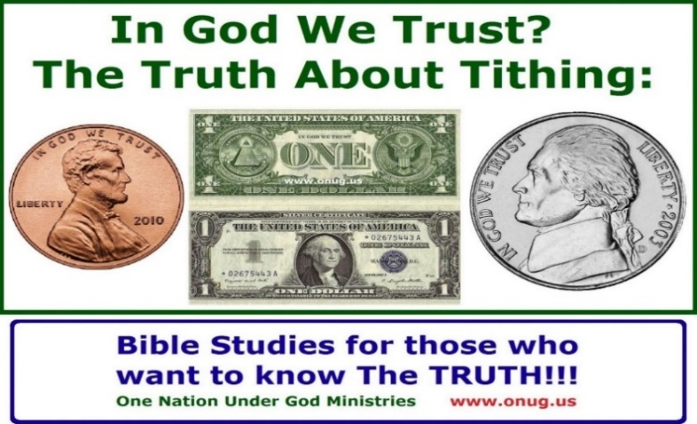
.If YOU Would Like to Donate to this Ministry:. Simply visit our website at: www.onug.us, then just Click the DONATE Button! ---THANK YOU SO MUCH!!!--- - YOU can also make your Checks/Money Orders Payable to: One Nation Under God Ministries - We also accept all of the world’s Paper Currencies, all of which can be mailed to us at: 211 19th Street N.W., Naples, Florida 34120, U.S.A.
If you would like to help us in our efforts to Breed, Raise, and Teach the world about these Gentle Giants and The Coming Kingdom of God (Isaiah 11:6-9), we would gladly accept Your Help! You can Donate online at www.onug.us, or mail a check or money order to us at: One Nation Under God Ministries (Attn: Aldabra Park), 211 19th Street N.W., Naples, Florida, 34120 U.S.A.
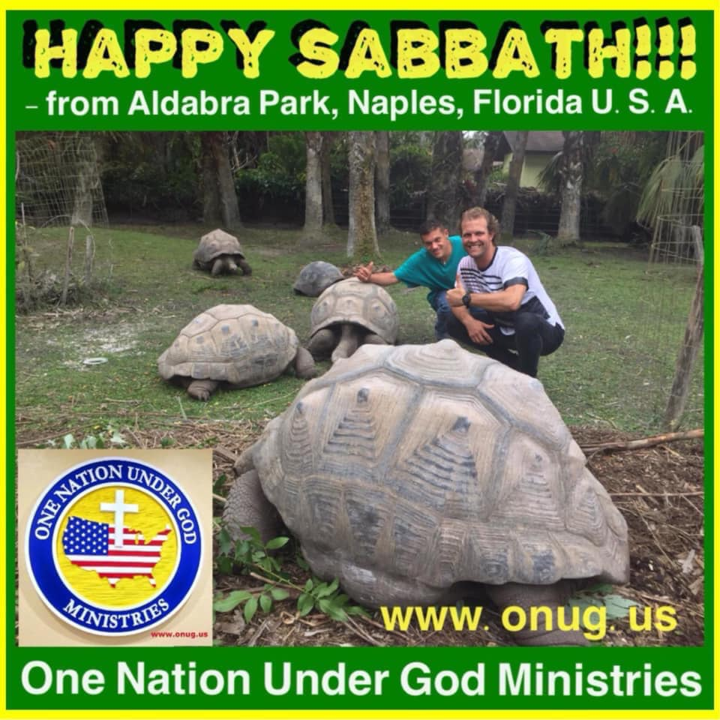
.HURRICANE IAN UPDATE (As of April 2023):.
God’s Hand Protected Us from the worst of this category 4 storm!!! DAMAGES: 1) Our two central air conditioning units were heavily damaged and must be replaced, 2) there is some structural damage to our chimney, 3) rain gutters must be repaired, 4) both garage doors must be replaced, 5) several perimeter fences and main gates must be replaced; 6) several trees have fallen and must be cut up, 7) there is a massive debris field that must be removed from the grounds. IF YOU WOULD LIKE TO MAKE A DONATION TO HELP WITH OUR HURRICANE REPAIRS AND RECOVERY, PLEASE ATTACH A NOTE TO YOUR DONATION (Attn: Hurricane Ian Relief). THANK YOU SO MUCH!!!
To God The Father’s Very Great Glory; In Jesus Christ’s Mighty Name! One Nation Under God Ministries JESUS IS LORD!!!
NOTES:

One Nation Under God Ministries www.onug.us 211 19th Street N.W., Naples, Florida 34120 U.S.A. Telephone: (239) 877-8043 JESUS IS LORD!!!

