BETTER WORK PROGRAM APPLICATION

Better Work tasks do not require any specialized training or the use of hazardous equipment or materials. Work sites are selected by the City of Sierra Vista and tasks may include collecting litter and light land scaping. The sites selected are City owned property and State Trust land. At the end of the workday, participants are returned to the pick-up site at Catholic Community Services of Southern Arizona (CCSSA) DBA Good Neighbor Alliance, where they have access to showers, clean clothing, and a meal.
Better Work Requirements:
1. Must meet very low, or extremely low-income requirements listed below:
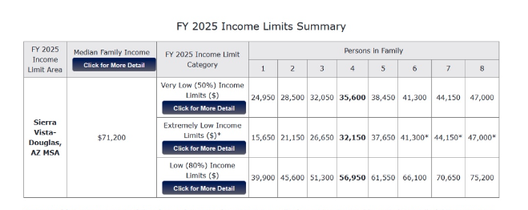
2. Must inform Better Work of any health issues that would prevent them from completing assigned tasks or participation in the Better Work Program.
3. Must apply or possess a valid State ID, assistance is available to obtain an ID.
4. Complete the Better Work application.

Participant information :

Name: _________________________ ____________ _______________________________________
First Middle Initial Last

Date of Birth: ________/________/__________ Phone Number: ______ ________-_____________
Month Day Year

Do you have a Social Security Number (SSN)? If so please provide: _________________________
Will you need temporary kennel services for your pet if selected for Better Works?
Gender: Male___________Female____________Trans____________Refused__________
Are you a veteran?___________
Where are you living? (Check all that apply)
Shelter______ Home_______Hotel/Motel______ Outdoors_______ Friends______ Vehicle_______ Other_______ with voucher

Emergency contact information: Name__________________ phone# ______________________
Criminal History background checks will not be done.

_____________________________________ ____________________
Participant Signature Date

Better Work Program Orientation and Expectations
Due to the nature of the work, participants will be required to be able to perform specific physical tasks. The supervisor will decide whether persons are able to perform the work assignment for the day. You are required to follow the standards listed below while participating in the Better Work Program.
- Appropriate work attire is required. Close toed shoes, long pants, and shirt.

- Do not bring any type of knife/weapon to the work site.

- First aid kit will be carried out to the work site. Participants are required to report all injuries to
the supervisor.

- Restroom facilities will be limited. Please use the facilities prior to departure. If the need arises reasonable accommodations will be made.

- Sunscreen is available upon request.

- Please refrain from using electronic devices, except on breaks.

- Any requests for shelter the same night will be relayed to the appropriate service provider on your behalf.

- NO drinking alcohol or drug use is allowed on the crew.

- The day is concluded and pay distributed once we return to the point of pick up.

- At the beginning of the workday the supervisor will demonstrate the tasks for the day and explain safety precautions.

____________________________________ ____________________________________
Print Name Signature

Date: ________________________
Liability Waiver:
I agree to participate in the Better Work Program and to release, waive, discharge, and covenant not to sue, and agree to hold Better Bucks of Sierra Vista, a non-profit organization, its trustees, officers, and employees from and against any and all liabilities, demands, claims, or injuries, including death, that I may sustain during or in conjunction with the activity. I agree that my safety is primarily my own responsibility. I agree to make sure that I know how to safely participate in the Better Work Program, and I agree to observe any rules and practices that may be employed to minimize the risk of injury. I agree to stop and seek assistance if I do not believe I can safely continue, to limit my participation to reflect my personal fitness level and to refrain from all actions that would pose a hazard to myself or others.

_______________________________ _____________
Participant Signature. Date

______________________________
Printed Name of Participant

_________________________________. __________
Better Bucks of Sierra Vista Date
Authorized Signature

Health Questionnaire:
Name: _______________________________________ Date of Birth_____________________
Please think about your health. Please circle one answer only.
In general, how would you rate your overall health? Good Fair Poor
Do you have any serious health or medical conditions that prevent you from meeting expectations? Yes No

When was the last time you saw a doctor? _____________________________
Is there anything about your health that presents a challenge for you to work? Yes No
If YES, please explain. ___________________________________________________________________
Do you have an active health care plan? Yes No __________________________
Name of Health Care Plan

____________________________________ ________________________________
Participant Signature Better Bucks Authorized Signature

Administrative Section :

Waiver Signed: Yes No
Health Questionnaire Competed Yes No
Orientation form signed: Yes No

Approved for Better Work Program Yes No

Date Received: ___________________________ Reviewed By: ________________________________

