 |  | 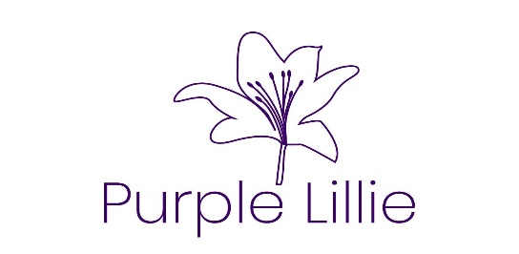

Educational Support Services

Purple Lille, LLC  August 18, 2020  Created by C. Everett, MBA | P: 734-252-6031  E: purplelillie@ceverettenterprises.org  W: https://www.ceverettenterprises.org

About Us

Purple Lillie, LLC was formed, as an extension of C. Everett Enterprises, in August 2020 by Catherine L. Everett, MBA. The company name is in honor of Catherine’s grandmother Lillie Bolden, who passed away in 2019 at the age of 95. The color purple is a symbol of royalty, nobility, and power; while the name Lillie means pure, passion, and rebirth. It is with Power and Passion that Purple Lillie, LLC will serve. It is the mission of Purple Lillie, LLC to be a leader in educational support services in the Detroit area for individuals and corporations using a holistic approach. Services include virtual private tutoring, parental support and resources, and corporate training events.

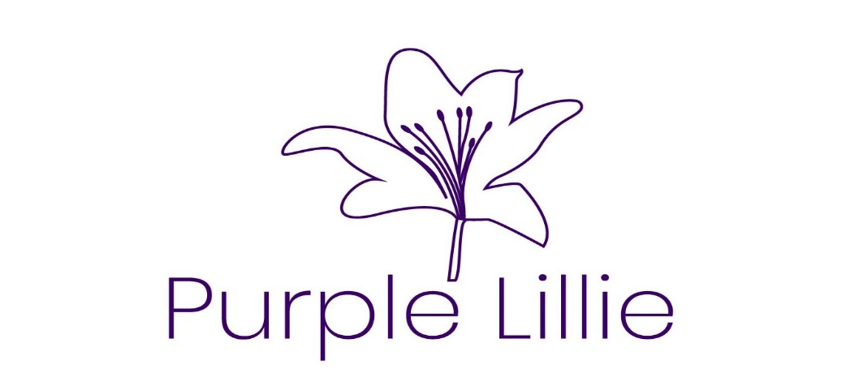
Virtual Private Tutor  What does virtual tutoring look like? At initial contact, you will be asked questions regarding your specific needs. An Individual Learning Plan will be created from this information. You control the scheduling according to your needs. If there are materials that will be beneficial, other than school provided materials, they will be provided at no additional cost. We will ship or email the materials to you. We use the Zoom or Google Meet platforms and Google Classroom.  Corporate Training  We will gladly meet with your company to devise a training program for your employees to implement new procedures or just build teamwork skills. Please contact us for more information. | A typical session is one to two hours. All sessions have the following format, only the time span of each may change:  - Greeting  - Meditation (Focus)  - Review  - Lesson  - Practice  - Next Steps / Closing  Parents are welcome to join the conference and all sessions are secured with ID and Passcode requirements.  Scheduling and Pricing are available at  https://ceverettenterprises.org/purple-lillie

The power of education extends beyond the development of skills we need for economic success. It can contribute to nation-building and reconciliation.
~ Nelson Mandela

Holistic Approach
We believe learning is a product of the brain and body working together. It has been scientifically proven that the mind-body connection helps us learn and retain information. We will focus on learning to learn as well as practicing concepts for specific subjects through breathing exercises, skills practice, and other learning techniques. We have seasoned, professional educators review our Individual Learning Plans, our material, and our processes regularly.

For our corporate clients, we offer a personalized, professional experience that also uses the mind-body connection. We work with you to develop a dynamic, interactive experience for your employees. We take care of the subject matter expertise, if needed, and supply all materials (included in package cost). All you have to do is make contact and after an in-depth interview, we will take care of the rest.
Goals*
We set SMART goals together at our first meeting and document them in the student’s Individual Learning Plan and track progress.
Reporting*
We provide our students with a detailed report on their progress and celebrate all victories.
Growth Mindset*
We employ growth mindset thinking where we encourage our students to believe that their most basic abilities can be developed through dedication and hard work—brains and talent are just the starting point.
*Purple Lillie Private Tutoring Services Only.

