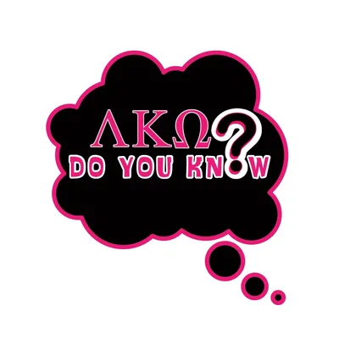

Test your Expansion Knowledge

Growth or increase in size or scope __________________________________
A structure with only one division or unit _________________________________
A system made up of multiple grouped units _____________________________
VP of Expansion _______________________________
To link or bring together ________________________________
To enlist or bring in new members ____________________________________
A group sharing common values or location __________________________________
Director of Expansion __________________________________
The state of being a member _______________________________
Keeping members engaged over time _________________________________
The process of attracting new members ____________________________________
The process of admitting new members ____________________________________

Word bank
Expansion, Retention, Intake, Single Chapter, Cluster Chapter, Katisa, Arvionka, Community, Recruit, Membership, Recruitment, Intake, Connect

