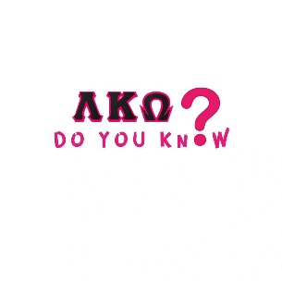

Did You Know Operations Quiz
When a problem accours at hand, we go by the proper chain of command.
Answer the questions below to test your Knowlegde

1.What are the steps a member take when following the proper chain of Command?
Member reports issue to _____________________, If the issue can’t be resolved, then she reports to ________________________, if issue still not resolved she will then send it over to her ____________________. If the issue continue to happen, it goes to her lead which is _______________________, if the issue stiil at hand who does it goes to? _______________________________ If this person has to furthur assist the issue, who will finailze the issue? _______________________.

Answer Choice:
Founders Operations Regional President
National President Regional Director Regional Lead
Vice President Coummunication Expansion
Chapter President Sgt At Arms Social Engagment

