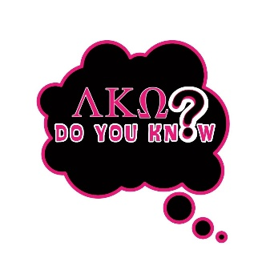
Did You Know Operations Word Scramble

Name: ___________________________________________________________________
1. COMIIUTNNMOCA _______________________________
2.ANCCOIPEML ____________________________________
3.GNNEAGETEM ___________________________________
4.ASONXPIEN ____________________________________
5. ICNNEFA _______________________________________
6. TI _____________________________________________
7. AEKRNTMIG _____________________________________
8. BMMESRPEIH ____________________________________
9. RNCINIEMAGSDH ________________________________
10. SOIAPOTERN ___________________________________
11. RTNEEPDSI _____________________________________
12. RRRICEUET _____________________________________
13. YTOHU SIERVESC ________________________________

