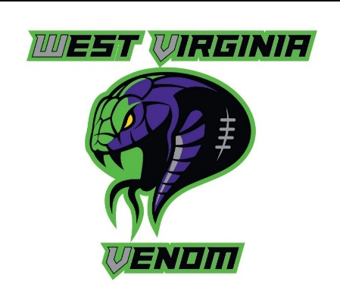

SPONSORSHIP REQUEST FORM
WV Venom youth football is a non-profit football organization comprised of kids from the tri-county area. Our team currently consists of a 7U, 9U, 11U, and 13U team that will be heading to The Battle in Rocky Top in Tennessee. In order to keep the costs for our parents reasonable we are looking for sponsors within our community to make this experience possible for our players. Your generous donation will assist our players and their families with travel fees, equipment, uniforms, tournament fees, and opportunities for the kids who do not have the means. WV Venom is dedicated to building a family environment for our players by providing them with opportunities to learn and love the game of football; as well as, achieving their dreams through personal development and personalized coaching.

Sponsor Name: _______________________________________________

Contact Person(s):_____________________________________________
$75 Sponsor ________
$100 Sponsor ________
$125 Sponsor ________
$150 Sponsor ________
$200 Sponsor ________
Age group being sponsored: 7U ____ 9U _____ 11U ______ 13U ______
Make checks payable to: WV Venom Tax ID #: 83 - 1796705
The sponsors will receive a plaque at the end of the season and their company will be advertised on our website and Facebook page.

