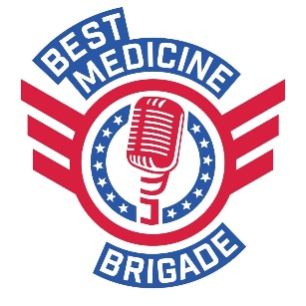
Best Medicine Brigade Application

Name :
Stage Name:

Applying to be considered for:
______Best Medicine Brigade: Must be a comedian that meets at least one of the following Criteria:
- currently serves in U.S. military
- Veteran
- Military Spouse (or former military spouse)
- Child of a military service member or veteran

Military affiliation: _______________________________ (branch of service, mil spouse, etc)
Years Served___________________________

OR
_____Best Medicine Brigade Auxiliary: For all comedians that do not qualify for the above, but believe in supporting our U.S Servicemen and women and our veterans.

City Residing In____________________State________________________
Website:_________________________________________________________
Contact info:
Phone # :
Primary Contact email_______________________________________________________________
IG:
Facebook: YouTube:
Twitter:
Other social:

How many years have you been doing comedy?

What types of opportunities are you seeking:
_____Opener (5-10 minute spots)
________ Feature (10-25 minute spots)
________ Headliner (30-60 minute spots)

How would you describe your material?
_________Church Clean
_________ PG
_________ PG-13
__________ R

Are you able to perform at least 10 solid minutes of PG-13 material?

List some of your comedy performance venues and role (host, guest spot, open mic, feature, headliner):

Have you taken any comedy courses or training? If so, please list:

Are you willing to travel for gigs? If so, any limitations?

Do you have the desire and/or ability to do virtual comedy?

Short Bio:

Sign below that you understand the following:
- This application does not guarantee performance spots in Best Medicine Brigade shows. You will be considered, but nothing is guaranteed.
- The Best Medicine Brigade brand prides itself on producing consistent, PG-13 shows. Content restrictions are not your call, they are the producer’s call. You are not allowed to say the following words in your set: Ni&$er, Pussy, Cunt, F%^k, God Damn It, and Jesus Christ (in vain). Keep in mind, we are typically a NOT “church” clean show. You can be edgy and use sexual innuendos. The following words are allowed: Bitch, Shit, Damn, AF, “F”, etc.
- We only consider comedians who have at least one year of experience, auditioned in person or have submitted a video.
- A good, professional headshot is required to get paid gigs. If you are not at the point where you have headshots, a website (or something similar like a press kit, gigsalad/bash account, then you are probably not ready for Best Medicine Brigade. We are looking for professional, experienced comedians. We do offer open mics monthly, free coaching, and sometimes will give a 5-minute guest spot to beginners. Meaning, you can still be a part of BMB without being in the que for paid spots.

Sign______________________________________________
Date____________________________________

