**Now Reopening**

**Dear Players, Members and Parents:**

In readiness for Opening and resumption of play.

ALL students can contact us to book schedule for private lessons.

**The summer trainings will start on July 6**, more summer training details will come out.

[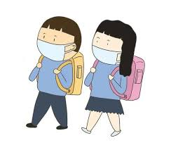](https://www.google.com/url?sa=i&url=http%3A%2F%2Fwww.kaimalo.com%2Fimg%2F8adc8afbca6ccbdc4c5b6d5dadfb7f4b2aab1a0d.html&psig=AOvVaw0o-Tow8HmQfMSV664oFYNN&ust=1592658343203000&source=images&cd=vfe&ved=0CAIQjRxqFwoTCIilzv74jeoCFQAAAAAdAAAAABAS) **For Trainings:**

❤If your child is sick, keep them home!

We can always reschedule and accommodate as long as you inform as ahead of time.

❤Parents who are dropping off and picking up their kids have to be on time and if parents have to come in. They need to wear Masks.

❤Management can also REQUEST parents/Guardians to leave and just to drop off and pick up if the Gym occupancy is deemed full.

❤If you book a private lesson or Group class, please arrive on time, can enter the venue 5 minutes in advance to prepare. When your class ends please try to leave Gym within 15 minutes.

❤Juniors also advised to wear Masks and can take them off while training.

❤Players should keep safe distance among each other as well as their belongings including gym bag and shoes

 **For all the Players, Members:**

**STOP**

**Please stay home**

If you have the following symptoms temperature of **99.7F** and higher,

Sore throat, loss of taste, flu-like symptoms, cough and cold, diarrhea.

[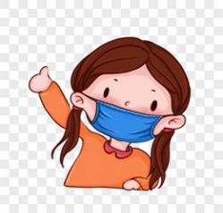](https://www.google.com/url?sa=i&url=https%3A%2F%2Fm.tukuppt.com%2Fsopng%2Fqban.html&psig=AOvVaw15drbSTrWHlr8uPjbymmWv&ust=1592614424803000&source=images&cd=vfe&ved=0CAIQjRxqFwoTCNiymKTVjOoCFQAAAAAdAAAAABAD) **MASKS**

Masks are required upon entering the facility. You will not be allowed in the Gym

Without a Masks. Masks can be taken off during play but must be worn again once off

the court and while waiting in-between games.

[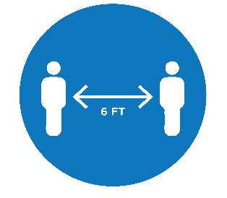](https://www.google.com/url?sa=i&url=https%3A%2F%2Fwww.cityofsanrafael.org%2Fstay-healthy-covid-19%2F&psig=AOvVaw2Qu7cp9H7mMawASDuqVvQR&ust=1592615151800000&source=images&cd=vfe&ved=0CAIQjRxqFwoTCODZ-PvXjOoCFQAAAAAdAAAAABAD) **SAFETY**

While waiting for your games, please observe social distancing on and off court.

Place your belongings apart and maintain distance between your belongings also.

[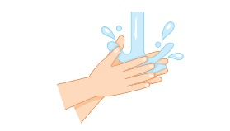](https://www.google.com/url?sa=i&url=https%3A%2F%2Fwww.nationaljewish.org%2Fpatients-visitors%2Fpatient-info%2Fimportant-updates%2Fcoronavirus-information-and-resources%2Fhealth-tips%2Fstop-germs-wash-your-hands&psig=AOvVaw0HqldbtIggpVgCEt2n4ZyT&ust=1592615309701000&source=images&cd=vfe&ved=0CAIQjRxqFwoTCNjH6dHYjOoCFQAAAAAdAAAAABAM) **Please wash your hands!**

We will provide limited amount of hand sanitizer due to limited availability. Please bring your own.