Doc# 2013159141, OR BK 16421 Page 2433, Number Pages: 42, Recorded 06/21/2013 at 12:16 PM, Ronnie Fussell CLERK CIRCUIT COURT DUVAL COUNTY RECORDING $358.50

Prepared by - Record and Return to:
Colony Cove Civic Association PO Box 11405
Jacksonville, Florida 32239-1405

AMENDMENT BY RESTATEMENT OF DECLARATION OF COVENANTS AND RESTRICTIONS FOR
COLONY COVE, DUVAL COUNTY, FLORIDA

This Amendment by Restatement of Declaration of Covenants and Restrictions made and recorded this 21st day of June, 2013, by the Colony Cove Civic Association, Inc, ("The Association"), Assignee of Wurn-Arlington Construction Company, Millan Builders, Inc., and Gene Whitehurst, inc., ("The Developer'') by assignment recorded in Official Records of Duval County, Florida, volume 6018, p.1104,

WITNESSETH

WHEREAS, the Developer in respect of certain real property situated in Duval County has heretofore filed among the public records of Duval County, Florida, certain Covenants and Restrictions (as hereinafter defined); and

WHEREAS, the Association, with authority derived through the Assignment from the Developer as set forth above, and the Owners desire to make certain amendments to the AMENDED, REVISED AND RESTATED COVENANTS AND
RESCRICTIONS stated Covenants and Restrictions in accordance with Paragraph 29 and 30 of the amended, revised and restated Covenants and Restrictions for COLONY COVE, DUVAL COUNTY, FLORIDA, recorded in volume 15703, pages 163 et seq. of the official records of Duval County, Florida; and

WHEREAS, the Association with respect to the amendments and complete restatement of the Covenants and Restrictions embodied herein has obtained the written consent of 146 Lot owners representing more than 75% of the 190 Lots in Colony Cove, as required in Article V, Section 5, of the CONSOLIDATION AND AMENDMENT OF BY RESTATEMENT OF DECLARATION OF COVENANTS AND RESTRICTIONS FOR COLONY COVE, DUVAL COUNTY, FLORIDA,
recorded in volume 15703, pages 163 et seq. of the official records of Duval County, Florida,

NOW, THEREFORE, the Owners and the Developer, through the initiative of the Association, do hereby amend, rename, and restate the Covenants and Restrictions so that from the Effective Date (as hereinafter defined), the real property described in Article II hereof is and shall be held, used, transferred, sold, conveyed, given, donated, leased and occupied subject to the covenants, restrictions, conditions, easements, and affirmative obligations set forth in this Declaration

1

TABLE OF CONTENTS COVENANTS AND RESTRICTIONS

STATEMENT OF AMENDMENT

ARTICLE I: DEFINITIONS ARTICLE II: PROPERTIES

Page

1

2

3

A: Procedures
- Approvals
ARTICLE III: RESTRICTIONS

4

- Actions without approvals

- Construction, Improvement and Repair
  - New Residence
  - Existing Structures 5
  - Repairs
  - Repairs - nonconforming structures
  - Construction by Association
B: NEW CONSTRUCTION 6
- Single Family Residence
- Minimum Square Footage - Principal Residence
  - 2000 square foot minimum
  - 2200 square footage two story
- No Garage Entrance to face street- No Carports
- Setbacks for all Structures
  - Interior lots
  - Riverfront lots
- Street Lamps
- Well Limitation - Water Supply 7
- Sewage Disposal
- No Overhead Wires
C: OTHERSTRUCTURES 8
- All Structures to be Approved
- Utility Yards 9
- Non Conforming Structures inside Utility Yard
- Non Conforming Structures outside Utility Yard
  - Detached structure
  - Air Conditioner Screened
- Hedges, Fences and Walls 10
  - Fence and Hedges defined
  - Fences specifically permitted if:
    - Built on rear lot line
    - Join side lot lines

  - Hedges, fences prohibited
    - Cannot exceed 4 feet
    - Parallel to street
    - Parallel to front of house
    - Enclosure front yard
    - Closeness to the right of way than 25 feet
    - Comer Lot setback
- Fences and walls prohibited
- Fences are prohibited
  - Posts location
  - Wire fences
  - No PVC or synthetic materials
- Fence types permitted with approval
  - Small landscape
  - Concealment or enclosure
  - Courtyards
- Signs 11
- For Rent or Sale
- Security devices
- Solicitation
- Mandated
- Warnings
- Short term
- Aerials, Satellite dishes and Solar Panels 12
- Garbage Receptacles
- Mail Boxes
- Window Air Conditioners 13
- Prohibited living quarters
- Easements
D: COMPLETION OF CONSTRUCTION OR IMPROVEMENTS WORK
E: NONCONFORMING USES AND STRUCTURES
- Exceptions 14
- Destruction
- Repairs and Maintenance
- Existing Violations

ARTICLE IV

ACTIVITIES ANDYARD MAINTENANCE 15

- Activities Prohibited

Trash
- Motorists' Vision
- Maintenance
a Structures

    - Yards and Landscaping
    - Notice
    - Uninhabited or abandoned properties
- Waterfront Properties 16
  - Lot and Bank maintained
  - Trash
  - Increased size or lot
  - New or repaired bulkheads
  - Docks perpendicular
- Trees 17
- Florida Friendly Landscaping
- Pets 18
- Vehicles, Boats and Objectionable Objects

ARTICLE V: ENFORCEMENT 19

- Notice and Preliminaries
- Ombudsman Procedure
- The Association May Correct Violations
- Summary Abatement of Violations or Uninhabited Properties
- Non Compliance and Imposition of Fines, Penalties or Assessments 20
- Association May Seek Judicial Relief

ARTICLE VI: GENERAL PROVISIONS 21
- Clarifications
- Amendments of Restrictions with Consent of Owners
- Effective Period 22
- Interpretation
- Choice of Law 23
- Notices
ARTICLE VII: MEMBERSHIP 24
- Membership - Dues
- Grandfather Clause

\

ARTICLE I: DEFINITIONS
The following words and terms when used in this Declaration (unless the context shall clearly indicate otherwise) shall have the following meanings herein:

- "Association" means Colony Cove Civic Association, Inc., a Florida nonprofit corporation, its successors and assigns. The Association is the assignee of the rights of the Developer of Colony Cove to enforce the Covenants. The Association, through its duly elected board, enforces the Covenants and Restrictions and Bylaws of Colony Cove.

- "Colony Cove" means any and all of the real property defined or described in Article II and Exhibit A relating thereto and as may be more particularly named and described in Exhibit B, both exhibits attached hereto.

- "Covenants and Restrictions" means the present Declaration, in the context of the following history of covenants and restrictions recorded among the public records of Duval County, Florida, as amended, all of which are hereby superseded:

- "Developer" means Wum-Arlington Construction Company, Millan Builders, Inc., and Gene Whitehurst, Inc., Colony Cove Civic Association, Florida Corporations, their successors and assigns.

- "Effective Date" means the date when this Declaration is recorded among the public records of Duval County, Florida.

- "Lot" means any residential subdivision lot within the defined area of Colony Cove, which is intended for use as a site for a single family detached dwelling established by a plat of any portion of the Properties recorded among the public records of Duval County, Florida.

- "Member" means a property owner('s) in Colony Cove that has paid all dues required in full, either voluntarily or as a new property owner after the recorded date of these new covenants and restrictions. Each vested parcel owner, after having paid such dues, shall be considered a member and may be counted as such with full voting privileges and any other rights which may be allowed a member in good standing.

- "Nonconforming Uses and Structures" refers to some structures or to some uses of property which, as of the Effective Date, are out of compliance with these requirements or prohibitions. Specifically, the term refers to those situations on Lots which would normally be violations, but which have been granted an exception or variance by the Developer or the Association, or which have been

2

adjudicated in favor of the owner, and it also refers to situations which have passed the applicable statute of limitations so that legal enforcement has become impossible. However, the term does not apply to existing violations known or unknown to the Association which do not meet one of the criteria specified in the preceding sentence.

(h-1) "Nonconforming Uses and Structures - Utility Yard" is an Association approved area not to exceed 6 feet in height or dimensions exceeding 10 feet by 10 feet, which must be attached to the rear of the residence but must conform to location and setbacks as described or defined in Article 111, Restrictions.

(h-2) "Nonconforming Uses - Any Detached Utility Yard" must be approved by the Association. Such detached utility yard must be in an approved area and may not exceed 3 feet in height nor dimensions exceeding those approved by the Association. It is to be to the rear of the residence and is not attached thereto, but must conform to location and setbacks as described in Article 111, Restrictions

(i) "Owner" means the owner of a Lot in Colony Cove, as shown by the public records of Duval County, Florida, whether it be one or more persons, firms, associations, corporations, or other legal entities in whom is vested fee simple title to any Lot, but shall not mean the holder of any mortgage or lien encumbering a Lot unless and until such holder has acquired title by foreclosure or otherwise; nor shall the term "Owner" mean any lessee or tenant of an Owner. To the extent necessary for determination of any right or responsibility herein, any named person or corporation in the title shall have the right and power to act as the owner of the property and each and every person or corporation shall be personally responsible, jointly and severally with the other owners, for duties and responsibilities, including financial responsibilities, contained herein.

- "Properties" means the land described in Article II of this Declaration and any additions thereto, as are subjected to Declaration under the provisions of Article II.

. (k) "Violation" A breach or non compliance with any rule or regulation contained in the Covenants and Restrictions and By Laws that govern Colony Cove. Such violation could, if not corrected, lead to a penalty, fine or judgment against the parcel or owner determined judicially or otherwise to be in violation.

ARTICLE II: PROPERTIES

The real property which is and shall be held, used, transferred, sold, conveyed,

3

given, donated, leased, and occupied subject to this Declaration and the covenants and restrictions contained herein is described in Exhibit A and those parcel owners identified in Exhibit B attached hereto and made a part hereof.

ARTICLE Ill: RESTRICTIONS A: PROCEDURES

Manner of Requesting Approval

Wherever in these covenants and restrictions the consent or approval of the Association is required to be obtained, no action requiring such consent or approval shall be commenced or undertaken until after a request in writing seeking the same has been submitted to and approval received in writing from the board of the Association. The Association shall promptly reply to each request, but may require additional information before making a decision. The board for the Association meets once monthly to consider the business of Colony Cove. Consideration for such request or consent of approval should be observed under that schedule.

The Board of the Association must approve all requests in writing, which may include electronic communications, provided that a permanent copy may be preserved. No individual officer, including the President of the Association, shall have the power to waive compliance with any provision herein, nor to grant a variance.

Actions Taken Without Approval

Any action taken by the Owner without the written permission of the Association, acting through the entire Board or the Covenants and Restrictions Committee is at risk of being disapproved and the action corrected as required. Neither expense nor inconvenience shall be a defense to actions taken without prior authorization.

Construction, Improvement, and Repair of Structures

For the purpose of further ensuring the development and continuation of the Properties as a residential community of highest quality and standards, the Association reserves the exclusive right to control and approve all of the residences, buildings, structures, and other improvements on each Lot in the manner and to the extent set forth herein.

    - No new residence shall be commenced, placed, erected, or allowed to remain on any Lot until building plans for the main building residence have been

4

I

submitted to and approved by the Association in writing. For the main building residence, the Association shall have the right to review building plans to ensure compliance with all covenants and restrictions herein provided.

    - In order that all improvements or proposed structures on each Lot containing an existing residence shall present an aesthetically attractive and pleasing appearance from all sides of view, no new building, playground equipment, swing set, sporting equipment, fence, wall, driveway, swimming pool, barbeque or other structure or improvement, regardless of size, function and purpose, whether attached to or detached from the main residence, shall be
- commenced, placed, erected, or allowed to remain on any Lot, nor shall any additions to or changes made to the exterior or alterations thereto be made, unless and until approved in writing by the Association after they have been provided with and reviewed a complete description, plan, specifications, location, the nature, kind, shape, height, size, materials, floor plans, exterior color schemes, land orientation on the Lot, approximate square footage, construction schedule, and such other information as the Association shall require, including, if so required, plans for the grading and landscaping of the Lot showing any changes proposed to be made in the elevation or surface contours of the Land. The Association shall act thereon in a reasonable time. The Association shall have the right to refuse to approve any such building plans and specifications and Lot-grading and landscaping plans which are not suitable or desirable in its opinion for any reason, including purely aesthetic reasons. In passing upon such building plans and specifications and Lot-grading and landscaping plans, the Association may take into consideration the suitability and desirability of proposed construction and of the materials of which it is proposed to erect the same, the quality of the proposed workmanship and materials proposed to be used as the Association shall specify or require.

    - Repairs or improvements may be made to existing approved structures only with the written approval of the association. Cosmetic or minor repairs, providing there is no change in the appearance, nature, style, composition or materials may be made without submitting plans to the Association._ If a repair project includes a change of any of the foregoing, plans must be submitted to the Association as specified above for written approval.

    - Repairs to nonconforming structures are controlled by Article 111, Section E.

    - No construction by the Association or other actions shall be deemed to be in violation of these covenants and restrictions, and to the extent that the Association takes any action, it shall be construed as being in compliance with, not subject to, or a permitted variance from, any provision herein.

5

B: NEW CONSTRUCTION

- Single Family Residence Only: Two Stories Limit

No structure shall be erected, altered, or permitted to remain on any Lot other than for use as a single family residence without the prior approval of the Association in writing. The height of the main residence on each Lot shall be not more than two (2) full stories above the normal surface of the ground.

Minimum Square Footage For Any Principal Residence

  - No one-story residence shall be erected or allowed to remain on any ·Lot unless the square foot area thereof, exclusive of screened porches, garages, and storage rooms, shall equal or exceed 2,000 square feet.

  - No one and one-half story residence, no split-level residence and no two-story residence shall be erected or allowed to remain on any Lot unless the square foot area thereof, exclusive of screened porches, garages and storage rooms, shall equal or exceed 2,200 square feet.

No Garage Entrance to Face Street No Carports

All residences shall have a garage with a capacity for at least two (2) automobiles. Garages shall be so located that doors and entrances thereto shall not face any street or way on which the Lot abuts. No carports shall be built on any Lot.

Setback For All Structures

  - No building or any type or kind of permanent structure (except drives and walks) or any part of any of same, shall be erected, placed or allowed in the area of any Lot lying between the front building restriction line of 25 feet and the street on which the Lot abuts; or nearer than seven and one-half feet to any interior side line nor nearer than ten feet to any interior side line of any Lot.

  - No building or any type or kind of permanent structure shall be placed on any river front Lot nearer than 40 feet to the back Lot line or existing bulkhead, except for docks, swimming pools, and required swimming pool enclosures, which latter shall comply with paragraph (a) above.

Street Lamps

The builder has provided street lamps from time to time on lots and parcels herein. Said street lamps are and will remain the property of the owner of said

6

lots and parcels. The entire installation was by each builder, and the owner shall from time to time be responsible for the maintenance, operation, safety, repair and replacement of the entire unit (excluding street markers and their mounting brackets attached thereto from time to time. The number and location placement of said lamps shall be at the complete discretion of The Association. No other street or carriage lamp of any type or style shall be placed or allowed in the area of any lot lying between front building restrictions line of 25 feet and the access way or ways of which the lot abuts, except installations not extending more than 2 feet above the normal surface of the ground.

- Well Limitation: Water Supply

The central water supply system, provided by the Jacksonville Electric Authority, its successors or assigns, for service to the Properties, shall be used as the primary source of water for all water spigots and outlets located within all buildings and improvements located on each Lot, and each Owner, at his expense, shall connect his water lines to the water distribution main provided to serve that Owner's Lot and shall pay water meter charges established or approved by the appropriate regulatory authority. Individual water supply system, or well, shall be permitted to supply water for use on the Lot for air-conditioning, heating and irrigation purposes, swimming pools or other exterior use. All pumps shall be located on the side or rear yard, unless, in the discretion of the Association, and only with its written approval, such positioning is made impracticable due to the positioning of the Lot. All pumps shall be adequately or ornamentally screened so as not to be visible from the street.

Sewage Disposal

Each Owner, at his expense, shall connect his sewage disposal line to the sewage collection line provided to serve that Owner's Lot so as to comply with the requirements of such sewage collection and disposal service of Jacksonville Electric Authority, its successors or assigns. No septic tank or other private sewage disposal unit shall be installed or maintained on any Lots and no sewage shall be discharged onto the open ground or into any river, marsh, pond, creek, park, ravine, drainage ditch, or canal access way.

No Overhead Wires

All telephone, electric, cable television or other utility lines and connections between the main utility lines and the residence and other buildings located on each Lot shall be concealed and located underground so as not to be visible. Electric service is provided by the City of Jacksonville, Florida, through underground primary service lines running to transformers. The Association shall have no responsibility or liability for the maintenance, operation, safety, repair, or replacement of any electrical system serving any improvements on a Lot.

7

C: OTHER STRUCTURES

- ALL STRUCTURES TO BE APPROVED BY THE ASSOCIATION

For the purpose of further insuring and maintaining said land as a residential area of highest quality, and standards, and in order that all improvements on each lot and parcel shall present an attractive and astatically pleasing appearance from all sides of view, The Association reserves the exclusive power and discretion to control and approve all buildings, structures and other improvements on each lot or parcel in the manner and to the extent set forth herein. No new residence, structure or building, including but not limited to, fence, wall, utility yard, driveway, swimming pool, playground equipment, swing set, sporting equipment, basketball hoop (permanent or portable), netting for sport activities, trampoline, or other structure or improvement, regardless of location, size or purpose, whether attached to or detached from the main residence, shall be commenced, placed, erected or allowed to remain on any lot, nor shall any addition to or exterior change or alteration or modification thereto be made unless and until building plans and specifications covering same showing the nature, kind, use, shape, height, size, materials, floor plans, exterior color schemes, location and orientation on the lot. Resident shall provide square footage, construction schedule, and such other information as The Association shall require, including, if so required, plans for the grading and landscaping of the lot or parcel showing any changes proposed to be made in the elevation or surface contours of the land have been submitted to and approved in writing by The Association. The Association shall have the absolute and exclusive right to refuse to approve any such building plans and specifications and lot-grading and landscaping plans which are not suitable or desirable in its opinion for any reason, including purely aesthetic reasons and reasons connected with future development plans of The Association of said land or contiguous lands. In passing upon such building plans and specifications and lot-grading and landscaping plans, the Association may take into consideration the suitability and desirability of the proposed constructions and of the materials of which the same are proposed to be built to the building plot upon which is proposed to erect the same, the quality of the proposed workmanship and materials, the harmony of external design and the surrounding neighborhood and existing structures therein, and the effect and appearance of such constructions as viewed from neighboring properties. In addition, there shall be submitted to The Association for approval such samples of building materials proposed to be used as The Association shall specify and require. Also, changes or modifications of any type during construction shall be submitted to the Association for review and approval by the Association using the same methods incorporated herein above. When not in use, movable or portable equipment will be in the back yard of the property, not visible from the street. No equipment, temporary or permanent shall be placed with its back to a property line.

8

UTILITY YARDS - ATTACHED TO RESIDENCE

An attached utility yard shall be described as an area not to exceed 1O feet by 1O feet, be no taller than six (6) feet, attached to the rear of a residence and bounded on either side by the line running parallel to the outside edges of the residence. Construction of a utility yard must be submitted to the Association in writing with approval delivered and received prior to construction.

NON CONFORMING STRUCTURES INSIDE UTILITY YARD

After plans for design, location, proposed use and materials to be used have been submitted to the Association for approval and written approval delivered and received, any detached outbuilding may be erected and maintained wholly within a utility yard, but, any part of which extends above the tip of a utility yard fence or enclosing shall be subject to approval of the Association. The following buildings, structures and objects, may be erected and maintained within a utility yard on any lot providing they are wholly within and the height does not extend over the walls of such utility yard: Pens, houses for pets, above-ground storage of construction materials, wood, trash cans, garbage or recycle cans, or installations in connection therewith. The Association may require appropriate concealment measures. Any repairs, modifications, visual changes, replacement, alterations or different use there of must be submitted to the Association in writing for approval and such approval delivered and received prior to commencement of work.

NON CONFORMING STRUCTURE OUTSIDE UTILITY YARD

  - No detached structure shall be erected or allowed to remain outside a utility yard or any part of any lot or property in Colony Cove. For defining purposes, the term "detached structure" as used in these covenants and restrictions means any garage, tool or workshop, gazebo, hothouse, greenhouse, or guest house. Other detached structures such as, but not limited to, child's swing set, playhouse, outdoor fireplace, barbeque pit, swimming pool or any structure of any kind which is attached to or detached from a single family residence and extends more than three feet above the normal surface of the ground, must have written approval from the Association after plans and specifications covering same showing the nature, kind, shape, height, size, materials, floor plans, exterior color schemes, location and orientation to the lot, approximate square footage, and any other information the Association may require have been submitted to and approved in writing by the Association.

  - Each air/heating condensing unit must be adequately screened, if visible, from the street or a neighbor's yard, whether such screening presently exists

9

  - Above ground swimming pools are prohibited.

HEDGES, FENCES AND WALLS

  - No fence or wall shall be erected until the quality, style, color, and design shall have been first approved by the Association in writing. A hedge is defined as a line of closely spaced shrubs and/or tree species, planted in such a way as to form a barrier or to mark the boundary of a Lot. The term is applied herein only to such growth along or near a boundary line.

  - Fences, walls, or hedges are specifically permitted if they

    - Are built, created, or maintained on a Lot only on the rear Lot line or on the interior side Lot line;

    - Are portions that join side Lot line fence, wall, or hedges to the main residence, whether gated or not, provided, that no part
thereof shall be constructed closer to the street or right-of-way than the portion of the residence to which it attaches;

  - Hedges, fences, and walls are specifically prohibited if they

- Exceed four feet in height from the normal surface of the ground, excluding ornamentation which shall be subject to the approval of the Association;

- Run parallel to the street in front of the house;

- Are in front of and run parallel to the front of the house;

- Enclose an area including any portion of a front yard, except for flower beds or shrubbery;

- Are closer to the right of way than twenty-five feet; or

- Are closer than 25 feet to a right-of-way line, when the house is situated on a corner Lot.

  - Fences and walls (but not hedges) are specifically prohibited if they are closer to the street than the nearest edge of the house

  - Fences are prohibited that are:

10

1. Built with support posts unless the support posts face the side of the owner of the Lot;

- Made of Wire; or

- Made of PVC, vinyl, composite or other synthetic materials of any color.

  - The following are specifically permitted with the approval of the Association, provided that they are for the purpose of decoration rather than as a barrier to entry on the Lot:

- Small landscape borders and contouring of shrubbery or flower beds, not greater than thirty inches in height;

- Camouflage for air conditioners, pumps, swimming pools, and other objects which are identified herein as requiring concealment or enclosure;

- Any portion of the main residential structure approved by the Developer or the Association, whether it contains a walled courtyard, or other structure that may otherwise be construed as a violation. No approved structure shall be classified as nonconforming or a violation for any purpose.

SIGNS

All signs permitted herein are subject to the Association's approval of which includes materials, size, height, color, design, content, appearance, location, and duration. All permitted signs shall be relatively small and may be displayed without prior approval of the Association, subject to the following provisions. The following signs are specifically permitted and all other signs, including but not limited to political signs or commercial signs are prohibited:

    - "For Rent" or "For Sale" shall be 24 inches by 30 inches and 2" squared at each corner. Signs shall refer only to the particular premises on which displayed.

    - Signs indicating the presence of security devices, alarms or cameras shall be no larger than 1O" x 1O".

    - Signs prohibiting solicitation and/or peddling.

    - Signs specifically permitted or mandated by statute or municipal ordinance,
11

l

    - Signs warning of dangers.

    - Signs for short term special family occasions, garage sales, and open house sales.

    - Street name and address identification signs on a parcel, but, shall be no larger than 20" x 1O".

Signs for other purposes may be posted only upon the approval of the Association.

All signs shall be removed by the Owner at the conclusion of any of the foregoing events or upon notice by the Association.

Signs may not be placed in the common areas, public property, or right of ways without Association approval, and may be summarily removed by the Association.

Aerials, Antennas and Solar Panels

No radio or television aerial or antenna nor any other exterior electronic equipment or devices of any kind shall be installed or maintained on the exterior of any structure located on a Lot or on any portion of any Lot occupied by a building or other structure.

However, subject to the approval by the Association of the materials, size, height, color, design, and location thereof, television satellite dishes and solar energy devices are permitted, but installation thereof is subject to the procedures for prior approval of any construction contained in these covenants and restrictions.

Mail Boxes

Only one mail box per Lot is permitted. No mail box shall be erected or located on any Lot until the size, location, design, color, shape, and type of material for said boxes or receptacles shall have been approved by the Association.

Garbage can and Recyclables Cans

No garbage cans, recyclable cans, garbage receptacles of any kind or type shall be placed or permitted to remain on a lot or any part thereof except within an approved utility yard or the garage, but in any manner so stored, all such cans or containers must be hidden or concealed from view.

12

Window Air Conditioners

No window air conditioning units shall be installed in any dwelling unit or garage.

Prohibited Living Quarters

No shed, shack, trailer, motor home, Recreational vehicle, tent, or other temporary or movable building or structure of any kind for temporary or permanent living quarters shall be erected or permitted to remain on any Lot. No basement, garage, or any outbuilding or enclosure of any kind, even if otherwise permitted hereunder to be or remain on a Lot, shall at any time be used as a residence either temporarily or permanently.

Easements I
Nothing in this Declaration contained shall be construed to permit any Owner to I
use any Lot for road purposes or easements to any lands not contained within the Properties.

D: COMPLETION OF WORK

When the construction, repair, or maintenance of any building is once begun, work thereon shall be prosecuted diligently and continuously until the full completion thereof unless such completion is rendered impossible as the direct result of strikes, fires, national emergencies, natural calamities, or the like.

Construction of the main residence and all related structures shown on the plans and specifications approved by the Association must be completed within twelve
(12) months after the start. Prior to completion of construction, the Lot owner shall install at his expense, a suitable paved driveway from the paved portion of the abutting street to his garage entrance. During construction on any Lot, all vehicles involved in such construction, including those delivering materials and supplies (except those trucks large or heavy enough to damage the driveways), shall enter upon such Lot from the street only through the driveway. Such vehicles shall not be parked at any time on the street or upon property other than the Lot on which the construction is proceeding. If remodeling, repairing, maintenance or construction of any home or structure requires the use of a dumpster or portable storage unit, said dumpster or portable storage unit shall not remain on the property for more than 6 weeks from the date of the commencement of construction without prior approval of The Association. Remodeling, repairing, maintenance or construction of any home or structure shall be completed within ninety (90) days of commencement.

13
I
l

E: NONCONFORMING USES AND STRUCTURES

- Exceptions

It is the intent of this Declaration that Nonconforming Uses and Structures as defined in Article I (f) above be permitted but shall not be enlarged upon, expanded, or extended, nor be used as grounds for adding other uses or structures which do not conform to the provisions of this Declaration, nor to approve such nonconforming uses on other Lots. Nonconforming Uses and Structures shall be strictly regulated and controlled as follows:

  - Enlargement. Nonconforming Uses and Structures shall not be enlarged upon, expanded, or extended.

  - Movement. Nonconforming Uses and Structures shall not be moved in whole or part to any portion of a Lot other than that occupied on the Effective Date of this Declaration.

  - Discontinuance. If any Nonconforming Use ceases or Nonconforming Structure is removed for any reason, the nonconforming status is terminated.

Destruction

Where a nonconforming status applies to a structure, removal or destruction thereof shall cause such nonconforming structure status to automatically terminate unless the use has been granted a variance by the original Developer, the Association, or through judicial process. For the purpose of this Section, destruction of a structure shall mean damage to an extent of more than 75% of the replacement value of the structure at the time of destruction. Upon removal or destruction, subsequent structures and their uses shall conform to the provisions of this Declaration.

Repairs and Maintenance

Ordinary repairs and replacement not exceeding 25% of the replacement value of a nonconforming structure may be made in any twelve month period; provided that the size of the nonconforming structure shall not be increased, nor the nature, color, style, or appearance modified.

Existing Violations

Nothing contained in this Section or elsewhere shall be construed or deemed to permit, authorize, or approve a violation of the Covenants and Restrictions.

14

l

ARTICLE IV: ACTIVITIES AND YARD MAINTENANCE

- Activities Prohibited
No Owner or a tenant, invitee, family member, or agent of an Owner shall do, create or cause any illegal, noxious, offensive activity, noise, amplified noise, construction noise, lawn mowing, party or playing activity to be carried on in such a time (before 7:30 AM or after 10:00 PM) as to disturb or annoy any Owner or resident. No activity or condition shall be permitted or done thereon which is, or may become, a nuisance or a source of embarrassment, discomfort, or annoyance to the neighborhood. Only members of a single family may reside on any Lot. All pets which make noises or actions which are a nuisance or threat to any resident shall be confined to the inside of the dwelling.

Trash

No trash, garbage, rubbish, debris, waste material, recycle materials, grass, tree trimmings or other refuse shall be deposited or allowed to accumulate or remain on any part of the Properties, streets, right of ways or lands contiguous thereto. Owners are prohibited from placing such materials outside prior to 6:00 pm on the evening prior to the scheduled pickup. Empty containers or trash of any kind not collected shall be removed from sight prior to 7:00 pm of the day scheduled for such collection.
No fires for burning of trash, leaves, clippings, or other debris or refuse shall be permitted on any part of the Properties or road right of way.

Motorists' Vision

The Association shall have the right to remove or require the removal of any fence, wall, hedge, shrub, bush, tree, or other thing, natural or artificial, placed or located on any Lot if the location of same will, in the sole judgment and opinion of the Association, obstructs the vision of a motorist of any street in the Properties.

Maintenance

Each Lot and all improvements thereon shall be maintained in good order and repair and kept in an attractive condition by the Owner. Such owner shall keep such lot free of all tall grass, undergrowth, dead trees, dangerous or dead tree limbs, weeds, trash and rubbish. Failure to comply is a violation and shall make the lot subject to the provisions of enforcement in these covenants and restrictions, including but not limited to, those provided in Article IV, paragraphs 3 and 4 herein.

15

  - Structures. The structural improvements of the residence and other
permitted buildings shall be maintained in an attractive manner, including, without limitation, the roofs, gutters, downspouts, exterior building surfaces, fences, screening, glass surfaces, doors, driveways, and any other equipment, structures, improvements, additions, or attachments located and visible on the Lot.

  - Yards and Landscaping. The lawn and other landscaped portions of the Lot and that portion of the public right-of-way located between the Lot line and the paved portion of the street shall be maintained in a neat and attractive condition. Lots must be kept free of litter, debris, and nuisances, and undergrowth removed.

  - Notice. Upon notice from the Association, the Owner of a Lot shall
. perform the maintenance or repair specified within the time specified in the notice. The Association shall consider extensions upon documentation of need.

  - Uninhabited or abandoned properties. In the case of an unsuccessful attempt to notify the Owner, due to the Owner's abandonment of the property, when the property is uninhabited, the Association may enter upon the Lot to perform basic maintenance, to maintain the appearance standards of the community, at the cost of the Owner.

Waterfront Properties
Neither the properties facing Mill Cove or the St. Johns River shall be used for any commercial purpose, nor shall any use thereof be made which is objectionable to the Association and the majority of owners fronting the subject waterway. The reference to majority in this paragraph shall separately relate to properties facing Mill Cove or the St. Johns River. With respect to all Waterfront Lots:

  - Each Owner shall keep his Lot and the bank adjacent to the water's edge grassed, trimmed, and cut and properly maintained so as to present a pleasing appearance, maintain the proper contour of the waterway, and prevent erosion, after completion of construction. The bank, as defined herein, shall relate to the property between any bulkhead or the natural water's edge and the main portion of the property.

  - No trash, garbage, sewage, waste water (other than surface drainage and water discharged from swimming pools), rubbish, debris, ashes, or other refuse shall be deposited in the river.

16

  - No lot shall be increased in size beyond the established bulkhead or natural water's edge by filling in the waters on which it abuts. No changes in elevations of the land shall be made which will cause change or hardship to adjoining property and any such change must provide Federal, State, and/or locally permitted drainage.

  - All bulkheads shall be erected within limits of the established bulkhead at a location and of materials, size, and design specific, accepted, and approved by the Association and all shall be approved in writing prior to commencement of construction.

  - All docks must be perpendicular to the lot's water boundary, and no docks, boat slips, bulkheads, mooring piling or any other construction shall be erected on the waterfront without the written consent of the Association in addition to any Federal, State, or local permit required.

Trees

The Association strongly supports the preservation of the natural beauty of the neighborhood through the maintenance of trees. The wholesale removal of trees from Lots is against the policy of the Association and Owners are urged to maintain the attractive appearance of the neighborhood provided by proper tree maintenance and selection. Owners are referred to the tree preservation provisions of the Jacksonville Municipal Code and shall comply with regulations therein.

Florida Friendly Landscaping

The Jacksonville Municipal Code's definition of Xeriscaping is adopted. "Xeriscaping" means a landscaping method that maximizes the conservation of water by the use of site-appropriate plans and an efficient watering system. The principles of "Xeriscaping" include planning and design, appropriate choice of plants, soil analysis which may include the use of solid waste compost, practical use of turf, efficient irrigation, appropriate use of mulches, and proper maintenance." Section 656.1203, Jacksonville Municipal Code.

The implementation or continuation of a yard upon the principle of Xeriscaping requires submission to the Association a plan, including a design showing the entire Lot, the location and designation of plants and turf, an irrigation plan, and an acceptable soil analysis. The sufficiency of the submission and approval of the plan shall be in the sole discretion of the Association. "Xeroscaping," which is defined herein as the lack of planning, is hereby prohibited.

17

- Pets

No animals, livestock, or poultry of any kind shall be raised, bred, or maintained on any Lot. No more than two dogs or two cats or four birds or four rabbits shall be allowed or kept on a single building plot providing such pets are kept for the pleasure and use of an Owner, and not for commercial purposes. No pets shall be permitted to run free. Birds and pet rabbits shall be caged at all times. If, in the sole discretion of the Association, if any of said pets become dangerous or a nuisance or an annoyance or destructive of wildlife or property belonging to other residents of Colony Cove they, after notice, may be subject to legal action or fine from the Association. The more restrictive pet care, pet welfare, annoyance or nuisance restriction, applicable, whether these covenants and restrictions or municipal code, ordinances or regulations shall apply.

Motor Homes, Vehicles, Campers, Boats, Inappropriate Objects or Disagreeable Nuisances or Conditions

No Motor Home, Camper, Boat, offensive object, visually displeasing condition, or nuisance of any type which may occur because of noncompliance by the owner, his guest, tenant or others shall be allowed to remain overnight on a lot or driveway without having received prior written approval from The Board. With no such approval and upon notice, the parcel owner will remove or cure such violation or violations within 24 hours or be subject to the provisions for penalties under Article V Paragraph 4 of these Covenants and any other applicable covenant violation which may have occurred.

Boats, recreational vehicles of any type, motorcycles, campers, trailers, motor homes, storage "Pods" and the like may be kept only or worked on only if completely housed within the garage. No boat, vehicle, motorcycle, camper, or objectionable object of any type may remain, unless hidden from view. Additionally, no such wheeled vehicle of any type may be parked on any neighborhood street right of ways in violation of these covenants and restrictions or any applicable municipal, county or state prescribed codes, rules or regulations for usage of neighborhood right of ways.

Private vehicles may not be parked on any Lot except in the required garage or in the driveway adjacent to the garage. To do otherwise is a violation. Unused, non-functional, or derelict vehicles parked, stored, or maintained on any Lot is a violation. Vehicles or other offensive objects may not be kept or parked between the street which a lot abuts and the structures thereon.

Private automobiles of the Owners or commercial vehicles used by Owners bearing commercial signs may not be parked except in the garage. Vehicles of commercial entities performing maintenance or construction work for the Owner may be parked only while work is being performed.

18

I

ARTICLE V: ENFORCEMENT

- NOTICE AND PRELIMINARIES

The Board shall have discretion to set time limits to correct or cure noncompliance for each covenants' violation as felt reasonably appropriate per the violation. The Association shall make an effort to negotiate a resolution of every perceived violation on any Lot with the owner prior to utilizing any enforcement procedure authorized herein. Any Owner who has received a notice relating to noncompliance and the enforcement of these covenants may submit a request for a stay of the proceedings or an extension of time within which to perform. Such request shall be granted only for good cause shown in the request.

OMBUDSMAN PROCEDURE

During the notification process and prior to the institution of any litigation, an Owner may request the intervention of an Ombudsman, who may be picked by the Owner from a list of non-board member owners of other properties appointed by the Board of the Association. The process is non-adversarial, intended to provide the Owner with an interpretive listener with knowledge of the covenants and the processes set forth herein. The Ombudsman shall counsel the Owner and report the concerns to the Board with the goal of resolving the matter amicably.

SUMMARY ABATEMENT OF VIOLATIONS ON UNINHABITED
PROPERTIES

The provisions of this section shall apply only to properties which are not being lived in
by the owner or a tenant, whether through abandonment, foreclosure, or similar circumstances, and when such property is being neglected. Wherever there shall have been built, or there shall exist on any such Lot, any structure, building, improvement, object, use, or condition which is in violation of this Declaration, the Association shall have the right to enter upon the Lot where such violation exists and summarily abate, correct, or remove the same, all at the expense of the Owner of such Lot, including a reasonable fee to the Association, all of which shall be payable by such Owner to the Association, on demand, and such entry and abatement, correction or removal, shall not be deemed a trespass or make the Association liable in any way for any damages on account thereof. Summary abatement shall be limited to violations exterior to the main residence and of violations deemed minor, except when the Owner's location is unknown and/or in situations that are clearly emergencies that threaten the decorum, beneficial use or property values of neighboring homes or property.

19

ASSOCIATION MAY DEMAND COMPLIANCE AND IMPOSE SPECIFIC ASSESSMENTS, FINES AND PENALTIES FOR NONCOMPLIANCE

Wherever there shall have been built, or there shall exist on any Lot, any structure, building, improvement, object, use, or condition which is in violation of this Declaration, The Association or its appointed agent shall have, with notice, the option to demand compliance from the Owner in violation, to cure such violation or violations. All notices for noncompliance and covenants violations shall include a description of the violation along with a fair and reasonable time period to cure the violation. Such notice shall be sent to the property owner by US Mail or FAX or hand delivery or posted on the front door of the dwelling. In the event that notice is sent or delivered and the Owner fails to cure the violation, unless the Owner has requested and received an extension of time for compliance, then the Association, in addition to other actions which may be available under these covenants, may impose a specific assessment of $25.00 per day or such other amount as may be approved by the membership of Colony Cove Community Association, Inc., until the violation is cured, but, not more than forty five (45) consecutive days per occurrence, and unless otherwise allowed by Florida Statute, not more than one violation may incur the assessment simultaneously. Fines shall commence only clearly specified by the Association, which may be contained in the original notice. Fines or assessments under this provision, shall not commence until specified by the Association or as stated in the notice of violation. Interest, if applied, may be charged at the highest annual rate allowed by statute.

Interest on the fine, assessment or penalty and if incurred, costs, expenses, and attorney fees will be due and payable whether suit is filed or not. Failure to pay any assessment, penalty or fine shall be deemed a violation of the covenants.

All sums assessed to any Lot, Parcel or Owner, together with interest, and expenses of collection, including reasonable attorneys' fees, are personal debts of the Owner and may additionally become a lien on such Lot or Parcel in favor of the Association upon the recording of a claim of lien signed by an officer of the Association. The Association shall mail or email or fax or hand deliver a notice of intent to file a lien when any assessment is more than 45 days delinquent. After forty-five days, or as may be allowed under Florida Statutes, have passed and without payment being made by the Owner, The Association may record and file the lien in the public records. Such lien will be perfected upon re-recording without judicial action, and shall remain as an encumbrance against the property without the application of any statute of limitations. Upon payment of such lien, The Association will cause a release of lien to be filed in the public records where such lien is recorded.

ASSOCIATION MAY SEEK JUDICIAL RELIEF
If any person, corporation, or other entity shall violate or attempt to violate any of
20

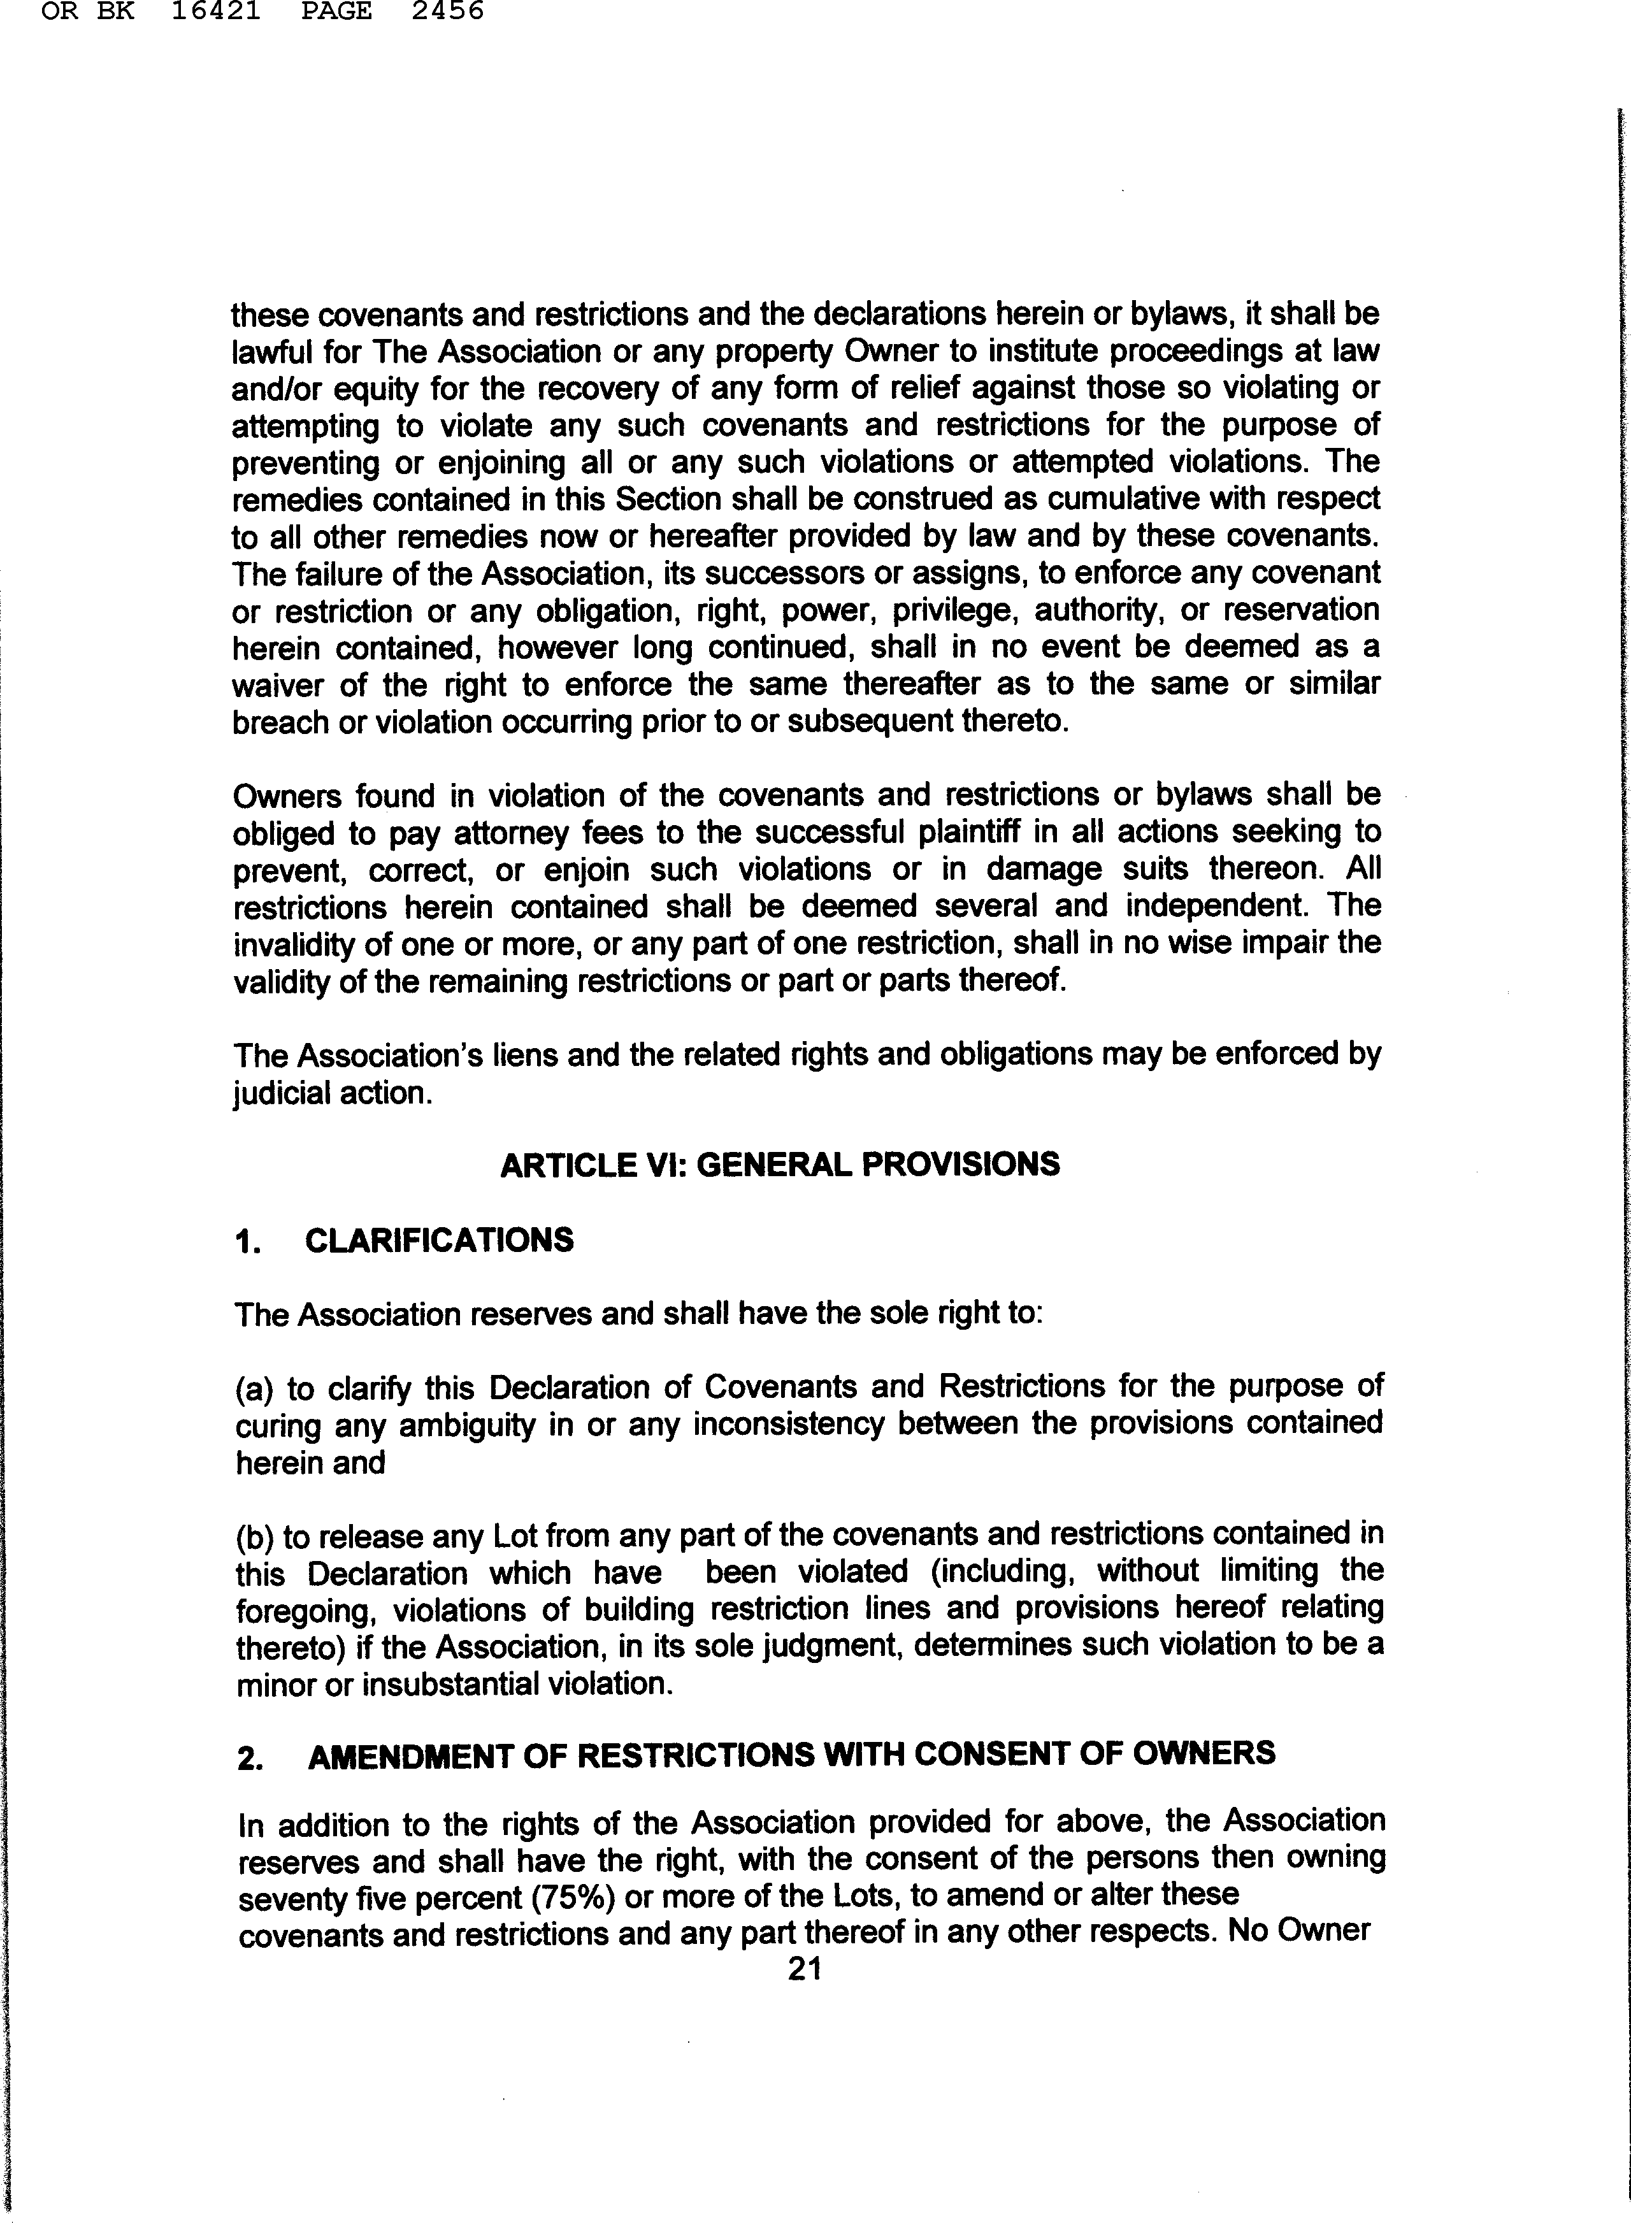

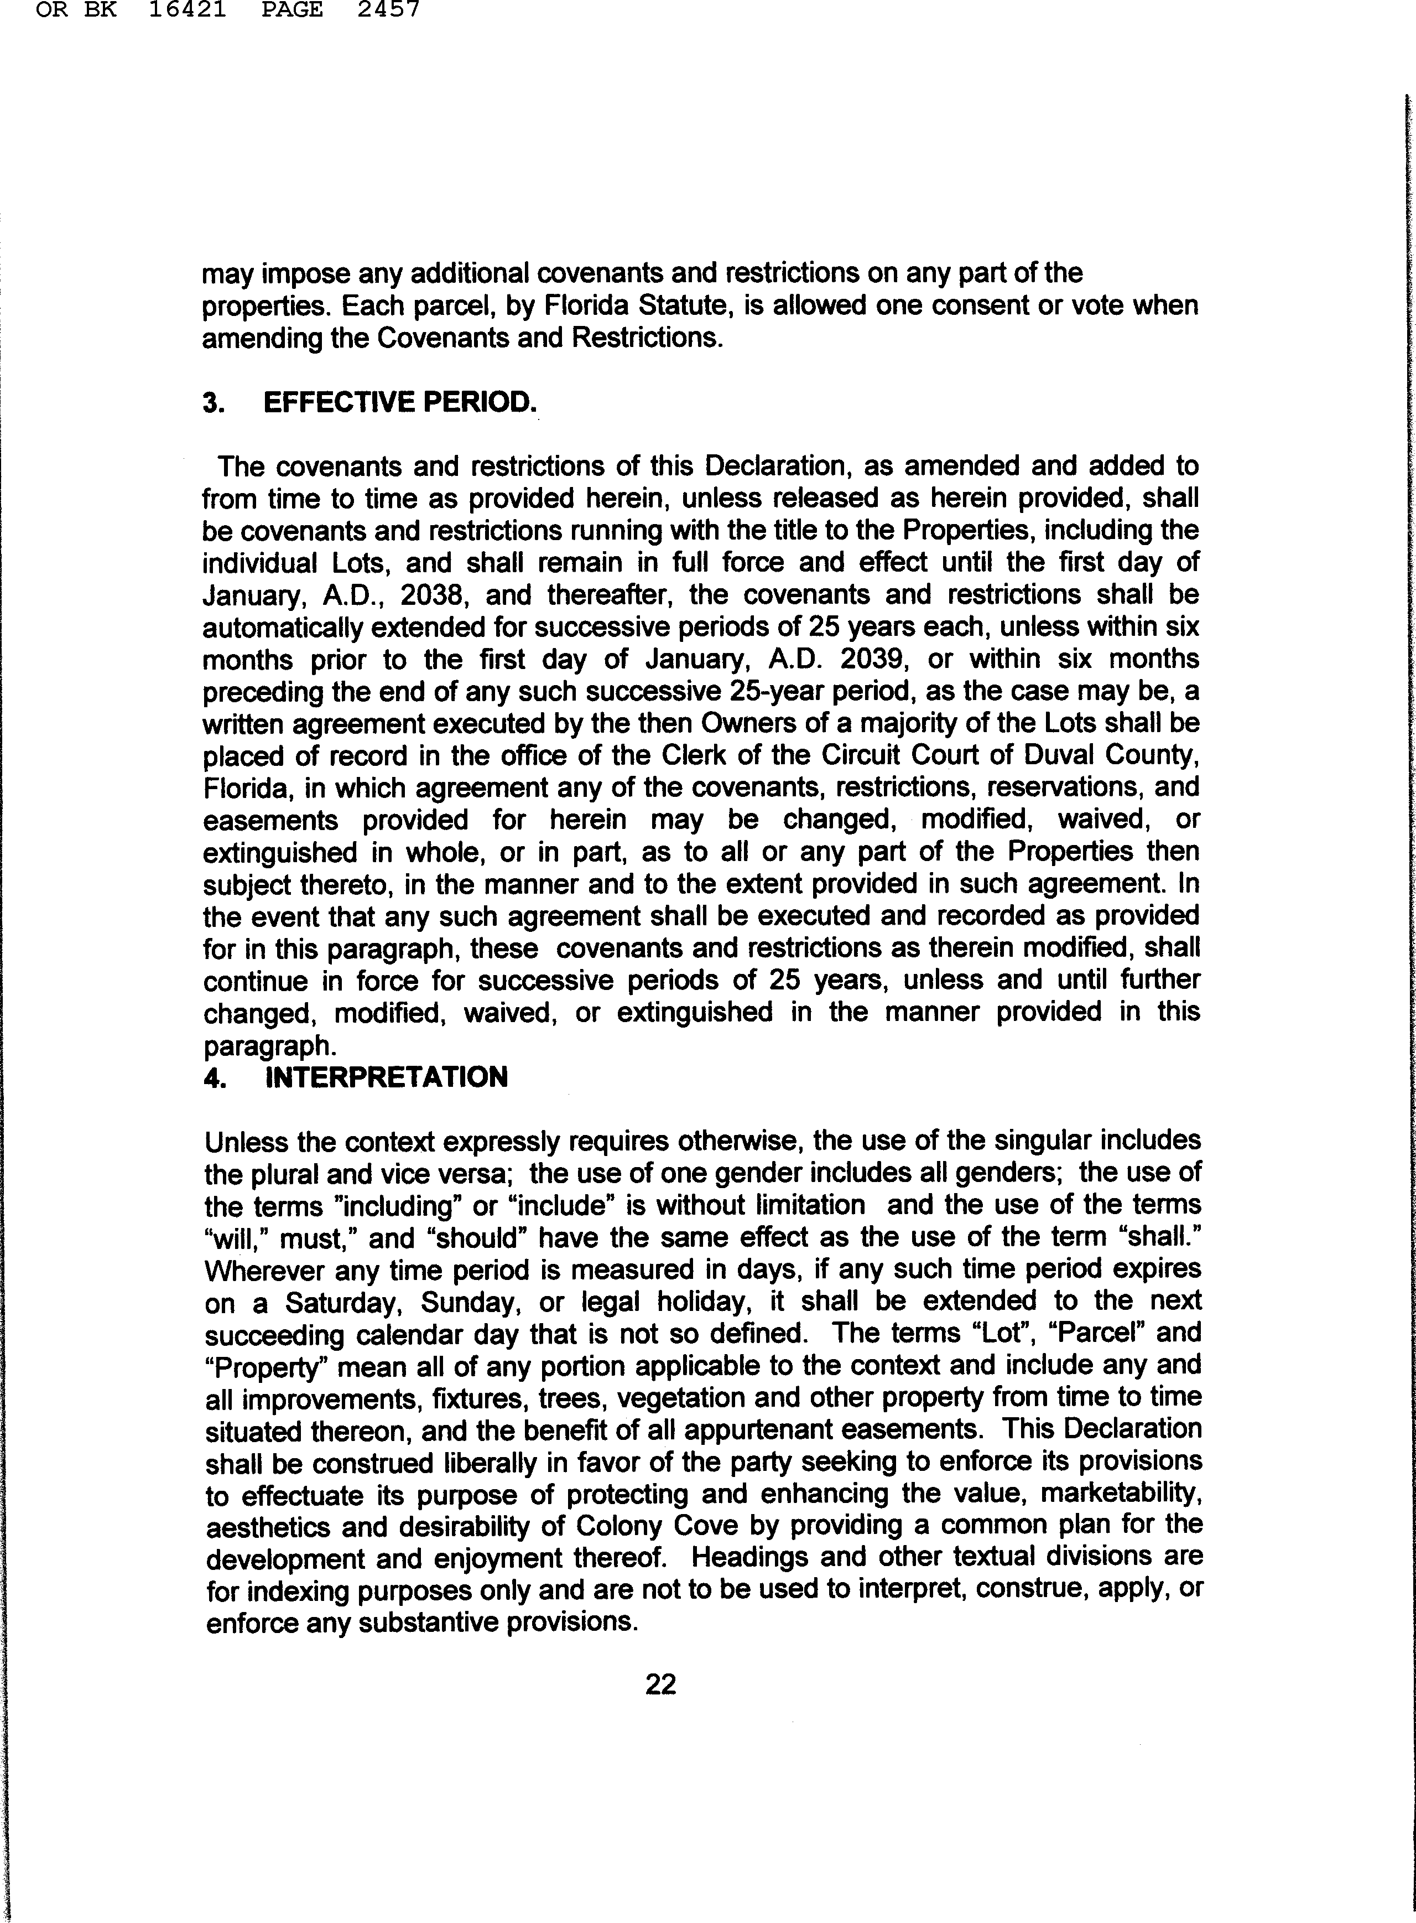

In the event of any conflict between this Declaration of Covenants and Restrictions and the bylaws or other official documents of Colony Cove Civic Association, Inc., the provisions of this Declaration shall prevail. In the event of any conflict between the restrictions contained herein and the provisions of any municipal ordinance, Florida or U.S. Statute, government regulation, or the Constitution of Florida or the United States, then the more restrictive provision shall control.

CHOICE OF LAW

The laws of the State of Florida shall be applicable to all matters pertinent hereto.

- NOTICES

Any notice required or authorized to be delivered to the Association may be delivered by mail or by hand delivery to the President, the Secretary, or, in the absence of either of them, then to any board member of the Association.

Any notice required or authorized to be delivered to the Owner may be sent by mail to the address of the Lot or posted on the front door, if that is the residence of the Owner. If the Owner does not reside at that address, then the notice may be sent to the address given to the Property Appraiser or Tax Collector of Duval County, Florida, or to the address listed on the deed to the property, if available. Notice to a corporate Owner shall be sent to the address of any officer of the Corporation or the registered agent listed with the Secretary of the State of Florida. In the event the foregoing appear to be ineffective, then a notice may be tacked on the door of the residence and such physical notice shall be deemed sufficient.

In the event the foregoing efforts are ineffective, then a notice to an Owner shall be sufficient if sent to a fax number or email address provided by the Owner to Colony Cove or any of its officers for any purpose.

23

ARTICLE VII: MEMBERSHIP

- Members

All persons who take title to a Lot in any of the Properties in Colony Cove as identified in Article II and Exhibit A after the recording of these approved Covenants and Restrictions shall be members of Colony Cove Civic Association, Inc., with rights as defined therein. At the point of time of the transfer of title in any manner whatsoever after the recording hereof, membership shall be conferred upon each person with resulting or continuing ownership interest, together with all of the rights and obligations of such membership. Annual dues, maintenance assessments, special assessments, and specific assessments that are assessed by the Association pursuant to these covenants and restrictions, its bylaws, and other official documents shall be charged to and run with the land and shall also be personal obligations of the Owner and shall be paid by the owners, jointly and severally, together with interest, costs, and attorney fees at such times and in such amounts as shall be specified by the Association. Membership is non-transferable and non-assignable, except by transfer of title of the Lot.

Grandfather Clause

Owners who took title prior to the date of public notice and recording of these Covenants and Restriction are permanently entitled to choose each year whether to voluntarily pay dues and join the Association.

24

IN WITNESS WHEREOF, the Association has caused this Declaration to be executed by its duly authorized officers and its corporate seal to be affixed at Jacksonville, Duval County, Florida, this ';) M'ay of :T'1t<Q... , 2013.

COLONY COVE CIVIC ASSOCIATION, INC.
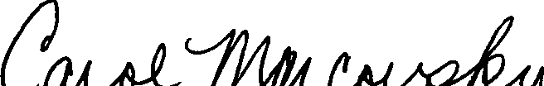
A Florida Corporation not for profit,

BY_ ;;. ;_....; i .:.....:;.....:...:::...::+-----
Carol Marcovsky, President

Attest &Jt'.l!Wl! ,a:::.:_ Sarah Christenbury, S

Corporate Seal

I HEREBY CERTIFY that on this day before me, an officer duly authorized in the State and County aforesaid to take acknowledgments, personally appeared Carol Marcovsky and Sarah Christenbury to me well known and known to be the persons described in and who executed the foregoing Covenants and Restrictions, as President and Secretary, respectively, of COLONY COVE CIVIC ASSOCIATION, INC., a Florida not for profit corporation, and severally acknowledged to and before me, that they executed the same as the act and deed of the corporation.

WITNESS my hand and official seal in the County and State aforesaid, this .J , ay of .Tv-¥ g, , 2013.
11A,,
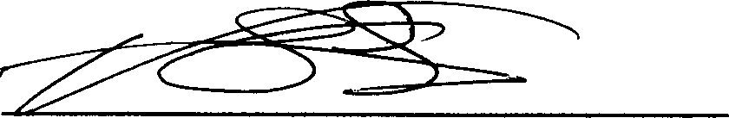
Notary Public, State of Florida at Large My commission expires: ·:Js:?tf.f Identification: personally known

- V.THOMASFOII.! ,,.
1•: :• Notary Public, Stat _{oi} i-::,.
: ' My Comm. Expires Nov ,h ,..
. ' Commission No. El: 42'.iJ,

THOMAs FOUNTAIN
My ConwPn.ubic, State of Rorida
Corr,,n;,&,;,,,In,,Nov. 18, 2014
11No.E£421o7
25

EXHIBIT "A"

To 2013 Amended Colony Cove Covenants and Restrictions

Being the same plats as those recorded in OR Book 15703 Pages 208 through 214 of the current public records of Duval County, Florida
The following described properties in Duval County, Florida Lots 1 through 26, inclusive, Block 1,
Lots l through 32, inclusive, Block 2,
Lots 1 through 2, inclusive Block 3,
Lots 1 through 5, inclusive Block 4, Lots 1 through l l, inclusive, Block 5,
Lot 1, Block 9, Colony Cove Unit No. 1 according to the plat thereof, recorded in Plat Book 34, Page 12 and 12A, of the current public records of Duval County, Florida.

Lots 27 through 44, inclusive, Block 1, l
Lots 3 through l 7, inclusive, Block 3,
Lots 6 through 12, inclusive, Block 4,
Lots 12 through 22, inclusive, Block 5,
Lots 1 through 16, inclusive, Block 6,
Lots 1 through 6, inclusive, Block 7,
Lots 1 through 15, inclusive, Block 8,
Lots 2 through 28, inclusive, Block 9, Colony Cove Unit No. 2, according to plat thereof recorded in Plat Book 34 Page, 36, 36A and 368, of the current public records of Duval County, Florida.

Lots 1 through 20, Inclusive, Block A, Colony Cove Addition, according to plat thereof recorded in Plat Book 34 Page 61, 61A of the current public records of Duval County, Florida.

INFORMATION ONLY:
With the creation and recording of Lots l through 20, Colony Cove Addition, Block A in Plat Book 34 Pages 61 and 61A, lots 23, 24, 25 and 26 inclusive were removed from Unit
No. 1. Lots 27 through 44, inclusive, Block 1, Colony Cove Unit No. 2 were removed from Colony Cove Unit NO. 2 and made a part of Colony Cove Addition. The net affect was to reduce the total lots within Colony Cove from 192 to 190 lots.

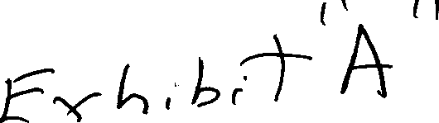

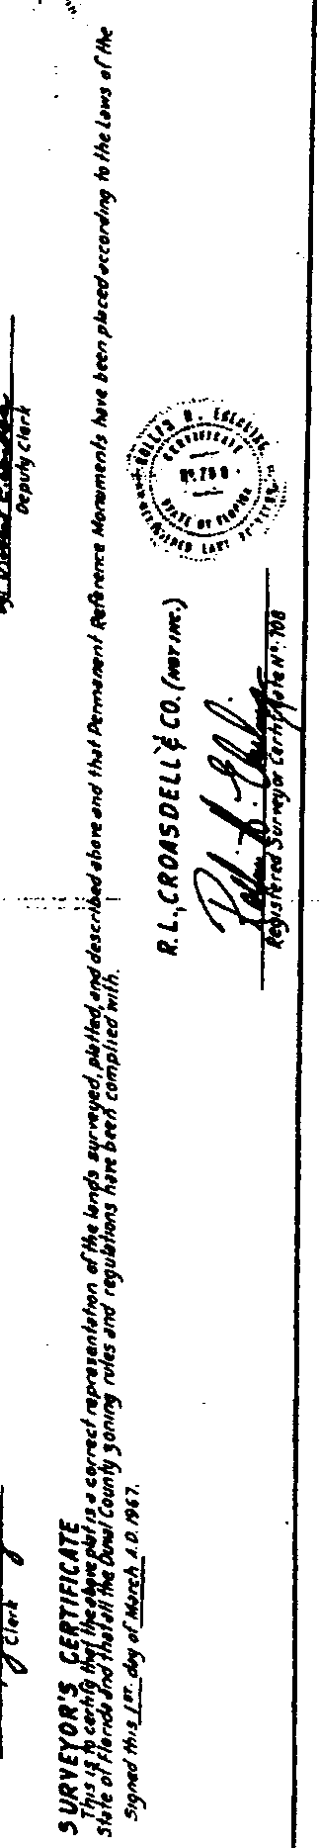
'-, !.,_./
-==-....- -.(>
..
"
1
. 1!.----·---·
{
al'
-If.

f

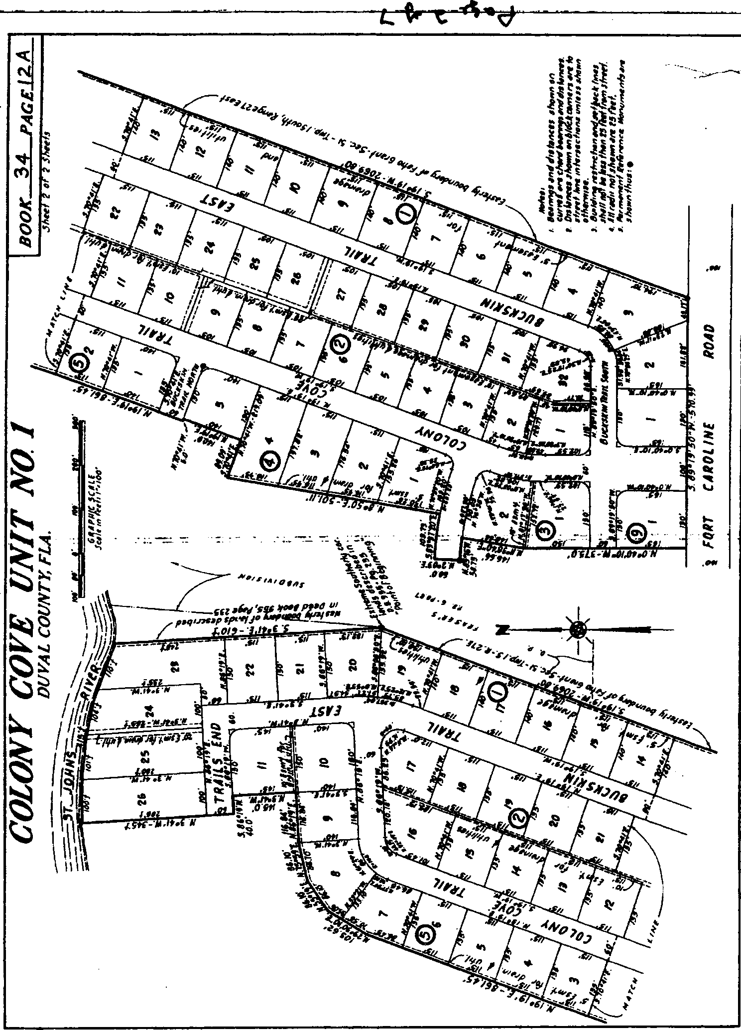
!

I
I

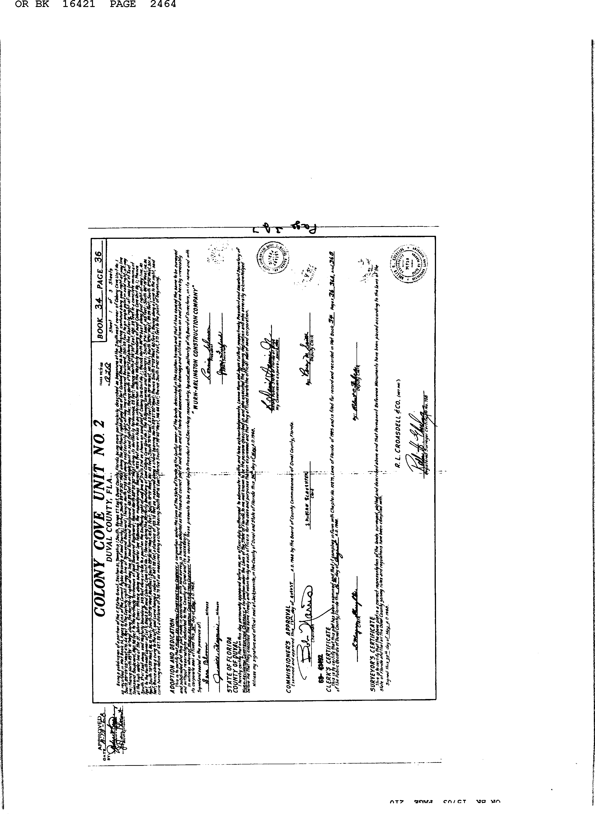

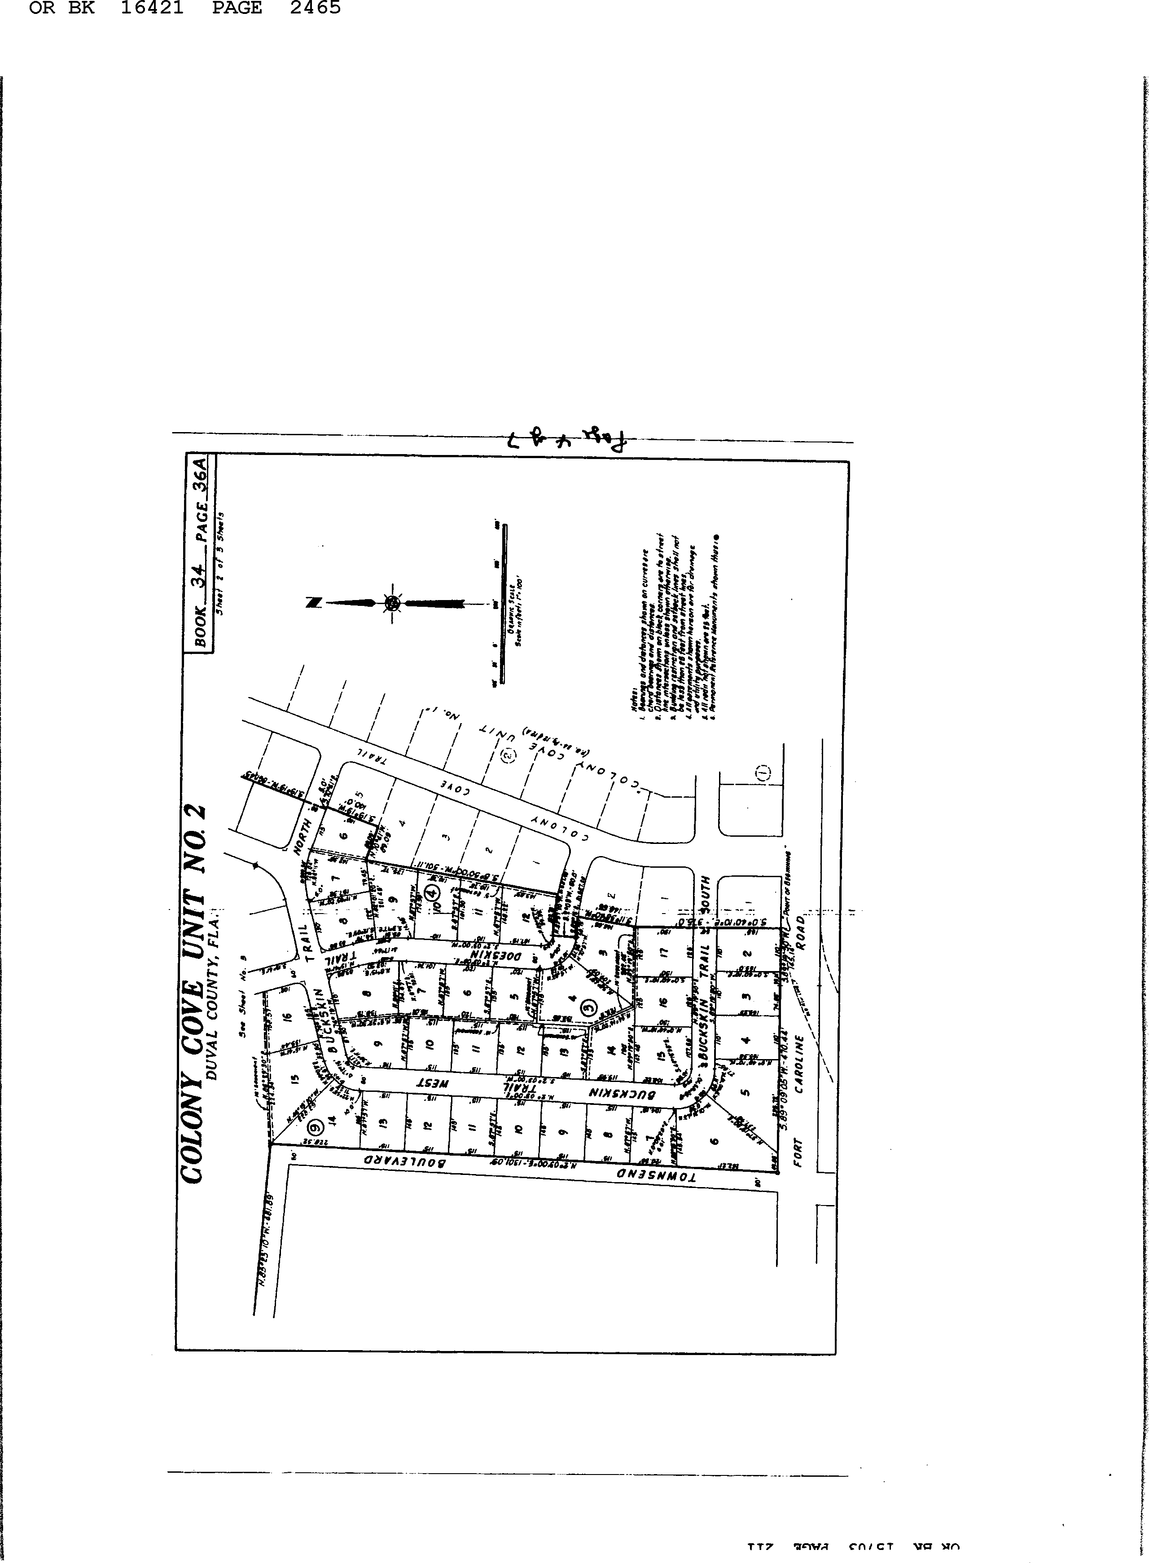

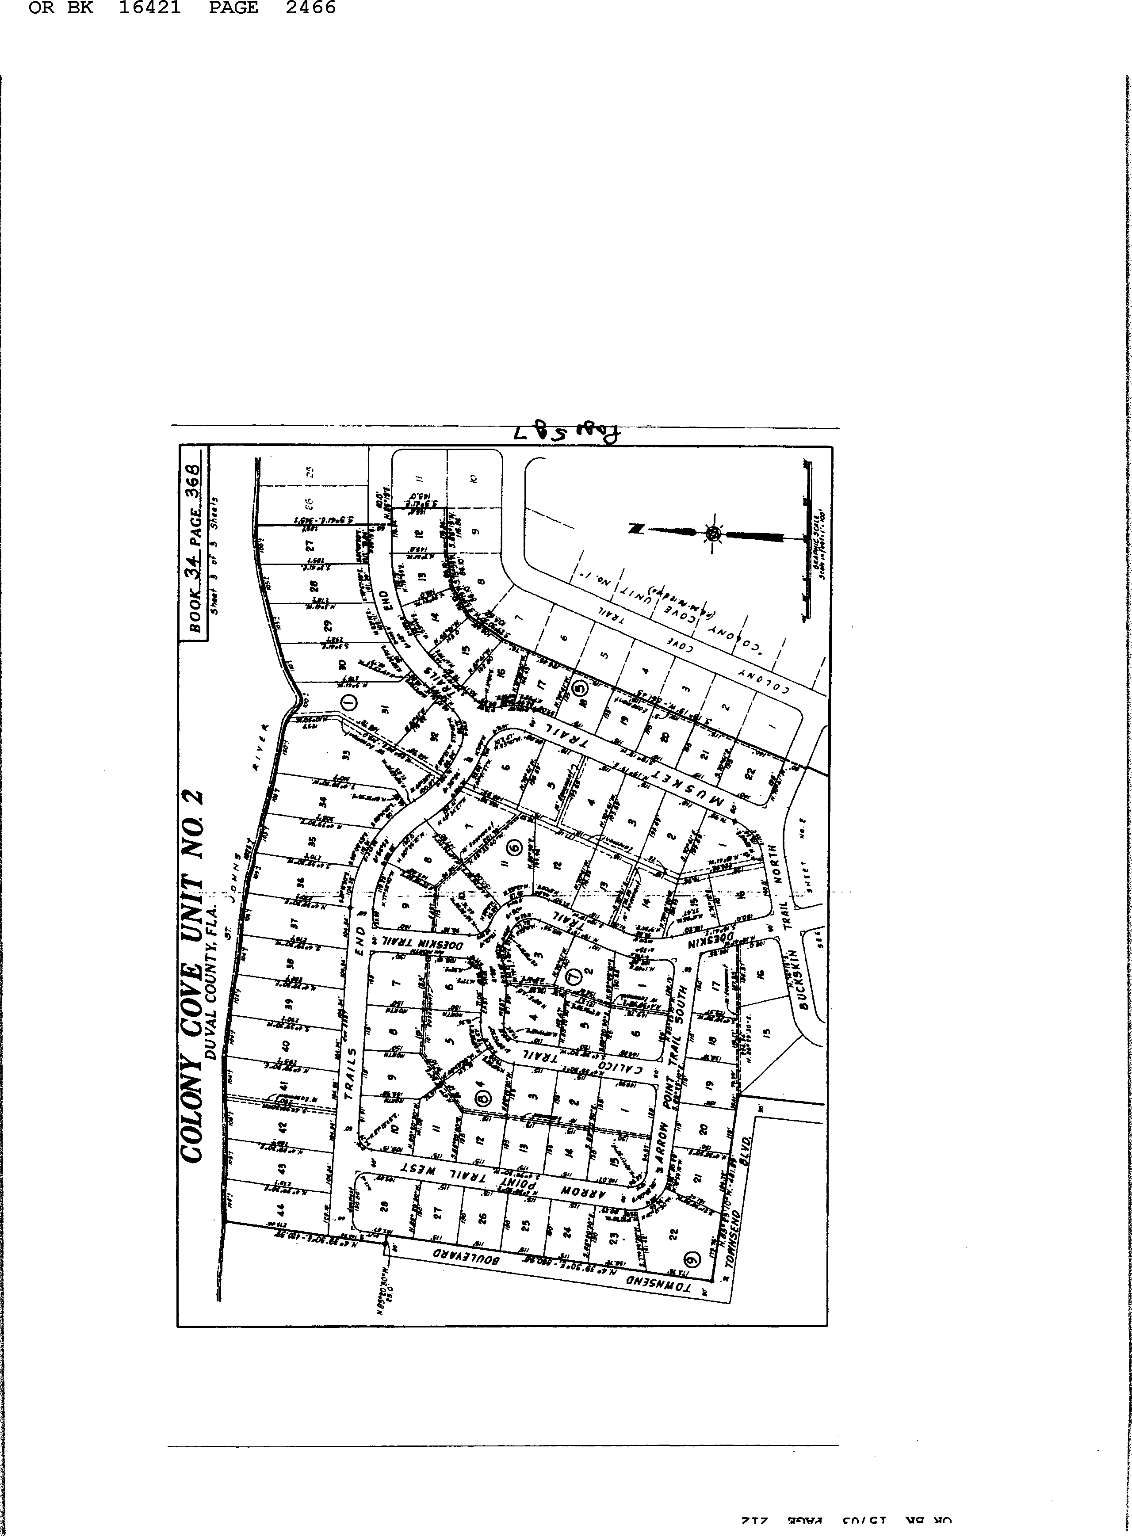

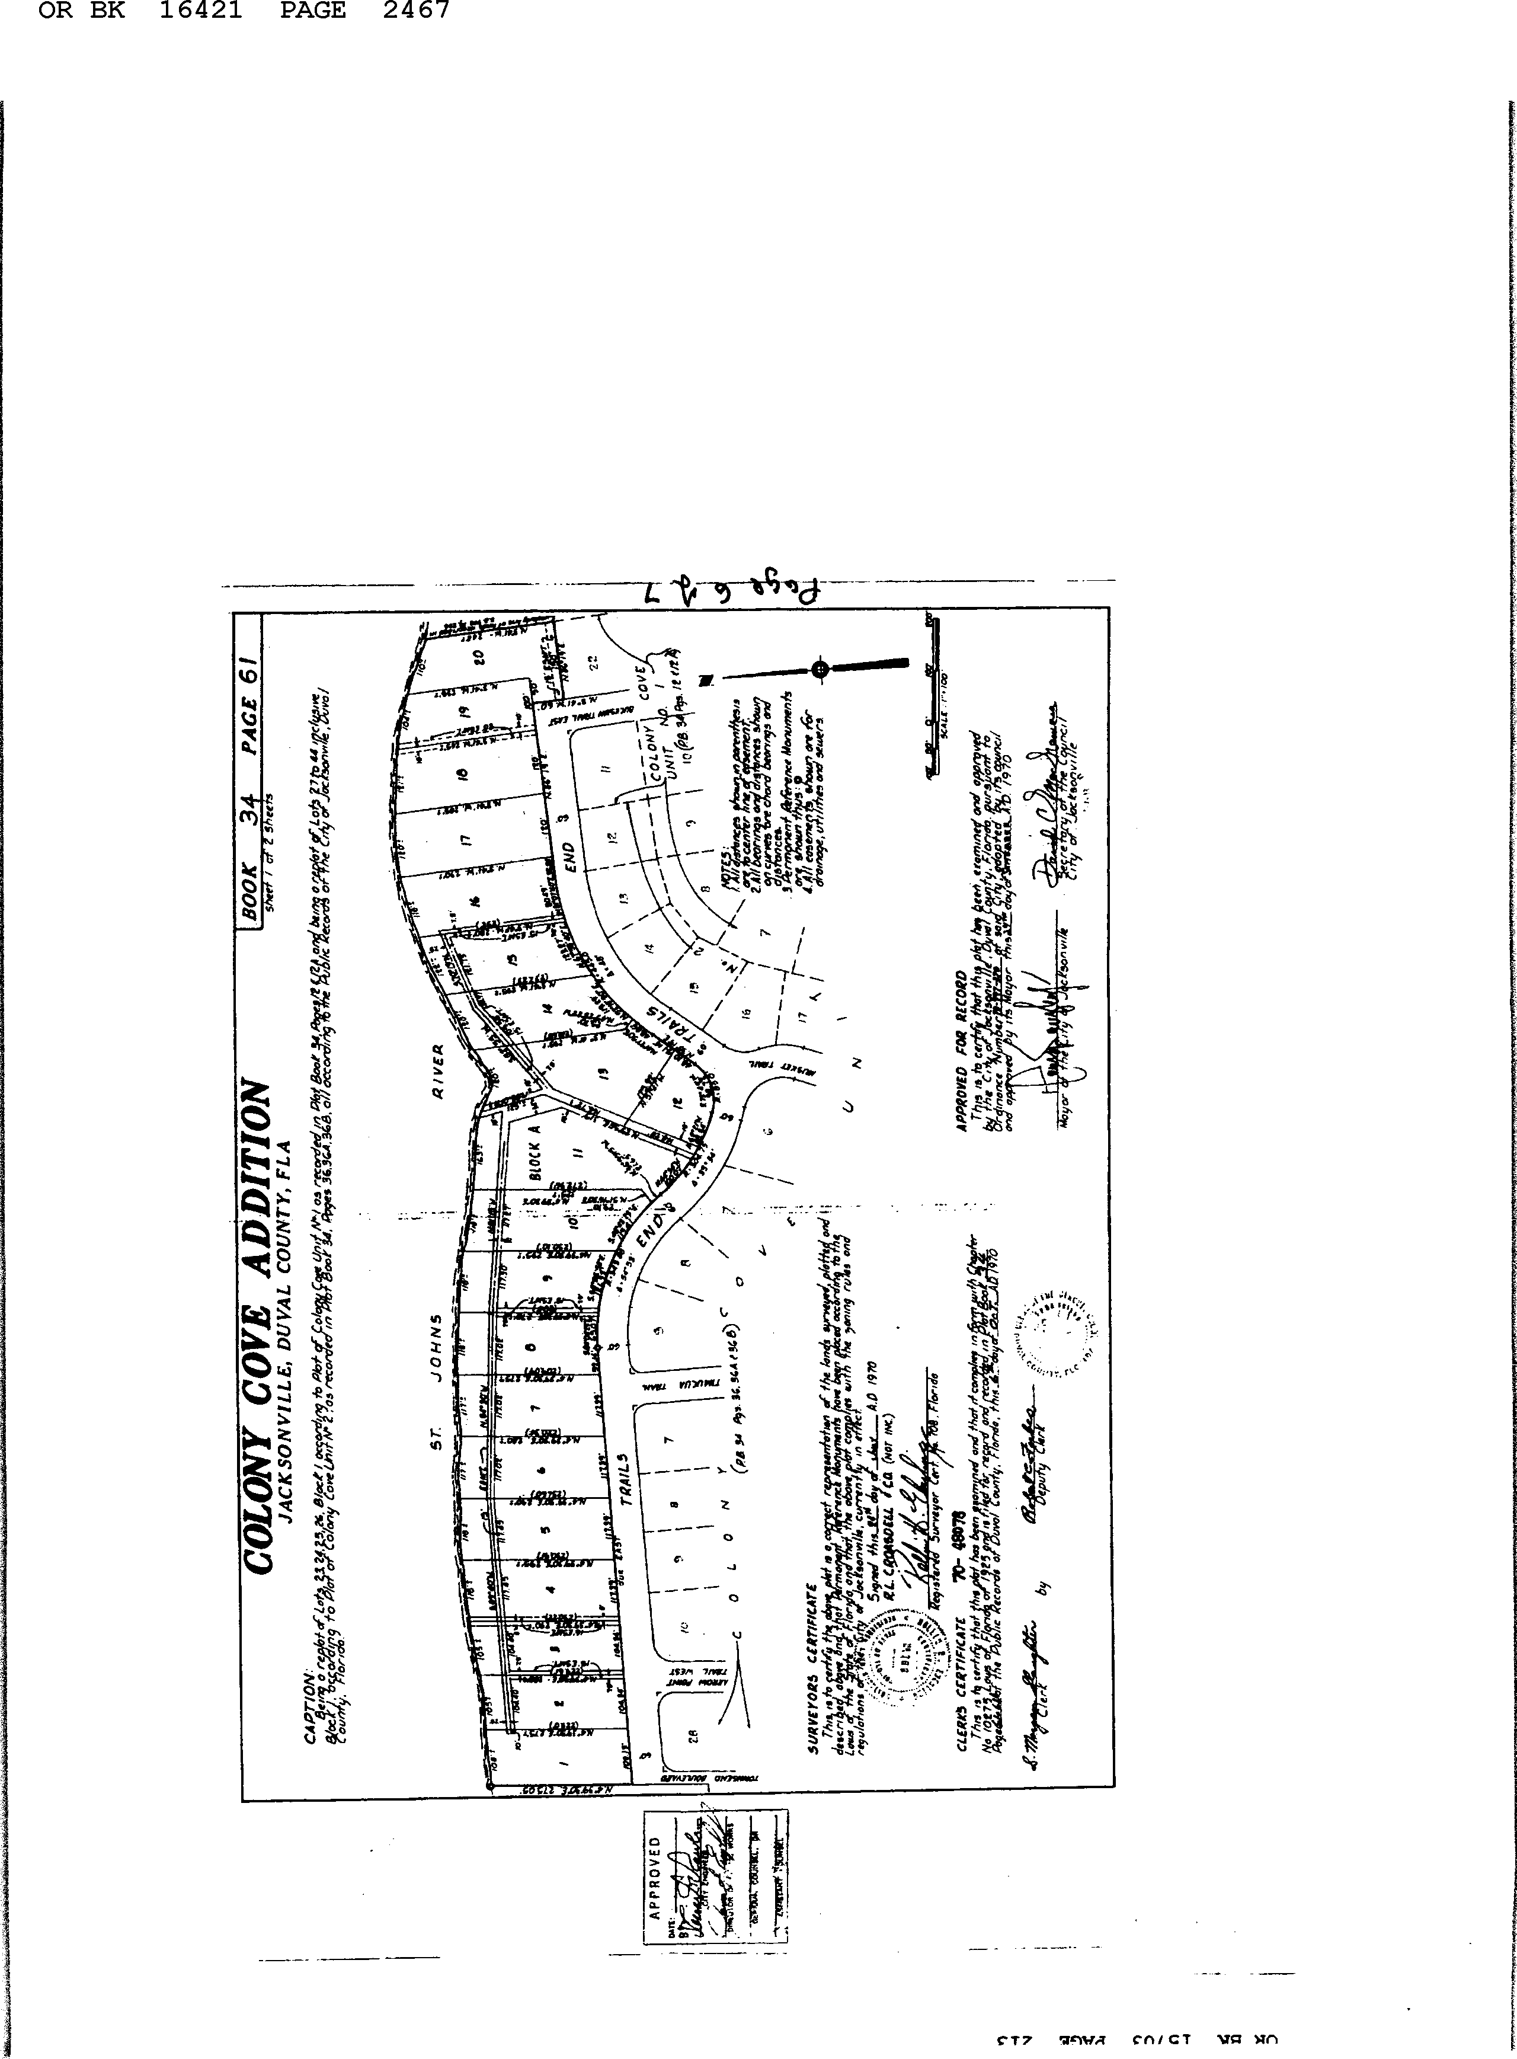

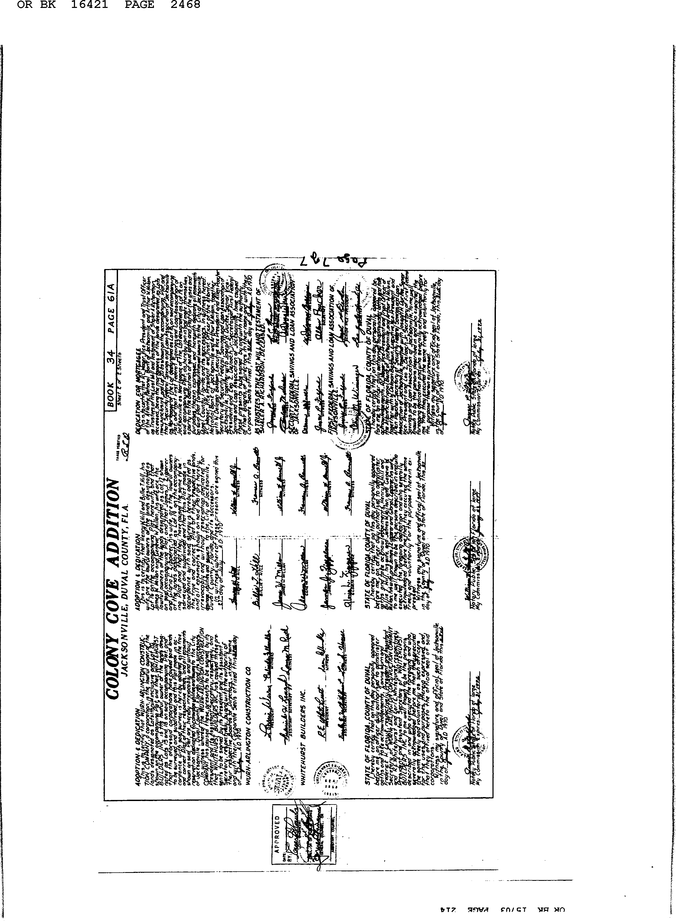

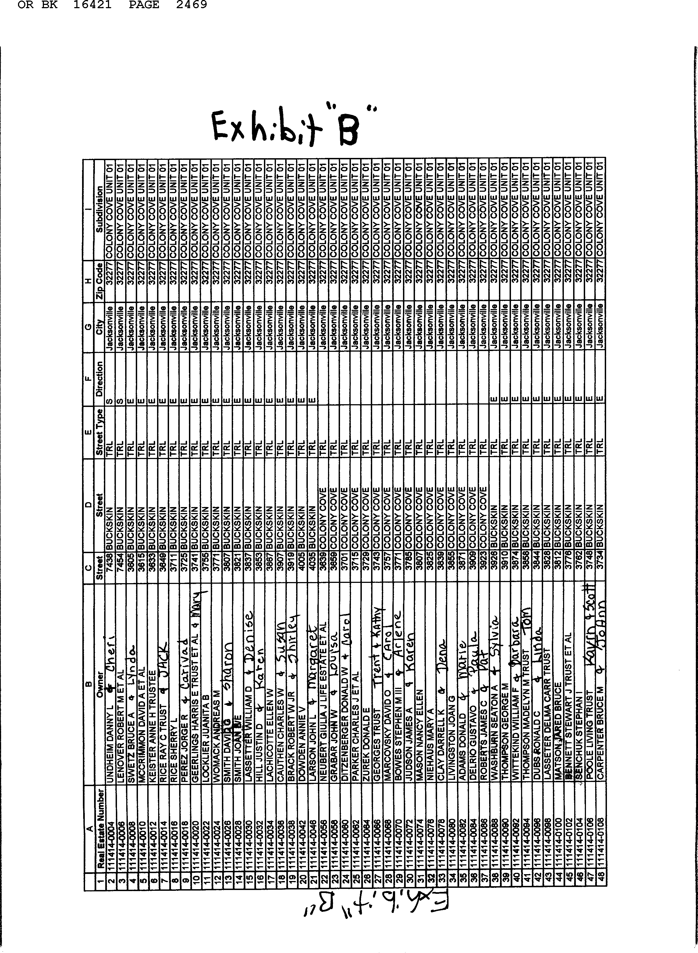

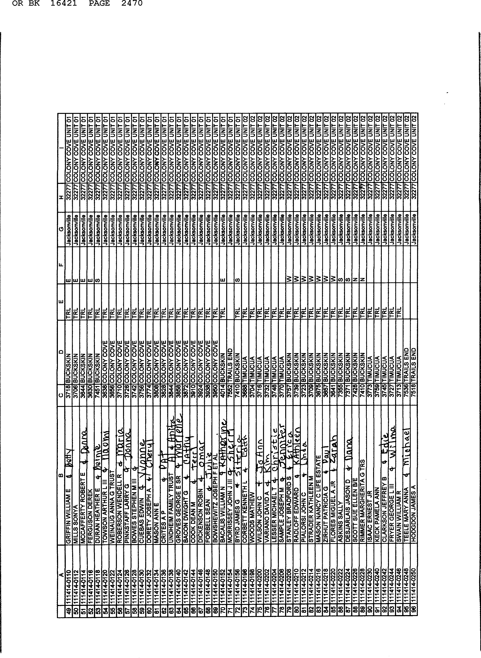

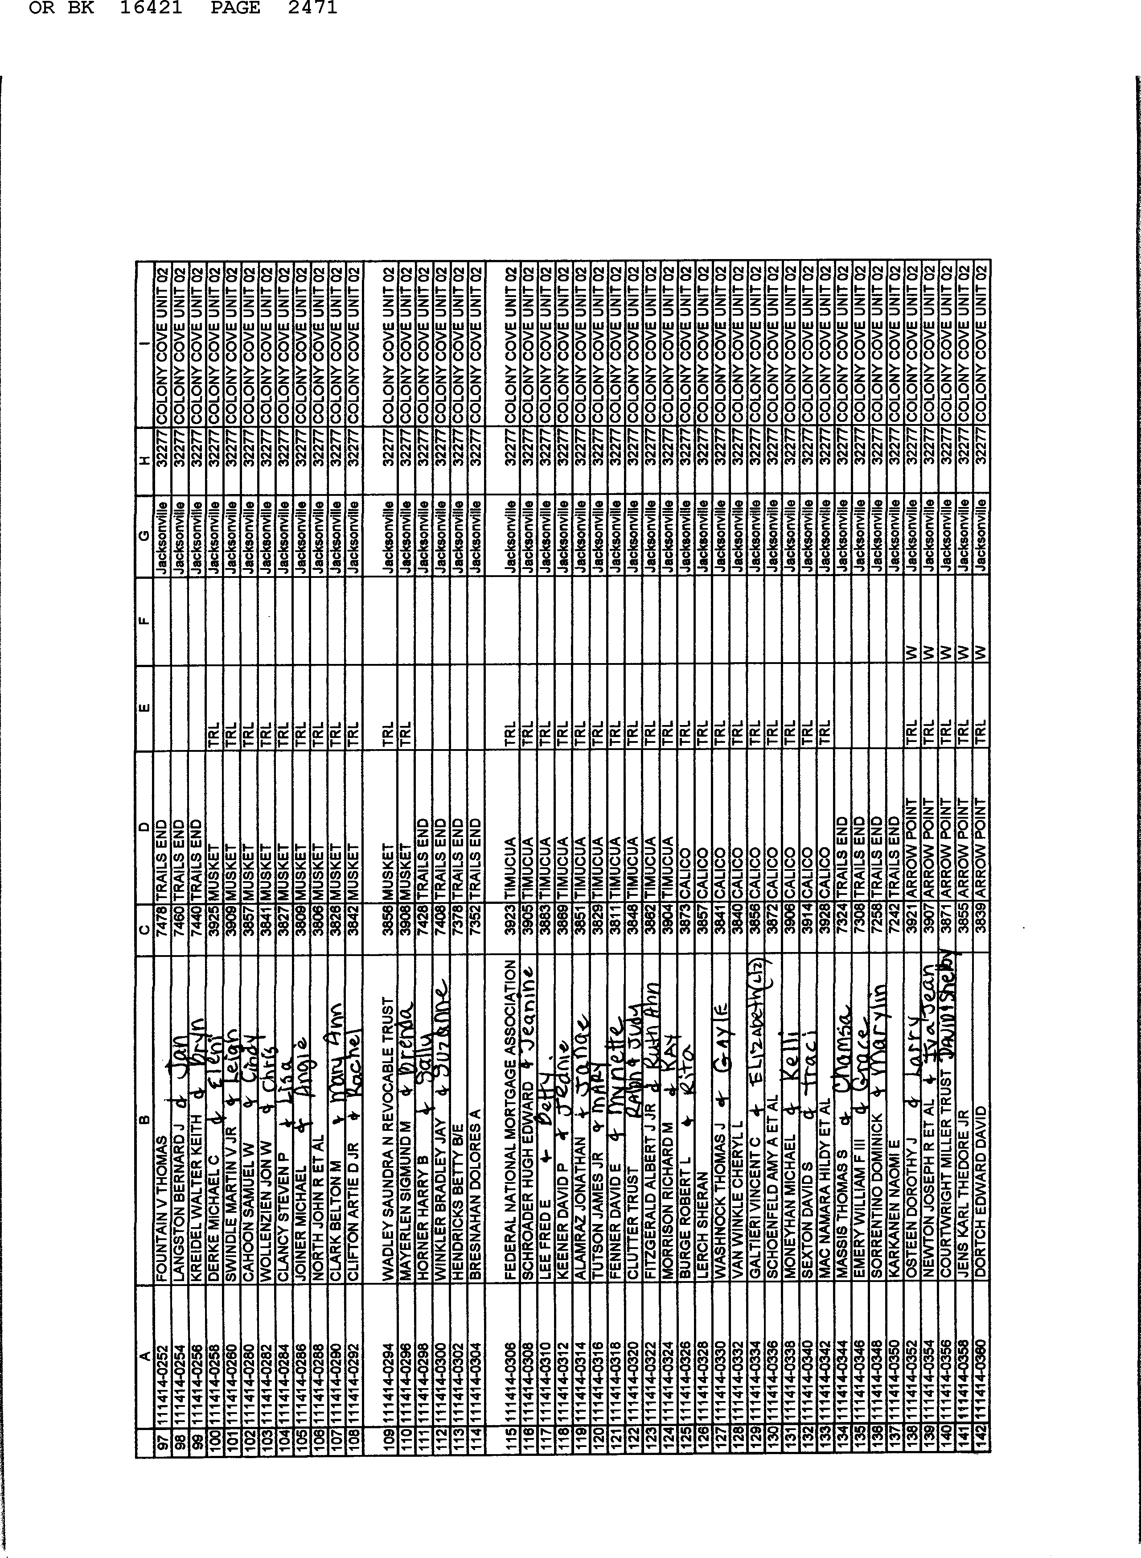

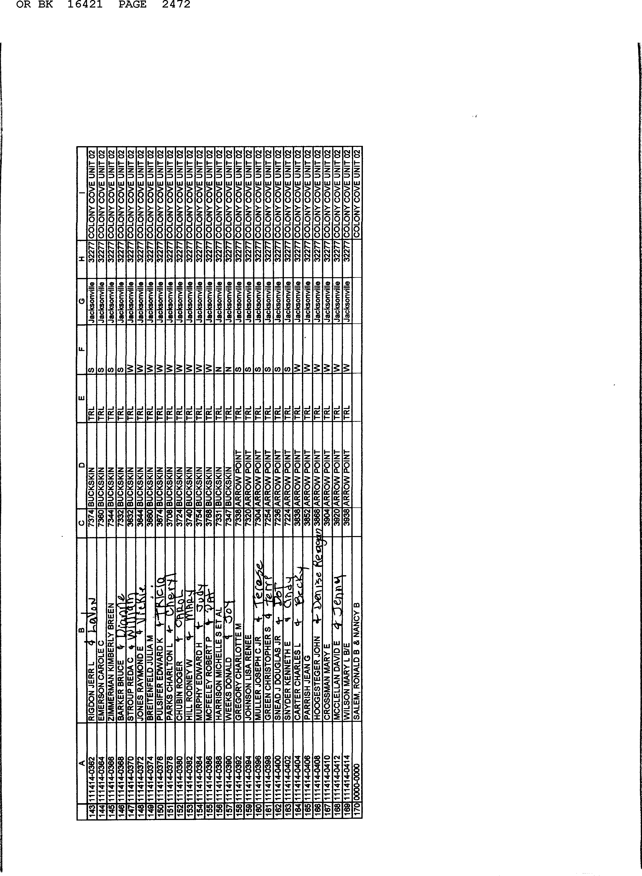

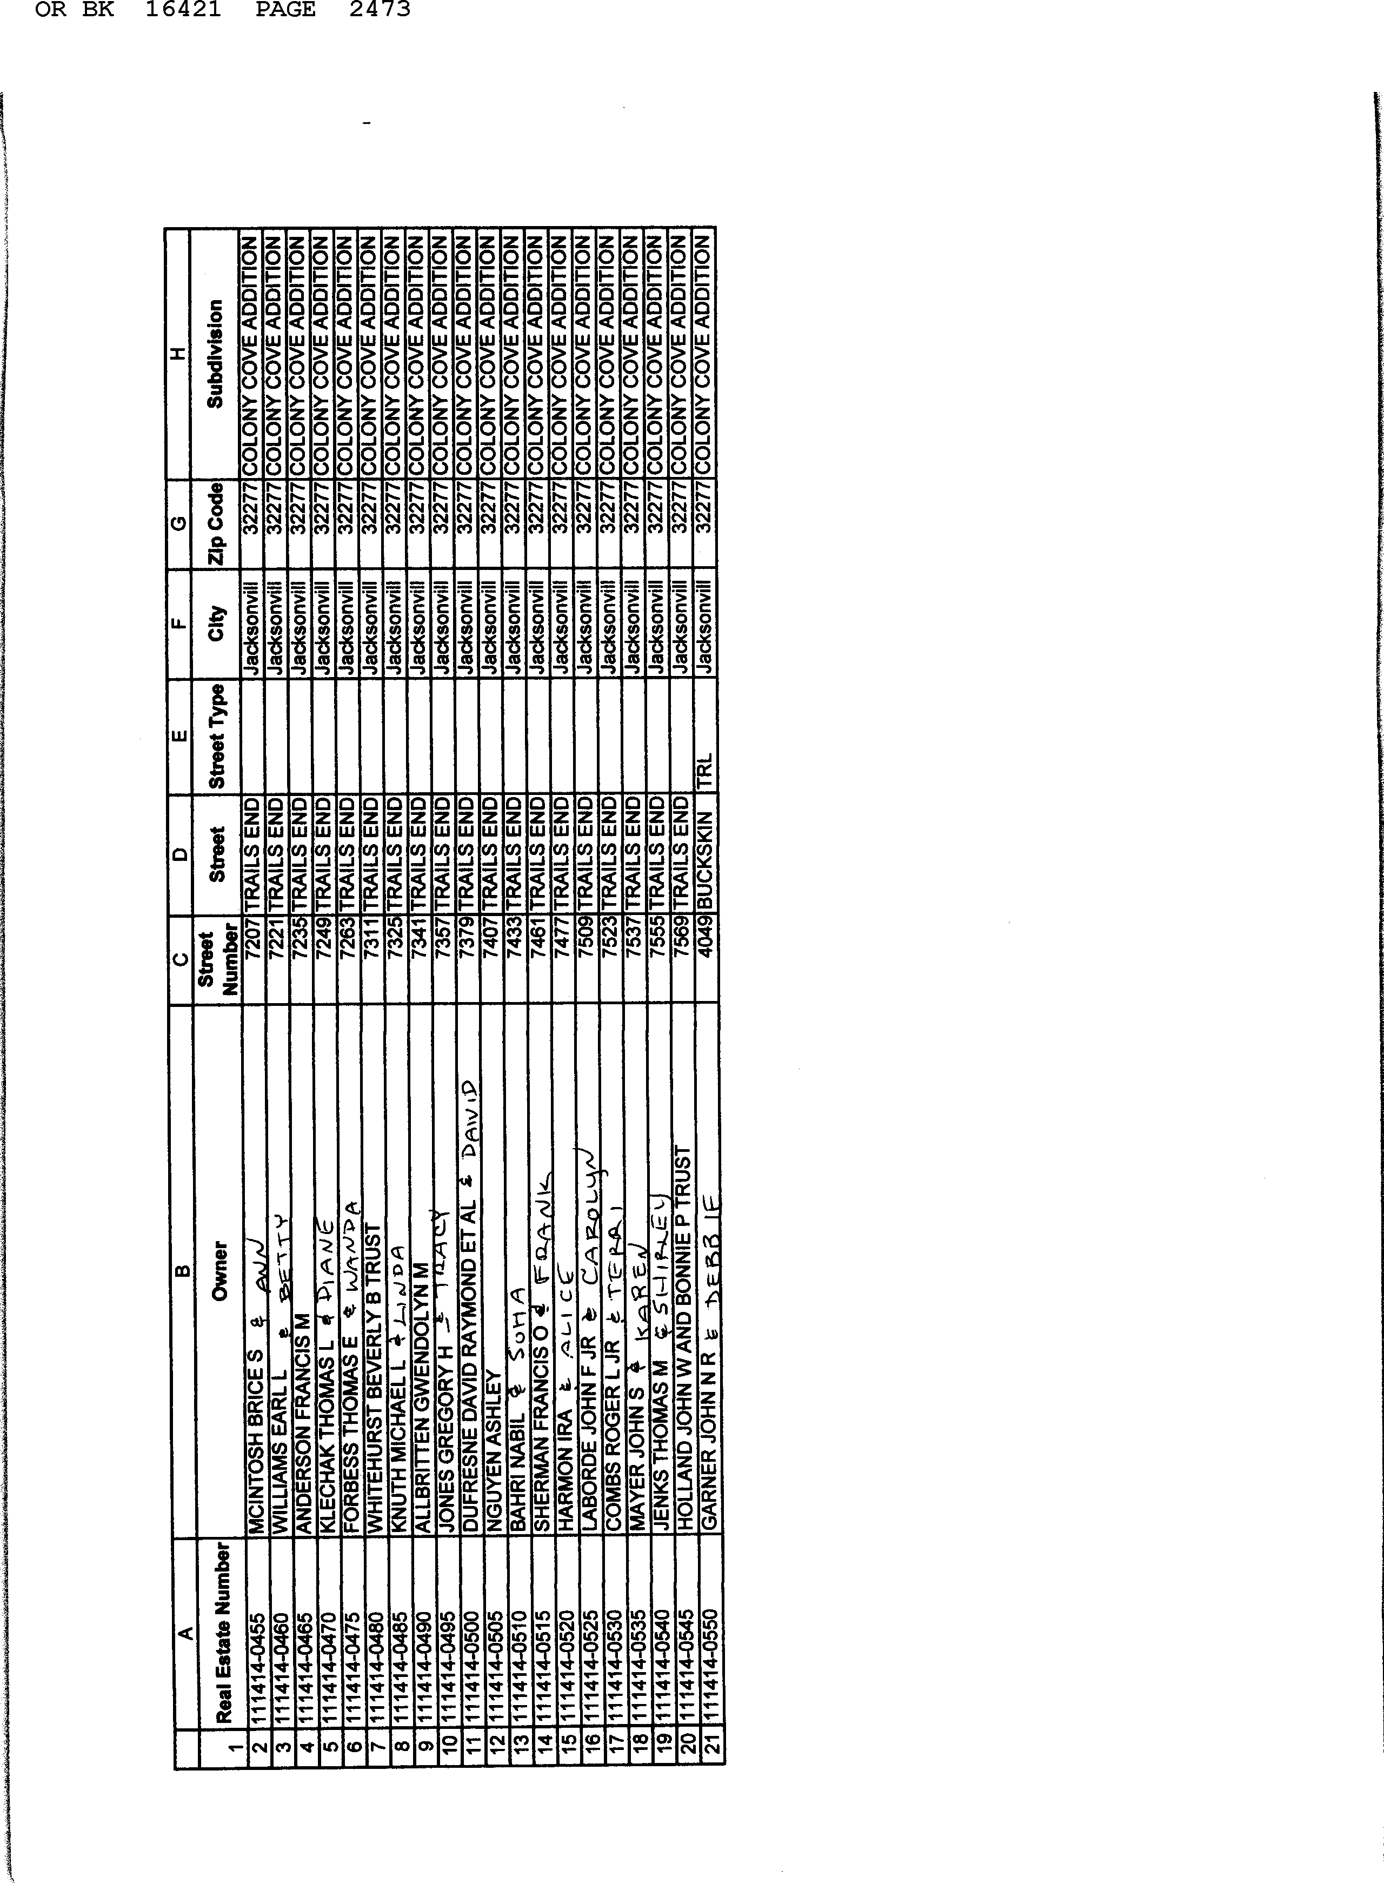

OR BK 16421 PAGE 2474

June 21, 2013

The Board of Colony Cove, having specifically met for the purpose of considering the new Covenants and Restrictions, does hereby consent to the recording thereof to which this consent is attached.

COLONY COVE CIVIC ASSOCIATION BOARD
=
rJft
President: Carol Marcovsky (}a,.,o.R IJ'lM
Vice President: Mary Ann Clarrk,--...
Treasurer: Trent Georges I_ -........J:L_.e..; =--CL..,iii'J-----------

Recording Secretary: Sarah Christenb ct-wi
Hospitality: Mary Crossman
Recreation: Pat Mcfeeley J;>' t·d
Community Improvements: Linda Dubs _ c;;-""' .o.¥--=-J!!,,,,,.L"I.,,_.,,. =---
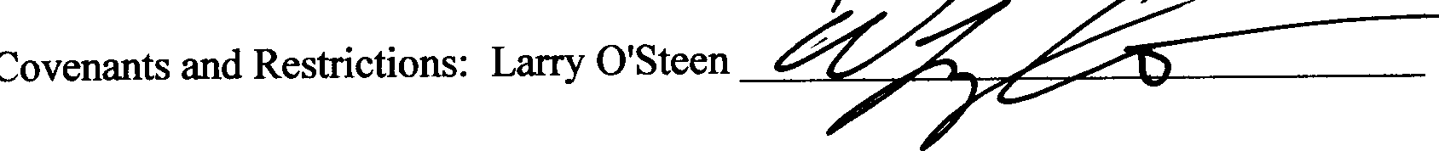
c:S.- f C>.!£' ,C/ v,Jo..
S<
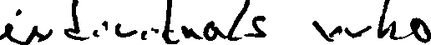
c.. t D "'-v- .. ,(
{.v ""7 p-v- o._,....._
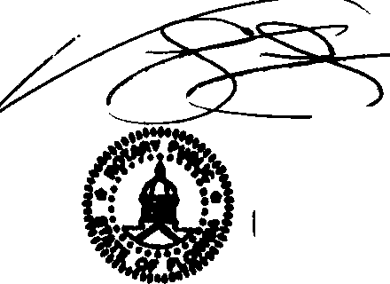
o.VQ.. f o 1..o ....(( 1 kAe' \JJ'-f' T
- <l'-' ,...,.. < ..Lo t..3
V. llfOMAS FOUNTAIN Notary Public, State of Rorida Mv Comm. Expires Nov. 18, 2014
Commission No. EE 42807

I
t

