Top 15 Tips to Choose the Best Jiu Jitsu Gi For Yourself

Meta Description

Your Jiu Jitsu Gi should provide you with mobility, comfort, safety, and durability. It should also follow IBJJF rules if you want to compete, or gym rules if you want to train only.

Featured Image

Table of Contents

30 Second Summary - Choosing Your Best Jiu Jitsu Gi
1. Importance of Choosing Your Jiu Jitsu Gi
1.1 Mobility
1.2 Comfort
1.3 Safety
1.4 Must be Suitable for Your Climate
1.5 Durable
1.6 IBJJF Rules
1.7 Grip Fighting
1.8 Size and Fit
1.9 Quality
1.10 Budget Requirements
1.11 Sturdy Collar
1.12 Gym Rules
1.13 Lower vs. Upper Belts
1.14 Right Weave
1.15 Right Material

30 Second Summary - Choosing Your Best Jiu Jitsu Gi

Your Jiu Jitsu Gi should provide you with mobility, comfort, safety, be suitable for your climate, and be durable. It follows IBJJF rules if you want to compete, or gym rules if you want to train only. Prevents grips by your opponent, fits you snugly (not too loose or too tight), has high-quality fabric, and a sturdy collar. The material and weave should be designed to improve your grappling. One good example of a Gi that follows all these rules is the Elite Sports Jiu Jitsu Gi, which is the best beginner's Gi, provides accurate sizing, and is also good for competitions.

1. Importance of Choosing Your Jiu Jitsu Gi

Choosing your Jiu-Jitsu Gi is important for your grappling due to the following reasons:

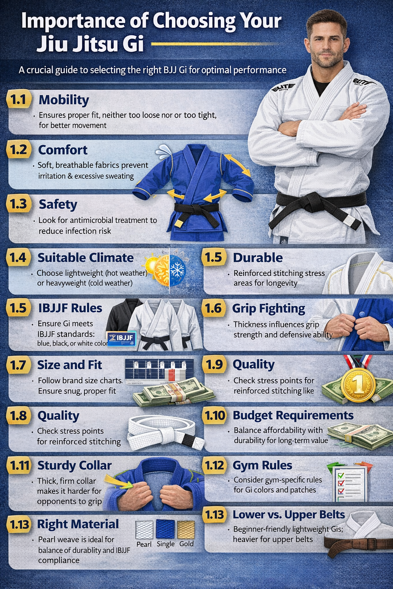

1.1 Mobility

Your Jiu Jitsu Gi should always be a right fit for you. It should neither be too loose nor too tight. It must always be the right size for your body type. Your Gi fitting decides how well you can move during the grappling. The more fitter or the right size Gi you have, the better your moves will be, and vice versa.

1.2 Comfort

Your Jiu Jitsu Gi must provide comfort to you during grappling. Some Gis are made of fabric that can cause irritation, or they can absorb a lot of sweat during your intense grappling sessions. So you must avoid all of them, because if you cannot even find comfort, you will not be able to grapple with it in full focus. Prefer the ones that feel soft. You can choose a stiff feel, but it must not be irritating.

1.3 Safety

Pick the Jiu Jitsu Gis that are treated with anti microbial treatments. It will keep you safe from infections during the grappling.

1.4 Must be Suitable for Your Climate

You should choose your Jiu Jitsu Gi according to your climate conditions. For example, if you need to train in a very hot climate (summer), then you should prefer lightweight Gis with thinner stuff. But ensure it must not be so thin that it tears after just a few days of training. On the other hand, if you are training in cold conditions, such as severe winter weather, you'd better buy a heavyweight Gi with thick material. This will help you focus more on grappling rather than just being effected from the climate.

1.5 Durable

Your Jiu-Jitsu Gi must be highly durable. Some brands offer their Gis with reinforced stitching in the high-impact areas. These can include parts of your body, such as your knees, elbows, and other areas that are more prone to injury or stress. This will make the Gi highly durable, resisting all sorts of wear and tear during intense grappling sessions. So ensure you notice these things in your Gi when making a purchase. One good example of the best Jiu Jitsu Gi, which follows all these things, is the Elite Sports Jiu Jitsu Gi. It is the best beginner's Gi which provides accurate sizing and is also best for competitions.

1.6 IBJJF Rules

Another key thing to note in your Gi is whether it complies with IBJJF rules. It depends on your goal. For example, if you are just training to build the skills to defend yourself during street fighting or other situations like these, then you don’t need to consider any rules. But if you are hoping to compete in IBJJF matches, you must buy a Gi that follows IBJJF rules. These rules state the basics, like the colors you can wear: blue, black, and white. The size must not be too loose or too tight.

1.7 Grip Fighting

One of the most crucial aspects of Jiu-Jitsu is grip fighting. These grips can make you win the match, but you can also lose if you cannot control your opponent. The chances of gripping depend on the Gi. If the Gi is durable, thick, and heavy, it would be harder for your opponent to grip. But if your Gi is very thin, lightweight, and durable, it will be easier for them to get a grip. The most common options for these grips include sleeves, collars, pants, and lapels. So consider this when buying a Jiu-Jitsu Gi as well.

1.8 Size and Fit

Nearly all Jiu-Jitsu Gi brands have their own size charts, which vary primarily by height and weight. Ensure you are wearing the right size and that it fits snugly. It should not be too loose or too tight, because either way, you are getting worse at grappling. For example, the Elite Sports, which provide the best-fitting Gi.

1.9 Quality

The most crucial thing to note in a Jiu-Jitsu Gi is its quality. Check the stress points and prefer the high-quality reinforcements. For example, the armpits, shoulders, lapel, and knees all should have reinforced stitching. This ensures that extra fabric panels or rows of thread are used at these points, improving durability and longevity.

1.10 Budget Requirements

You buy any Jiu Jitsu Gi you want, but ensure you are buying it to use for a long time, not just one or two weeks, i.e., high quality and durable. If you are on a tight budget or do not want to spend much on it, you can switch to the Gis with a lower price option. But don’t buy a cheap gi. Choose the Gi that is less costly but provides high quality.

1.11 Sturdy Collar

The collar must be very thick because it serves as a point of contact for the grapplers. If it is thin, then you will be easily gripped, but if it is thick, then your opponent will have to try much harder to grab your collar for chokes or other attacks.

1.12 Gym Rules

If you do not aim to compete and want to train only for any of your goals, then you do not have to comply with the IBJJF rules. But you should consider your gym's rules for buying the Gi. You can ask the trainers or read the rules to know what you cannot buy and what you can to ensure a smooth grappling performance.

1.13 Lower vs. Upper Belts

There must be a difference between the New white belt choosing a Jiu-Jitsu Gi and an upper belt, like a brown belt, doing the same. The reason is that beginners cannot easily lift the weight of a heavyweight Gi. This also diverts them from their grappling focus to the carrying and adjusting of their Gi. White belts should start with a lighter-weight BJJ Gi, and higher belts can choose any Gi based on their goals and needs.

1.14 Right Weave

The best weave choice for Jiu-Jitsu Gis is the pearl weave because of its compliance with IBJJF rules and its durability and lightweight. Other options include single weave for a lighter Gi in hot summers and heavier gold weave for cold climates, usually for black belts.

1.15 Right Material

The fabric must be preshrunk to prevent the size from changing after washing. The Jiu Jitsu Gi pants or jackets must be made of ripstop material or a blend of CVC, cotton, and polyester.

