Altitude Insurance Ltd  General Insurance Intermediary  Managing Director – Laura Durcan  Registered Address - Ground Floor, 71 Lower Baggot Street, Dublin, D02 P593, ROI  Telephone – 00353 (0)89 2231051/ 0044 (0)7780 552494  Email – office@altitudeinsuranceltd.com  www.altitudeinsuranceltd.com | 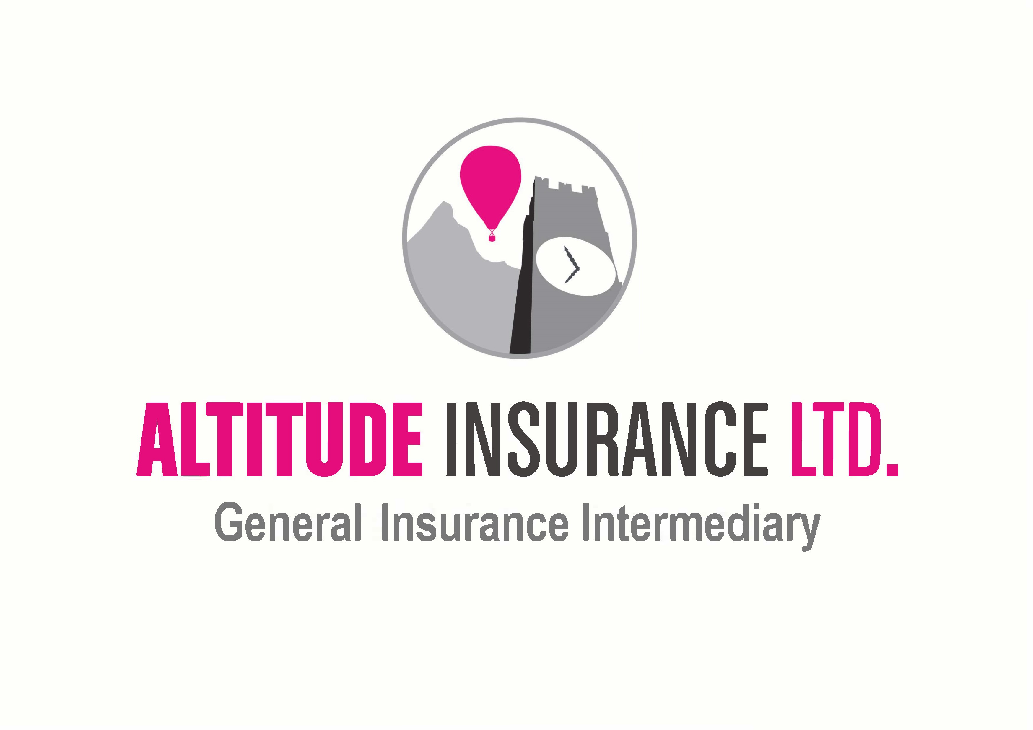

Questionnaire
By completing this Questionnaire, you are looking to enter into a legal contract with an insurance company, via your chosen Intermediary. You are obliged to answer all our questions honestly and disclose all information as set out below. If you have any questions, then we are here to answer them fairly.

We would like to ensure that all claims are paid for you, but unfortunately, we may find ourselves defenceless to assist you, when all the Facts are not disclosed at the outset. Such items include (but are not limited to) – all previous claims or incidents, description of risk to be covered and inaccurate general information.

In order to provide all necessary information to Insurers so that we are able to obtain a quotation, please can we ask for you to complete and return this document.

If you have any questions, need anything explaining or believe this Policy would not meet your needs, please contact us immediately.

About You –

Name of Insured:
Your Name (if different from above):
Insured Address:
Postcode:
Home/ Work/ Mobile Number:
Email Address:
Your Country of Birth:
Your Country of Residence:
Your Occupation:
Would you define yourself as a Politically Exposed Person (PEP) – an individual who is or has been entrusted with prominent public functions in a foreign or domestic country?
Website Address:
How many years trading:
Do you own or occupy any airport premises? If yes, please list airport name(s).
Describe the nature of your Aviation related business:
Provide a brief description of any non-aviation business activities of associated companies (i.e. parent, subsidiaries etc.)
Period of Cover required:
Limit of Liability required:

Premises Liability –

Coverage Required? Yes ☐ No ☐

Please advise the following: -

Location of premises and brief description:
Largest aircraft utilising the airport:
Total number of your own employees working at each airport:
Estimated annual revenue, excluding revenue from Hangarkeepers and Products Liability (see below):
Number and type of vehicles airside:
Number and type of vehicles non-airside:

Hangarkeepers Liability –

Coverage Required? Yes ☐ No ☐

Please advise the following: -

Number of hangers you own/ lease and aircraft capacity:
Average value any one aircraft:
Maximum value any one aircraft:
Average total value of aircraft in any one hangar:
Maximum total value of aircraft in any one aircraft:
Types of aircraft/ engines worked on:
Do you carry out test flights?
If Yes, please state the number of flying hours per annum and provide details of pilot(s) experience, including number of hours on type:
Do you perform any engine running/ bench testing?
If Yes, please provide the estimated number of hours per annum:
Estimated annual revenue from the provision of hangarage:

Non-Owned Aircraft Liability –

Coverage Required? Yes ☐ No ☐

Please advise the following: -

Please provide details of any chartering of third-party aircraft undertaken by your company:
Please provide details of any rental or personal aircraft usage by employees on company business:

Products Liability –

Coverage Required? Yes ☐ No ☐

Please advise the following: -

Please provide full details of the types of activities performed (include brochures where possible) together with aviation turnover during the last 12 months and the estimated aviation turnover for the forthcoming period of insurance:

Service and Repair (aircraft spare parts and components) | Yes ☐ No ☐
Product End Use | Turnover last 12 months | % of which to USA | Estimated Turnover next 12 months | % of which to USA
Civil:
Fixed Wing
Rotor Wing
Other
Military:
Fixed Wing
Rotor Wing
Other
Total

Refurbishment | Yes ☐ No ☐

Product End Use | Turnover last 12 months | % of which to USA | Estimated Turnover next 12 months | % of which to USA
Civil:
Fixed Wing
Rotor Wing
Other
Military:
Fixed Wing
Rotor Wing
Other
Total

Sale of aircraft spare parts | Yes ☐ No ☐

Product End Use | Turnover last 12 months | % of which to USA | Estimated Turnover next 12 months | % of which to USA
Civil:
Fixed Wing
Rotor Wing
Other
Military:
Fixed Wing
Rotor Wing
Other
Total

Sale of aircraft | Yes ☐ No ☐

Product End Use | Turnover last 12 months | % of which to USA | Estimated Turnover next 12 months | % of which to USA
Civil:
Fixed Wing
Rotor Wing
Other
Military:
Fixed Wing
Rotor Wing
Other
Total

Sale of fuel | Yes ☐ No ☐

Product End Use | Turnover last 12 months | % of which to USA | Estimated Turnover next 12 months | % of which to USA
Civil:
Jet A-1
AVGAS
Other
Military:
Jet A-1
AVGAS
Other
Total

Please provide full details of the types of aircraft worked on:
Please provide details of engine work, including types of engines worked on:
Please give details of contract wordings or disclaimers or indemnities used by the Insured in connection with work or services:
Do you provide Continuing Airworthiness and Maintenance Management (CAMO) Services? | Yes ☐ No ☐

Other Information –

Do you currently buy Aviation Premises, Hangarkeepers and Products Liability coverage? | Yes ☐ No ☐
If previously insured, give details of any paid and outstanding claims over last 5 years or if not previously insured please give details of any incidents which may have given rise to a claim?
Is there any other information that you consider relevant? This may include risk management procedures undertaken plus any other risk assessment, identification or minimisation that the company undertakes.
Please advise the estimated number of landings per annum:
Please advise additional details regarding your airfield i.e. runway type, length etc:

Declaration –

I/ We declare that to the best of my/ our knowledge, all the information given above is true and complete and contains all the necessary detail in order for Insurers to adequately quote my/ our risk. I/ We understand that this Questionnaire shall form the basis of any contact between me/us, Altitude Insurance Limited and Insurers and any incorrect statements/ information may render such contract void. I/ We accept that the basis of Insurance will be the standard Policy for this type of insurance as agreed between Altitude Insurance Limited and Insurers. I/ We accept that by providing Altitude Insurance Limited with contact details such as telephone numbers/ email address, Altitude Insurance Limited may use these in order to make contact regarding insurance products and/or services.

Has any Insurance Company ever -?

Declined your proposal? Yes ☐ No ☐

Refused to renew your policy? Yes ☐ No ☐

Cancelled your policy? Yes ☐ No ☐

Required an increased rate or imposed special terms on renewal (for reasons other than claims history)? Yes ☐ No ☐

If YES to any of the above, please provide further details: -

Status
Altitude Insurance Ltd (‘the Company’) is regulated by the Central Bank of Ireland.

Terms of Business
You have previously been provided with the Company’s Terms of Business, which outline the basis on which we provide services to our clients. Please ensure that you have read this document carefully. These Terms of Business apply to all business transactions undertaken for you or services provided to you and will remain in force until further notice. Should we make any material changes to our Terms, we will advise you in advance of providing any further services to you.

Privacy Policy
Here at Altitude Insurance Ltd, we take your privacy seriously and will only use your personal information to provide the products and services you have requested from us.

However, from time to time we would like to contact you with details of other General Insurance products and services we provide. If you consent to us contacting you for this purpose, please tick to say how you would like us to contact you:

Post ☐
Email ☐
Telephone ☐

We may also use your data for Profiling for Marketing purposes – e.g., to identify if you are likely to want/ require any other forms of insurance we offer of in respect of risk assessments for fraud prevention/ AML purposes. If you would like to Opt Out from Profiling for Marketing purposes but not for Fraud Prevention or AML, please tick this box - ☐

Signature:
Name:
Date:

Altitude Insurance Limited complies with the requirements of the General Data Protection Regulation 2018 and the Irish Data Protection Act 2018. Altitude Insurance Limited is a Data Controller as defined in the Data Protection Act 1988 (Amended 2003). The 2003 Amendment Act brought the law into line with the EU Data Protection Directive 95/46/EC.

We only keep data for a purpose(s) that is specific, lawful and clearly stated and the data is only processed in a manner compatible with that purpose(s). An individual has a right to question the purpose for which we hold his/her data and we must be able to identify that purpose. The data which you provide to us will be held on a computer database and paper files for the purpose of arranging transactions on your behalf. The data will be processed only in ways compatible with the purposes for which it was given and as outlined in our Data Privacy Notice and Data Protection policy.

We will take all reasonable steps to ensure that any and all personal data you provide, will be held securely and in accordance with this Legislation(s). We will ensure that our data security procedures are adequate, abided by and robust enough to prevent unnecessary risk of loss of data and financial crime. In return, we will retain all ownership/ title/ copyright and other intellectual property over any and all materials utilised in the placement of your Policy.

We will only use your personal data for the purposes for which you have provided it to us – general insurance. We request this information as we believe that it is necessary in order for us to provide our services to you, including but not limited to, quotations/ arranging Policy coverage/ conducting our relationship with you/ marketing/ research and statistical analysis/ internal record keeping/ crime prevention.

In carrying out our services, it may be necessary to disclose any/ all of your personal data to Third Parties, including but not limited to, Insurers/ agents and service providers/ consultants/ our Affiliates/ industry regulators and professional advisors and auditors. Depending on the circumstances, the disclosure of personal data (including sensitive personal data) to any of the above may involve a transfer of data outside of the European Economic Area.

If personal data about any person other than the original proposer is included within this Questionnaire (and any subsequent documentation provided by us/ received by you), you confirm that they have given you permission to do so, have explained to them who we are and what we will use their data for, that you have made that person aware that we hold their personal data (i.e. name/ D.O.B. etc of any named Pilots) and that they can also request a copy of our TOBA for more information on our Data Protection policy.

Insurers may subscribe to industry databases for credit and/or fraud prevention i.e. the electoral roll and credit information, in this instance, your data may be passed on in order to share information. A record of the enquiry may be viewed by other companies if you apply for their services. Insurers may also pass information onto the Claims and Underwriting Exchange Register, run by Insurance Database Ltd (IDS Ltd). The aim is to help insurers to check information provided and also prevent fraudulent claims. When insurers deal with requests for insurance, they may search the register. When insurers are informed about an incident, which may or may not give rise to a claim, they will pass information relating to it to the register. You can ask insurers for more information about this. Insurers may also pass your information to reinsurers and/or loss adjusters.

By providing us with your personal data, you consent to all of the information being used/ processed/ disclosed and retained as required by Altitude Insurance Limited and/or GBJ. More information regarding Data Protection can be found in our Terms of Business Agreement.

