Altitude Insurance Ltd  General Insurance Intermediary  Managing Director – Laura Durcan  Registered Address - Ground Floor, 71 Lower Baggot Street, Dublin, D02 P593, ROI  Telephone – 00353 (0)89 2231051/ 0044 (0)7780 552494  Email – office@altitudeinsuranceltd.com  www.altitudeinsuranceltd.com | 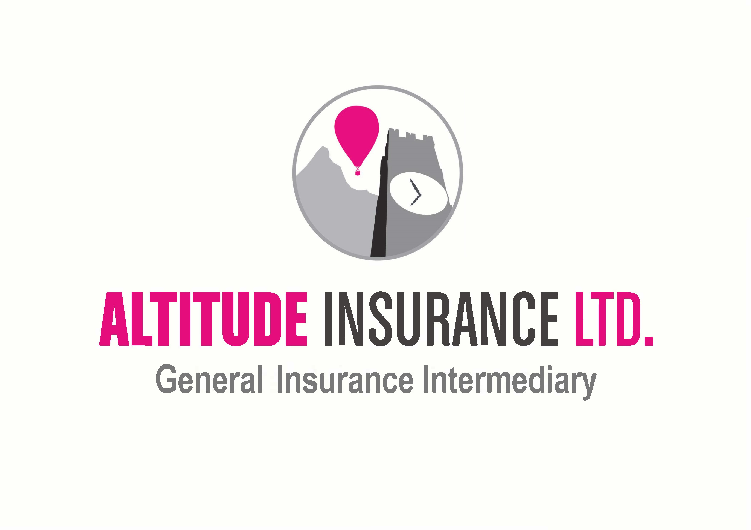

Questionnaire
By completing this Questionnaire, you are looking to enter into a legal contract with an insurance company, via your chosen Intermediary. You are obliged to answer all our questions honestly and disclose all information as set out below. If you have any questions, then we are here to answer them fairly.

We would like to ensure that all claims are paid for you, but unfortunately, we may find ourselves defenceless to assist you, when all the Facts are not disclosed at the outset. Such items include (but are not limited to) – all previous claims or incidents, description of risk to be covered and inaccurate general information.

In order to provide all necessary information to Insurers so that we are able to obtain a quotation, please can we ask for you to complete and return this document.

If you have any questions, need anything explaining or believe this Policy would not meet your needs, please contact us immediately.

About You/ Your Company/ Your Shop –

Company Name:
Your Name:
Business Address:
Home/ Work/ Mobile Number:
Email Address:
Your Country of Birth:
Your Country of Residence:
Your Occupation:
Would you define yourself as a Politically Exposed Person (PEP) – an individual who is or has been entrusted with prominent public functions in a foreign or domestic country?
Business Type i.e. PLC/ Ltd/ Sole Trader:
How many years has the business proposed been trading?
Annual Turnover:
Primary Trade - The trade description that best suits your company activities:
Is a secondary trade undertaken within the same premises?
Is the property shared with another business?
What year was the property built?
Is the property of standard construction? i.e. walls constructed of bricks, stone or concrete with slates, tiles or concrete flat roof and any other incombustible material?
Does the property have a flat felt roof?
What is the construction of all floors?
Does the property have composite panels?
Is the property heated solely by electricity, mains gas and/or solid fuel and/or oil-fired central heating or is not heated?
Does the property have a cash machine?
Does the business undertake any cooking or baking?
Is cover for buildings/ tenant’s improvements required?
Is cover required for Loss of Rent Receivable? (12 Months indemnity period only)
Is cover for Household Contents required? If so, please advise the Sum Insurers required.
Does the property have an intruder alarm?
Does the property have CCTV with 24-hour monitoring? (recorded only is not sufficient for this purpose)
Does the property have a fire alarm with central station monitoring?
Does the property have a maintained and operated sprinkler system?
Is the property occupied 24 hours by the proposer / on-site security?
Is there a business continuity plan in place?

Coverage Required –

Please advise the value(s) to be Insured:

Own contents, fixtures and fittings EUR

Computers, IT and electrical business equipment EUR

Stock other than that detailed below EUR

Cigarettes and Tobacco EUR

Wines & Spirits EUR

Coverage | Yes | No
Is cover for Loss of Licence required?
Frozen and Perishable Stock - our policy automatically includes cover up to
EUR2,000, is a higher amount required?
Goods in Transit - Our policy automatically includes cover up to EUR5,000 any one load, is a higher amount required?
Book Debt - Our policy automatically includes cover up to EUR10,000, is a higher amount required?
Money and Assault - The standard policy limits are:

Money EUR5,000 during business hours and in transit, EUR3,000 in a locked safe

Assault EUR25,000 death, EUR10,000 all other capitals, EUR100 per week TTD
Is a higher limit required for money in transit, during business?
Is a higher limit required for money locked in a safe?
Public and Product Liability - EUR 2,600,000 is automatically included, would
you like to increase this to EUR 6,500,000?
Does the business carry out any manual work away from the premises other than collection or delivery?

Business Interruption - Our policy automatically includes cover of gross

profit up to €500,000 with a 24-month indemnity period is a higher amount required?

Are you aware of any current or potential matters that will give rise to any legal or contractual disputes?

Excess - The current policy standard excess is €250, discounted increased excess options are available. Is an increased excess required?

Is cover required for business equipment away from the premises? (add items accordingly)

Assumptions –

In order to obtain a quotation, you must confirm that the following statements are correct: -
- The premises must NOT have been previously flooded, be located in an area which has previously flooded or be particularly exposed to flood damage
- The premises are in a good state of repair and sealed (including fascia, soffit, roof, windows and doors), to ensure the prevention of weather damage and water/rain ingress, all electrical circuits and appliances and all equipment is in good working order
- All exposed tanks, pipes & apparatus in the attic/boiler/plant room of the building(s) are adequately lagged and protected
- The property is not undergoing any construction, alteration or redevelopment and there are no plans to do so
- The premises meets all statutory obligations including Fire Safety, Electrical Inspections and Health and Safety regulations relevant to the premises and business
- All external doors are secured by 5 lever mortice deadlocks and all accessible windows are either secured by key operated locks or screwed permanently shut
- The business does not undertake any wholesaling or manufacturing process or export to any country or knowingly supply goods or services to the USA or Canada

Confirmation Yes ☐ No ☐

Please confirm that all principals, partners or directors have not:
- Had more than 3 claims in the past 5 years in respect of any of the risks to which the proposed insurance relates
- Been declined insurance or had an insurance policy cancelled or refused, cover restricted or been asked to pay an increased excess, either personally or in relation to any business they have been involved with
- Been refused a renewal or had special terms imposed (increased excess, restriction in cover), either personally or in relation to any business they have been involved with
- Been charged with (but not yet tried) or convicted of a criminal offence (other than motor offences)
- Got any outstanding Court Judgements, been subject to a winding up order, declared bankrupt or insolvent, or made any arrangement with creditors, or been a director or partner of a company which has gone into insolvent liquidation, receivership or administration
- Been prosecuted for failing to comply with any Health and Safety or Welfare or Environmental Protection legislation

Confirmation Yes ☐ No ☐

Claims Information –

Have you made any claims in the last 5 years?

Yes ☐ No ☐

If YES, please provide full details below: -

Date of Claim | Details | Approximate Cost of Claim

Declaration –

I/ We declare that to the best of my/ our knowledge, all the information given above is true and complete and contains all the necessary detail in order for Insurers to adequately quote my/ our risk. I/ We understand that this Questionnaire shall form the basis of any contact between me/us, Altitude Insurance Limited and Insurers and any incorrect statements/ information may render such contract void. I/ We accept that the basis of Insurance will be the standard Policy for this type of insurance as agreed between Altitude Insurance Limited and Insurers. I/ We accept that by providing Altitude Insurance Limited with contact details such as telephone numbers/ email address, Altitude Insurance Limited may use these in order to make contact regarding insurance products and/or services.

Has any Insurance Company ever, for ANY reason? -

Declined your proposal? Yes ☐ No ☐

Refused to renew your policy? Yes ☐ No ☐

Cancelled your policy? Yes ☐ No ☐

Required an increased rate or imposed special terms on renewal (for reasons other than claims history)? Yes ☐ No ☐

If YES to any of the above, please provide further details: -

Status
Altitude Insurance Ltd (‘the Company’) is regulated by the Central Bank of Ireland.

Terms of Business
You have previously been provided with the Company’s Terms of Business, which outline the basis on which we provide services to our clients. Please ensure that you have read this document carefully. These Terms of Business apply to all business transactions undertaken for you or services provided to you and will remain in force until further notice. Should we make any material changes to our Terms, we will advise you in advance of providing any further services to you.

Privacy Policy
Here at Altitude Insurance Ltd, we take your privacy seriously and will only use your personal information to provide the products and services you have requested from us.

However, from time to time we would like to contact you with details of other General Insurance products and services we provide. If you consent to us contacting you for this purpose, please tick to say how you would like us to contact you:

Post ☐
Email ☐
Telephone ☐

We may also use your data for Profiling for Marketing purposes – e.g., to identify if you are likely to want/ require any other forms of insurance we offer of in respect of risk assessments for fraud prevention/ AML purposes. If you would like to Opt Out from Profiling for Marketing purposes but not for Fraud Prevention or AML, please tick this box - ☐

Signature:
Name:
Date:

If the Policyholder is a Limited Company, is the person signing this a Director of the Company?

Yes ☐ No ☐

If any part of this form has been completed by anyone other than the Policyholder/ Director, please provide the relationship to the Policy holder: -

Altitude Insurance Limited complies with the requirements of the General Data Protection Regulation 2018 and the Irish Data Protection Act 2018. Altitude Insurance Limited is a Data Controller as defined in the Data Protection Act 1988 (Amended 2003). The 2003 Amendment Act brought the law into line with the EU Data Protection Directive 95/46/EC.

We only keep data for a purpose(s) that is specific, lawful and clearly stated and the data is only processed in a manner compatible with that purpose(s). An individual has a right to question the purpose for which we hold his/her data and we must be able to identify that purpose. The data which you provide to us will be held on a computer database and paper files for the purpose of arranging transactions on your behalf. The data will be processed only in ways compatible with the purposes for which it was given and as outlined in our Data Privacy Notice and Data Protection policy.

We will take all reasonable steps to ensure that any and all personal data you provide, will be held securely and in accordance with this Legislation(s). We will ensure that our data security procedures are adequate, abided by and robust enough to prevent unnecessary risk of loss of data and financial crime. In return, we will retain all ownership/ title/ copyright and other intellectual property over any and all materials utilised in the placement of your Policy.

We will only use your personal data for the purposes for which you have provided it to us – general insurance. We request this information as we believe that it is necessary in order for us to provide our services to you, including but not limited to, quotations/ arranging Policy coverage/ conducting our relationship with you/ marketing/ research and statistical analysis/ internal record keeping/ crime prevention.

In carrying out our services, it may be necessary to disclose any/ all of your personal data to Third Parties, including but not limited to, Insurers/ agents and service providers/ consultants/ our Affiliates/ industry regulators and professional advisors and auditors. Depending on the circumstances, the disclosure of personal data (including sensitive personal data) to any of the above may involve a transfer of data outside of the European Economic Area.

If personal data about any person other than the original proposer is included within this Questionnaire (and any subsequent documentation provided by us/ received by you), you confirm that they have given you permission to do so, have explained to them who we are and what we will use their data for, that you have made that person aware that we hold their personal data (i.e. name/ D.O.B. etc of any named Pilots) and that they can also request a copy of our TOBA for more information on our Data Protection policy.

Insurers may subscribe to industry databases for credit and/or fraud prevention i.e. the electoral roll and credit information, in this instance, your data may be passed on in order to share information. A record of the enquiry may be viewed by other companies if you apply for their services. Insurers may also pass information onto the Claims and Underwriting Exchange Register, run by Insurance Database Ltd (IDS Ltd). The aim is to help insurers to check information provided and also prevent fraudulent claims. When insurers deal with requests for insurance, they may search the register. When insurers are informed about an incident, which may or may not give rise to a claim, they will pass information relating to it to the register. You can ask insurers for more information about this. Insurers may also pass your information to reinsurers and/or loss adjusters.

By providing us with your personal data, you consent to all of the information being used/ processed/ disclosed and retained as required by Altitude Insurance Limited and/or GBJ. More information regarding Data Protection can be found in our Terms of Business Agreement.

