Altitude Insurance Ltd  General Insurance Intermediary  Director – Laura Durcan  Registered Address - Ground Floor, 8-9 Marino Mart  Fairview, Clontarf, Dublin, D03 P590, ROI  Telephone – 00353 (0)89 2231051/ 0044 (0)7780 552494  Email – office@altitudeinsuranceltd.com  www.altitudeinsuranceltd.com | 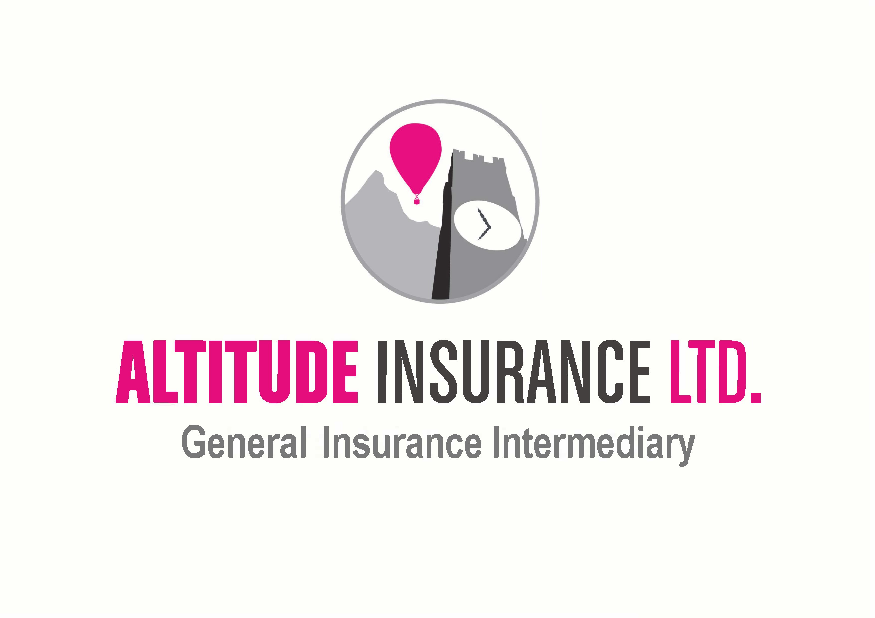

Questionnaire
By completing this Questionnaire, you are looking to enter into a legal contract with an insurance company, via your chosen Intermediary. You are obliged to answer all our questions honestly and disclose all information as set out below. If you have any questions, then we are here to answer them fairly.

We would like to ensure that all claims are paid for you, but unfortunately, we may find ourselves defenceless to assist you, when all the Facts are not disclosed at the outset. Such items include (but are not limited to) – all previous claims or incidents, description of risk to be covered and inaccurate general information.

In order to provide all necessary information to Insurers so that we are able to obtain a quotation, please can we ask for you to complete and return this document.

If you have any questions, need anything explaining or believe this Policy would not meet your needs, please contact us immediately.

If you employ anyone on a full-time, part-time, casual or even self-Employed labour basis, you are required by law (in the UK, recommended for ROI) to arrange and keep in force cover in respect of your legal Liability for death or injury including industrial diseases. The limit of indemnity is GBP 10,000,000 reducing to GBP 5,000,000 for acts of terrorism (or currency equivalent).

Whilst there is no legal requirement to provide Employers Liability insurance cover for Employed family members, we recommend that you have this cover.

About You –

Name of Insured/ Company Name:
Your Name (if different from above):
Insured Address:
Postcode:
Home/ Work Telephone Number:
Mobile Number:
Email Address:
Your Country of Birth:
Your Country of Residence:
Your Occupation:
Employers Reference Number (ERN – if applicable):
Business Type i.e. PLC/ Ltd/ Sole Trader:
Business Description 1. - The trade description that best suits your business activities (note the percentage of activities must total 100% and the main trade must be more than 50%):
Business Description 2. - The trade description that best suits your business activities (note the percentage of activities must total 100% and the main trade must be more than 50%):
How many years has the business proposed been trading?
Annual Turnover:
Does any of the business require the use of heat?

Assumptions –

In order to obtain a quotation, you must confirm that the following statements are correct: -
- The business meets all statutory obligations including Fire Safety, Electrical Inspections and Health and Safety regulations relevant to the business
- The business does not undertake any work or has never previously undertaken any work involving asbestos or asbestos containing materials
- The business does not undertake any work in aircraft operational areas, chemical works, gas works, nuclear installations, offshore installations, petrochemical works, power stations or railway infrastructure
- All persons working with children have their staff Garda vetted at least once per annum
- The business does not undertake any demolition work
- The business does not do any excavation work over 3 meters in depth
- The business does not have a waste transfer or waste carriers licence
- The business has been trading for at least 2 years with insurance continuously in force or the proposer has at least 3 years’ experience in their trade
- The proposer only works in Republic of Ireland and Great Britain, Northern Ireland, the Channel Islands or the Isle of Man
- There are no current or potential matters that may give rise to a legal or contractual dispute

Confirmation Yes ☐ No ☐

Please confirm that all principals, partners or directors have not:
- Had more than 2 claims in the past 5 years
- Been declined insurance, had an insurance policy terminated, been refused a renewal or had special terms imposed (increased excess, restriction in cover)
- Been charged with (but not yet tried) or convicted of a criminal offence (other than motor offences)
- Had any prosecutions or received notice of an intended prosecutions under Safety Legislation
- Had any Court Judgements against them
- Been declared bankrupt or insolvent
- Previously traded without insurance

Confirmation Yes ☐ No ☐

About your Employees –

How many manual Principal/ Partners/ Directors and their annual wage:
How many manual workers (including Permanent Labour Only Subcontractors) and their annual wage:
How many clerical Principals/ Partners and Directors and their annual wage:
How many other clerical workers and their annual wage:
Do you have/ use any temporary Labour Only Subcontractors? And their annual wage?
Do you use any Bone-Fide Subcontractors?
If yes, please advise the annual Turnover applicable to Bone-Fide Subcontractors:

Limits of Liability –

Please select the level of Public Liability indemnity required:

EUR 2,600,000 ☐

EUR 6,500,000 ☐

Do you wish to include EUR 13,000,000 cover in respect of Employers Liability?

Yes ☐ No ☐

Do you require Contract Works / Plant and Equipment?

Yes ☐ No ☐

Please advise the level of Turnover applicable to Contract Works:
EUR

Do you require Tools and Business Equipment cover?

Yes ☐ No ☐

Please advise the value for which you would like your Tools and Business Equipment covered:
EUR

Are you aware of any current or potential matters that will give rise to any legal or contractual disputes?

Yes ☐ No ☐

Is an increased excess of €1,000 required?

Yes ☐ No ☐

Claims Information –

Are you currently or have you been previously Insured for Employers or Public Liability?

Yes ☐ No ☐

If YES, please provide the following details: -

Name of Present/ Previous Insurer | Policy Number | Expiry Date

Have any Employer’s or Public Liability claims been made against you in the last 5 years whether Insured or Not?

Yes ☐ No ☐

If YES, please provide full details below: -

Date of Claim | Details | Approximate Cost of Claim

Declaration –

I/ We declare that to the best of my/ our knowledge, all the information given above is true and complete and contains all the necessary detail in order for Insurers to adequately quote my/ our risk. I/ We understand that this Questionnaire shall form the basis of any contact between me/us, Altitude Insurance Limited and Insurers and any incorrect statements/ information may render such contract void. I/ We accept that the basis of Insurance will be the standard Policy for this type of insurance as agreed between Altitude Insurance Limited and Insurers. I/ We accept that by providing Altitude Insurance Limited with contact details such as telephone numbers/ email address, Altitude Insurance Limited may use these in order to make contact regarding insurance products and/or services.

Has any Insurance Company ever, for ANY reason? -

Declined your proposal? Yes ☐ No ☐

Refused to renew your policy? Yes ☐ No ☐

Cancelled your policy? Yes ☐ No ☐

Required an increased rate or imposed special terms on renewal (for reasons other than claims history)? Yes ☐ No ☐

If YES to any of the above, please provide further details: -

Status
Altitude Insurance Ltd (‘the Company’) is regulated by the Central Bank of Ireland.

Terms of Business
You have previously been provided with the Company’s Terms of Business, which outline the basis on which we provide services to our clients. Please ensure that you have read this document carefully. These Terms of Business apply to all business transactions undertaken for you or services provided to you and will remain in force until further notice. Should we make any material changes to our Terms, we will advise you in advance of providing any further services to you.

Privacy Policy
Here at Altitude Insurance Ltd, we take your privacy seriously and will only use your personal information to provide the products and services you have requested from us.

However, from time to time we would like to contact you with details of other General Insurance products and services we provide. If you consent to us contacting you for this purpose, please tick to say how you would like us to contact you:

Post ☐
Email ☐
Telephone ☐

We may also use your data for Profiling for Marketing purposes – e.g., to identify if you are likely to want/ require any other forms of insurance we offer of in respect of risk assessments for fraud prevention/ AML purposes. If you would like to Opt Out from Profiling for Marketing purposes but not for Fraud Prevention or AML, please tick this box - ☐

Signature:
Name:
Date:

If the Policyholder is a Limited Company, is the person signing this a Director of the Company?

Yes ☐ No ☐

If any part of this form has been completed by anyone other than the Policyholder/ Director, please provide the relationship to the Policy holder: -

Altitude Insurance Limited complies with the requirements of the General Data Protection Regulation 2018 and the Irish Data Protection Act 2018. Altitude Insurance Limited is a Data Controller as defined in the Data Protection Act 1988 (Amended 2003). The 2003 Amendment Act brought the law into line with the EU Data Protection Directive 95/46/EC.

We only keep data for a purpose(s) that is specific, lawful and clearly stated and the data is only processed in a manner compatible with that purpose(s). An individual has a right to question the purpose for which we hold his/her data and we must be able to identify that purpose. The data which you provide to us will be held on a computer database and paper files for the purpose of arranging transactions on your behalf. The data will be processed only in ways compatible with the purposes for which it was given and as outlined in our Data Privacy Notice and Data Protection policy.

We will take all reasonable steps to ensure that any and all personal data you provide, will be held securely and in accordance with this Legislation(s). We will ensure that our data security procedures are adequate, abided by and robust enough to prevent unnecessary risk of loss of data and financial crime. In return, we will retain all ownership/ title/ copyright and other intellectual property over any and all materials utilised in the placement of your Policy.

We will only use your personal data for the purposes for which you have provided it to us – general insurance. We request this information as we believe that it is necessary in order for us to provide our services to you, including but not limited to, quotations/ arranging Policy coverage/ conducting our relationship with you/ marketing/ research and statistical analysis/ internal record keeping/ crime prevention.

In carrying out our services, it may be necessary to disclose any/ all of your personal data to Third Parties, including but not limited to, Insurers/ agents and service providers/ consultants/ our Affiliates/ industry regulators and professional advisors and auditors. Depending on the circumstances, the disclosure of personal data (including sensitive personal data) to any of the above may involve a transfer of data outside of the European Economic Area.

If personal data about any person other than the original proposer is included within this Questionnaire (and any subsequent documentation provided by us/ received by you), you confirm that they have given you permission to do so, have explained to them who we are and what we will use their data for, that you have made that person aware that we hold their personal data (i.e. name/ D.O.B. etc of any named Pilots) and that they can also request a copy of our TOBA for more information on our Data Protection policy.

Insurers may subscribe to industry databases for credit and/or fraud prevention i.e. the electoral roll and credit information, in this instance, your data may be passed on in order to share information. A record of the enquiry may be viewed by other companies if you apply for their services. Insurers may also pass information onto the Claims and Underwriting Exchange Register, run by Insurance Database Ltd (IDS Ltd). The aim is to help insurers to check information provided and also prevent fraudulent claims. When insurers deal with requests for insurance, they may search the register. When insurers are informed about an incident, which may or may not give rise to a claim, they will pass information relating to it to the register. You can ask insurers for more information about this. Insurers may also pass your information to reinsurers and/or loss adjusters.

By providing us with your personal data, you consent to all of the information being used/ processed/ disclosed and retained as required by Altitude Insurance Limited. More information regarding Data Protection can be found in our Terms of Business Agreement.

