Altitude Insurance Ltd  General Insurance Intermediary  Managing Director – Laura Durcan  Registered Address - Ground Floor, 71 Lower Baggot Street, Dublin, D02 P593, ROI  Telephone – 00353 (0)89 2231051/ 0044 (0)7780 552494  Email – office@altitudeinsuranceltd.com  www.altitudeinsuranceltd.com | 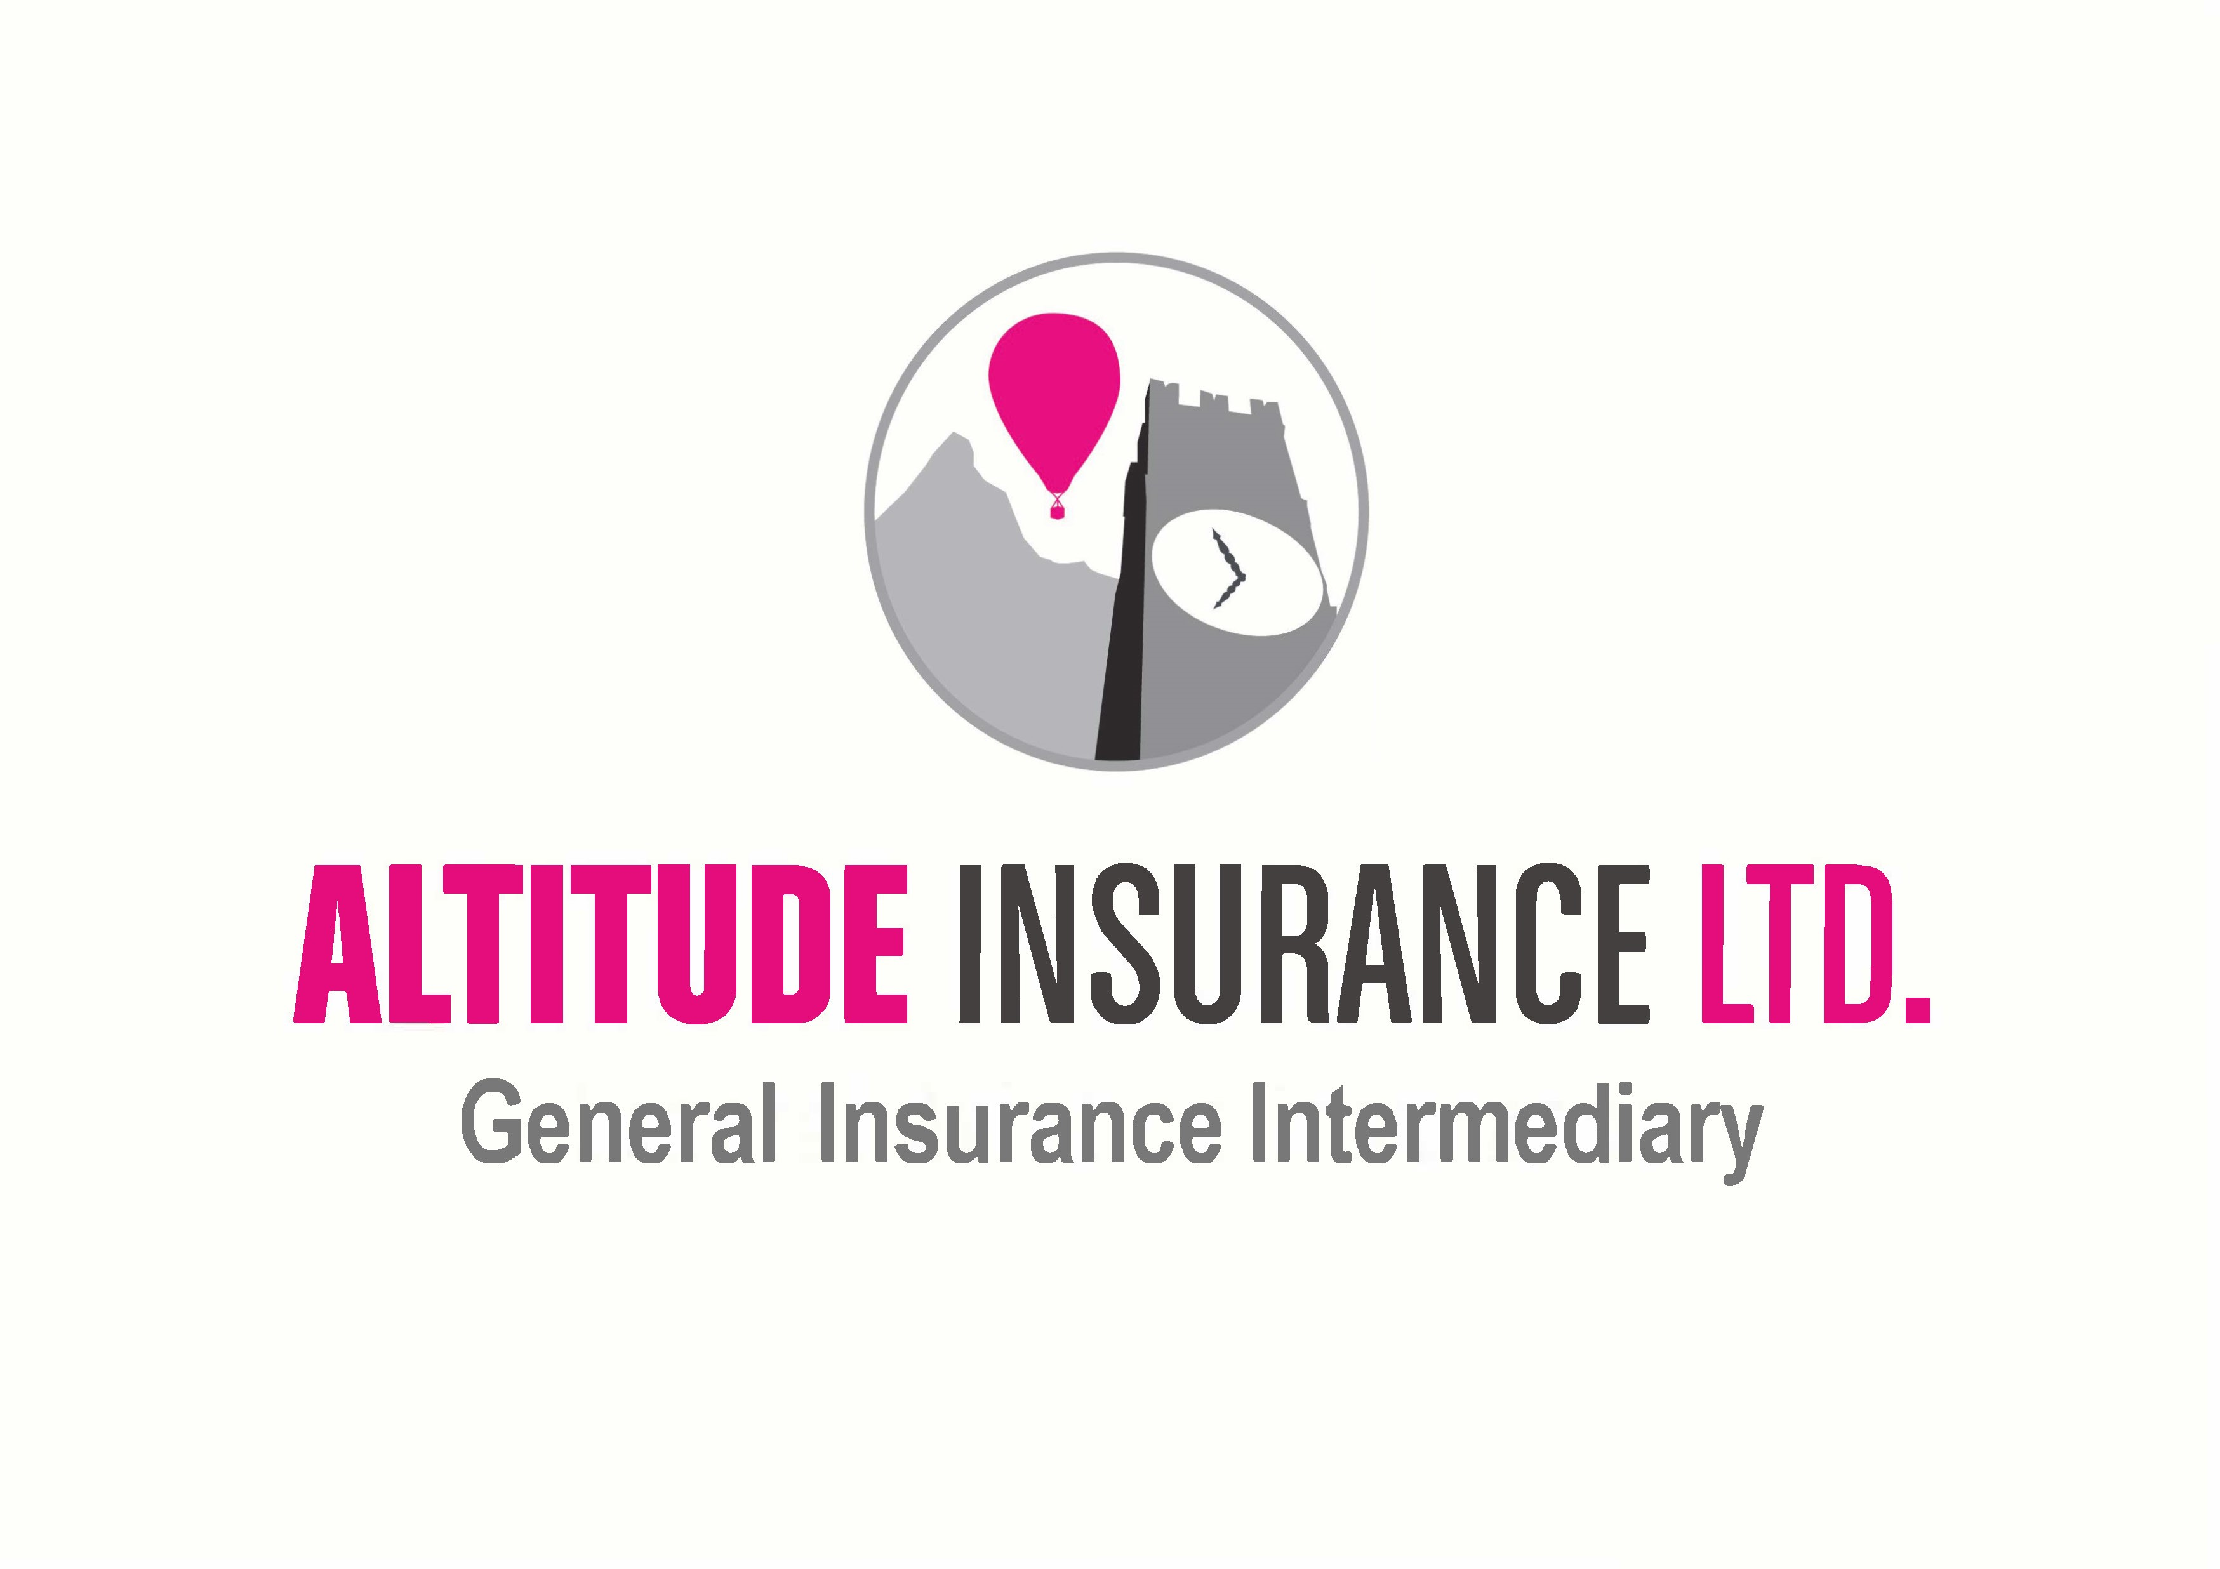

Claims Form
Immediate notice of any claim is to be given to –

Altitude Insurance Limited
Ground Floor,
71 Lower Baggot Street,
Dublin,
D02 P593
Republic of Ireland
Telephone – 00353 (0)89 2231051/ 0044 (0)7780 552494
Email – office@altitudeinsuranceltd.com
Please provide the following information when making a claim:

Aviation Claims –

Information Required | Details
Name of Insured:
Risk Reference:
Your Name:
Make and Model of Aircraft:
Registration of Aircraft:
Date of Incident:
Incident Location:
Pilot:
Type of Flight (Private or Commercial):
Type of Claim (Damage to Third Party/ Livestock/ Passenger/ Hull Damage):
Brief Description of Incident:

Non-Aviation Claims –

Information Required | Details
Name of Insured:
Risk Reference:
Your Name:
Date of Incident:
Incident Location:
Brief Description of Incident:

