Altitude Insurance Ltd  General Insurance Intermediary  Managing Director – Laura Durcan  Registered Address - Ground Floor, 71 Lower Baggot Street, Dublin, D02 P593, ROI  Telephone – 00353 (0)89 2231051/ 0044 (0)7780 552494  Email – office@altitudeinsuranceltd.com  www.altitudeinsuranceltd.com | 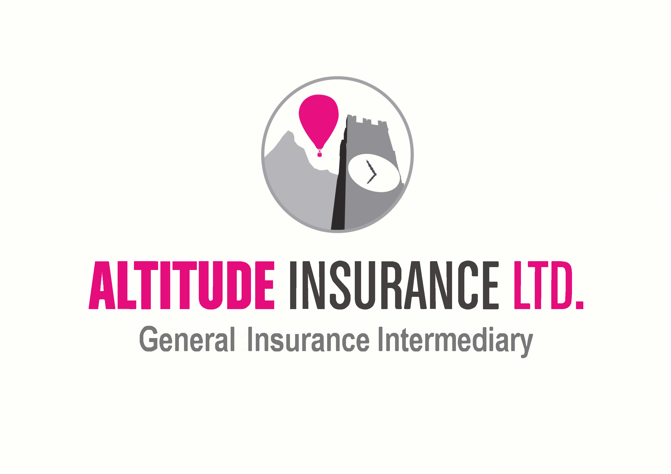

Customer Data Access Request Form
As our customer, you are entitled to request a copy of the personal data we hold about you within 30 calendar days and for no charge.

You are not obliged to use this form to request your data but, it helps us to process your request more promptly if you do.

Please provide the information requested in full using block capitals.

If there is something in particular you are looking for, please specify this.

You can post this form to us at the address above in which case we will post your personal data to you. Alternatively, you can email this form to us at office@altitudeinsuranceltd.com in which case we will send your personal data to the email address you provide us in a secure (encrypted) format.

Customer Name (please give us your full name):
Postal Address (please give us your correspondence address):
Email Address:
Date of Birth:
Policy Number(s):
If there is something in particular you are looking for, please specify giving as much detail as you can:
Customer Signature:
Date:
Office Use Only
Date Received:

