PulseNexis – Unlimited License Agreement

This agreement ("Agreement") is between the purchaser ("Licensee") and PulseNexis ("Licensor").

1. Grant of Rights

Licensor grants Licensee a non-exclusive, non-transferable, perpetual right to use the selected song(s) in:

- Commercial releases (music, streaming, retail)

- Advertising and marketing

- Film, TV, or video content

- Public performances

- Client work or freelance media projects

2. Restrictions

Licensee may not:

- Re-sell or re-license the music as standalone audio

- Claim ownership of the original master or composition

- Use the music in obscene, defamatory, or hate-based material

3. Ownership

Licensor retains full ownership of all copyrights. This agreement grants usage rights only, not authorship or publishing claims.

4. Credit

Credit must be given in applicable formats as: “Music licensed from PulseNexis”

5. Payment

Full payment is required before license delivery. Price for Unlimited License: $299 per song or per terms agreed upon.

6. Termination

License is revoked upon breach of terms or failure to complete payment.

7. Governing Law

This Agreement is governed by the laws of [Nevada/Clark Country].

Signed electronically upon purchase by Licensee and Licensor.

Licensor 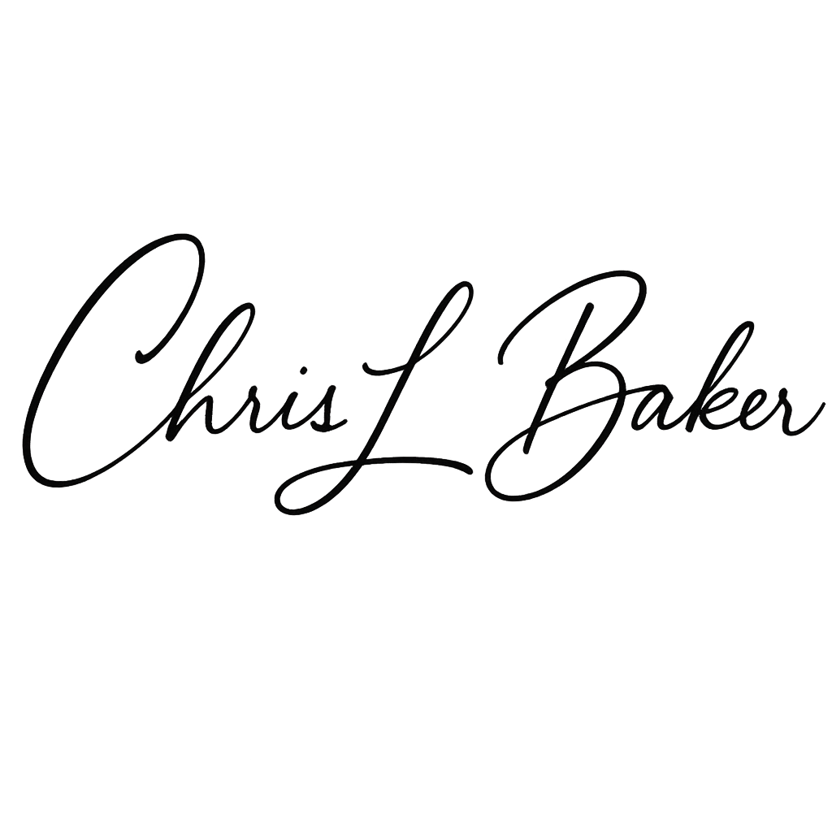

Licensee_____________________________________