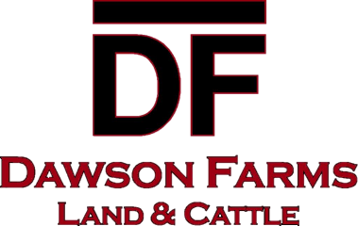
3888 Hwy 3 • Dawson, ND 58428
Office: 701-327-1258 • Fax: 701-327-1260 • Email: dawsonfm@bektel.com

July 16, 2026

The 2026 harvest is fast approaching at Dawson Farms, and we are looking for independent tandem drivers. The potato harvest will start in early September 2026.

Simplot is requiring Dawson Farms to submit a list of all tandem drivers prior to the start of harvest. Due to this, all paperwork must be submitted to the Dawson Farms office by August 10, 2026. Please read and sign all of the enclosed forms and return with a Proof of Insurance Certificate via mail or fax. Each driver needs to sign a GAP Form. Remember, you will not receive payment UNTIL all paperwork is turned in. Payments will be made on designated payday only. CWT rate will be decided closer to harvest start-up.

If you are planning to purchase a 10% Over Permit from the DOT, you will need to have this in your possession prior to transporting any potatoes. Dawson Farms employees will not be responsible for obtaining these permits for you.

If you have any questions, please feel free to contact Mike Sitzmann at 701-320-8777, Michael Sitzmann at 701-320-8776 or myself at 701-327-1258. Thank you for hauling for Dawson Farms. We look forward to seeing you this fall and having a great harvest! For more information closer to September check out our website for any updates
www.dawsonfarmslandandcattle.com

Sincerely,

Hannah Smith

