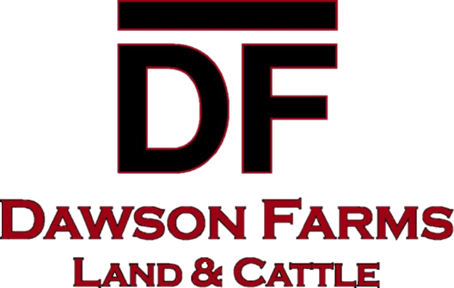

2025 TRUCKING AGREEMENT

This agreement is entered by and between Dawson Farms and _____________________________________________ (hereinafter, “Trucking Company”)

Whereas Dawson Farms is a partnership engaged in various agricultural enterprises, and

Whereas Trucking Company is an independent concern, engaged in the enterprise of trucking; and

Whereas Dawson Farms desires to engage Trucking Company to help haul its crop of potatoes to facilitate its fall potato harvest; and

Whereas, Dawson Farms pays Trucking Company by the cwt of potatoes hauled by Trucking Company, the price of which has been mutually agreed upon between the parties in the separate agreement; and

Whereas the parties hereto, wish to reduce to writing the terms and conditions of their agreement with respect to liability

NOW THEREFORE, based on the premises contained herein, and for good and valuable consideration, the parties hereto agree as follows:

1. Trucking Company is responsible for the maintenance of its trucks.
2. Trucking Company is responsible for all its operating costs including but not limited to fuel, repairs, supplies, insurance and personal expenses.
3. Trucking Company is an independent contractor and operators of the trucks are not employees of Dawson Farms.
4. Trucking Company is responsible for providing operators for its trucks.
5. Trucking Company agrees to that Dawson Farms shall not carry Workers Compensation insurance on Trucking Company’s operators and hereby waives and releases Dawson Farms from any liability there from.
6. Trucking Company agrees to indemnify and hold Dawson Farms harmless of all loss or damage Dawson Farms might suffer because of an accident or injury to Trucking Company’s operators, that occurs during fall potato harvest or any other time operators are working within the scope of Trucking Company’s contract with Dawson Farms. Part of the consideration for this contract and other contracts that might exist between Dawson Farms and Trucking company, is that the burden of Workers Compensation Insurance for employers and employees, is hereby assumed by Trucking Company because of their independent contractor status.
7. Trucking Company agrees to carry full liability insurance (with a minimum combined single limit of $500,000.00) on all equipment used by Trucking Company during the scope of this contract and to name Dawson Farms as an additional insured therein. Trucking Company agrees to deliver to Dawson Farms a Certificate of Insurance prior.
8. Trucking Company agrees to have a current DOT inspection of its truck(s) and to be complying therewith.
9. **Trucking Company agrees to wrap trailer bows** and use care when loading product so minimal damage occurs.
10. Trucking Company agrees to abide by all Good Agricultural Practices (GAP).
11. Trucking Company and **ALL** drivers agree, by signing below, to abide by all above policies.

_____________________________________Date___________________________________

**Trucking Company/Individual**

_____________________________________Date____________________________________

**Driver**

_____________________________________Date____________________________________

**Driver**

_____________________________________Date____________________________________

**Driver**

_____________________________________Date____________________________________

**Driver**

_____________________________________Date____________________________________

**Driver**

_____________________________________Date____________________________________

**Driver**