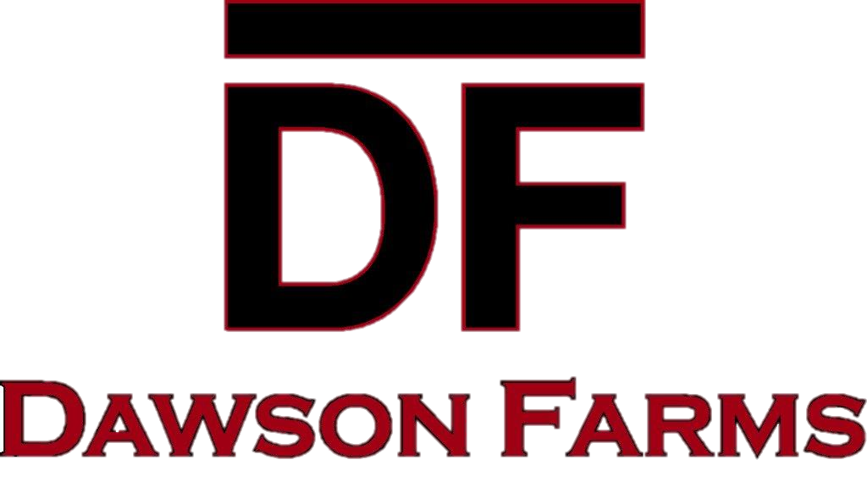
July 16, 2025

Potato harvest is approaching soon. As always, I am seeking dependable, patient, self-motivated truck drivers to transport potatoes to Simplot in Grand Forks, ND. I will need hopper bottoms (must have a 15” clearance) or live bottom belted trailers.

Our approximate start date will be September 8. Length of harvest could be 2-3 weeks depending on weather conditions; I would appreciate the trucks for the duration. We will be running two lines simultaneously, one in Dawson and the other in Tappen. We do not have any early plant loads this year. With the fluctuation of fuel prices, the rate will be determined closer to the start of harvest. Once I know, I will post the rate on our website along with an updated start date, trucking documents and any other pertinent information so, please stay posted on dawsonfarmslandandcattle.com.

Kidder County Overweight permits will be available for $50 for 2 weeks. Speed limits will be enforced! This permit will become null and void if a violation occurs. I will not be responsible for obtaining these permits for you. Any questions regarding the permit, call Jean at 701-475-4547.

Enclosed is our standard Trucking Agreement, a W-9, Good Agricultural Practices (GAP) and a Direct Deposit form. Please read the agreements/sign, complete and return all documents along with a Proof of Insurance Certificate via mail, fax or email. Information is provided below. This is first come first serve, I will need all documentation prior to harvest.

If you have any questions, please feel free to contact me. If you want to stop at the office, we are located 1 mile south of the Dawson exit 208.
My office hours prior to harvest are 8:00am-4:00pm.

EVERYONE IS RESPONSIBLE FOR THEIR GARBAGE. NO SMOKING OR EATING WHILE LOADING TRUCKS.
No unleashed dogs.

Many thanks to those of you that hauled for us last fall.
I hope to see all of you again!

Please stay posted on our website for any updates at: dawsonfarmslandandcattle.com

Best Regards,

Enedilza Montemayor
Dawson Farms Land & Cattle

Office: 701-327-1258 (Office Hours: 8:00 am – 4:00 pm)
Fax: 701-327-1260
Email: Emontemayor@RDOFFUTT.COM
Address: Dawson Farms • 3888 Hwy 3 • Dawson, ND 58428

TRUCKING INFORMATION
NAME OF DRIVERS: _________________ Cell ______________
_________________ Cell ______________
_________________ Cell ______________
Number of trucks you will have daily _________________
PAYMENT INFORMATION
I wish to use Direct Deposit ( ) Direct Deposit form enclosed
Please issue my check to: _____________________________________________
( ) Place my check in the scale house
( ) Mail my check to:
________________________________________________________________________________________________________________________________________________________________________________________________________
Any questions regarding payroll contact Hannah Smith 701-327-1258/701-320-8778

PLEASE MAKE SURE WE HAVE ALL YOUR COMPLETED PAPERWORK ON FILE (You won’t get paid until we have it) W-9, Trucking Agreement, GAP Agreement, Direct Deposit, Proof of Insurance.
SCALE TICKETS / BILL OF LADINGS NEED TO BE TURNED INTO THE OFFICE OR LEFT IN THE SCALE HOUSES or EMAILED TO dawsonfm@bektel.com BY 10AM SUNDAY. If you choose to be paid by CHECK, they will be MAILED Weekly. Direct Deposit will be Wednesdays, weekly. PAY STUBS will be EMAILED so please make sure to provide us with your updated email address. (Pay period is Sunday thru Saturday)

Rev: 7/1/2024 JJA

