January 25, 2026 – Third Sunday in Ordinary Time

Saturday – Jan 24th – Vigil Mass
5:00PM Intentions of Bernie Boylan (Steinberg Family)

Sunday – Jan 25th – Mass is Streamed Live
9:30AM Intentions of Cherie Hoops (Steinberg Family)

Monday – Jan 26th – Weekday – St. Timothy & St. Titus, Bishops
9:00AM Protection of the Unborn (Parish Community)

Tuesday – Jan 27th – Weekday – St. Angela Merici, Virgin & Religious Founder
9:00AM Living/Deceased Members of St. Lawrence

Wed. – Jan 28th – Weekday – St. Thomas Aquinas, Priest & Doctor of the Church
9:00AM World Peace (Parish Community)

Thurs. – Jan 29th – Weekday –
9:00AM Readings & Communion Distribution Only
Friday – Jan 30th – Weekday –
9:00AM Wounded Warriors & First Responders (Parish Community)

Saturday – Jan 31st – Weekday – St. John Bosco, Priest
9:00AM Joseph Balkus (Helfant Family)

Please Pray for Our Sick and Housebound, Deceased Members, for an End to
Abortion and Respect for all Life!
Lynda Stefanski, Peter Libasci, Joseph Bonk, Tom Trotter, Dave Blessing, Jeff Olimpo,
Matt Sebastiano, Maria Middleton, Fern & John Gibson, William Merkle, Russ Funkhouser,
Joseph Jones, Elizabeth Ann Schlotter, Andrew Schlotter, Bethany Steinberg, Joann Thaler,
Julie Petry, Steven Fusco, Greg Gambino, Patrick D. Brown, Douglas Defreest, Jr., Benny
LoScalzo, Steve Ombalski, Jane Burger, Ginny LaBar, Michael Gawronski, Marciano Alves Viera, Bernadette Maszczak, Shawn Kelly, Beth Collins, Nikia Helfant Messier, Anthony Libasci, Louis Cortese, Faith Marie Messier, Ann Lewis, Alvin LaBar, Emma Jones, Bernie Boylan

Church of Saint Lawrence Rev. Walter J Benn, Pastor
345 Elmwood Lane Rectory: 610-749-2684
Riegelsville, PA 18077 Email: saintlawrence@verizon.net

Website: saint-Lawrence-church.org
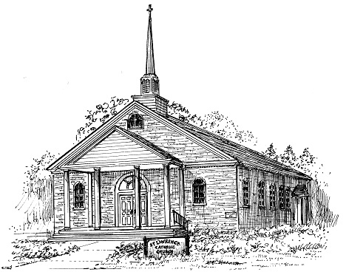
Mass Schedule: Saturday Evenings @ 5PM; Sunday Morning @ 9:30AM; Holy Days @ 9AM, 12 Noon & 7PM; Monday, Tuesday, Wednesday, Friday, Saturday @ 9AM, Thursday Readings & Communion Distribution Only.
Eucharistic Adoration: Wednesday @ 9:30AM – 11AM
Confessions: Saturday @ 3:30PM - 4:30PM @ Church. Via Appointment - Contact Rectory
Holy Name Society: Meets Monthly; Second Monday @ 7PM @ Ceader Hall (Sept – May)
Altar Rosary Society: Meets Monthly; Second Thursday @ 7PM (Sept – May)
Lay Carmelite Community of St. Teresa of Jesus of Los Andes: Meets Monthly, First Saturday Following the 9AM Mass in Ceader Hall.
Marthas & Marys Ministry: Faith based group, meets First Friday @ 11:30AM @ Ceader Hall
Weddings: Contact Rectory for Details. Plans Preferred Minimun 6 Months in Advance.
Parish PREP Classes & New Parishoners: Contact Rectory via Phone or email.
Rectory Office: Mon-Fri @ 9:30AM – 12 noon

Pastor’s Corner January 25, 2026

Often, when most people think of Palestine, they think of it as a region bordering a desert. And indeed, there are many sections of that land that are. However, it is surprising to learn that agriculture has always been a large part of Israel’s economy and that fish is a popular part of the population’s diet. Those fish came from either the Mediterranean Coast or the Sea of Galilee, a very large freshwater lake. Wherever there is water, the people make it work for them. The city of Capernaum was a successful city because it hosted a large population of fishermen; in time, it would also become Jesus’ base of operations. It is not surprising to hear that Jesus is walking along the shore of the Sea of Galilee. Today’s Gospel gives us a peek into how Jesus went about developing his followers and eventually preparing some of them as future leaders of the Church.

As Mathew relates the story, he is anxious to portray Jesus as the Son of God, with divine powers. This would be important to his congregation, who were initially almost exclusively Jewish and very familiar with what we call the Old Testament. Recall when God created the world. He spoke, and something came into being. He spoke, and the Sun was created. He spoke, and the birds of the air would come into existence. In ancient Jewish thought, God’s spoken word held power. What do we see in today’s Gospel? Jesus is walking along the shore of the Lake; he encounters the fishermen, Simon and his brother Andrew, James and his brother John. He interrupts their work by calling out to them. He calls them to join him. Incredibly, they drop everything; leave everyone, including their expensive boats and equipment, to follow Our Lord. Perhaps they had heard Jesus preaching in their synagogue, witnessed his acts of compassion, or seen him perform a healing miracle. Maybe not. But what is evident is that the power of Our Lord’s love, wrapped in the words of His invitation, was irresistible; it touched their hearts. Our Lord’s words did not overpower them; rather, His words inspired them.

My brothers and sisters, there is no doubt in my mind that Our Lord speaks to each of us, especially at key moments in our lives, in the life of the Church, and in the life of those whom He calls us to bring His Good News. Only the person who pays attention to God will hear his voice. If we are not women, men, and children of prayer, we will never hear His voice, understand or recognize His invitation, nor understand the new path He has called us to travel.
Serious prayer and reflection must be a part of our daily life. Keep working at it!

Your brother in Christ,

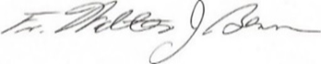
Collections: January 18 Parish @ $1853, Thank You.
Need Your Help If You Can: we are in need of Altar Servers, Eucharistic Ministers & Lectors. Advise Fr. Benn. Thank you!!
Martha & Mary Society: Thank you to the anonymous donor for their generous donation. Appreciated & needed.
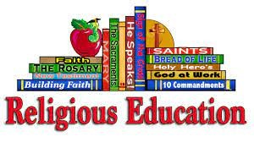
Religious Education Financial Assistance: forms available in vestibule for Fall 2025 & Spring 2026. Provided by the Ceader Trust Trustees. Time sensitive, act now. Deadline March 1, 2026.
Weekly Contribution Envelopes 2026: are available for pick up in church. Please make the time to do so. Envelopes not picked up by February 1 will be discarded and removed from the 2027 envelope list. No changes can be made to the 2026 product which was completed in October2025.

Bingo Night @ St. John The Baptist, Friday Jan 30th. Doors open @ 6PM. Gaming starts @ 7PM. Admission $30pp or $35pp @ door. BYOB, Ditto your own snacks. Age 18 + years only Please.
2025 Day of Sanctification for Priests:
Prayer: “Lord our God, who is governing your people; make use of the ministry of Priests, grant to these men; preserving obedience to your will, so that by their ministry & life, they may gain glory for you in Christ; Who lives & reigns with you in the unity of the Holy Spirit, God, forever & ever. Amen”.
Knights of Columbus THANK YOU: to the anonymous donor for their generous donation. Your support is gratefully appreciated.
Crab Cake Sale: KOC accepting orders Jan 31 - Feb 8. Order forms in vestibule.


- How do you make an egg-roll?
- Where do polar bears keep their money?
- What do you call an angry carrot?
- What did the janitor say when he jumped out of the closet?
- What did the horse say after it tripped?
- Imagine that you are in a boat, in the middle of the sea. Suddenly, you are surrounded by hungry sharks, just waiting to feed on you. How can you put an end to this?
- Push it; 2) In a snow bank;
- A steamed veggie; 4) Supplies; 5) Help; I’ve fallen and I can’t giddy up; 6) Stop imagining

