Arugula Salad with Lemon Dressing

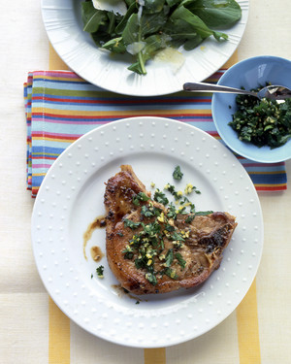
This salad sounds simple, but the flavors meld together perfectly, making it a go-to recipe.
Source: Everyday Food, January/February 2005
15 mins15 mins4
TOTAL TIMEPREPSERVINGS

INGREDIENTS
- juice of 1 lemon
- 2 tablespoons olive oil
- 1/4 teaspoon ground pepper
- 1 pound (2 to 3 bunches) arugula
- 2 ounces Parmesan cheese

DIRECTIONS
- 1. In a small jar or bowl, combine lemon zest and juice with olive oil, coarse salt, and ground pepper; shake or whisk to combine.
- 2. Wash arugula and remove stems; place leaves in a large bowl. With a vegetable peeler, shave Parmesan cheese over arugula; toss with dressing. Garnish with more grated zest, if desired.

