Butternut Squash, Feta, and Arugula Salad

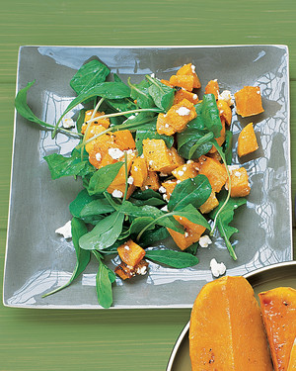
The sweet-tasting squash is counterbalanced with the salty cheese and tangy arugula in this salad.
Source: Everyday Food, October 2004
55 mins10 mins
TOTAL TIMEPREP

INGREDIENTS

❯

- 1 medium butternut squash
- 2 teaspoons olive oil
- 1/4 cup crumbled feta cheese (1 ounce)
- 1 bunch (5 ounces) torn arugula

DIRECTIONS
- 1. Preheat oven to 425 degrees. Prepare 1 medium butternut squash; cut into 3/4-inch cubes. In a roasting pan, combine squash with olive oil; season with coarse salt and ground pepper. Toss to coat and spread squash in a single layer. Roast until fork-tender, 35 to 45 minutes.
- 2. Transfer squash to a bowl; gently toss with crumbled feta cheese and torn arugula.

