Butternut Squash with Maple Butter

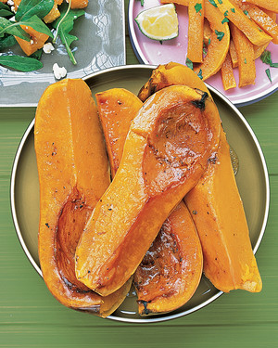
This is a simple way to enjoy and enhance the squash's inherent sweetness.
1 hour 5 mins5 mins
TOTAL TIMEPREP

INGREDIENTS
❯

- 1 medium (unpeeled) butternut squash
- 1 tablespoon butter
- 2 teaspoons pure maple syrup
- coarse salt and ground pepper

DIRECTIONS
- 1. Preheat oven to 425 degrees. Halve butternut squash lengthwise; scoop out seeds. Place cut sides up in a roasting pan (to help it sit level, slice a thin strip from skin sides). Fill each cavity with butter and pure maple syrup; season with coarse salt and ground pepper. Roast until fork-tender, 45 minutes to 1 hour.
- 2. Halve squash again lengthwise; spoon butter mixture from pan over tops (skins are edible).

