SUPER GREEN SMOOTHIE BOWL

I’ve been drinking a green smoothie for breakfast for about five years now.
There’s a certain sense of accomplishment that comes with working out and getting in two servings each of fruit and vegetables before 10 a.m.
But have you heard the new thing about smoothies? You can put them in BOWLS. Yes, bowls. Why, you ask?
Because you can make them into even more of a complete meal with the simple addition of a few blend-in ingredients and toppings. Count me in!

This smoothie bowl is absolutely delicious. Plus, it’s simple (as always), requiring just 10 minutes to make, and entirely customizable. I provide a basic round-up of ingredients for you to start with so you can then experiment and make this bowl your own.
The basic idea, in my opinion, is to make a slightly thicker, more nutritionally dense smoothie (with things like avocado and nut butter) and then top it with some game-changing ingredients, like coconut, hemp seeds, granola, nut butters, etc. You get the drift.
Basically, anything in your pantry that will take your smoothie from tide-me-over snack to seriously-substantial meal.
My ideal green smoothie bowl has:
Super bright green color (achieved with lighter-colored berries and loads of greens)
Nut butter for extra protein
Avocado for healthy fats and richness
Flaxseed meal for fiber
And natural sweetness from frozen bananas

When it comes to toppings, a few of my favorites include:
Roasted unsalted sunflower seeds
Grain-Free Granola
Unsweetened coconut
Fresh berries
& Hemp seeds
I also think coconut butter, peanut butter, or even a crumbled-up Coconut Berry Muffin would be amazing! Dream big, people – the options are endless.
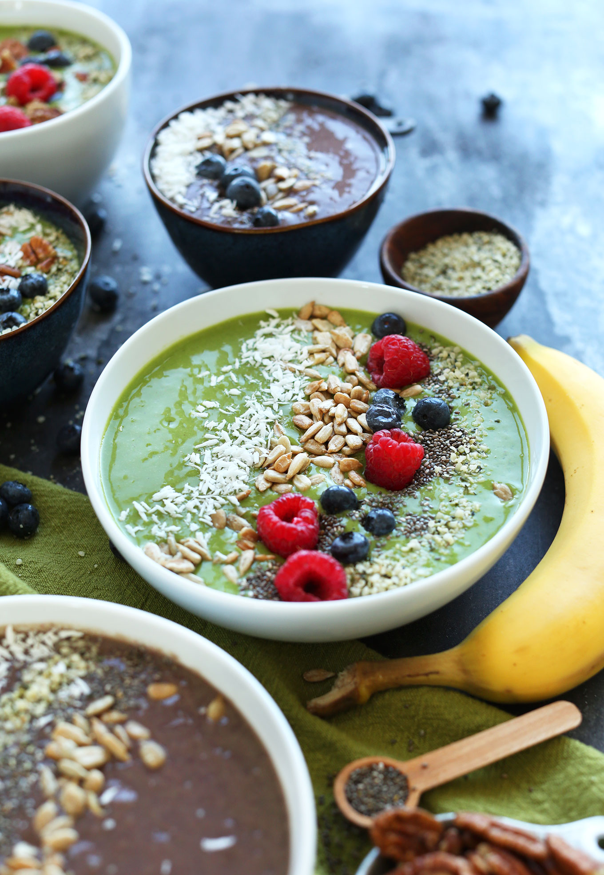
SUPER GREEN SMOOTHIE BOWL

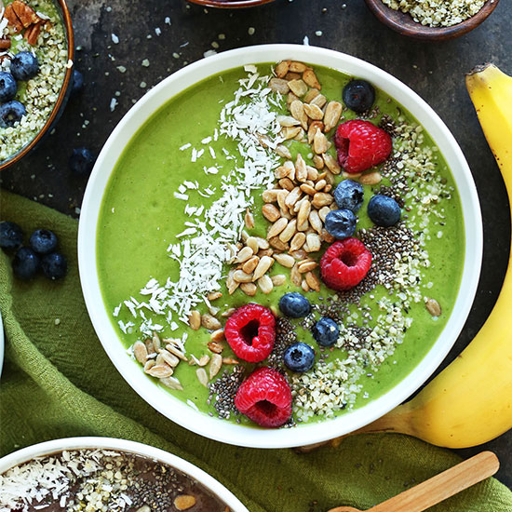
PRINT FRIENDLY VERSION
Prep time
10 mins
Total time
10 mins

Simple SUPER green smoothie bowls packed with tons of greens and customizable toppings! The healthiest and easiest way to turn a smoothie into a meal.
Author: Minimalist Baker
Recipe type: Smoothie, Beverage
Cuisine: Vegan, Gluten-Free
Serves: 2
Ingredients
SMOOTHIE
- 1/4 ripe avocado
- 2 medium ripe bananas, previously sliced and frozen
- 1 cup fresh or frozen mixed berries (organic when possible) - use strawberries/raspberries for a greener smoothie, darker berries for a purple smoothie
- 2 large handfuls spinach (organic when possible)
- 1 small handful kale (organic when possible), large stems removed
- 1 1/2 - 2 cups unsweetened non-dairy milk (DIY or store-bought - will depend on if your berries are frozen)
- 1 Tbsp flaxseed meal
- Optional: 2 Tbsp salted creamy almond or peanut butter
TOPPINGS (optional)
- Roasted unsalted sunflower seeds
- Granola
- Raw or roasted nuts (almonds, pecans, walnuts, etc.)
- Shredded unsweetened coconut
- Fresh berries
- Hemp seeds
Instructions
- Add all smoothie ingredients to a blender and blend until creamy and smooth. Add more almond milk (or water) to thin.
- Taste and adjust flavor as needed, adding more ripe banana (or maple syrup) for added sweetness, more spinach for a bright green hue, or almond milk for creaminess.
- For the green smoothie, I used strawberries, which let the green color come through more. For the purple bowl, I used darker berries (raspberries, blackberries, blueberries).
- For more protein, add nut butter! This also offsets / enhances the natural sweetness of the smoothie.
- Divide between 2 serving bowls and top with desired toppings!
- Best when fresh, though leftovers can be kept in jars in the fridge for up to 1-2 days.
Notes
*Nutrition information is a rough estimate for 1 of 2 smoothie bowls calculated with nut butter and without toppings.
*Adapted from my Favorite Green Smoothie.
Nutrition Information
Serving size: 1 bowl (1/2 of recipe) Calories: 310 Fat: 15.6g Saturated fat: 1.9g Carbohydrates: 41.5gSugar: 19g Sodium: 171mg Fiber: 9.5g Protein: 7.9g

