

It was a pleasure seeing you today. I hope that I was able to answer all of your questions. My goal is to partner with you to help you meet your healthcare needs. If you would like to schedule another appointment with me, please call 763-421-7300. Have a great day!
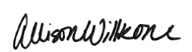
Allison Willkom, DPM

What is Pediatric Flatfoot?
Flatfoot is common in both children and adults. When this deformity occurs in children, it is referred to as a “pediatric flatfoot,” a term that actually includes several types of flatfoot. Although there are differences between the various forms of flatfoot, they all share on characteristic – partial or total collapse of the arch.
Flatfoot can be apparent at birth or it may not show up until later years, depending on the typ of flatfoot. Some forms of flatfoot occur in one foot only, while others may affect both feet.
Types of Pediatric Flatfoot
Various terms are used to describe the different types of flatfoot. For example, flatfoot is either asymptomatic (without symptoms), or symptomatic (with symptoms).
Most children with flatfoot have no symptoms, but some children have one or more symptoms. When symptoms do occur, they vary according to the type of flatfoot. Some signs and symptoms may include:
- Pain, tenderness, or cramping in the foot, leg, and/or knee
- Outward tilting of the heel
- Awkwardness or changes in walking
- Difficulty with shoes
- Reduced energy when participating in physical activities
- Voluntary withdrawal from physical activities
Other terms used to describe the different types of flatfoot include flexible or rigid. Flexible means that the foot is flat when standing (weight-bearing), but the arch returns when not standing. Rigid means that the arch is always stiff and flat, whether standing on the foot or not. Several types of flatfoot are actually categorized as rigid, the most common being:
- Tarsal Coalition – this is a congenital condition (exists at birth). It involves an abnormal joining of two or more bones in the feet. Tarsal coalitions may or may not produce pain, but if and when pain does occur, it usually starts in preadolescence or adolescence.
- Congenital Vertical Talus – Because of the foot’s rigid “rocker bottom” appearance that occurs with this condition, this condition is apparent and usually diagnosed in the newborn. Symptoms begin at walking age, since it is difficult for the child to bear weight and wear shoes.
Diagnosis
In diagnosing flatfoot, the Foot & Ankle specialist examines the foot and observes how it looks when the child stands and sits. The podiatrist also observes how the child walks and evaluates the range of motion of the foot. Because flatfoot is sometimes related to problems in the leg, the podiatrist may also examine the knee and the hip. X-rays are often taken to determine the severity of the deformity. Sometimes sand MRI or CT scan and blood tests may also be ordered.
Treatment
Non-Surgical Approaches
If a child’s flatfoot is asymptomatic, treatment is often not required. Instead, the condition will be observed and re-evaluated periodically. Custom orthotic devices may be considered for some cases of asymptomatic flatfoot. In symptomatic pediatric flatfoot, treatment is required. The patient’s foot and ankle surgeon may select one or more approaches, depending on the child’s particular case. Some examples of non-surgical options include:
- Activity Modifications. The child needs to temporarily decrease activities that bring pain as well as avoid prolonged walking or standing
- Orthotic Devices. Provider may prescribe custom orthotic devices that fit inside the shoe to support the structure of the foot and improve function.
- Superfeet – Men (Green / Blue), Women (Green/ Berry)
- Green tends to have slightly higher arch than the latter option
- REI, Dicks Sporting, Schuler Shoes, Amazon
- 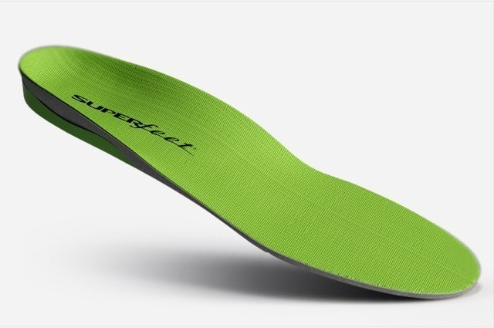

- Physical Therapy. Stretching exercises, supervised by the podiatrist or physical therapist, can help provide relief in some cases of flatfoot.
- Medications. Non-steroidal anti-inflammatory medications (NSAIDs), such as Ibuprofen, may be recommended to help reduce pain and inflammation.
- Shoe Modifications. Your podiatrist may advise you on footwear characteristics that are important for the child with flatfoot.
When is Surgery Needed?
In some cases, surgery is necessary to relieve the symptoms and improve foot function. Podiatrists perform a variety of techniques to treat the different types of pediatric flatfoot. The surgical procedure or combination of procedures selected for your child will depend on his or her particular type of flatfoot and degree of deformity.
Adapted from ACFAS Literature & https://www.annapolisfootandankle.com/docs/handouts/handout-pediatricflatfoot.pdf

