

It was a pleasure seeing you today. I hope that I was able to answer all of your questions. My goal is to partner with you to help you meet your healthcare needs. If you would like to schedule another appointment with me, please call 763-421-7300. Have a great day!

Allison Willkom, DPM

What Is Haglund’s Deformity?
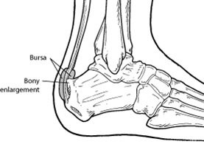Haglund’s deformity is a bony enlargement on the back of the heel. The soft tissue near the Achilles tendon becomes irritated when the bony enlargement rubs against shoes. This often leads to painful bursitis, which is an inflammation of the bursa (a fluid-filled sac between the tendon and bone).
Causes
Haglund’s deformity is often called “pump bump” because the rigid backs of pump-style shoes can create pressure that aggravates the enlargement when walking. In fact, any shoes with a rigid back, such as ice skates, men’s dress shoes or women’s pumps, can cause this irritation.
To some extent, heredity plays a role in Haglund’s deformity. Inherited foot structures that can make one prone to developing this condition include:
- A high-arched foot
- A tight Achilles tendon
- A tendency to walk on the outside of the heel.
Symptoms
Haglund’s deformity can occur in one or both feet. The symptoms include:
- A noticeable bump on the back of the heel
- Pain in the area where the Achilles tendon attaches to the heel
- Swelling in the back of the heel
- Redness near the inflamed tissue
Diagnosis
After evaluating the patient’s symptoms, the foot and ankle surgeon will examine the foot. In addition, x-rays will be ordered to help the surgeon evaluate the structure of the heel bone.
Nonsurgical Treatment
Nonsurgical treatment of Haglund’s deformity is aimed at reducing the inflammation of the bursa. While these approaches can resolve the pain and inflammation, they will not shrink the bony protrusion. Nonsurgical treatment can include one or more of the following:
- Medication. Oral nonsteroidal anti-inflammatory drugs (NSAIDs), such as ibuprofen, may be recommended to reduce the pain and inflammation. Ice. To reduce swelling, apply an ice pack to the inflamed area, placing a thin towel between the ice and the skin. Use ice for 20 minutes and then wait at least 40 minutes before icing again.
- Exercises. Stretching exercises help relieve tension from the Achilles tendon. These exercises are especially important for the patient who has a tight heel cord.
Stretching Exercises
- Calf & Soleal Stretch
- This is the first and easiest step. Loosen the gastrocnemius and soleus with these stretches. Make sure to drive your heel down as you bring the rest of your leg forward. By bending the knee, you can focus on stretching the ankle and soleus more.
- Doming
- Maintain the alignment of your foot with doming, and potentially orthotics. The doming exercise (also known as short foot) teaches you how to maintain your arch using your foot muscles. If you are unable to do this, then supplement this with arch support. You should be able to maintain this position whenever you stand.
- Position – Single Leg Balance
- Challenge your balance (with proper foot mechanics) to help strengthen your foot muscles. Start with simply standing tall and balancing on one foot. Once you can do 10 seconds consistently, also try these two other positions: single leg squat and single leg hip hinge (pics). And then once you can do 3 of those consistently, grab a weight and perform halos while maintaining your balance.
- Eccentrics & Time Under Tension
- These are the most important exercises for rehabbing Achilles tendinopathy. When there is pain in the Achilles, most people are told to rest. This is good advice at first, however the calf muscles AND the tendon will also begin to atrophy. To avoid this, practice isometric and eccentric exercises.
- Isometrics
- Introduce isometric exercises first, where you load the tendon without movement. Just stand on one leg, and lean forward so that the weight is on the ball of your foot (heel should still be touching the floor). Hold this for 10 seconds at a time. Repeat for sets of 10. You should feel your calf working as you lean forward. This is a very physiologically safe exercise as there is no movement to the tendon. Ideally, you would perform this throughout the day for multiple sets of 10.
- Eccentrics
- This exercise is generally considered the gold standard for tendon rehab. After you are comfortable with isometrics, transition to eccentrics, which add in motion mostly in only one direction.
- Also known as negatives, you will rise onto the ball of your feet using the strength of both legs. Then, put all of your weight on your injured side, and SLOWLY lower yourself. Take at least 4 seconds to get back to the start position. You can even do this on a step and allow your heel to go lower than your forefoot (unless you have insertional pain at the heel bone). Once you hit bottom, use both legs to press back up, and then repeat.
- Parameters: As this is your main exercise, perform as many sets as you can.
- 3 sets of 15 repetitions with a straight leg.
- 3 sets of 15 repetitions with a bent knee.
- Repeat everything again at night for a total of 240 reps/day.
- As your strength increases and you can do 3 sets of 15 without too much fatigue, you can wear a backpack with weights (or hold dumbbells). However, if this causes too much soreness the next day, decrease the weight.
- Foam Roll
- Lastly, help the calf muscle relax by spending a few minutes rolling it out with a foam roller. Try to get both the medial and lateral sides of your calf, and be patient – the more weight you apply to the calf, the slower you should roll.
- The hardest part about exercising with Achilles tendinopathy is trying to find the right balance of exercise without flaring up the tendon, and rest.
- Remember the basic rule: you should stop BEFORE the pain makes you stop, and your symptoms the next day should never be worse than the previous day. If you are able to do this while exercising to increase the strength and flexibility of your leg, then your tendon should slowly be able to recover and regenerate.
For examples of these stretching exercises, visit:
https://www.builtlean.com/2016/12/05/rehab-achilles-tendinitis/

- Heel lifts. Patients with high arches may find that heel lifts placed inside the shoe decrease the pressure on the heel.
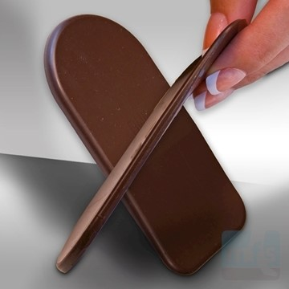
- https://www.myfootshop.com/medi-heel-lift
- Heel pads. Pads placed inside the shoe cushion the heel and may help reduce irritation when walking.
- 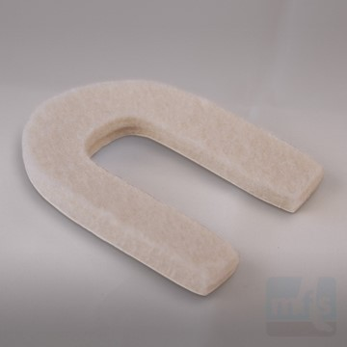https://www.myfootshop.com/horseshoe-heel-spur-pads

- Shoe modification. Backless or soft backed shoes help avoid or minimize irritation. Ask your doctor for full list of recommended shoes.
- Physical therapy. Physical therapy modalities, such as ultrasound, can help to reduce inflammation.
- Orthotic devices. Custom arch supports control the motion in the foot. Over-the-counter arch supports support the arch structure, options include:
- Superfeet – Men (Green / Blue), Women (Green/ Berry)
- Green tends to have slightly higher arch than the latter option
- Found at REI, Dicks Sporting Goods, Schuler Shoes, Amazon
- 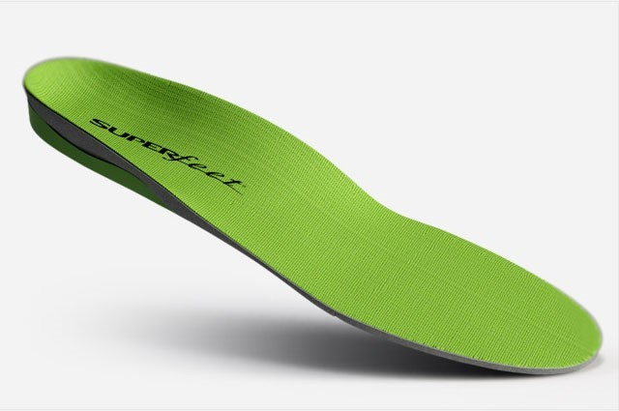
- SOLE Active Insole–Softec Response Heat Moldable Insert - better for high arch feet (do NOT recommend heat-molding them)
https://www.myfootshop.com/sole-active-insole
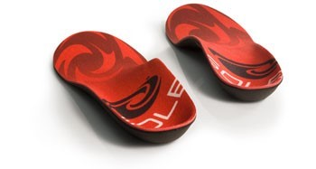

- Immobilization. In some cases, casting may be necessary.
When Is Surgery Needed?
If nonsurgical treatment fails to provide adequate pain relief, surgery may be needed. The foot and ankle surgeon will determine the procedure that is best suited to your case. It is important to follow the surgeon’s instructions for postsurgical care.
Prevention
To help prevent a recurrence of Haglund’s deformity:
- wear appropriate shoes; avoid shoes with a rigid heel back
- use arch supports or orthotic devices
- perform stretching exercises to prevent the Achilles tendon from tightening
- avoid running on hard surfaces and running uphill

https://www.foothealthfacts.org/conditions/haglund’s-deformity

