

It was a pleasure seeing you today. I hope that I was able to answer all of your questions. My goal is to partner with you to help you meet your healthcare needs. If you would like to schedule another appointment with me, please call 763-421-7300. Have a great day!
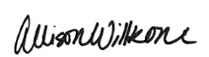
Allison Willkom, DPM

Calcaneal Apophysitis (Sever's Disease)
What Is Calcaneal Apophysitis?
Calcaneal apophysitis is a painful inflammation of the heel’s growth plate. It typically affects children between the ages of 8 and 14 years old, because the heel bone (calcaneus) is not fully developed until at least age 14. Until then, new bone is forming at the growth plate (physis), a weak area located at the back of the heel. When there is too much repetitive stress on the growth plate, inflammation can develop.
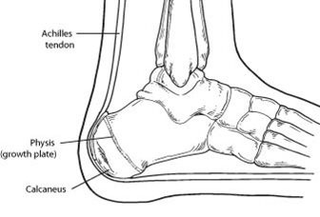Calcaneal apophysitis is also called Sever’s disease, although it is not a true disease. It is the most common cause of heel pain in children, and it can occur in one or both feet. Heel pain in children differs from the most common type of heel pain experienced by adults. While heel pain in adults usually subsides after a period of walking, pediatric heel pain generally doesn’t improve in this manner. In fact, walking typically makes the pain worse.
Causes
Overuse and stress on the heel bone through participation in sports are a major cause of calcaneal apophysitis. The heel’s growth plate is sensitive to repeated running and pounding on hard surfaces, resulting in muscle strain and inflamed tissue. For this reason, children and adolescents involved in soccer, track or basketball are especially vulnerable. Other potential causes of calcaneal apophysitis include obesity, a tight Achilles tendon and biomechanical problems, such as flatfoot or a high-arched foot.
Symptoms
Symptoms of calcaneal apophysitis may include:
- Pain in the back or bottom of the heel
- Limping
- Walking on toes
- Difficulty running, jumping or participating in usual activities or sports
- Pain when the sides of the heel are squeezed
- Tiredness
Diagnosis
To diagnose the cause of the child’s heel pain and rule out other more serious conditions, the foot and ankle surgeon obtains a thorough medical history and asks questions about recent activities. The surgeon will also examine the child’s foot and leg. X-rays are often used to evaluate the condition. Other advanced imaging studies and laboratory tests may also be ordered.
Treatment
The surgeon may select one or more of the following options to treat calcaneal apophysitis:
- Reduce activity. The child needs to reduce or stop any activity that causes pain.
- Support the heel. Temporary shoe inserts or custom orthotic devices may provide support for the heel.
- Medications. Nonsteroidal anti-inflammatory drugs (NSAIDs), such as ibuprofen, help reduce the pain and inflammation.
- Orthotic devices. Custom orthotic devices that fit into your shoe help correct the underlying structural abnormalities causing the plantar fasciitis.
- Vs. Over-the-counter arch support options:
- Superfeet – Men (Green / Blue), Women (Green/ Berry)
- Green tends to have slightly higher arch than the latter option
- Schuler Shoes, REI, Dicks Sporting Goods, Amazon
- 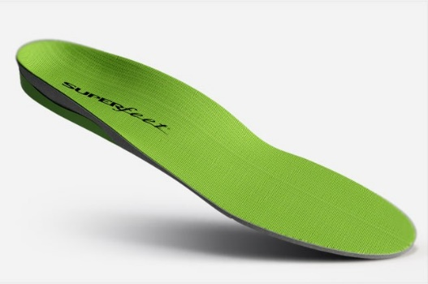
- SOLE Active Insole–Softec Response Heat Moldable Insert - better for high arch feet (do NOT recommend heat-molding them)
        - REI, Online Sales as Below
- https://www.myfootshop.com/sole-active-insole
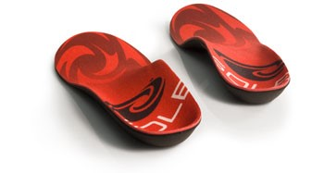

- Physical therapy. Stretching or physical therapy modalities are sometimes used to promote healing of the inflamed issue.
- Immobilization. In some severe cases of pediatric heel pain, a cast may be used to promote healing while keeping the foot and ankle totally immobile.
Often, heel pain in children returns after it has been treated because the heel bone is still growing. Recurrence of heel pain may be a sign of calcaneal apophysitis or it may indicate a different problem. If your child has a repeat bout of heel pain, be sure to make an appointment with your foot and ankle surgeon.
Can Calcaneal Apophysitis Be Prevented?
The chances of a child developing heel pain can be reduced by:
- Avoiding obesity
- Choosing well-constructed, supportive shoes that are appropriate for the child’s activity
- Avoiding or limiting wearing of cleated athletic shoes
- Avoiding activity beyond a child’s ability.

https://www.foothealthfacts.org/conditions/calcaneal-apophysitis-(sever-s-disease)

