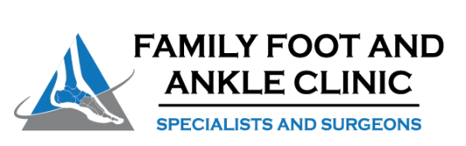

It was a pleasure seeing you today. I hope that I was able to answer all of your questions. My goal is to partner with you to help you meet your healthcare needs. If you would like to schedule another appointment with me, please call 763-421-7300. Have a great day!
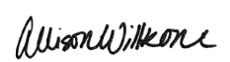
Allison Willkom, DPM

Cavus Foot (High-Arched Foot)
What Is Cavus Foot? 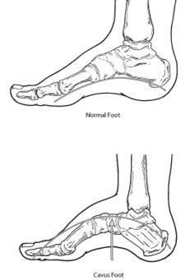
Cavus foot is a condition in which the foot has a very high arch. Because of this high arch, an excessive amount of weight is placed on the ball and heel of the foot when walking or standing. Cavus foot can lead to a variety of signs and symptoms, such as pain and instability. It can develop at any age and can occur in one or both feet.
Causes
Cavus foot is often caused by a neurologic disorder or other medical condition, such as cerebral palsy, Charcot-Marie-Tooth disease, spina bifida, polio, muscular dystrophy or stroke. In other cases of cavus foot, the high arch may represent an inherited structural abnormality. An accurate diagnosis is important because the underlying cause of cavus foot largely determines its future course. If the high arch is due to a neurologic disorder or other medical condition, it is likely to progressively worsen. On the other hand, cases of cavus foot that do not result from neurologic disorders usually do not change in appearance.
Symptoms
The arch of a cavus foot will appear high even when standing. In addition, one or more of the following symptoms may be present:
- Hammertoes (bent toes) or claw toes (toes clenched like a fist)
- Calluses on the ball, side or heel of the foot
- Pain when standing or walking
- An unstable foot due to the heel tilting inward, which can lead to ankle sprains

Some people with cavus foot may also experience foot drop, a weakness of the muscles in the foot and ankle that results in dragging the foot when taking a step. Foot drop is usually a sign of an underlying neurologic condition.

Diagnosis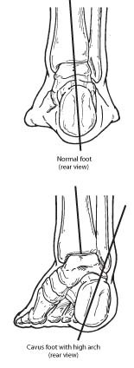

Diagnosis of cavus foot includes a review of the patient’s family history. The foot and ankle surgeon examines the foot, looking for a high arch and possible calluses, hammertoes and claw toes. The foot is tested for muscle strength, and the patient’s walking pattern and coordination are observed. If a neurologic condition appears to be present, the entire limb may be examined. The surgeon may also study the pattern of wear on the patient's shoes.
X-rays are sometimes ordered to further assess the condition. In addition, the surgeon may refer the patient to a neurologist for a complete neurologic evaluation.

Nonsurgical Treatment
Nonsurgical treatment of cavus foot may include one or more of the following options:
- Orthotic devices. Custom orthotic devices that fit into the shoe can be beneficial because they provide stability and cushioning to the foot.
    - Sole Active Insole – Softec Response Heat Moldable Insert (good over-the-counter arch support for high arch feet, but don’t recommend heat molding them)
      - REI, Online Sales
- Shoe modifications. High-topped shoes support the ankle, and shoes with heels a little wider on the bottom add stability.
- Bracing. The surgeon may recommend a brace to help keep the foot and ankle stable. Bracing is also useful in managing foot drop.

When Is Surgery Needed?
If nonsurgical treatment fails to adequately relieve pain and improve stability, surgery may be needed to decrease pain, increase stability and compensate for weakness in the foot. The surgeon will choose the best surgical procedure or combination of procedures based on the patient’s individual case. In some cases where an underlying neurologic problem exists, surgery may be needed again in the future due to the progression of the disorder.

https://www.foothealthfacts.org/conditions/cavus-foot-(high-arched-foot)

