

It was a pleasure seeing you today. I hope that I was able to answer all of your questions. My goal is to partner with you to help you meet your healthcare needs. If you would like to schedule another appointment with me, please call 763-421-7300. Have a great day!

Allison Willkom, DPM

Posterior Tibial Tendon Dysfunction (PTTD)
What Is PTTD? 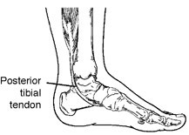
The posterior tibial tendon serves as one of the major supporting structures of the foot, helping it to function while walking. Posterior tibial tendon dysfunction (PTTD) is a condition caused by changes in the tendon, impairing its ability to support the arch. This results in flattening of the foot.
PTTD is often called adult acquired flatfoot because it is the most common type of flatfoot developed during adulthood. Although this condition typically occurs in only one foot, some people may develop it in both feet. PTTD is usually progressive, which means it will keep getting worse, especially if it is not treated early.
Causes
Overuse of the posterior tibial tendon is often the cause of PTTD. In fact, the symptoms usually occur after activities that involve the tendon, such as running, walking, hiking or climbing stairs.
Symptoms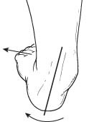
The symptoms of PTTD may include pain, swelling, a flattening of the arch and an inward rolling of the ankle. As the condition progresses, the symptoms will change.
For example, when PTTD initially develops, there is pain on the inside of the foot and ankle (along the course of the tendon). In addition, the area may be red, warm and swollen.
Later, as the arch begins to flatten, there may still be pain on the inside of the foot and ankle. But at this point, the foot and toes begin to turn outward and the ankle rolls inward.
As PTTD becomes more advanced, the arch flattens even more and the pain often shifts to the outside of the foot, below the ankle. The tendon has deteriorated considerably, and arthritis often develops in the foot. In more severe cases, arthritis may also develop in the ankle.
Nonsurgical Treatment
Because of the progressive nature of PTTD, early treatment is advised. If treated early enough, your symptoms may resolve without the need for surgery, and progression of your condition can be arrested.
In contrast, untreated PTTD could leave you with an extremely flat foot, painful arthritis in the foot and ankle and increasing limitations on walking, running or other activities.
In many cases of PTTD, treatment can begin with nonsurgical approaches that may include:
- Orthotic devices or bracing. To give your arch the support it needs, your foot and ankle surgeon may provide you with an ankle brace or a custom orthotic device that fits into the shoe.
- Over-the-counter arch support options:
- Superfeet – Men (Green / Blue), Women (Green/ Berry)
- Green tends to have slightly higher arch than the latter option
- REI, Dicks Sporting Goods, Schuler Shoes, Amazon
- 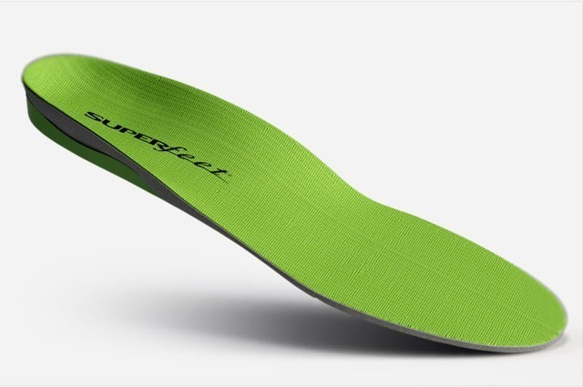
- Sole Active Insole – Sofetec Response Heat Moldable Insert
- Better for high-arched feet (do not recommend heat molding them)
- REI, Myfootshop.com, Online Sales
- 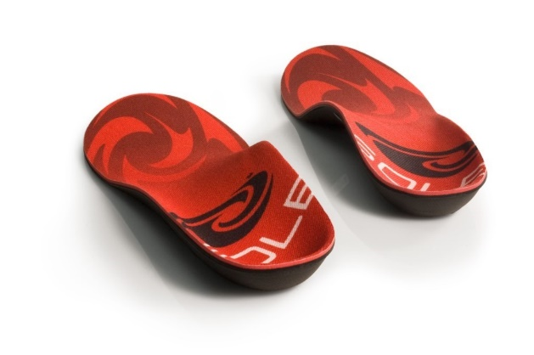
- Immobilization. Sometimes a short-leg cast or boot is worn to immobilize the foot and allow the tendon to heal, or you may need to completely avoid all weightbearing for a while.
- Physical therapy. Ultrasound therapy and exercises may help rehabilitate the tendon and muscle following immobilization.
- Medications. Nonsteroidal anti-inflammatory drugs (NSAIDs), such as ibuprofen, help reduce the pain and inflammation.
- Shoe modifications. Your foot and ankle surgeon may advise changes to your shoes and may provide special inserts designed to improve arch support.
When Is Surgery Needed?
In cases of PTTD that have progressed substantially or have failed to improve with nonsurgical treatment, surgery may be required. For some advanced cases, surgery may be the only option. Your foot and ankle surgeon will determine the best approach for you.
https://www.foothealthfacts.org/conditions/posterior-tibial-tendon-dysfunction-(pttd)

