**JUNE 14TH THE DAY!**

The 2025 All-Class Dinner has been finalized. It will be held on Saturday June 14th at the Putnam County Museum. Doors will open at 4:00 p.m. with dinner served at 6:00 p.m. The menu includes salmon, broasted chicken, herb crusted pork loin with cranberry sauce, mashed potatoes and gravy, steamed vegetable blend, sweet corn casserole, and Caesar salad. Desserts include cake and cookies. Drinks include ice tea, lemonade, and coffee. The meal will be catered by Putnam Inn. The 2025 scholarship recipients will be recognized. And there will be a scavenger hunt using the museum displays. The cost for the evening is thirty dollars (thirty-five dollars after June 6th). A reservation form is on page six. They are due by June 6th. Hope to see you there as we reconnect with other GHS alumni and friends as well as recognize our scholarship recipients!

**WE OFTEN FORGET OR TAKE FOR GRANTED** those who have made sacrifices so that we may live in a country where freedom reigns! Today we pay tribute to GHS alumnae Frank Cancilla who served our country during World War II. Mr. Cancilla received the Purple Heart after suffering a hip wound while fighting the Japanese in the Buna, New Guinea sector on December 8, 1942. After recuperating from his wound, he returned to the fighting front. Frank was just one of the many GHS alumni who served our country during World War II. To all GHS alumni who have served**-THANK YOU!**

A LITTLE OF

**THIS** and **THAT**

We have reached another one of our goals as Dawn York McMickle, class of 77, has joined our board. A former board member, Dawn is able to rejoin the board as she and her husband are moving back to Greencastle. We now have reached our goal of at least fifteen board members and hope to eventually have twenty members. Welcome aboard Dawn!!

The Greencastle Alumni Dollars for Scholars has $26,000 in scholarship money to be awarded this year. Scholarship recipients will be announced at the Greencastle High School Awards Day in May and will be recognized at our All-Class Dinner on June 14th. These scholarships are made possible by the generosity of our GHS alums and the Greencastle community.

Check out Teenage Thoughts on page 2. We have included two of the ten teenage thoughts that were originally printed in “The Tiger” school newspaper of Central High School in Cape Girardeau, Missouri. Five through ten will appear in later editions of ‘Tiger Tales”.

Our Greencastle Alumni Scholarship Fund has surpassed our goal of $600,000. As of April 2nd, our account with the Putnam County Community Foundation had a balance of $613,410.43. The earnings from this account provides us with the funds for our scholarships.

Don’t forget to send in your reservation form for the All-Class Dinner on June 14th!

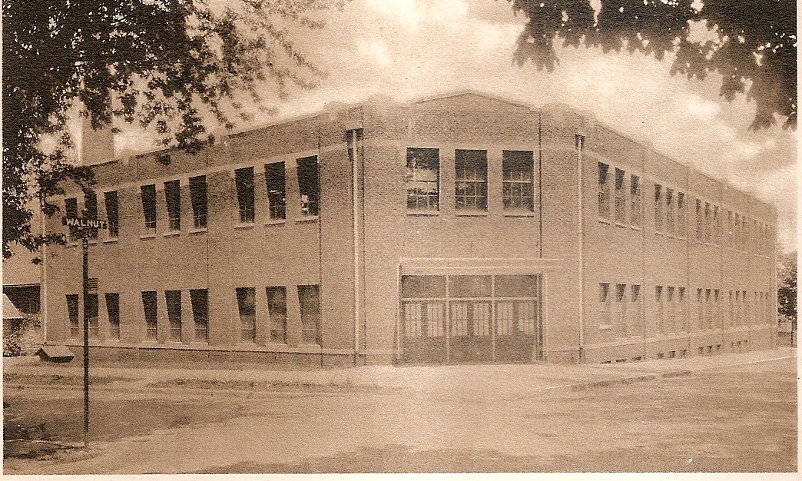

**2006-07 TIGER CUBS**

Even though the 2006-07 Tiger Cubs were unable to claim any team Sectional Championships, they did win ten individual Sectional titles and five individual Regional crowns. In addition, eleven individuals qualified to compete in the state meet for their individual sport.

Andy Weatherford claimed three Sectional and one Regional Championships. He won the boys cross country title with a winning effort of 15:52, the 1600 meter run with an effort of 4:31.03, and the 3200 meter run with a time of 9:44.59. Andy then advanced to the state meet by claiming the 1600 meter run Regional title with a time of 4:21.54. At the state meet he finished fifth with an outstanding time of 4:13.71. In cross country he finished second in the regionals (15:33) to advance to the state meet. At the state meet he was unable to find his “comfort zone” as he finished 26th with a disappointing time of 16:39.

The girls swimming 200 yard medley relay squad advanced to the state meet by claiming Sectional honors with a time of 1:54.90. Members included Kelsey Murtaugh, Morgan Terry, Melissa Ball, and Erica Soster. At the state meet, misfortune hit as the Tiger Cubs squad of Murtaugh, Caitlin Gannaway, Ball, and Soster were disqualified.

The wrestling team had two individuals enter the sectionals undefeated. And they both remained undefeated as they claimed the Championship. Chris Pingleton won the 160 lb. class and Robert Bittles the 171 lb. class. They continued their undefeated ways and advanced to the Semi-State by winning the regionals at Mooresville. They both suffered their first loss at the Evansville Semi-State as Chris finished third and Robert fourth. But that enabled them to advance to the state meet. Chris took his 43-1 record and defeated his opponent who had a 48-1 record in a hard-fought match 9 to 5. Unfortunately, he lost his next two matches to finish with an outstanding record of 45 wins and three losses. Robert lost his first match to an undefeated opponent at the state meet to finish the season with a fantastic record of 34 and 3.

Girls track claimed three Sectional titles and two Regional championships as all three title holders advanced to the state track meet at Bloomington. At the sectionals Jamie Patterson claimed the 100 meter dash title with a time of 12.77. Laura Weatherford won the 200 meter dash with an effort of 26.34. And the 400 meter relay squad of Megan Clodfelter, Laura Weatherford, Jamie Patterson, and Laura English won their event with a time of 49.52. At the regionals Patterson claimed the 100 meter title with an effort of 12.69. Laura advanced to the state meet by finishing second in the 200 with a time of 26.16. But the highlight of the day was the 400 meter relay team as they set a new **Regional record** by winning their event in 49.23. At the state meet they all improved their regional times as Patterson finished 10th (12.40), Weatherford 15th (26.05), and the 400 meter squad finished 12th (49.04).

The last Sectional Championship came in boys track as Joel Bottom won the long jump with a leap of 20’7 ¾”. At the regionals Joel’s effort of 21’4 ¾” was good for fourth place but was one spot short of qualifying for the state meet.

**TEENAGE THOUGHTS**

The Ink Pot

March 31, 1953

Important—Take Time for 10 Things!

(3) Take time to Play--it is the secret of youth. Along with the work and seriousness of life, you must have some recreation and relaxation to have a well-rounded life. “All work and no play makes Jack a dull boy.”

(4) Take time to Read—it is the foundation of knowledge. All great minds are learned by reading. Books are filled with the knowledge of the world.

**NEWEST CRAZE HITS AT GHS**

1984 Minaret

Put on your shades, your parachute pants, come on zoids, let’s break dance! Supported by Brylcreem, Converse high tops, bandanas and penny loafers, fads moonwalked their way into GHS.

Some students impersonated their favorite rock star such as Michael Jackson. Leather jackets as well as one glove worn on the right hand made their appearances. Torn sweatshirts straight from the movie Flashdance could be viewed in the hallways.

A few fads began to create individual personalities or to become trendsetters. Tiger mascot Any Mowrer said, “I wear fads because they make me my own person and in that way, I feel like I’m not just the same as everyone else.”

To some students money was a drawback to buying fads, but others found fads well within their budget. Plastic shoes in all colors and styles sold for as low as $5. Sweatshirts cost around $8, while Michael Jackson jackets sold anywhere from $50 to $300.

Dangle earrings, cropped shirts and striped pants were the most popular girl’s fads, while high tops, parachute pants and striped shirts hit it off for the boys.

Both sexes invested in sunglasses, heart shaped and even fish shaped ones, but the most popular ones copied those seen in Risky Business, otherwise known as “Tom Cruise shades”.

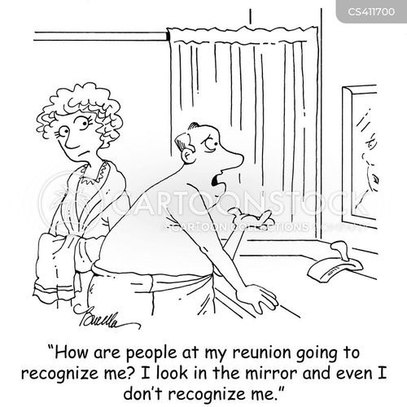

**NEW STARS SHINE BRIGHT**

1998 Minaret

“Where are my shoes?” Oliver cried, rushing across the area backstage. “I don’t know! What is my first line?” asked Charlotte (junior Courtney Smock).

Has anyone ever wondered what goes on backstage while preparing for a production? “It’s a zoo-but all business! I sometimes think we should sell tickets to watch backstage. It’s often as entertaining as what goes on on-stage!” said Vicki Parker, drama director.

“I was very pleased with the turnout of Oliver! We had lots of new people playing some major roles. I was proud of everyone,” Parker said.

Junior Dara McMains (Nancy) felt that the play brought people together. She said, “You make good friends that you may have never considered. People become closer through it. Everyone should be involved.”

The cast of Oliver! did a wonderful job of interacting with one another both on the stage and off. A lot of the energy of the actors and actresses came from the audience.

“Being on stage makes you feel so incredible! You play off the energy from an audience that enjoys the performance, The audiences for Oliver! were great! There were times when I walked off stage smiling because I could just feel how much they liked it,” said sophomore Lanie Wieland.

Oliver! took six weeks to prepare and cost approximately $2,100. Nine hundred dollars for royalty/rental, $800 for costumes, and $400 for lumber and miscellaneous supplies. “Six weeks is the normal time allotment, so the time we had to work on this play was fine. A cast reaches a point where they need an audience,” said Parker.

Everyone involved with the production agreed that it was a great success because of the cast, directors, costumes, set, pit and the audience.

**CLASS OF 1974 HALL OF FAME**

Most Musical: Amy Phillips & Rick Bittles

Most Athletic: Jan Smaltz & Bob Newsome

Best Looking: Diane Morrison & Mike Duncan

Most Popular: Holly Knights & Kim Jones Most Likely to Succeed: Susan Robertson & Jay

Franklin

**“THE GOOD OLD DAYS”**

Continuing with “The Good Old Days’ theme from the files of your alumni association, GHS class of 1933’s James W Grimes wrote about his memories at GHS, Here are a few of them.

I remember that Jesse McAnally lost the first joint of one of his fingers. I think it was his index finger in an automobile accident when he was either an eighth grader or freshman. The loss didn’t affect his ability and he became one of the best centers in Hoosier basketball.

I was a cheerleader along with Jack Boyd and I think Derma Maddox and Charlotte Donohue were song leaders, The gym was always packed and the cheering section was large and loud.

In 1933 we beat Crawfordsville 13-12 in the regional. As I remember McAnally made the winning basket in the last few seconds.

We then went to the state finals at the Butler Fieldhouse. Back then the finals were played in one day with sixteen teams. In the morning we played Logansport and defeated them in a double overtime.

In the final game we were a very tired team and Martinsville won 27 to 24.

If my memory is correct that was the last year we had a sixteen teams finals that was played on one day.

I also remember we had some wonderful teachers. My opinion of them has greatly increased over these many years. Oscar Thomas was principal of junior high and a wonderful history teacher and disciplinarian. Lela Walls was a wonderful English teacher. Glenn Skelton was my high school history teacher who picked me up one day when I skipped school and delivered me back to school. Leona Kestner – later Dobbs – taught girls phys. ed. and in later years helped rehabilitate our son who had polio.

Memories become dearer as the years pass by and my memories of Greencastle High and the old gym are very dear to my heart.

**IT’S A GREAT DAY TO BE A TIGER CUB!**

**TERRY GOBERT DAY IN GREENCASTLE**



(Picture from [www.nwitimes.com](http://www.nwitimes.com))

Greencastle Mayor Lynda Dunbar proclaimed Saturday April 12th as “Terry Gobert Day in Greencastle”. Terry, a 1979 GHS graduate, was recognized April 12th by the Greencastle community at the Tiger Cubs vs. Jasper baseball game. Terry brought his 6th ranked class 3A Wildcats team to play the 6th ranked class 2A Tiger Cubs. Terry, a 2007 inductee into the Indiana Baseball Hall of Fame, is in his fortieth year as their baseball coach during which he has compiled 912 wins and six state championships. Included among the hundreds of players he has coached is Major League Baseball Hall of Famer Scott Rolen. He is the second baseball coach in Indiana history to achieve 900 wins. A 1983 graduate of Indiana University, Coach Gobert had never coached against the Tiger Cubs until April 12th. Unfortunately for the Tiger Cubs, Jasper was victorious 11 to 1.

**2025 GREENCASTLE ALUMNI DIRECTORS**

Jon Blue ’69 (President) 765-721-1539

Audra Dorsett Holton ‘54 (Vice-Pres) 765-848-8053

Patty Sillery McCastle ’72 (Secretary) 765-653-5510

Terri Sutherlin McKee ’74 (Treasurer) 765-653-5620

Ron Blotch ’65 (Historian) 317-989-5601

Mary Lou Blue 630-750-9185

Josh Bonebrake ’11 765-720-2359

Cathy Gram Lowery ’69 765-721-0150

Nancy Livesay Clodfelter ’55 765-721-7214

Jane Green Hansen ’69 765-721-0150

Anita Barr McEnulty ’63 765-720-2568

Dawn York McMickle ’77 765-247-8222

Cathy Evens Rossok ‘75 765-918-6164

Suzy Gould Schneider ’64 765-720-2822

Linda Alderfer York ‘68

**GHS ALUMNI MEMORIES**

We contacted some GHS Alumni and asked them about their high school memories. Their responses are:

**ANITA BARR McENULTY**

GRADUATION YEAR: 1963

PRESENT ADDRESS: Greencastle

HIGH SCHOOL PRINCIPAL: Mr. Norman McCammon

FAVORITE HIGH SCHOOL TEACHER: Mr. Bates

FAVORITE JUNIOR HIGH TEACHER: Mr. Eggloff

ELEMENTARY SCHOOL: Miller

FAVORITE ELEMENTARY TEACHER: Mrs. Knaur

FAVORITE HIGH SCHOOL CLASS: Band, Choir

FAVORITE HIGH SCHOOL EXTRA-CURRICULAR ACTIVITY: Anything music related

CAR YOU DROVE TO SCHOOL: none

CLOSEST HIGH SCHOOL FRIEND: Susie Clark

FAVORITE PLACE TO EAT LUNCH: school

DID YOU ATTEND THE PROM: Yes, Rufus Hartman

DID YOU PARTICIPATE IN ANY SENIOR PRANKS: no

FAVORITE HIGH SCHOOL MEMORIES: Triple Trio

MOST EMBARRASSING HIGH SCHOOL MOMENT: none

WHAT WOULD YOU DO DIFFERENT: nothing

**WALLY BENNETT**

GRADUATION YEAR: 1962

PRESENT ADDRESS: Walton, Indiana

HIGH SCHOOL PRINCIPAL: Mr. Norman McCammon

FAVORITE HIGH SCHOOL TEACHERS: Jim McCammon, Al Novak, Lloyd Cooper, Mrs. Hanna, Miss Curd

FAVORITE JUNIOR HIGH TEACHERS: Mrs. Loveless

ELEMENTARY ATTENDED: Ridpath

FAVORITE ELEMENTARY TEACHERS: Mr. Rightsell, Mr. Dixon

FAVORITE HIGH SCHOOL CLASSES: Art, Typing, Econ, Phys. Ed.

FAVORITE HIGH SCHOOL EXTRA-CURRICULAR ACTIVITIES: Football, Basketball, Follies, Dances

CAR YOU DROVE TO SCHOOL: 1959 Chevy Impala, 1961 Corvair

CLOSEST HIGH SCHOOL FRIENDS: Jim Newman, Bill McCormick, Marty Harmless, Steve Norris, Chuck Jennings, Tom See

DID YOU PARTICIPATE IN ANY SENIOR PRANKS: No

FAVORITE PLACE TO EAT LUNCH: School

DID YOU ATTEND THE PROM: Yes, 1961, 1962, and 1963 with Judy Carwell

FAVORITE HIGH SCHOOL MEMORY: Watching the basketball team win the Wabash Valley Tournament. Playing basketball in the old gym. Playing football on Friday nights. Being with teammates and friends. Taking girl fiends to the movies.

MOST EMBARRASSING HIGH SCHOOL MOMENT: Dropping the winning trophy and breaking it after a basketball game.

WHAT WOULD YOU DO DIFFERENT: Nothing. I enjoyed it and the friends.

**WHY I LIKE RETIREMENT**

BABY BOOMERS OLD SOULS

QUESTION: How many days in a week?

ANSWER: Six Saturdays and one Sunday

QUESTION: When is a retiree’s bedtime?

ANSWER: Two hours after falling asleep on the couch

QUESTION: How many retirees does it take to change a light bulb?

ANSWER: Only one, but it might take all day

QUESTION: What is the biggest gripe of retirees?

ANSWER: There is not enough time to get everything done.

QUESTION: Why don’t retirees mind being called seniors?

ANSWER: The term come with a 10% discount.

QUESTION: Among retirees, what is considered formal attire?

ANSWER: Tied shoes

**JOKE OF THE DAY**

(THE IDEA ROOM)

Bumper Sticker On A Senior’s Car: “I am speeding because I have to get there before I forget where I am going.”

**GREENCASTLE ALUMNI DOLLARS FOR SCHOLARS, INC.**

**ALL-CLASS DINNER**

**June 14, 2025**

**Putnam County Museum**

**Doors open @ 4 pm Dinner @ 6 pm**

_____________________________________________ __ GHS Class year

*Print Name (Include Maiden Name)*

_______________________________________________ GHS Class Year

*2nd Person Name* *(Or Guest)*

*Address City State Zip*

*Phone e-mail address*

Amount included $____________ Mail to:

*Amount enclosed at $30.00 each ticket* **Greencastle Alumni**

***($35.00 after June 6)*** **Dollars for Scholars, Inc.**

**P.O. Box 846**

**Meal catered by the Putnam Inn**. **Greencastle, IN 46135**

Any special dietary needs ______________________________________________

**Help us support our graduates! Instead of a Silent Auction this year, we will be accepting donations to be able to add additional scholarships—cash or check only. Thank you for your support. All donations may be designated “In Honor of” or “In Memory of” ____________________________________________________.**

**Amount of Donation $____________ We will also be accepting donations at the dinner.**

Note: An inherent risk of exposure to COVID-19 exists in any public place regardless of precautions that may be taken. Attendee on their behalf and on behalf of any accompanying minor(s) agrees to (1) assume all risks associated with COVID-19 and other communicable diseases, and (2) comply with all related health and safety policies in effect at the time of the event

Greencastle Alumni Dollars for Scholars, Inc.

formerly known as GHS Alumni Association

Join or Renew Now!

Joining or renewing your Greencastle Alumni Membership will allow you to benefit in a variety of ways...

* You will receive the Tiger Tales newsletter up to 3 times per year
* Receive current news about the association and upcoming events
* Maybe you just want to reminisce or contact former classmates
* Support the awarding of scholarships to GHS graduates

The GHS Alumni Association was created in 1995 for the purpose of supporting Greencastle High School and operating a Scholarship Fund for our graduates. We currently use a number of fundraising events and activities to add to our scholarship fund including the All Class Dinner held June 14, 2025, as well as the Farm to Fork Dollars for Scholars in Putnam County Dinner held September 20, 2025.

**Membership is only $10 per person per year. To join or renew, complete this application form and mail it to us with your $10 dues payment. Another option is a one-year free membership with a $25 contribution to the Greencastle Alumni Dollars for Scholars, Inc. Scholarship Fund. A $50 donation will be listed in a Banner Graphic Ad. All contributions may be designated**

**"In Honor of” _______________ or "In Memory of” _____________________ for anyone that you choose.**

Please Print  JOIN  RENEW

**_______________________________________________________________________________ _____________**

Name (include Middle Initial and/or Maiden Name) Class Year

**_______________________________________________________________________________ _____________**

Name (for use by Couples please include Middle Initial and/or Maiden Name) Class Year

**_________________________________________________________________________________________________**

Address City State Zip

**_____________________________________ _____________________________________________________**

Phone **Email Address**

**Receive Tiger Tales via email? Yes _______ No ____________**

Total Enclosed $_____________ Mail to. **Greencastle Alumni Dollars for Scholars, Inc.**

**P.O. Box 846**

Referred By: __________________ **Greencastle, Indiana 46135**

* Contribution to Greencastle Alumni Dollars for Scholars, Inc. Scholarship Fund

**In Honor of ___________________________or In Memory of ______________________________**

