**FROM THE PRESIDENT**

Hello to all Greencastle Alumni. This has been a great year for the Greencastle Alumni Dollars for Scholars. The All-Class Dinner on June 17th was a great event. While Harris Hall at the Putnam County Fairgrounds was a smaller venue, it was perfect for us. I would like to thank everyone that came out to support us. Several people commented that the meal was outstanding. Special thanks to the Putnam Inn for the main meal and to Lauren Day, Culinary, Hospitality, & Tourism Instructor at Area 30 Career Center and Chef, Instructor at Nestle Inn Bed & Breakfast for the delicious desserts.

The Greencastle Alumni has recently purchased a pop-up canopy and two new banners. They made their debut at the Putnam County Airport Appreciation days on September 9th and 10th. We had two great days of fellowship and fun - - Bi planes, helicopters, and free airplane rides, oh my! The weather even cooperated, and it was a beautiful weekend. Look for us this winter and upcoming spring at Greencastle High School ball games.

Also in September, we helped GHS purchase approximately 250 tee shirts for the renewed Cheer Block. Board members Jane Hansen class of 69, Cathy Gramm Lowery class of 69, and I helped Principal Chad Rogers and his staff pass them out. The students were very excited and appreciative to receive these shirts.

A goal of the Alumni is to be more active in the development of GHS students by working with the students and staff, with the common goal of building a better community.

If you would like to receive a GHS Alumni shirt or have ideas contact me President Jon Blue 765-721-1539, or Vice-President Jane Hansen at 765-247-9257.

LITTLE OF

**THIS** and **THAT**

We would like to apologize for the lateness of this issue of Tiger Tales. Due to some health issues the Fall Issue was delayed until now. Our next issue normally scheduled for January will be distributed in February.

Officers for 2024 have been elected. Jon Blue will continue as President as will Jane Green Hansen as Vice-President. Patty Sillery McCastle will be Secretary and Terri Sutherlin McKee will continue as Treasurer. Terri will also continue as Scholarship Chairman. And Ron Blotch will serve as Historian.

There WILL be a 2024 All-Class Dinner. It will be held June 15th at the Putnam County Museum. Please mark your calendar and plan to attend!

We would like to welcome two new members to your Greencastle Alumni Dollars for Scholars Board. Nancy Livesay Clodfelter from the class of 1955 and Linda Alderfer York class of 1968 have increased our number of board members to thirteen. Welcome aboard Nancy and Linda!

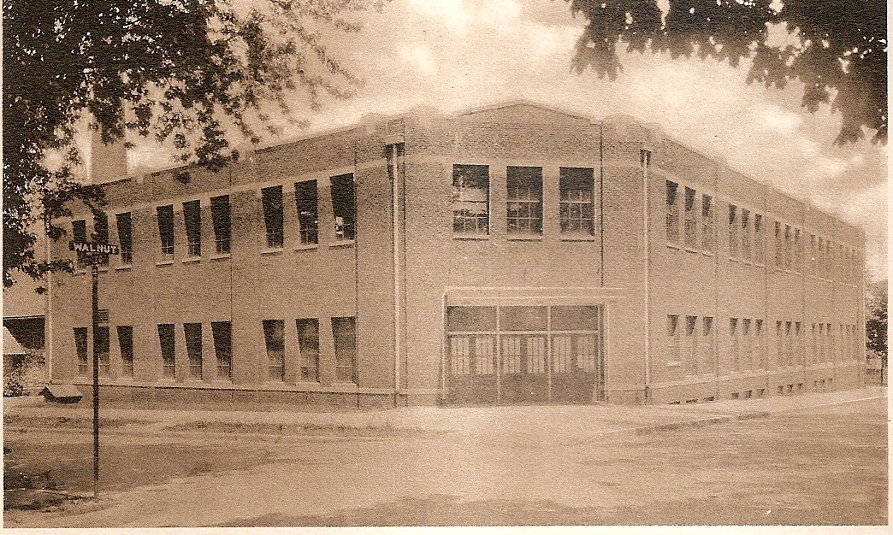

**TIGER CUBS IN THE 2000s**

**2005-06**

Although the 2005-06 school year saw the Tiger Cubs fail to win any team Sectional Championships, individually, Tiger cub athletes captured 18 Sectional Titles, four Regional Championships, one Semi-State Crown, one State-Runner-up, and one State Championship making the school year a very successful one!

Andy Weatherford started the parade of individual Sectional Titles by winning boys cross country with a time of 15:38. Andy was runner-up at the Regional, 5th at the semi-state, and finished 10th at the state meet. Girls swimming added two titles as Alys Moore captured the 100 yard breaststroke with 1:12.11 effort. The 200 yard freestyle relay squad added another Sectional title with a time of 1:45.08 The wrestling team won two Sectional Championships with Chris Pingleton winning the 145 lb. class and Robert Bittles the 160 lb. class. Chris then claimed the Cubs first Regional Title of the year by winning the Mooresville regional. Boys swimming claimed three Sectional Crowns as Mark Jedele won the 500 yard freestyle in 5:16.22. The 400 yard relay team won their event in 3:26.89. And Andrew Bretscher claimed both the 50 yard freestyle (21.53) and the 100 yard freestyle (48.59). But Andrew saved his best for last as he was named the 100 yard freestyle State Runner-up by finished second at the state meet with a time of 46.33. Girls track had a banner year as they won five Sectional Titles and two Regional ones. Dee Wood won the 100 meter dash with a time of 12.82. Laura Weatherford captured the 200 meter dash with an effort of 48.59. Hannah Serlin was the 1600 meter champ with a time of 5:27.73. The 400 meter relay team won their event with a time of 49.79. And Kristen Ness won the shot put crown with an effort of 38’1”. The 400 meter relay squad also won the regionals with a time 49.79. And Kristen added the Regional Title to her resume with a toss of 38’6 ¾”. Boys track was not to be outdone by the girls as they were victorious in four events. The 1600 meter relay squad was named Sectional Champs as they won their event in 3:36.98. Quinn Fenlon captured the high jump title with a height of 5’10”. And Andy Weatherford claimed two Sectional Titles by winning the 800 meter run with an effort of 1:59.97 and the 1600 meter run with a time of 4:33.11. Andy also claimed the Regional Crown in a winning time of 4:24.37. But Andy saved his best time for the state meet as he won the title State Champion with an outstanding time of 4:08.71.

One State Championship, one State Runner-up, four Regional Titles, and 18 Sectional Championships made the 2005-06 school year one to be remembered!!

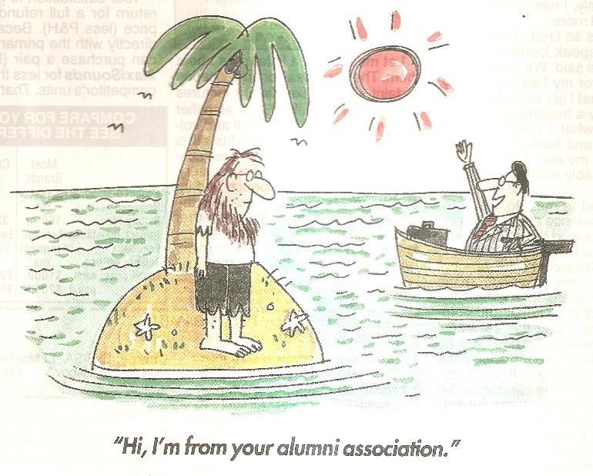

**DID YOU KNOW**

that Bob Flanigan, a founding member and lead vocalist of the jazz vocal group “The Four Freshmen”, was born in Greencastle. They made several records and made many appearances on television in the 1950s and early 60s.

**29 SCHOLARSHIPS AWARDED**

**GREENCASTLE ALUMNI SCHOLARSHIP**

**($1000)**

Jacie Bumgardner Ball State

Lucy Butler Indiana State

Kelsey Carrington Marian

Daniel Ensley Miami (Ohio)

Caroline Gooch IUPUI

Elijah Hardwick Indiana

Hannah Hebert Cedarville

Emma Huber DePauw

Elise Lausee IU-South Bend

Vincent Martoglio Ball State

Jordan Meyer Franklin

Gillian Monnett Southern Indiana

Olivia Richardville IUPUI

Allison Scott Indiana State

Hannah Seaman Stanford

Maria Serapio Purdue

Mya Weddle Savannah College of

Art and Design

Nina White Hanover

Kinzee Wilson Southern Indiana

Keifer Wilson Olney Central

Anna Zellers Trine

**MAXINE HASKETT MEMORIAL SCHOLARSHIP**

**($500)**

Lucy Butler Indiana State

Gillian Monnett Southern Indiana

Anna Zellers Trine

**RENZ SCHOLARSHIP**

**($500)**

Elise Lausee IU-South Bend

**BAUMAN FAMILY SCHOLARSHIP**

**($500)**

Stephen Dombrowski Purdue

Jack Howard Purdue

Milly Ramey Purdue

Duncan York (S. Putnam) Purdue

A LITTLE MORE

**THIS** and **THAT**

Your Greencastle Alumni Dollars for Scholars awarded twenty-nine scholarships last spring. The Greencastle Alumni Scholarship (21) and the Maxine Haskett Memorial Scholarship (3) were funded through our organization. The Bauman Family Scholarship (4) and the Renz Scholarship (1) were initiated by those families.

The board would like to thank those individuals who donated items for our silent auction held at last summer’s All- Class Dinner. We raised $783 for our scholarship funds. And we thank those who participated in the bidding. THANK YOU!!

Congratulations to Andrew Adams, Allison Landry, and Landon Miller. Last spring Andrew was the Sectional Champ in pole vault with a height of 11’6”. Allison advanced to the regional championship match in girls tennis. And Landon was the Terre Haute North Sectional Champion in boys cross country this past fall with a time of 16:01.1. Landon qualified for the state meet by placing 11th at the regionals. At the state meet Landon finished 14th with a time of 15:29.3.

Congratulations to the girls tennis program as they captured the Sectional title last spring by defeating South Vermillion 5-0 and Northview 5-0.

This past fall boys soccer, girls soccer, and volleyball captured Sectional Championships. Boys soccer won in class 2A by defeating Indian Creek 3-0, South Vermillion 3-0, and Northview 3-0. Girls soccer won a 1A title by defeating Cascade 4-1 and North Putnam 4-0. Volleyball was successful in Class 2A by defeating North Putnam 25-21, 25-14, 18-25, 25-15 and Riverton Parke 25-23, 25-18, and 25-16. Congratulations!

**SAVE THE DATES**

SATURDAY JUNE 15TH

**ALL-CLASS DINNER**

SATURDAY SEPTEMBER 21ST

**FARM TO FORK DOLLARS FOR SCHOLARS DINNER**

**MEET YOUR BOARD MEMBERS**

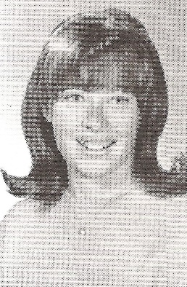

**LINDA ALDERFER YORK**

Linda is a 1968 graduate of Greencastle High School. After graduation she found employment in the law office of Frank Stoessel and took night classes at Indiana Central. Her forty years of working in law offices continued with the Lyon and Boyd law firm, Boyd and Young law firm, and law office employment with James Young.

Linda was born in South Bend. In 1964, her family moved to Greencastle where she lived until 2011 when she moved to Florida to help her mother. She moved back to Greencastle in 2022 and became a board member this year. She has one daughter Jennifer.

In her spare time Linda enjoys reading and watching sports. She has attended and camped at many NASCAR races, rooting for her favorite driver Jeff Gordon. She is a Cincinnati Reds fan and enjoys watching both football and basketball. She also likes to knit, especially shawls for the Indiana Donor Association.

**NANCY LIVESAY CLODFELTER**

Born in Illinois, Nancy and her family moved to Greencastle when she was 13. She graduated from GHS in 1955. After graduation she worked in Indianapolis for a year before returning to Greencastle to get married and work at IBM. Employed there for five years, she left to start a family. She has two children, a son Matt and a daughter Lyn.

In her spare time she enjoys spoiling her six grandchildren and her four great grandchildren. She also plays the piano and the organ, having done so for her church for many years. She is a quilter and enjoys playing bridge and euchre.

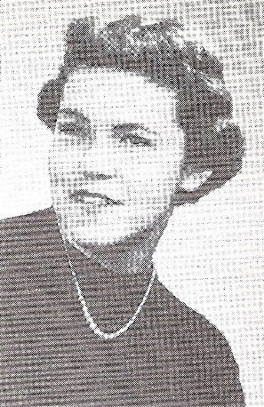

**SCHOLARSHIP INFO**

(as of October 12, 2023)

Founded: 1994

First Donor: Norman Handy

First Scholarship Recipient: Jon Blue

GHS Alumni Scholarship Balance: $535,393.52

Maxine Haskett Memorial Scholarship Balance: $22,889.57

Number of Scholarships Awarded: 249

Dollar Amount of Scholarships Awarded: $245,700.00

**GREENCASTLE ALUMNI DIRECTORS**

Jon Blue ’69 (President) 765-721-1539

Jane Green Hansen ‘69(Vice-Pres.) 765-721-0150

Patty Sillery McCastle ’72 (Secretary) 765-653-5510

Terri Sutherlin McKee ’74 (Treasurer) 765-653-5620

Ron Blotch ’65 (Historian) 317-989-5601

Mary Lou Blue 630-750-9185

Josh Bonebrake ’11 765-720-2359

Cathy Gram Lowery ’69 765-721-0150

Nancy Livesay Clodfelter ‘55 765-721-7214

Audra Dorsett Holton ’54 765-247-9064

Anita Barr McEnulty ‘63 765-720-2568

Suzy Gould Schneider ’64 765-720-2822

Linda Alderfer York ’68

**GHS ALUMNI MEMORIES**

We contacted a GHS Alumni and asked him about his high school memories. His responses are:

**JASON BUCHANAN**

GRADUATION YEAR: 1989

PRESENT ADDRESS: Evansville, Indiana

HIGH SCHOOL PRINCIPAL: Robert Harbison

FAVORITE HIGH SCHOOL TEACHERS: Mr. Franklin, Ms. Lucas, Mr. Little, Mr. Ware, Mr. Garner

FAVORITE MIDDLE SCHOOL TEACHERS: Mr. Shoemaker, Mr. Hamm

ELEMENTARY SCHOOL: Northeast Elementary

FAVORITE ELEMENTARY TEACHERS: Ms. Jackson, Mrs. Lawrence

FAVORITE HIGH SCHOOL SUBJECT: Science

FAVORITE HIGH SCHOOL EXTRA-CURRICULAR ACTIVITY: Working on cars and trying to stay out of trouble

FAVORITE HIGH SCHOOL MEMORIES: Doing doughnuts in my ’67 Camaro in the new parking lot (old football field)

MOST EMBARRASSING HIGH SCHOOL MOMENT: I used to say I was going to the library during study hall. I was actually going to McDonald’s. One day I had signed up for college guidance and they had come to get me during study hall. When they went to the library to find me, I wasn’t there. I was at McDonald’s. That ended that.

WHAT WOULD YOU DO DIFFERENT: I would try harder to be a good student.

**JAY FRYE ELECTED TO INDIANA BASKETBALL HALL OF FAME**

Jay Frye, a 1968 graduate of GHS, has been elected to the Indiana Basketball Hall of Fame. Jay is the fourth inductee to be associated with Greencastle High School. The others are Jess McAnally (1972), Marian Crawley (1964), and Tom Goldsberry (1984). Jay was a starting guard on the 1968 Semi-State team. He played basketball for DePauw University. And later owned the Ft. Wayne Fury of the Continental Basketball Association. He will be inducted March 20th.

**SOUTH END BLACK HISTORY ONLINE MUSEUM OPENS**

**(created by DeWayne “Pete” Norris)**

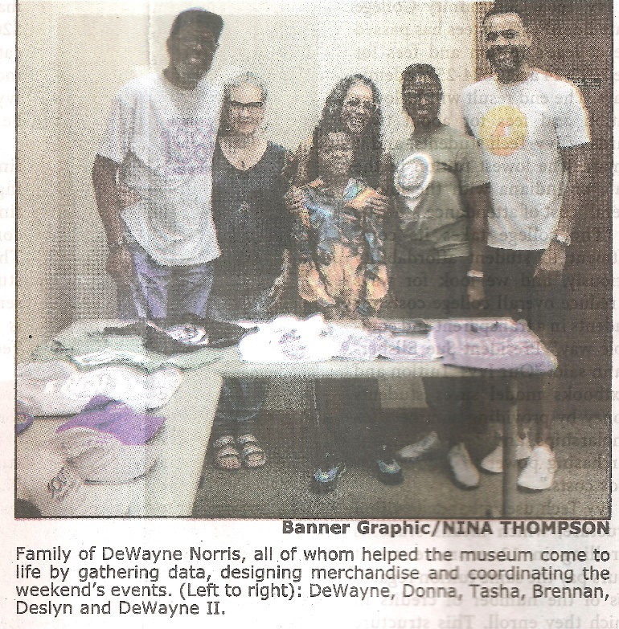

( Photo from the Banner Graphic/Nina Thompson)

DeWayne “Pete” Norris, a 1968 graduate of GHS, is the proud creator of the South End Black History museum. The museum’s opening was celebrated last July with a luncheon and music at The Inn at DePauw. The museum celebrates accomplishments of people who lived in the South End and includes interviews with South End residents. It also include digitized yearbooks, photos, documents, businesses, and other pertinent information.

**THE INK POT**

May 18, 1956

Seventh Grade News

Some of the couples going to the mixer are:

Karen Vote-Bobby Irwin

Sara Hanna-Larry Giddings

Bobby Jo Steele-John Compton

Rita Nickols-Teddy Whitaker

Charlotte Erdmann-Ronnie Pingleton

Judy Elmore-Marvin Ogle

Wanda Smithers-Billy Mahoney

Jo Ellen Hickman-Billy Lewis

Kay Johnson-Bob Fletcher

Malinda Williams-Mike Haines

**“THE GOOD OLD DAYS”**

While going through some of our files we found an interesting paper written by Carolyn Carson discussing the “Good Old Days”. She listed fourteen items. We will print some of them each issue. If some of them remind you of your childhood, you have earned the title “senior citizen”.

I lived on a small farm, approximately 124 acres. My dad worked in town, and while I was very small, we had a hired hand, Reuben Thompson. We had two work horses, Nancy and Jerry, milk cows, and chickens. When I was really small, we had hogs for awhile. One time I accidentally climbed down from the hayloft and got off the ladder on the wrong side-in with the hogs. Luckily, one of the boys, who was playing basketball in the loft, saw me and rescued me. After WWII was over, Reuben got a job in town, my dad bought a tractor, sold the horses, and he did a lot of farm work before and after work.

We had electricity all through the house, but it was only brought to our neighborhood the year before I was born. Before that, our electricity came from what was called a Delco plant, powered by batteries. It was long gone when I came along, so I’m not sure how it worked.

When I was small, we had a gas stove, powered by propane or butane tanks that we had to take to town to get refilled. It was a nuisance to run out of gas when you were cooking for company. We had two small tanks. Later, we got an electric stove.

There was no public transportation in the rural area where I lived. I think Greencastle had one taxi, and both Greyhound and Trailways bus lines stopped in our town at what was called the bus station. They picked up passengers several times a day. Up until about 1940, there was a service called the interurban – kinda half bus and half train (on rails) – that went between some of the larger cities in Indiana. They went out of business right before WWII. There were three different railroad lines that went through Greencastle, and people used the trains for transportation a lot more than they do now.

**THE INK POT**

March 31, 1953

National Honor Society Chosen

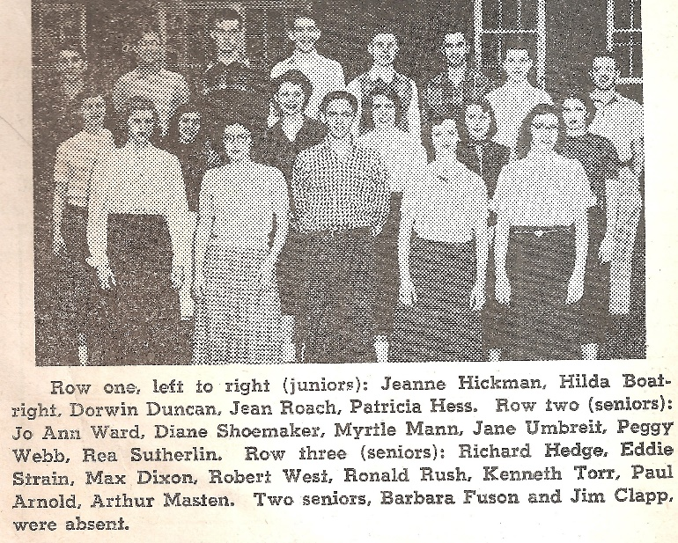

**THE INK POT**

May 11, 1962

Senior Prophecy

For 1984

Mike Leisure is a famous engineer working on a multi-million dollar project in Iraq.

Harry Maginity finally graduated from DePauw after spending 15 years trying to get his final literature paper turned in.

Paul Harrold has made a fortune in imitation bird call whistles.

Dick Hatcher is now the manager of a large business firm with wife Shirley as his private secretary.

Gary Osborne is throwing knives at Linda Nelson in a Ringling Brothers Circus.

Harriett Williams is a famous nurse with Doctor Ben Casey.

Sally Swope is the housemother in the DU house.

Jim Schimpf is the GHS economics teacher who replaced Mr. Cooper.

Linda Schmitt owns a racing strip around the Double Decker.

Tom See, president of the Tom See fan club, is also the voice of Donald Duck for Walt Disney.

Greencastle Alumni Dollars for Scholars, Inc.

formerly known as GHS Alumni Association

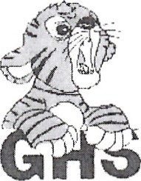Join or Renew Now!

Joining or renewing your Greencastle Alumni Membership will allow you to benefit in a variety of ways...

* You will receive the Tiger Tales newsletter up to 3 times per year
* Receive current news about the association and upcoming events
* Maybe you just want to reminisce or contact former classmates
* Support the awarding of scholarships to GHS graduates

The GHS Alumni Association was created in 1995 for the purpose of supporting Greencastle High School and operating a Scholarship Fund for our graduates. We currently use a number of fundraising events and activities to add to our scholarship fund including the All Class Reunion Dinner held June 20, 202, as well as the Farm to Fork Dollars for Scholars in Putnam County Dinner to be held September 19, 2020.

**Membership is only $10 per person per year. To join or renew, complete this application form and mail it to us with your $10 dues payment. Another option is a one-year free membership with a $25 contribution to the Greencastle Alumni Dollars for Scholars, Inc. Scholarship Fund. All contributions may be designated**

**"In Honor of” _______________ or "In Memory of” _____________________ for anyone that you choose.**

Please Print

 JOIN  RENEW

**_______________________________________________________________________________ _____________**

Name (include Middle Initial and/or Maiden Name) Class Year

**_______________________________________________________________________________ _____________**

Name (for use by Couples please include Middle Initial and/or Maiden Name) Class Year

**_________________________________________________________________________________________________**

Address City State Zip

**_____________________________________ _____________________________________________________**

Phone **Email Address**

**Receive Tiger Tales via email? Yes _______ No ____________**

Total Enclosed $_____________ Mail to. **Greencastle Alumni Dollars for Scholars, Inc.**

**P.O. Box 846**

Referred By: __________________ **Greencastle, Indiana 46135**

* Contribution to Greencastle Alumni Dollars for Scholars, Inc. Scholarship Fund
* **In Honor of ___________________________or In Memory of _________________________________**

