**ALL-CLASS DINNER**

The 2024 Greencastle Alumni Dollars for Scholars All-Class Dinner and Scholarship Recognition Night will be Saturday June 15th at the Putnam County Museum. Prior to dinner attendees will be able to tour the museum and participate in a scavenger hunt. Plus, they will be able to view and bid on items that are in our silent auction. All proceeds from the auction goes toward our scholarship fund.

Following dinner the 2024 scholarship recipients will be recognized. The evening will conclude with a euchre tournament. Doors will open at 4:00 p.m. with dinner served at 6:00 p.m. Putnam Inn will cater the dinner. The menu incudes broasted chicken, herb crusted pork loin with cranberry sauce, mashed potatoes and gravy, seasoned green beans, sweet corn casserole, garden salad, and dessert. Iced tea, lemonade, and coffee will be available.

The cost for the ENTIRE evening is $29.00 per person. After June 7th the cost is $35.00. Any class that reserves seating for ten or more people will receive a five dollar discount per person. A reservation form is on page six. It should be received no later than June 1st.

We hope to see you on June 15th for an enjoyable evening of socializing, eating, and playing euchre. Remember, you do NOT have to be a GHS graduate to attend.

**ONCE A TIGER CUB ALWAYS A TIGER CUB**

LITTLE OF

**THIS** and **THAT**

RENEWAL TIME

As we have entered 2024, it is now time for you to join or renew your membership in the Greencastle Alumni Dollars for Scholars. Membership dues for 2024 are ten dollars. Membership is free if you make a donation of twenty-five dollars or more to our scholarship fund. Because of your past support we were able to award twenty-one alumni scholarships in 2023 to deserving GHS graduates. Since 1996 we have awarded 249 scholarships totaling $245,700.00. A membership form can be found on page 7. Please help us help GHS graduates by joining or re-upping your membership.

Chad Rodgers, a Purdue graduate, has resigned as principal of Greencastle High School, effective at the end of this school year. He has accepted the position of principal at West Lafayette Junior-Senior High School. Selected as Principal of the Year in 2021 by the Indiana Association of School Principals, he returns to the West Lafayette area where he taught for sixteen years. We thank him for his years of service at Greencastle High School and wish him the best of luck at West Lafayette!

The GHS Class of ’64 will be celebrating their 60th class reunion on Saturday August 3rd at the Putnam County Museum. Dinner and fellowship start at 6:00 p.m. Reservations can be made by sending $30 to Ken Eitel 941 Evensview Drive Greencastle, In 46135. For further information contact Dick Cooper at 219-365-4326 or email Ken Eitel at keneitel@gmail.com.

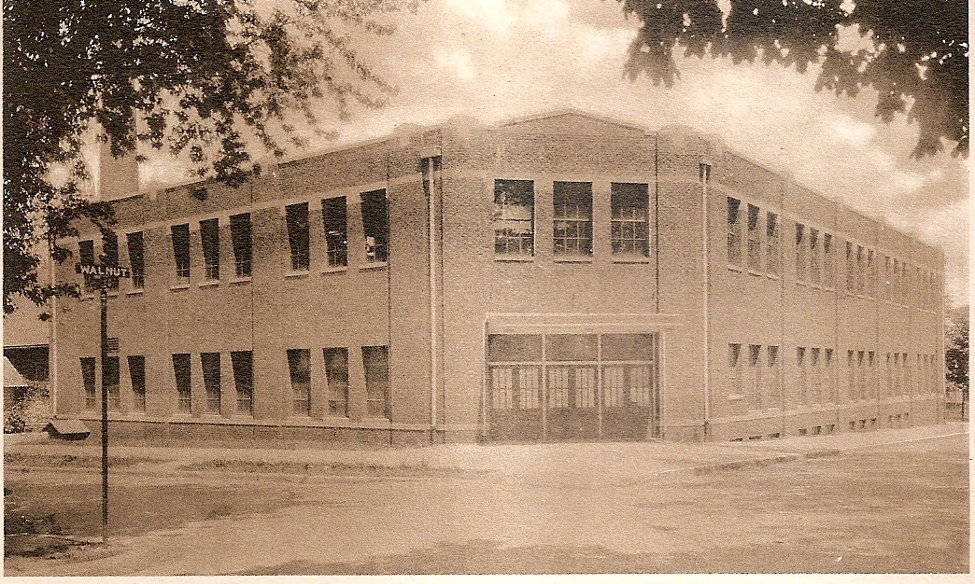

**2003-04 TIGER CUBS**

The 2003-04 Tiger Cubs won sixteen Sectional Championships, two Regional Titles, one Semi-State Title, and had a State Runner-up.

John Reno and Devin Lee advanced to the regionals in the doubles in boys tennis by going undefeated in the sectionals. They defeated North Montgomery, Turkey Run, and Crawfordsville in the sectionals before falling to Zionsville in the regionals. Andy Weatherford won the boys cross country Sectional Title with a time of 16:30. Girls swimming claimed three Sectionals Titles. Tracy Menzel won the 50 yard freestyle with a time of 24.72 and the 100 yard freestyle in 53.38. The 400 yard freestyle relay squad of Kendi Thomas, Elizabeth Lorton, Anna Harmless, Alys Moore, and Tracy Menzel claimed the Sectional Championship with a winning effort of 3:52.17. Boys swimming won a Sectional Title as Brian Barnes won the 100 yard breaststroke in 1:03.92. In wrestling Josh Myers claimed a Sectional Title in the 171 lb. class. After finishing third in the 130 lb. class, Jeremy Butler came back the following week to claim the Regional Championship. And Charles Pingleton entered the state tournament undefeated in the 140 lb. class. He didn’t disappoint the Tiger Cub faithful as he claimed Sectional, Regional, and Semi-State Titles. In the State meet Charles won three straight bouts before losing a heart breaking 10 to 9 decision in the State Championship match. As State Runner-up Charles finished the season with a 54 and 1 record! The boys basketball team claimed Sectional honors in class 3A by defeating Edgewood 54-47 and Sullivan 62-58. Girls track claimed two Sectional Titles. The 3200 meter relay squad of Brittany Hanners, Alys Moore, Erika Grammel, Tracy Menzel, Amanda Franklin, and Rachel Woodall had a winning effort of 10:06.47. And Laura Smith won the shot put win a heave of 36’3 ½”. Boys track won four Sectional Titles. Andy Weatherford won two Sectional Titles by winning the 1600 meter run (4:30.90) and the 3200 meter run (9:57.21). Randy Robinson claimed the high jump title with a leap of 6’4”. Girls’ tennis completed the successful year by defeating North Montgomery 5 to 0 and Crawfordsville 3 to 2 to claimed the Sectional Championship.

Sixteen Sectional Titles, two Regional ones, A Semi-state Title, and one State Runner-up made the 2003-04 school year “one to remember”!!

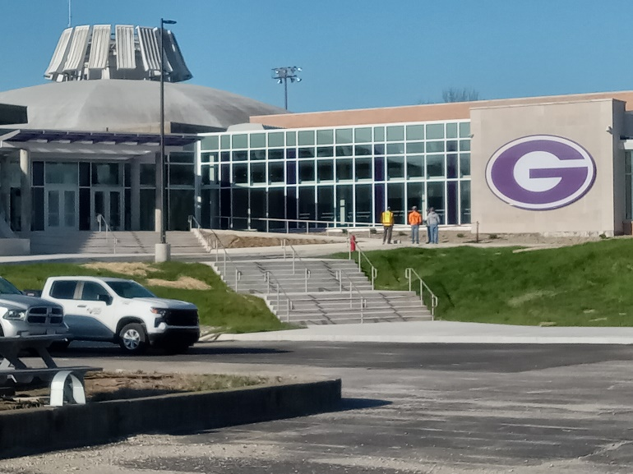

**IMPROVEMENTS AT GHS**

The construction project to connect the high school to McAnally Center is nearing completion as the two photos demonstrate. In addition, improvements have been made in the interior of the high school.

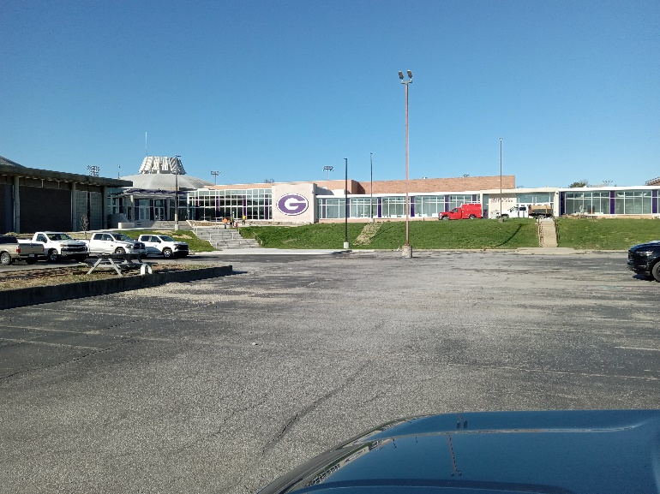

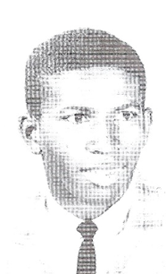

Steve Norris

1962 STATE CHAMPION

Stephen E. Norris, Class of 1962 will be honored on April 20, 2024 in celebration of his milestone 80th birthday!

Steve was born and raised in Greencastle. During Steve’s years at Greencastle High School, he was an outstanding student/athlete and contributed academically and athletically at our school. Steve played four sports (basketball, football, baseball, and track) and was captain of both the basketball and football teams. He broke the school’s high jump record and won the state championship in high jump in 1962.

Steve contributed to our country and joined the United States Army in 1969. He was stationed in Frankfurt, Germany, and served in Vietnam. He received an honorable discharge. During his time in the army, he participated in three sports in Germany (baseball, basketball, and football). Steve, we thank you for your service.

Steve graduated from Indiana University in 1975 with a Bachelor’s Degree in Business Administration.

He currently resides in Pasadena, California and is blessed to share his life with his wife Becky.

**McANALLY CENTER**

The following is from the February 13, 2004 edition of the Indianapolis Star. It was written by Kyle Neddenriep in his column High School Insider.

“We don’t give enough credit to the McAnally Center in Greencastle as one of the best high school gyms in the state. I was there Saturday to cover the girls basketball regional games and was reminded what a great place it is for hoops. It opened in 1969 and is currently part of a $32 million renovation that will connect the gym to the school. It is named after Jess McAnally, who led Greencastle to the state finals three times and won the 1932 Gimbel Award as a junior, went on to play at Northwestern, but died at age 21 from a bacterial infection.”

**THE INK POT**

(November 20, 1964)

**What Are You Thankful For?**

Since the Thanksgiving season is drawing near, we thought it would be appropriate if we took a poll to see what people were most thankful for.

* Shirley Saylor is thankful for her senior year.
* Kathy Carriker is thankful for men.
* Nancy Grimes is thankful for Indiana State College.
* Missy Lambert is thankful for B-Team Cheerleader.
* Janice Torr is thankful for Fillmore.
* Roger Ward is thankful for his rosy cheeks.
* Terry Sheldon is thankful for November 14---(His cast will be taken off.)
* Mead Childs is thankful for his little black Valiant.
* Clayton Kimble is thankful for everything. (Because everything always happens to him.)
* Elliott Wiliams is thankful for girls.
* Diane Nelson is thankful for “New” things.
* Debbie Geabes is thankful for John Hurst.
* Jim Lewis is thankful for his mother.
* Gary Samuels is thankful for false teeth.
* Dick Dean is thankful he hasn’t been killed in Chemistry.
* Pam Beaman is thankful for Louisville.
* Tom Burns is thankful for the “G” Mobile.
* Jim Simmerman is thankful for Nancy Slaughter

**DID YOU KNOW**

that Gillum Ridpath drew a map of Greencastle Township in 1897. On the map the schools were indicated by numbers (1-7). But instead of being referred to by their numbers, the schools were called Cowgill, Flatwood, Maple Grove, Stringtown, and Black Schoolhouse. In the 1930s there was a school called Maple Heights located in Fox Ridge. Did Maple Grove become Maple Heights? Did the school Fox Ridge become Maple Heights, or vice versa?

**GHS ALUMNI MEMORIES**

We contacted some GHS Alumni and asked them about their high school memories. Their responses are:

**SANDRA PEARSON MCCAMMON**

GRADUATION YEAR: 1964

PRESENT ADDRESS: Lafayette, Indiana

HIGH SCHOOL PRINCIPAL: Norman McCammon

FAVORITE HIGH SCHOOL TEACHERS: Mrs. Gooch, Mr. See, Miss Slack, Mr. Marketto

FAVORITE MIDDLE SCHOOL TEACHERS: Mr. Wilkenson, Mr. Egloff

ELEMENTARY SCHOOL: Jones Elementary, Miller Elementary

FAVORITE ELEMENTARY TEACHERS: Mrs. Miller, Miss Adams, Mr. Avery

FAVORITE HIGH SCHOOL SUBJECT: English

FAVORITE HIGH SCHOOL EXTRA-CURRICULAR ACTIVITY: Bowling, Theatre

FAVORITE HIGH SCHOOL MEMORIES: Senior Week

MOST EMBARRASSING HIGH SCHOOL MOMENT: Asking boys to dances and being turned down.

WHAT WOULD YOU DO DIFFERENT: I would be more outgoing and not so shy.

**SANDY SMITH**

GRADUATION YEAR: 1973

MAIDEN NAME: Grimes

PRESENT ADDRESS: Greencastle, Indiana

HIGH SCHOOL PRINCIPAL: Mr. Cooper & Dr. Coomer

FAVORITE HIGH SCHOOL TEACHERS: Mrs. Peterson (English), Mr. Layton (Driver’s Ed.), Mrs. Swalley (Biology)

FAVORITE HIGH SCHOOL CLASSES: English & Biology

FAVORITE EXTRA-CURRICULAR ACTIVITIES: Yearbook & attending sporting events

HIGH SCHOOL CAR: 1969 Yellow Chevelle Super Sport 396, Fancy!!

PROM DATE: Steve Thomas & Kent Williams

FAVORITE HIGH SCHOOL MEMORIES: I loved the Senior Bench. My classmates were really fun. I am not proud now but I did skip school a fair amount and Dr. Coomer called me “the Honey Creek kid.” He never caught me though. Steve Scott, Danny Perkins, Linda Coley, and Dee Fletcher were my besties in high school.

MOST EMBARRASSING HIGH SCHOOL MOMENT: Falling on the ice in front of a bunch of people

WHAT WOULD YOU DO DIFFERENT: I would have focused more on my academics and would have finished nursing school.

**ALUMNI’S NEW POP-UP CANOPY**

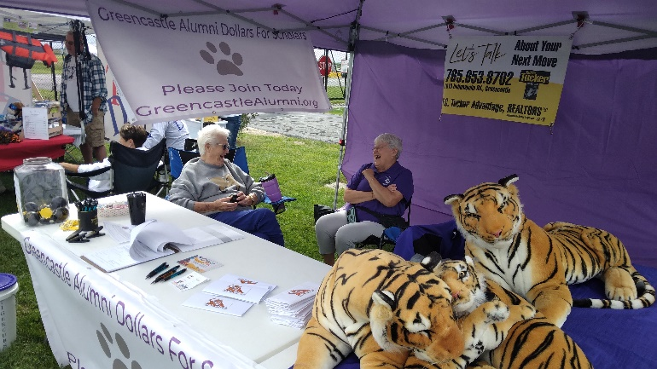

Board members Audra Holton(left) and Cathy Lowery share a laugh as they “man” the Greencastle Alumni Dollars for Scholars new pop-up canopy at the Putnam County Airport Appreciation Days last fall. In addition to the canopy the alumni purchased two new banners. One of the group’s goals is to be more visible at school activities and in the community.

**GREENCASTLE ALUMNI DIRECTORS**

Jon Blue ’69 (President) 765-721-1539

Jane Green Hansen ‘69(Vice-Pres.) 765-721-0150

Patty Sillery McCastle ’72 (Secretary) 765-653-5510

Terri Sutherlin McKee ’74 (Treasurer) 765-653-5620

Ron Blotch ’65 (Historian) 317-989-5601

Mary Lou Blue 630-750-9185

Josh Bonebrake ’11 765-720-2359

Cathy Gram Lowery ’69 765-721-0150

Nancy Livesay Clodfelter ‘55 765-721-7214

Audra Dorsett Holton ’54 765-848-8053

Anita Barr McEnulty ‘63 765-720-2568

Suzy Gould Schneider ’64 765-720-2822

Linda Alderfer York ’68

**“THE GOOD OLD DAYS”**

While going through some of our files we found an interesting paper written by Carolyn Carson discussing the “Good Old Days.” She listed fourteen items. We will print some of them each issue. If some of them remind you of your childhood, you have earned the title “senior citizen.”

We had a coal furnace in the basement that was not automatic. My dad had to rebuild the fire every morning. Somehow, our hot water line ran through that furnace, and it also heated the water. In the summer, there was a little stove that we made a fire in to heat the water. We had just one register-about 42 inches square-in the dining room that heated the whole house. It would get red hot sometimes. I was always very sleepy in the morning, so I would come downstairs, go to the bathroom and comeback with my toothbrush and stand over the register and brush my teeth. Many, many times I dropped my toothbrush down the register. I could find it later by opening up a door in the furnace surround, but it was too dirty to salvage.

A coal truck would bring us a load of coal, usually in the summer, and unload it into the furnace room in the basement through a window that opened.

The coal furnace kept the house toasty warm, but it was a lot of trouble for my dad, and having the coal in the basement was dirty. If it was too rainy or cold, my mother had a folding rack that she would put over the register and hang clothes on it to dry. They dried really fast, but steamed up the windows with all the moisture.

My dad milked cows morning and evening, and my mother kept the milk in two porcelain pans in the refrigerator. We had a cream separator in the basement, and she would run the milk through and keep the cream separately. If we ate cereal, we used the cream rather than milk. Extra cream we took to town to sell at a place called the creamery.

There was no permanent press, and everthing had to be ironed, including sheets and pillowcases, even some underwear. So…keeping clothes clean and ironed took most of two days a week, every week.

**GREENCASTLE HIGH STUDENTS TO GIVE 3-ACT COMEDY APRIL 8 AND 9**

THE TEEN EXPRESS  
FRIDAY MARCH 19, 1965

The Torch-Bearer’s, a satirical comedy by George Kelley, will be presented by Greencastle High School students April 8, 9.

The three act play evolves around a play within the play. The play within is a typical amateur performance. The actors stumble on stage, trip on rugs, and one man’s mustache consistently falls off.

The set for the first and third acts involves a scene in the living room at the house of Mr. and Mrs. Frederick Ritter. The set for the second act will considt of the stage at Horticultural Hall, or “Hutchy Kutchy” as it is called.

Nancy Slaughter will have the female lead role. She will play a small time play director. Mr. and Mrs. Ritter will be played by Jacque Schafer and Gerald York. Ann Silander will have the part as Jenny the maid. Nellie Fell, a seventy year old millionaire, will be played by Missy Lambert. Vicki Grimes will have the part of a widow.

Actors for the play within the play will be Steve Michael, Steve Pritchard, Kathy Carriker, Jeff Mont, Ray Guiliani, and David Robbins.

Miss Gertrude Slack, speech teacher, will direct the play. She will be assisted by Joanna Eitel, student director. Randy Hammond will be in charge of selling tickets. John Franklin, social studies teacher, will be technical director.

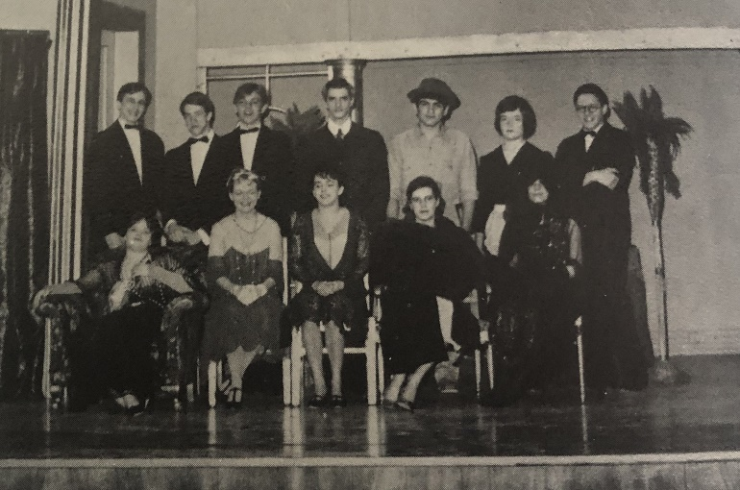

Row 1 (L-R): Nancy Slaughter, Missy Lambert, Sue Smaltz, Kathy Carriker, Vicki Grimes. Row 2 (L-R): Steve Michael, Steve Pritchard, Jeff Mont, Gerald York, Ray Guiliani, Ann Silander, David Robbins

(picture from the “65 Minaret Supplement)

**GREENCASTLE ALUMNI DOLLARS FOR SCHOLARS, INC.**

**ALL-CLASS DINNER**

**June 15, 2024**

**Putnam County Museum**

**Doors open @ 4 pm Dinner @ 6 pm**

_____________________________________________ __ GHS Class year

*Print Name (Include Maiden Name)*

_______________________________________________ GHS Class Year

*2nd Person Name* *(Or Guest)*

*Address City State Zip*

*Phone e-mail address*

Amount included $____________ Mail to:

*Amount enclosed at $29.00 each ticket* **Greencastle Alumni**

***($35.00 after June 7)*** **Dollars for Scholars, Inc.**

**P.O. Box 846**

**Greencastle, IN 46135**

**There will be a silent auction. Cash or check only.**

Meal catered by the Putnam Inn. Any special dietary needs _________________

Note: An inherent risk of exposure to COVID-19 exists in any public place regardless of precautions that may be taken. Attendee on their behalf and on behalf of any accompanying minor(s) agrees to (1) assume all risks associated with COVID-19 and other communicable diseases, and (2) comply with all related health and safety policies in effect at the time of the event.

Greencastle Alumni Dollars for Scholars, Inc.

formerly known as GHS Alumni Association

Join or Renew Now!

Joining or renewing your Greencastle Alumni Membership will allow you to benefit in a variety of ways...

* You will receive the Tiger Tales newsletter up to 3 times per year
* Receive current news about the association and upcoming events
* Maybe you just want to reminisce or contact former classmates
* Support the awarding of scholarships to GHS graduates

The GHS Alumni Association was created in 1995 for the purpose of supporting Greencastle High School and operating a Scholarship Fund for our graduates. We currently use a number of fundraising events and activities to add to our scholarship fund including the All Class Dinner held June 15, 2024, as well as the Farm to Fork Dollars for Scholars in Putnam County Dinner to be held September 21, 2024.

**Membership is only $10 per person per year. To join or renew, complete this application form and mail it to us with your $10 dues payment. Another option is a one-year free membership with a $25 contribution to the Greencastle Alumni Dollars for Scholars, Inc. Scholarship Fund. A $50 donation will be listed in a Banner Graphic Ad. All contributions may be designated**

**"In Honor of” _______________ or "In Memory of” _____________________ for anyone that you choose.**

Please Print

 JOIN  RENEW

**_______________________________________________________________________________ _____________**

Name (include Middle Initial and/or Maiden Name) Class Year

**_______________________________________________________________________________ _____________**

Name (for use by Couples please include Middle Initial and/or Maiden Name) Class Year

**_________________________________________________________________________________________________**

Address City State Zip

**_____________________________________ _____________________________________________________**

Phone **Email Address**

**Receive Tiger Tales via email? Yes _______ No ____________**

Total Enclosed $_____________ Mail to. **Greencastle Alumni Dollars for Scholars, Inc.**

**P.O. Box 846**

Referred By: __________________ **Greencastle, Indiana 46135**

Contribution to Greencastle Alumni Dollars for Scholars, Inc. Scholarship Fund

* **In Honor of ______________________________________________________________________ or**
* **In Memory of __________________________________________________________________**

