**ALL-CLASS REUNION DINNER CANCELED**

Due to the uncertainty of the coronavirus your Greencastle Alumni Dollars for Scholars board has regrettably decided to cancel this year’s All-Class Reunion Dinner. We definitely hope to resume what has been an annual event in 2021. Meanwhile, plans for this year’s Farm to Fork Dinner, sponsored by the alumni associations of Cloverdale, North Putnam, South Putnam, and Greencastle continue. Proceeds from the Saturday September 19th event will be split evenly among the four participating organizations. Please make plans to attend and help support the young people of Putnam County.

**JOHN ASH ALUM #1**

Tiger Tales

January 1996

John Ash, Class of 1949, received a life membership plaque and Alumni Card #1 in the newly formed GHS Alumni Association in appreciation of his work in compiling the names of over 9,000 alumni. The honorary membership, presented by 1953 graduate Jinsie Bingham and 1957 graduate John Carson, is the first honorary membership granted. Ash has spent the summer computerizing alumni information for the GHS Alumni Association and Scholarship Fund Drive.

A LITTLE OF

**THIS** and **THAT**

The coronavirus has played havoc with our goals, plans, and events for this calendar year. The All-Class Reunion Dinner has been canceled. Our attempt to become a full-fledged member of Scholarship America’s Dollars for Scholars has been placed on hold. And the scholarship committee has postponed their meeting to select this year’s scholarship recipients. We are disappointed but not discouraged. We plan to resume the All-Class Reunion Dinner next year. We will finalize and complete the final steps in becoming a member of Scholarship America. And the scholarship winners should be selected by the end of May.

The first All-Class Reunion Dinner was held in 1997. It was held every other year until 2011 when it became an annual event. Next year’s event will be the 17th All-Class Reunion Dinner.

This year we will be awarding eighteen $1000 scholarships!! This would not be possible without the generous support of the Greencastle Community and Alumni!! THANK YOU!!!

Once we are a member of Dollars for Scholars, we will develop a new website for Greencastle Alumni Dollars for Scholars, Inc. Scholarship applicants will be able to apply online.

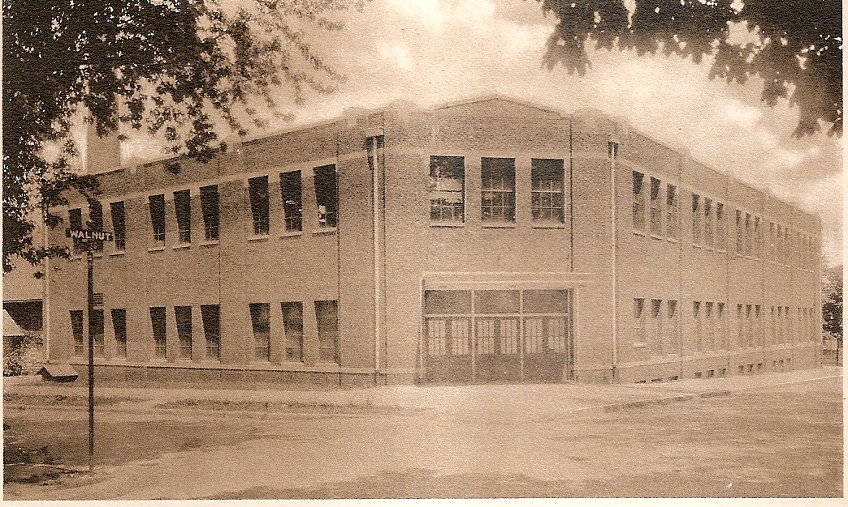

**TIGER CUBS IN THE 1980s (1988-89)**

As the 1980s were coming to a conclusion, high school athletes were working hard trying to accomplish the goal of a Sectional Championship. The 1988-89 Tiger Cubs were no different. They too wanted a Sectional Championship. In fact, they wanted several Sectional Championships. And they were not to be denied. The 1988-89 Greencastle Tiger Cubs claimed three team Sectional titles and five individual Sectional Championships. In addition, a team Regional Championship and an individual Regional title were added to the Tiger Cub resume!

The Tiger Cub Volleyball team captured the first Sectional title of the school year by defeating South Putnam (15-6, 16-14) and Cloverdale (15-11, 15-5). Their hopes of a Regional title came up short as they lost a hard-fought battle to North Vermillion (10-15, 13-15).

The wrestling squad produced three individual Sectional titles. Sam Ray won the 119 lb. class. Brad Garner claimed the 135 lb. title. Ray Hoover added the third individual wrestling Sectional Championship by claiming the heavyweight title. He then added the heavyweight Regional Championship to his resume the following week.

Track and field added two Sectional titles to the Tiger Cubs total. Susan Stark won the girls 800 meter run with a winning time of 2:25.9. And the boys 1600 meter relay team of Joe Tucker, Randy Pettit, Joe Buis, and Wes Trout claimed a Sectional Championship with a winning effort of 3:28.0.

The boys varsity golf team traveled to Martinsville in an effort to claimed the title Sectional Champs. And they succeeded! They defeated the twelve team field by shooting a round of 330. John Parmley led the Tiger Cubs with a round of 80. Ryan Wallace shot an 81. Todd Lancaster’s 84 and Chad Resner’s 85 rounded out the Cubs scoring.

The varsity baseball team won the eighth Sectional Championship and second Regional title of the school year. The Cubs won their own Sectional by defeating Cloverdale 9 to 2 and South Putnam 8 to1. They then traveled to Northview where they defeated Riverton Parke 6 to 1. They claimed the Regional Championship by defeating Sullivan 13 to 2. Their dream of a state championship ended in the semi-state at Lafayette where they fell to Logansport 7 to 0.

Eight Sectional Championships and two Regional titles for the 1988-89 Tiger Cubs made the school year a successful one for GHS athletics!

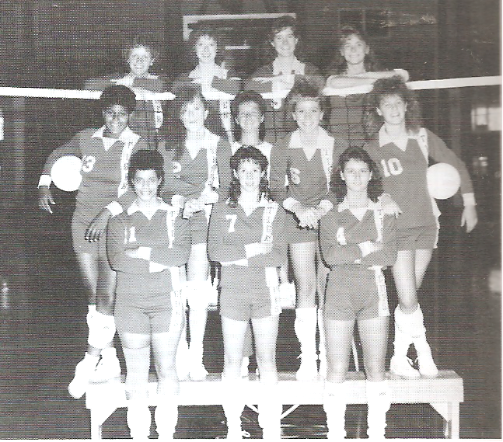

Front Row: Randi Weaver, Terri Lancaster, Kim Irwin. Middle Row: Kim Archer, Natalie Ward, Coach Trish Arthur, Melanie Marley, Jenny Black. Back Row: Alison Spencer, Nancy Claar, Katherine Emery, Mindy Nicholson

1988 VOLLEYBALL SECTIONAL CHAMPS

(1989 Minaret)

**THOUGHT OF THE DAY**

The courage to continue is what distinguishes success from failure.

Winston Churchill

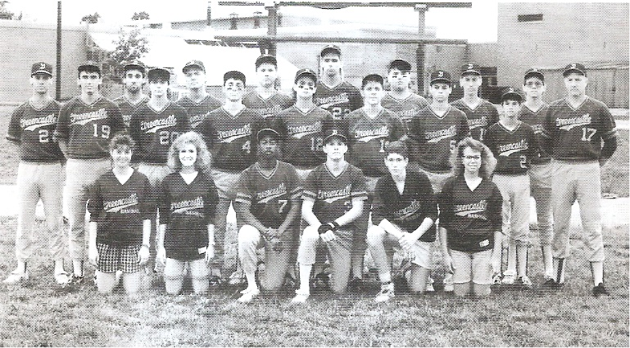

Front Row: Leah Shue (stat), Dana Cook (stat), Monye Steadman, A.J. Myers, Mark Heflin, Kelly Layton (stat). Middle Row: Eric Twigg, David Duff, Mike Greenawald, Rob Osborn, Mark Davis, Mark Pearson, Todd Shopmeyer, Coach Stan Ward. Back Row: Coach Craig Flint, Chris Hutchings, Scott Rehlander, Jamie Cox, Matt Bowen, Tom Baker, Bryan Murray, Corey Smaltz

1989 BASEBALL SECTIONAL & REGIONAL CHAMPS

(1989 MINARET)

**THE INK POT**

**November 2, 1934**

SCHOOL EXPENSES IN SECOND PLACE

America spends twice as much money annually for soft drinks, radios, tobacco, and automobiles as it does for education, according to Joseph Miller, Jr., secretary of the New York City Board of Education and president of the National Association of Public School officials.

Mr. Miller has just completed a thorough study of the average amount spent for public schools in the United States. His study, which was made for the National Schoolmart and National Schoolview, reveals that the nation spends $4,000,000,000 annually for luxuries, while it spends only $2,250,000,000 for its public schools.

The average amount spent per year per child for public school education was given by Mr. Miller as $86.69.

“When we consider the paltry amount we spend for education it is no wonder we are face to face today with one of the gravest national problems,” Mr. Miller said. “We have approximately 3,000,000 boys and girls of school age who are neither in school nor have jobs.”

**ONCE A TIGER CUB ALWAYS A TIGER CUB**

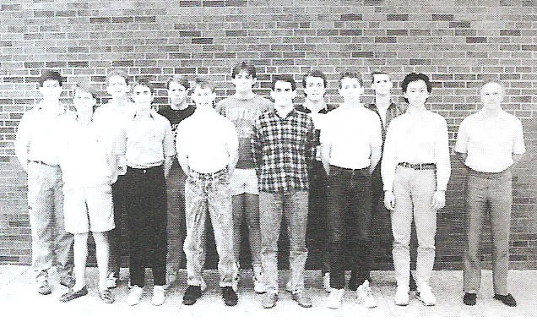

Front Row: John Parmley, Ryan Wallace, Pat Eitel, Todd Lancaster, Mike Scott, Taro Higashide, Coach Steve Paquin. Back Row: Doug Hill, Shawn Goldsberry, Jeff Flora, T.R. Harlan, Chad Resner, Nick York

1989 GOLF SECTIONAL CHAMPS

(1989 Minaret)

**THE INK POT**

**April 18, 1961**

HEAP OF THE WEEK

It’s a bird – It’s a plane – No, it’s Martha Craver on the way to the Kreme Kastle in her ’57 coral Chevrolet.

Martha’s car qualifies for “Heap of the Week” because of a broken gas gauge, no dash lights, slick tires and a worn-out transmission. Her pet name for it – the “Tank”, comes from the fact that it steers just like one.

Although Martha is a very orderly person her car looks like a barn-yard on wheels. Since her parents are the protective type, the Cravers had seat-belts installed in the car to prevent any sort of accident. (like running into the stone walk at the Kreme Kastle)

Martha’s “hot Chevy” has proved to be a very good traveling companion.

YES, Martha, your “Tank” deserves

“HEAP OF THE WEEK”

**DID YOU KNOW**

that U.S. 8th Circuit Court of Appeals Judge Jane Kelly was born in Greencastle

**GONE BUT NOT FORGOTTEN**

As we enter the month of May we would like to pay homage to those former Greencastle High School Alumni Association Board members who are no longer with us – in particular those who have left us within the last few years. Their contributions in terms of time and effort to your association has been nothing but overwhelming! Without their dedication the GHS Alumni Association would not have been able to exist! To Marilyn Gough (class of ’45), John Ash (’49), Libby Ash, Karen Wood (’54), John Carson (’57), Thelma Bumgardner (’57), Charlie Pritchett (’74), and Sherrie Aubrey Fenwick (’81) we say:

**JOB WELL DONE**

**YOU ARE GONE BUT NOT FORGOTTEN!**

**THE INK POT**

**March 17, 2000**

RUGBY

By Jill Coy

It’s new for some GHS athletes, and the first victory has already arrived against Earlham College on March 4.

Rugby is a new option for GHS athletes this spring. Rugby, a cross between football and soccer, is not actually a school-sponsored sport, but a DePauw sport.

It takes 15 players to compete as a team. The DePauw team coached by Kevin Boardman only had nine, so it recruited from GHS. Eight high schoolers now regularly participate on the team which practices each day after school at DePauw’s Blackstock stadium.

“Three GHS guys, Collin Brummett, Joe Anvoots and I started for the team (against Earlham)….That pretty much talks for itself,” said senior Adam Eitel. “No pads, no time-outs…nothing but your own strength, speed, and intellect. Only the toughest survive.”

**DID YOU KNOW**

that in some years “The Ink Pot” included paid advertisements. The October 22, 1934 issue had 36 different ads. They included: Hedge’s Market, Albin Dairy, Weber’s Shoe Shop, The Food Shop, Franklin Street Garage, Sam Hanna’s Book Store, Riley and Werneke Printing, Home Laundry, S.C. Prevo & Co., The Alley Inn, Locust Cottage, Browning & Hammond Hdw. Co., Castle Café, Greencastle Bowling Allies, Granada Theater, J.E. McCurry, Rickett’s, Star Barber Shop, Denny Motor Service, W.C. Glascock Jewelry & Music, Mullins Drug Store, Steven’s Drug Store, Potter Shoe Store, L. & H. Sales (cars), Binkleys Service Station, Cannon’s, Snider’s, Ideal Cleaners, Day-The Radio Man, Campus Market, Campus Barber Shop, Dr. H. Askew (chiropractor), Elms Inn, and Moore Electric.

How many of those “ring a bell” for you?

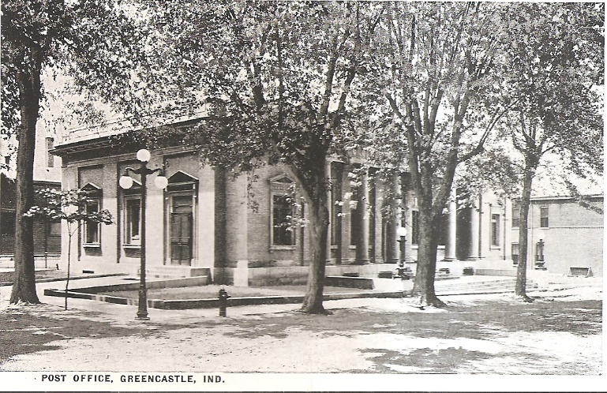

Postcard

United States Post Office – Greencaslte

Date Unknow

**GHS STATE CHAMPIONS**

(through 2000)

1925 - Andrew Ray Sears - Mile Run

1926 - Andrew Ray Sears - Mile Run

1927 - Andrew Ray Sears - Half-Mile Run

1927 - Andrew Ray Sears - Mile run

1962 - Steve Norris - High Jump

1981 - Lisa Allen - 800 Meter Run

**GREAT YEAR FOR 73 BAND**

**The Minaret 1973**

The GHS Band has been busy again this year. The band started off the year participating in the annual Putnam County 4-H Parade. They also accompanied Santa Claus on his annual trip to town.

Besides their playing at football and basketball games, they also participated in the DePauw Band Day and staged a special Winter Pops’ Concert in December. The Band played in the All-City Music Festival in April.

The band also received several excellent and superior ratings in the District Band Contest, and took part in the State Band Contest.

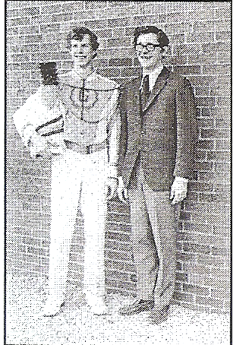

Drum Major David Boswell stands with GHS Band Director Mike Bailey

**DID YOU KNOW**

that Greencastle’s very first school was conducted in a log cabin near the corner of Washington and Spring Streets in 1824? As late as 1855 teachers allowed their homes to be used for classrooms and were paid rent by the school trustee.

SAVE THE DATE

**SATURDAY**

**SEPTEMBER 19, 2020**

**PUTNAM COUNTY FARM TO FORK**

**DINNER**

SPONSORED BY THE GREENCASTLE, CLOVERDALE, NORTH PUTNAM, AND SOUTH PUTNAM ALUMNI ASSOCIATIONS

**MORE ADS**

The 1934-35 school year was not the only year “the Ink Pot” sold ads to help support the school paper. Local businesses also helped support “The Ink Pot” during the 1995-96 school year. The January 26, 1996 issue had six advertisements. Those businesses supporting the school paper were: Delbert H. Brewer (Attorney At Law), Second Story CD’S, Skinner & Associates (CPA), You Got the Place I Got The Music, Ashley Square Cinemas, and Fine Print Book Store.

**DID YOU KNOW**

The eighteen $1000 scholarships being awarded this year make the total monetary value of all the scholarships awarded $184,200. Your generosity and the generosity of the Greencastle community has made this possible. THANK YOU!!

**2020 GREENCASTLE ALUMNI DIRECTORS**

Suzy Gould Schneider ’64 765-720-2822

(Co-President)

Ron Blotch ’65 (Co-President) 317-989-5601

Jon Blue ’69 (Vice-President) 765-721-1539

Dawn York Barger ‘77(Secretary) 765-247-8222

Terri Sutherlin McKee ’74 765-653-5620

(Treasurer)

Scott Monnett ‘95 352-283-3421

Paul Gould ’58 765-301-9266

Mary Lou Blue 630-750-9185

**THE INK POT**

**October 2, 1959**

59 GRADUATES

By Helen Rossok

Last year’s seniors have turned their thoughts to other things. They are no longer thinking about the things that happened back in GHS. They have turned their thoughts to college, marriage, the armed forces, and many other fields of business. I know you’ll be interested in knowing what they are doing in the “big” world.

David Stwalley is employed at the Allison plant in Indianapolis.

Dan Rossok spent his summer working in the meat department of the A & P store. He is looking forward to eleven weeks basic training in the Air Force Reserve.

David Jones is spending his time training to be a barber. I bet he’ll make a good one.

Jim Myers has been working for his father at White Cleaners. His future plans include attending a school for Cleaners.

Clyde Spencer is attending Indiana Central College. He says that he enjoys it very much.

Among those attending Indiana University are: Ronald Abbott, Jack Earnshaw, Jean Kircher, Alice Livesay, Mary Green, and Sara Borden.

Those enrolled at Indiana State Teachers College are: Richie Pierce, Patty Steele, Lola Sims, Pat Thompson, Beverly Best, and Marilyn Pell.

Among those who have heard wedding bells are: Carolyn Berry, Darla Masten, Rita Von Tress, and Kay Sutherlin.

Please help us keep current concerning any changes in your name, address, phone number, and/or email address. You can do this by email:

[mtmckee@frontier.com](mailto:mtmckee@frontier.com), or [suzy.schneider@talktotucker.com](mailto:suzy.schneider@talktotucker.com) or by phone at the numbers listed elsewhere on page 5.

A LITTLE MORE

**THIS** and **THAT**

If you haven’t already renewed your membership for this year it’s not too late. There is a renewal form on page 7. Membership is only ten dollars. And a twenty-five dollar donation to our scholarship fund gives you a free one year membership! PLEASE join. Help today’s students become tomorrow’s leaders.

We are still looking for past issues of “The Ink Pot” (any years). If you have any you would like to donate to your association please contact one of the board members listed on page 5.

The Putnam County Community Foundation plans on having a “Share the Dream” event again this year. But details are not yet finalized. We can thank the coronavirus for the delay. Please keep your Greencastle Alumni Dollars for Scholars in mind when details are announced.

The Greencastle Alumni Dollars for Scholars Board received a pleasant surprise last December and this February. A former member of your association included us in their estate planning. We received a check in December for our portion of the estate’s earnings prior to last year. And we received another check in February for 2019. The two checks totaled over $12,000! The board is in the process of establishing a scholarship in her honor. Once the scholarship is finalized we will announce the name of this new scholarship.

**GHS STATE-RUNNER-UPS**

(through 2000)

1931 - Boys Basketball

1933 - Boys Basketball

1964 - Elliott Williams - High Jump

1991 - Susan Stark - 800 Meter Run

**THOUGHT OF THE WEEK**

A loving heart is the truest wisdom.

Charles Dickens

Greencastle Alumni Dollars for Scholars, Inc.

formerly known as GHS Alumni Association

Join or Renew Now!

Joining or renewing your Greencastle Alumni Membership will allow you to benefit in a variety of ways...

* You will receive the Tiger Tales newsletter up to 3 times per year
* Receive current news about the association and upcoming events
* Maybe you just want to reminisce or contact former classmates
* Support the awarding of scholarships to GHS graduates

The GHS Alumni Association was created in 1995 for the purpose of supporting Greencastle High School and operating a Scholarship Fund for our graduates. We currently use a number of fundraising events and activities to add to our scholarship fund including the All Class Reunion Dinner held June 20, 2020, as well as the Farm to Fork Dollars for Scholars in Putnam County Dinner to be held September 19, 2020.

**Membership is only $10 per person per year. To join or renew, complete this application form and mail it to us with your $10 dues payment. Another option is a one-year free membership with a $25 contribution to the Greencastle Alumni Dollars for Scholars, Inc. Scholarship Fund. All contributions may be designated**

**"In Honor of” _______________ or "In Memory of” _____________________ for anyone that you choose.**

Please Print

 JOIN  RENEW

**_______________________________________________________________________________ _____________**

Name (include Middle Initial and/or Maiden Name) Class Year

**_______________________________________________________________________________ _____________**

Name (for use by Couples please include Middle Initial and/or Maiden Name) Class Year

**_________________________________________________________________________________________________**

Address City State Zip

**_____________________________________ _____________________________________________________**

Phone **Email Address**

**Receive Tiger Tales via email? Yes _______ No ____________**

Total Enclosed $_____________ Mail to. **Greencastle Alumni Dollars for Scholars, Inc.**

**P.O. Box 846**

Referred By: __________________ **Greencastle, Indiana 46135**

* Contribution to Greencastle Alumni Dollars for Scholars, Inc. Scholarship Fund
* **In Honor of ___________________________or In Memory of _________________________________**

