**ALL-CLASS REUNION DINNER**

**SCHEDULED FOR JUNE 18TH**

The Greencastle Alumni All-Class Reunion Dinner/Program is returning after a two-year absence due to the pandemic. It will be held on Saturday June 18th. Doors will open at 4:00 p.m. with dinner being served at 6:00. Due to the construction at the high school and McAnally Center the event will be held at the Greencastle Middle School cafeteria. The menu will consist of chicken/noodles, ham, veggie lasagna, green beans, mashed potatoes, salad, desserts, and drinks. Reservations may be made by returning the registration form located on page 7. The cost for the evening dinner/program is $25.00 per person ($30.00 after May 31st). Our very first scholarship recipient (1996) Jon “Buck” Blue will be our emcee.

Not only will we be recognizing this year’s scholarship recipients, we will also honor our scholarship winners from 2020 and 2021. Won’t you join us as we reminisce about our days at good ole GHS? And honor those whose academic achievements and extra-curricular/community involvement have enabled them to receive a scholarship through the Greencastle Alumni Dollars for Scholars organization?

**SAVE THE DATES**

SATURDAY JUNE 18th: All-Class Reunion Dinner

SATURDAY SEPTEMBER 17th: Farm to Fork Dinner

A LITTLE OF

**THIS** and **THAT**

We are pleased to announce that through the Greencastle Alumni Dollars for Scholars Inc. twenty-six GHS graduates will be receiving scholarships in 2022.

Twenty individuals will receive one thousand dollar scholarships from the Greencastle Alumni Association. In addition, the association is awarding two five hundred dollar Maxine Haskett scholarships. Three recipients will receive five hundred dollar Baumann Family Scholarships and one graduate will receive the Jim & Linda Renz Scholarship.

All of these 2022 Scholarship recipients will be announced at the GHS Awards ceremony on May 17th. We will also recognize them at the All-Class Reunion Dinner on Saturday June 18th.

Don’t forget to check out our alumni website at greencastlealumni.org. A big THANK YOU to board members Josh Bonebrake and Todd Detro for maintaining and updating the website!!

Congratulations to Tiger Cubs swimmer Olivia Headley for winning the 50 yard freestyle Sectional championship at Terre Haute South. Her winning time was 53.94.

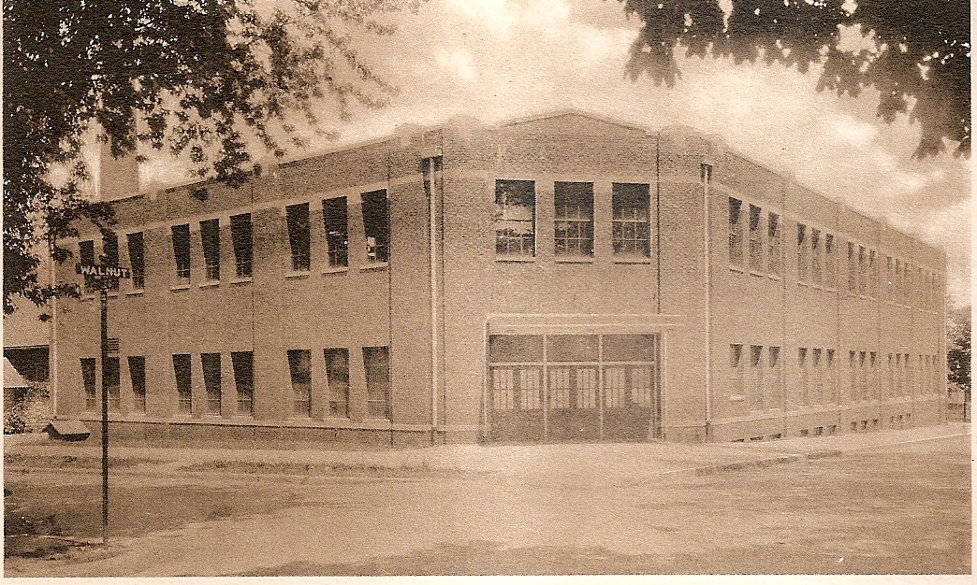

**TIGER CUBS IN THE 1990s**

**1993-94**

The 1993-94 Tiger Cubs started the year hoping to add a lot of hardware to the Tiger Cub trophy cases. Although they fell far short of the previous year’s thirteen Sectional championships, the 93-94 Tiger Cubs did add six Sectional titles to their resume.

The Lady Tiger Cub volleyball squad claimed the first Sectional title of the year by winning the South Vermillion sectional. They defeated Riverton Parke 15-7, 15-4 and Rockville 15-3, 15-10 to advance to the Martinsville Regional. There they defeated Terre Haute North in an exciting three game match. After dropping the first game 11-15 the Lady Cubs won the next game 15-8. The “all or nothing” third game was a “cliff hanger” as the Lady Cubs won 16-14. Their dream of a Regional championship ended with a 8-15, 10-15 loss to Martinsville.

Girls swimming had a very successful season as they captured the ten team Sectional championship at Crawfordsville with a team score of 242. They also added two individual Sectional titles. Angie Christian captured the diving title with a score of 368.60. And the 400 yard freestyle relay squad of Stephanie Schneider, Mandy Modlin, Michelle Schneider, and Shandol Swalley won the Sectional title with a winning time of 3:56.48.

The Lady Cub tennis team won the Crawfordsville sectional by defeating Turkey Run 5-0 and Crawfordsville 3-2. The season ended at the Lafayette regional as they fell to Covington 2-3.

The Tiger Cub baseball team captured the last Sectional title of the year by winning their own sectional. They defeated South Putnam 7-5, Rockville in ten innings 5-4, and North Vermillion 14-5. Their hopes of a Regional title ended at the Lafayette Jeff regional as they lost to McCutcheon 6-0.

**1994-95**

The 1994-95 school year saw the Tiger Cubs claim ten Sectional titles. The Lady Cub volleyball team claimed the South Vermillion sectional by defeating South Putnam 15-7, 15-8 and South Vermillion 15-5, 15-5. Their season ended at Martinsville as they lost to Eastern (Bloomfield) 9-15, 14-16.

In girls cross country, Erica Turner won the South Putnam Sectional championship with a winning effort of 15:46.

The girls swimming 400 yard relay squad of Laura Heeke, Kate Murray, Michelle Schneider, and Shandol Swalley claimed the Crawfordsville Sectional with a time of 4:00.60.

In wrestling Joe Gibbs claimed the Greencastle Sectional title by winning the 215 lb. weight class.

Boys swimming won two individual Sectional titles as Chris Hutchens won the 100 yard backstroke with a time of 56.87. And Brian Lanie won the 100 yard breaststroke with a winning effort of 1:06.41.

In track the Cubs claimed three Sectional titles. Erica Turner won the girls 3200 meter run at Danville with a time of 11:44.3. At Plainfield Alan Ball won the boys 800 meter run with a time of 2:05.1. And Jason Faletic claimed the pole vault title with a vault of 12’6”.

The Lady Cubs softball team won the Mooresville sectional by defeating South Putnam 11-7 and Mooresville 7-2. Their hopes of a Regional title ended at Rockville as they lost to Northview 6-2.

Sixteen Sectional Championship trophies in two years of competition were added to the Greencastle Tiger Cubs trophy case during the 1993-94 and 1994-95 school years!!

**ONCE A TIGER CUB ALWAYS A TIGER CUB**

**SHARE THE DREAM**

The Putnam County Community Foundation is once again sponsoring “Share the Dream.” This program provides each participating organization the opportunity to raise funds for their scholarships. Presently, your Alumni Association funds two different scholarship programs – the Greencastle Alumni Dollars for Scholars scholarship and the Maxine Haskett Memorial Scholarship. Under Share the Dream the PCCF will match (fifty cents for each dollar) each donation of $25 or more to either of the above scholarship funds providing there are at least ten separate donations from ten separate households. These donations must be made after June 1st and before July 31st. A “Share the Dream” donation form can be found on page 6. This is an excellent opportunity to donate to these scholarships in memory of a loved one, friend, teacher, co-worker, or alumni. And/or you may donate to honor that special person – someone who has done something special for you, the school, or the community. If you are considering donating fifty or more dollars, may we recommend that you split it and give twenty-five dollars or more to each of these scholarship funds.

Due to the generosity, kindness, and compassion of our alumni and the Greencastle community your Alumni Association has awarded more than $200,000 in scholarships to 228 deserving GHS graduates since 1996. WE THANK YOU!!!!

**SCHOLARSHIP INFO**

Founded; 1994

First Donor: Norman Handy

First Scholarship Recipient: Jon “Buck” Blue

Foundation Balance: $571,012.52 (as of Feb. 28, 2022)

GHS Alumni Scholarships Awarded: 225

Value of Scholarships Awarded: $223,200

Maxine Haskett Scholarships Awarded: 3

Value of Maxine Haskett Scholarships: $1500

**REUNION THOUGHT OF THE DAY**

With high-definition TV, everything looks bigger and wider. Kind of like going to your 25th high school reunion. Jay Leno

A LITTLE MORE

**THIS** and **THAT**

The Class of 1972 is celebrating their 50th reunion the weekend of August 26-27. Activities will begin on the 26th at 7:00 p.m. and conclude on the 27th at 10:00 p.m. Further details can be found in the Class of 72 group on Facebook. The contact persons are Danny McMains and/or Mary Drouillard. In addition, Patty Sillery McCastle has reserved a table for the Class of 72 at the June 18th All-Class Reunion Dinner.

The Class of 1977 is having their 45th class reunion the weekend of August 5-7. Vicky Oliver is the contact person.

The Class of 1954 is having their 68th class reunion on Saturday June 18th at 11:00 a.m. at the Fairway Restaurant in Greencastle. Contact Audra Holton for further details.

The Class of 1987 will be celebrating their 35th class reunion Saturday September 17th at 7:00 p.m. at The Inn at DePauw. Contact person is Amanda York.

We are sorry to report that former board member Marilyn Jackson passed away January 1st. She was a charter member of your alumni board and served as our first treasurer along with her husband Bob – a position that they held for several years. Bob and Marilyn were former owners of both Double Deckers – the one on DePauw’s campus and the one on Indianapolis Road. Many GHS students worked for them, especially at the one on Indianapolis Road. Marilyn will be sorely missed. Our condolences go out to Bob and his family. RIP Marilyn!

We are still looking for board members. We presently have thirteen board members. Our goal is to have between 15 to 20 members. You may contact any board member listed on page 4 for further information.

**HOPE TO SEE YOU SATURDAY JUNE 18TH**

**MEET YOUR BOARD MEMBERS**

**ANITA BARR MCENULTY**

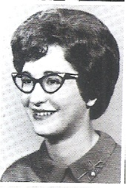

Anita Barr McEnulty is a 1963 graduate of Greencastle High School and a member of the first class to attend the present high school for four years. She recently rejoined the board after moving back to Greencastle from Cloverdale. Her father was a long-time writer for The Graphic and later editor at the Daily Banner. Anita’s knowledge of the newspaper business is a plus for the alumni board.

After graduation Anita continued working at Fleenor’s drugstore until moving to the Pueblo, Coiorado area. Living there ten years she was a homemaker and mother to her four children Randy, Kendra, Cory, and Kevin. Moving back to Indiana, Anita worked at the Putnam County Hospital for twenty-five years in the physical therapy rehab department. Now retired Anita volunteers at the Putnam County Museum, the Greencastle Food Pantry, and the Putnam County Library. She also enjoys researching the history of Putnam County with an emphasis on Greencastle and the different businesses throughout its history. Anita also enjoys spending time with her nine grandchildren and four great grandchildren.

**PATTY SILLERY MCCASTLE**

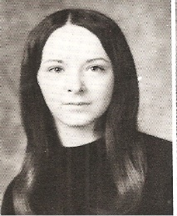

Patty Sillery McCastle is secretary for your Greencastle Alumni Dollars for Scholars Board. She is a 1972 graduate of Greencastle High School. After graduation she attended Indiana Business College in Terre Haute and graduated with a stenographic degree. She wanted to be a court reporter but found employment as a bookkeeper for Headley Hardware. She retired from there after 33 years. She was also an office manager for a dentist for one year.

For the last 25 years she has set-up Quick Books Programs for several businesses. In her spare time, she likes to read, needlefelt, and do bead work. She also tends to her garden and cans the produce. But along with reading her first love is to cut paper. She is a member of the Guild of American Paper Cutters which has a world-wide membership of approximately 800. She makes greeting cards, wall hangings and makes paper out of cotton linter.

Patty and her husband of 29 years Gary have a blended family of six children – Amy, Derek, Christopher, Benjamin, Adam, and Joseph. They also have sixteen grandchildren and eight great grandchildren.

**DON’T FORGET SATURDAY JUNE 18TH**

**ALL-CLASS REUNION DINNER**

**SEE YOU THERE**

**2022 GREENCASTLE ALUMNI DIRECTORS**

Jon Blue ’69 (President) 765-721-1539

Cathy Gram Lowery ’69 (Vice-Pres.) 765-721-0150

Patty Sillery McCastle ’72 (Secretary) 765-721-2320

Terri Sutherlin McKee ’74 (Treasurer) 765-653-5620

Ron Blotch ’65 (Historian) 317-989-5601

Mary Lou Blue 630-750-9185

Josh Bonebrake ’11 765-720-2359

Todd Detro ’87 317-281-6508

Sandra Quinnette Foster ‘71

Jane Green Hansen ’69 765-653-4969

Audra Dorsett Holton ’54 765-247-9064

Anita Barr McEnulty ‘63 765-720-2568

Suzy Gould Schneider ’64 765-720-2822

**GHS ALUMNI MEMORIES**

We contacted two GHS Alumni and asked them about their high school memories. Their responses are:

**CLYDE SPENCER**

GRADUATION YEAR: 1959

PRESENT ADDRESS: Greencastle, Indiana

FAVORITE HIGH SCHOOL TEACHERS: Tom Goldsberry & Gene Akers

FAVORITE MIDDLE SCHOOL TEACHER: Bill Bishop

FAVORITE ELEMENTARY TEACHER: Carl Foreman (Van Buren Elementary School)

FAVORITE HIGH SCHOOL EXTRA-CURRICULAR ACTIVITY: Basketball

FAVORITE HIGH SCHOOL MEMORY: Meeting Peggy Anthony who became my wife. We have been married 62 years.

MOST EMBARRASSING HIGH SCHOOL MOMENT: On one sunny afternoon, I along with 65 other students skipped school and received a 3 day vacation for our efforts.

WHAT WOULD YOU DO DIFFERENT: No regrets!

**MIKE SURBER**

GRADUATION YEAR: 1967

PRESENT ADDRESS: Cicero, Indiana

FAVORITE HIGH SCHOOL TEACHER: Coach McCracken

FAVORITE MIDDLE SCHOOL TEACHER: John Franklin

FAVORITE ELEMENTARY TEACHER: Mr. Rightsell

FAVORITE HIGH SCHOOL EXTRA-CURRICULAR ACTIVITIES: Cross Country, Basketball, Golf

FAVORITE HIGH SCHOOL MEMORY: Winning the (WIC) Western Indiana Conference Basketball Championship against T.H. Gerstmeyer’s undefeated team. Pete Norris hit two free throws to get us into overtime. In overtime I was fortunate to hit a 25 ft. net swisher to win the game.

MOST EMBARRASSING HIGH SCHOOL MOMENT: Puking in my driveway after a senior party and Coach McCracken saw me (he lived across the street). I got to sit on the bench a long time after that.

WHAT WOULD YOU DO DIFFERENT: Nothing

**THE INK POT**

**Nov. 19, 1941**

**Adjectives That Apply**

Ear-resistable – Georgia Anne Zeis

Nose-talgie – Judy Smith

Unde-feet-able – Mary Moseley

Hand-some -- John Harlan

Eye-deal – Virginia Torr

E-lip-tical – Peggy Sandy

H-arm-less -- Jim Long

E-leg-ant – Bob Bills

Capi-tall – Jerry Fowler

Neck-romancer – Emma Jane Conklin

Hair-em – Ed York

Back-ward – Jim Westfall

Knee-glectful – Miss May

Hip-nistic – Anna Mae Cancilla

Vital-istic – Pat Lenzen

Ego-tistical – Harriet Seller



**DID YOU KNOW**

Greencastle was named after Greencastle, Pennsylvania, And Putnam County was named after Israel Putnam a war hero of the French and Indian War?

2022 SHARE THE DREAM

PROGRAM GUIDELINES

1. Program Dates: June 1 to July 31

2. Eligibility. Restricted endowments, with the exception of Donor Advised Funds, are eligible to participate.

3. Participating endowments will be eligible for the matching opportunity.

a. Endowments wishing to participate must register by May 2.

b. Qualifying endowments must receive at least ten donations of $25 of more, from different households.

c. Donations, up to $10,000 per household, will be matched $0.50 to every dollar.

d. The endowment with the greatest number of donors will receive an additional $1,000 prize for their endowment.

4. Publicity. All participants will be included in press releases, listed on our website, and be featured in social media posts.

5. Recognition for your donors. Donors will receive personalized acknowledgement letters and be recognized in the Community Foundation’s publications and other recognition programs.

6. Tribute opportunities for your donors. Persons contributing $50 or more to your endowment may honor or memorialize a special person in the Banner Graphic.

**SHARE THE DREAM**

**Greencastle Alumni Dollars for Scholars, Inc. Scholarship**

**Or**

**Maxine Haskett Memorial Scholarship**

DONOR__________________________________DATE_________CLASS_________

ADDRESS____________________________________________________________

AMOUNT:__________ ____________________________________scholarship

IN MEMORY OF:______________________________________________________

IN HONOR OF:________________________________________________________

SEND TO (BETWEEN June 1st and July 31st)

The Putnam County Community Foundation GHS Alumni Association

2 South Jackson Street or PO Box 846

Greencastle, IN 46135 Greencastle, IN 46135

**GREENCASTLE ALUMNI DOLLARS**

**FOR SCHOLARS, INC.**

**ALL-CLASS Reunion Dinner**

**June 18, 2022**

**Greencastle Middle School Cafeteria**

**Doors open @ 4 pm Dinner @ 6 pm**

_____________________________________________ __ GHS Class year

*Print Name (Include Maiden Name)*

_______________________________________________ GHS Class Year

*2nd Person Name* *(Or Guest)*

*Address City State Zip*

*Phone e-mail address*

Amount included $____________ Mail to:

*Amount enclosed at $25.00 each ticket* **Greencastle Alumni**

***($30.00 after May 31)*** **Dollars for Scholars, Inc.**

**P.O. Box 846**

**Greencastle, IN 46135**

If you have not continued your membership with us for 2022, please use this form to do so. Annual dues are $10.00 each year. You do not have to be a paid member to attend. Dues included $ ____________

Note: An inherent risk of exposure to COVID-19 exists in any public place regardless of precautions that may be taken. Attendee on their behalf and on behalf of any accompanying minor(s) agrees to (1) assume all risks associated with COVID-19 and other communicable diseases, and (2) comply with all related health and safety policies in effect at the time of the event.

**Return Service Requested**

