**ALL-CLASS REUNION DINNER?? YES!!**

There WILL BE a 2021 GHS All-Class Reunion Dinner!! It will be held the same weekend as the Greencastle High School Football Homecoming. The Tiger Cubs’ varsity football squad will host Owen Valley on Friday October 8th. The Greencastle Alumni Dollars for Scholars, Inc. board will host the All-Class Reunion Dinner on Saturday, October 9th. Dinner will be served at 6 p.m. The evening’s activities will include recognition of the 2021 Greencastle Alumni Dollars for Scholars scholarship recipients. Further information, including a reservation form, will be included in the next issue of Tiger Tales scheduled for the latter part of August. PLEASE MARK YOUR CALENDAR and make plans to attend!

**SHARE THE DREAM**

Once again, your alumni association is participating in the Putnam County Community Foundation’s Share the Dream Program. This program started June 1st and lasts through July 31st. For every donation of $25 or more the Foundation will match it at the rate of fifty cents for every dollar. In addition, the organization with the greatest number of unique donors (minimum $25 gift) will receive an additional $1,000. The organization that raises the most money will also receive an additional $1,000. For those of you who are not members of our association, a donation of $25 or more also includes free membership in your alumni association.

A LITTLE OF

**THIS** and **THAT**

We would like to welcome Patty Sillery McCastle to your Greencastle Alumni Dollars for Scholars Board. Patty is a 1972 graduate of Greencastle High School. We now have twelve board members and are expecting to add another at our July meeting. Our ultimate goal is to have between fifteen to twenty board members.

I would like to apologize to board member Cathy Gram for misspelling her name in our last issue of Tiger Tales. Cathy is a 1969 graduate of GHS and became a board member in recent months.

Once again, the alumni associations of the four Putnam County High Schools are sponsoring a Farm to Fork drive-thru dinner to be held on September 18th. The proceeds will be divided evenly among the four alumni associations.

Superintendent Jeff Gibboney and High School Principal Chad Rogers attended our last board meeting. They provided us with information concerning the school’s facilities and plans for improving them. Among the many improvements planned for the corporation are a resurfacing of the high school track and the installation of artificial turf on the football field at Harbison Stadium. This will allow both the boys and girls soccer teams to play their games at Harbison Stadium.

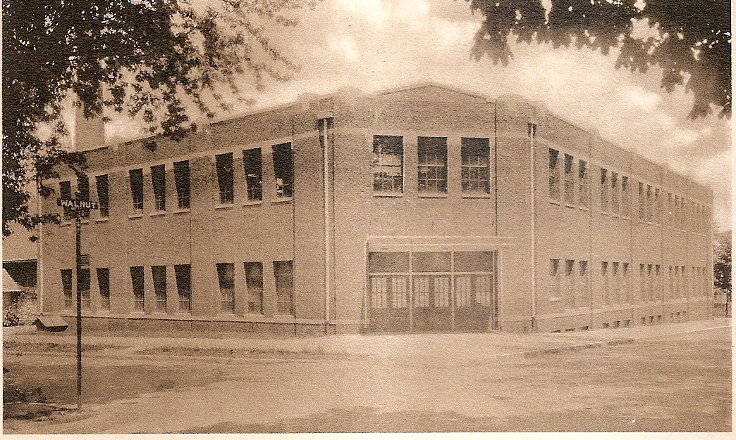

**TIGER CUBS IN THE 1990s (1991-92)**

As the 1991-92 Tiger Cub school year started, the Free World was inspired by the break-up of the communist country the Soviet Union. Eventually, the Soviet Republics of Uzbekistan, Tajikistan, Kyrgyzstan, Azerbeijan, Ukraine, Moldova, Lithuania, Latvia, Belarus, and Estonia became independent countries. Just as the Free World was celebrating this break-up, Tiger Cub athletes were hoping they would be celebrating Sectional Championships. They were not disappointed. A total of eighteen Sectional Championships and two Regional Championships were celebrated in the halls of GHS.

FALL SPORTS

Lori Garner claimed the first Sectional Championship by winning the South Putnam Girls Cross Country Sectional with a time of 15:10. The volleyball squad won their own Sectional by defeating South Putnam 15-3, 15-7 and Southmont 15-7, 9-15, and 17-15. The Lady Cubs then traveled to West Vigo and defeated them 15-13, 5-15, and 15-8. Their hopes of a Regional Championship ended as they fell to White River Valley 10-15, 13-15. The varsity football team had a season to remember as they won the Class 2A Sectionals by defeating Sullivan 42-0, Monrovia, 40-0, and Indian Creek 39-6. The Tiger Cubs then won the Regionals by defeating Tell City 21-14. But their hopes of playing in the State Championship game ended in the semi-state as they fell to Indianapolis Scecina 19-14.

WINTER SPORTS

Girls swimming provided two Sectional Championships as Susan Stark won the 100 yard freestyle in 55.73. And the 200 yard freestyle relay squad of C. Smock, B. Haymaker, K. Nelson, and S. Stark were Sectional Champs with a winning time of 1:46.68. The wrestling team added five Sectional Championships and one Regional Title to the trophy case. Claiming Sectional Championships were Scott Williams (103 lbs.), Scott O’Hair (135 lbs.), Brian Black (145 lbs.), Shane Thomas (160 lbs.), and Steve Graham (heavyweight). Shane Thomas also was the Regional Champ in the 160 lb. class. Girls basketball dominated the Sectionals by defeating Cloverdale 60-40, Monrovia 70-44, and South Putnam 55-28. The Lady Cubs then traveled to Ben Davis for the Regionals where they defeated Avon 61-54. But their dream of a Regional Title ended with a 67-58 defeat to Ben Davis.

SPRING SPORTS

Girls track added three Sectional Titles to the Tiger Cubs resume by dominating the individual distance events. Lori Garner won the 1600 M run in 5:41.6. Susan Stark claimed the 800 M run with a winning effort of 2:19.7. And Joy Tesmer was the Sectional Champ in the 3200 M run with a winning effort of 12:23.6. Boys track had a good performance in their own Sectional by claiming four Sectional Championships. The 400 M relay squad of D. Scamahorn, B. Resner, A. Hughes, and J. Gibbs were Sectional Champs with a time of 44.7. Monye Steadmon won the long jump with a leap of 20’8 1/8”. Jason Gibbs claimed the high jump title with winning effort of 6’6”. Doug Scamahorn won the 400 M dash in 50.8.

Yes, the Tiger Cubs celebrated at the end of the school year with eighteen Sectional Titles and two Regional Championships!

**DID YOU KNOW**

Greencastle has had four court houses? A two story frame building was the first court house from 1829 to 1832. A brick building served as the court house from 1832 to 1848. In 1848, a larger brick building became the court house. The corner stone for the present court house was laid on October 29, 1903. It was dedicated on July 4, 1905. Made of Bedford stone it cost $176,748 to build.

**SCHOLARSHIP RECIPIENTS ANNOUNCED**

The Greencastle Alumni Dollars for Scholars, Inc. awarded twenty-three scholarships this year. Nineteen GHS graduates/alumni received the $1,000 alumni scholarship. Two individuals received the Patrick Baumann Memorial $500 Scholarship. One P. James & Linda Renz Scholarship of $500 was awarded. One student received $500 in memory of Maxine Haskett. The recipients are:

ALUMNI $1,000 SCHOLARSHIP

Neva A. Brown Hope College

Jacie Lee Bumgardner Southern Indiana

Kensie Bumgardner Ivy Tech Community

Henry D. Carter Valparaiso

Emily Nicole Crowder Purdue

Grace Gillen Indiana

Emma L. Huber DePauw

Paige E. Kaiser Purdue

Jacob Meyer Millikin

Makenzie J. Miles Indiana State

Nicole R. Newgent Anderson

Allison R. Scott Indiana State

Jennifer K. Scott IUPUI

Conner R. Taylor Wabash

Corydon J. Taylor Wabash

Gretchen Weliever Purdue

Nina K. White Hanover

Rose White Taylor

Andrew T. York Purdue

MAXINE HASKETT MEMORIAL $500 SCHOLARSHIP

Madison A. Rogers Purdue

PATRICK BAUMANN MEMORIAL $500 SCHOLARSHIP

Jack C. Howard Purdue

Molly N. Ramey Purdue

P. JAMES & LINDA RENZ $500 SCHOLARSHIP

Emily Nicole Crowder Purdue

A LITTLE MORE

**THIS** and **THAT**

Because of your generosity and your efforts your alumni association has now awarded 207 scholarships totaling $204,700. This could not have been done without the support of our alumni and the Greencastle community! We THANK YOU!!!

You probably noticed that there were three new scholarships awarded this year – the Patrick Baumann Memorial Scholarship, the P. James & Linda Renz Scholarship, and the Maxine Haskett Memorial Scholarship. The Patrick Baumann Scholarship is the result of an endowment started by his family. It is for students who plan to study engineering. The P. James & Linda Renz family started an endowment for a four-year renewable scholarship. An endowment for the Maxine Haskett Memorial Scholarship is being established by your alumni board. A 1939 graduate of GHS she passed away in 2017. She included our alumni association in her trust. Consequently, the board has received a portion of the trust’s earnings at the beginning of each year. A major portion of that money is being used to establish the endowment in her memory. This scholarship is and will be awarded to a GHS graduate who is entering the social services field.

Breaking news: The Class of ’61 is having their 60th reunion on August 6 & 7. If your class is planning a reunion, PLEASE notify one of the board members. We would like to include class reunion dates in Tiger Tales and on our alumni website.

One of our two websites Is now “up and running.” You can find it at greencastlealumni.org. Our Dollars for Scholars website should be available in the very near future! A special thank you to Scott Monnett and Todd Detro for their efforts in developing these websites.

Congratulations to Brach Carrington for his State Runner-up accomplishment in wrestling this year. Brach had the greatest season in Tiger Cub wrestling history as he was undefeated until the state championship match! His record – 40 and 1.

**MEET YOUR BOARD MEMBERS**

**TERRI SUTHERLIN MCKEE**

Terri Sutherlin McKee, treasurer and scholarship chairperson of the Greencastle Alumni Dollars for Scholars, is a 1974 graduate of Greencastle High School. After graduation she attended Indiana State University majoring in business education. Graduating in 1978 she accepted a position as business teacher at Southmont High School where she taught for two years before accepting a position as a business teacher and assistant volleyball coach at Greencastle High School. In 1981 she was promoted to varsity coach which she held for two years. After thirty-two years as a business educator at GHS, she retired from teaching in 2012. Terri and her husband Maurice (GHS class of 1973) just recently celebrated their 43rd wedding anniversary. They have two daughters Deborah, GHS 2001, and Joanna, GHS 2005. In her spare time, she enjoys watching NASCAR both on TV and in person. She also enjoys showing dogs, especially Briards. Terri has dedicated her life to the Greencastle community as a teacher and now as a VITAL member of your alumni board. She likes to say that she has spent half of her life in Greencastle High School!

**PAUL GOULD**

Paul Gould is a 1958 graduate of Greencastle High School. After graduation Paul attended Indiana University and worked at Colonial Bakery Company. He eventually joined the Naval Reserves and was on active duty for two years serving on the destroyer U.S.S. Bache. Paul was part of the Cuban Missile Crisis as the U.S.S. Bache participated in the naval blockade of Cuba. While patrolling the waters surrounding Cuba, they intercepted a Russian submarine and helped escort it away from the blockade. The submarine had nuclear torpedoes on board. Some of those on board the sub thought that they were at war and wanted to launch the torpedoes at the U.S.S. Bache. Fortunately, one of the three Russians who had to agree to the launch refused to do so – probably preventing a world war. Paul still carries a picture of that Russian in his billfold. Paul and his wife Virginia (Ginny) have lived in Arkansas, Illinois, Kentucky, and Tennessee before moving back to Greencastle. Paul retired from IBM in 1993. After retirement Paul drove a school bus for several years and taught future bus drivers. Paul and Ginny have been married for sixty-one years and have two sons (Rodney and Mark) and two grandchildren (Gracie and Alden). In his spare time Paul enjoys woodworking and gardening.

**SAVE THE DATES**

**SATURDAY, OCTOBER 9, 2021**

**ALL-CLASS REUNION DINNER**

**AND**

**SATURDAY, SEPTEMBER 18**

**FARM TO FORK DRIVE THRU DINNER**

SEE YOU THERE!!

**STATE CHAMPIONS**

1925 - Andrew Ray Sears - Mile Run

1926 - Andrew Ray Sears - Mile Run

1927 - Andrew Ray Sears - Half-Mile Run

1927 - Andrew Ray Sears - Mile run

1962 - Steve Norris - High Jump

1981 - Lisa Allen - 800 Meter Run

2005 - Andy Weatherford - 1600 Meter Run

2006 - Andy Weatherford - 1600 Meter Run

2017 - Emma Wilson - 1600 Meter Run

2017 - Emma Wilson - 3200 Meter Run

2017 - Emma Wilson - Cross Country

2018 - Emma Wilson - 3200 Meter Run

2018 - Emma Wilson - Cross Country

**GHS ALUMNI MEMORIES**

We contacted four GHS Alumni and asked them about their high school memories. Their responses are:

MARIAN GIDDINGS

Graduation Year: 1944

Present Address: Greencastle

Favorite High School Teacher: Leona Dobbs, Chartille Donahue

Favorite Middle School Teacher: Mrs. Owens

Favorite Elementary Teacher: Paul Buis

Favorite High School Extra-Curricular Activity: Basketball

Favorite High School Memory: Singing in the Glee Club and playing basketball

Most Embarrassing High School Moment: Giving a report in front of the class or on stage

What Would You Do Different: Study harder

LORETTA DUNCAN MAXWELL

Graduation Year: 1958

Present Address: Greencastle

Favorite High School Teacher: Fauneil Stewart

Favorite Middle School Teacher: Reese Hammond

Favorite Elementary Teacher: Mr. Dixon Favorite High School Extra-Curricular Activity: decorating for the Proms! Also, choir, scouts, plays, follies

Favorite High School Memory: The Proms – getting all dressed up, post prom, going on a picnic the next day, friendships, teachers, writing the article “Dunks Junk” for the Ink Pot.

Most Embarrassing High School Moment: In the spring of my senior year, four of my girl friends and I decided to skip school on a Friday afternoon. After about two hours we got frightened and decided to rub some mud on the tires. So back to school we went. Mr. McCammon just looked at us and said “go to class”. At our 10th reunion he announced he knew we didn’t have a flat tire. We all laughed! What Would You Do Different: Study harder, not give up on a dream

TOM WILSON

Graduation Year: 1974

Present Address: Miami, Florida

Favorite High School Teacher: Mrs. Shumaker

Favorite Middle School Teacher: Mr. Egloff

Favorite Elementary Teacher: Mr. Casey

Favorite Extra-Curricular Activity: Representing the class of ’74 as class president (two terms)

Favorite High School Memory: Accepting the first place homecoming parade float for the sophomore class at the 1971 Homecoming game

Most Embarrassing High School Moment: Being invited to spend some time in Dr. Coomer’s office after school one day

What Would You Do Different: Absolutely nothing!

KAREN NELSON BIRT

Graduation Year: 1980

Present Address: Greencastle

Favorite Middle School Teacher: Jim Stevens

Favorite Elementary Teacher: Dorothy Brown

Favorite High School Extra-Curricular Activity: Basketball and cheerleading

Favorite High School Memory: The women’s basketball team beating Cascade 105-13. (I got to play a lot that game!) Being an office worker

Most Embarrassing High School Moment: (1) Getting called to the office for being disrespectful to a teacher (2) During a basketball game, Clyde Spencer called a foul on me, and I looked at him and said “Ah, come on Dad.” It mostly embarrassed him!!

What would you do differently: I would have participated all four years on the swim and track teams, and worked harder on my academics.

**A BIG THANK YOU!!**

We would like to publicly thank Paul Gould for his service in the United States Military during the Cuban Missile Crisis. War was definitely a possibility. And our military was protecting us from a very serious threat! THANK YOU PAUL !!

**1962 MINARET**

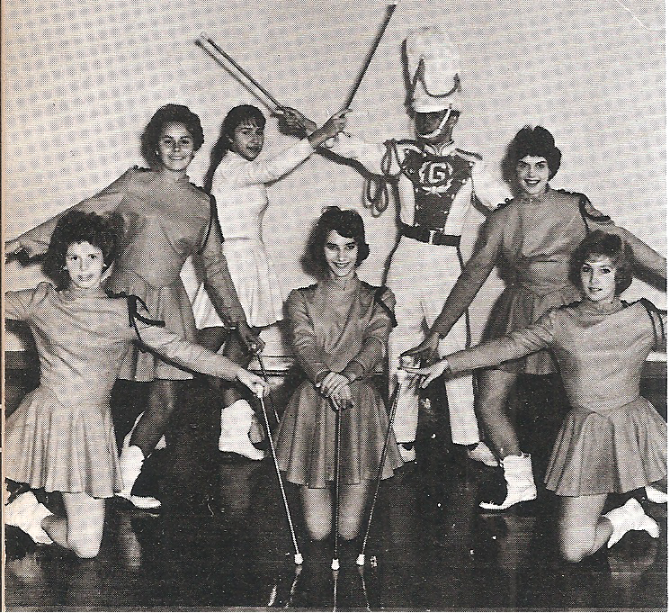

(L-R): Susie Gould, Nancy Grimes, Sandi Garriott, Jane Ann Thompson, Larry Taylor, Mary Jane Todd, Conni Hammond

**INK POT**

May 8, 1959 By Jane Turk

Here we are now. This is it!

Senioritis has finally hit.

We’ve had our moments, good and bad.

But look at all the fun we’ve had.

The things we’ve done we’ll keep in mind.

We’ll never forget what we’re leaving behind.

Yes, in years to come, whether more or less,

We’ll remember our days at GHS

**GREENCASTLE ALUMNI DIRECTORS**

Jon Blue ’69 (President) 765-721-1539

Scott Monnett ’95 (Vice-President) 352-283-3421

Suzy Gould Schneider ’64 (Secretary) 765-720-2822

Terri Sutherlin McKee ’74 (Treasurer) 765-653-5620

Ron Blotch ’65 317-989-5601

Dawn York Barger ’77 765-247-8222

Mary Lou Blue 630-750-9185 Paul Gould ’58 765-301-9266

Todd Detro ’87 317-281-6508

Jane Green Hansen ’69 765-653-4969

Cathy Gram Lowery ’69 765-721-0150

Peggy Sillery McCastle “72 765-653-5510

**INK POT**

OCTOBER 19, 1962

FLIP SIDE

409…..John Duell

The Waddle…..Carolyn Blue

Warmed Over Kisses…..Monna Brown

Where Have All The Flowers Gone…..The Seniors

Ramblin’ Rose…..Roma Brooks

Boys’ Night Out…..John Grimes, Jane Thompson,

and Cheryl Vaughn

Your Nose Is Gonna Grow….Agnes King

Teen Age Idol…..Bill Eckardt

You Can’t Judge A Book By Its Cover…..Jacque

Schafer

Devil Woman…..Rosemary Romalia

The Girl From Wolverton Mountain…..Carol

Monnett

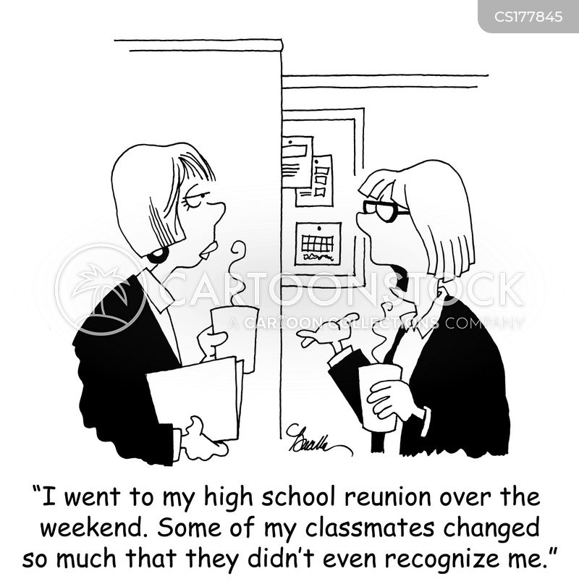

**GHS STATE-RUNNER-UPS**

1931 - Boys Basketball

1933 - Boys Basketball

1964 - Elliott Williams - High Jump

1991 - Susan Stark - 800 Meter Run

2003 - Charlie Pingleton - Wrestling

2004 - Charlie Pingleton - Wrestling

2006 - Andrew Bretscher - 50 yd. freestyle

2006 - Andrew Bretscher - 100 yd. freestyle

2013 - Colleen Weatherford - 800 Meter Run

2021 - Brach Carrington - Wrestling

Greencastle Alumni Dollars for Scholars, Inc.

formerly known as GHS Alumni Association

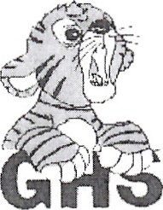Join or Renew Now!

Joining or renewing your Greencastle Alumni Membership will allow you to benefit in a variety of ways...

* You will receive the Tiger Tales newsletter up to 3 times per year
* Receive current news about the association and upcoming events
* Maybe you just want to reminisce or contact former classmates
* Support the awarding of scholarships to GHS graduates

The GHS Alumni Association was created in 1995 for the purpose of supporting Greencastle High School and operating a Scholarship Fund for our graduates. We currently use a number of fundraising events and activities to add to our scholarship fund including the All Class Reunion Dinner to be held October 9, 2021, as well as the Farm to Fork Dollars for Scholars in Putnam County Dinner to be held September 18, 2021.

**Membership is only $10 per person per year. To join or renew, complete this application form and mail it to us with your $10 dues payment. Another option is a one-year free membership with a $25 contribution to the Greencastle Alumni Dollars for Scholars, Inc. Scholarship Fund. All contributions may be designated**

**"In Honor of” _______________ or "In Memory of” _____________________ for anyone that you choose.**

Please Print

 JOIN  RENEW

**_______________________________________________________________________________ _____________**

Name (include Middle Initial and/or Maiden Name) Class Year

**_______________________________________________________________________________ _____________**

Name (for use by Couples please include Middle Initial and/or Maiden Name) Class Year

**_________________________________________________________________________________________________**

Address City State Zip

**_____________________________________ _____________________________________________________**

Phone **Email Address**

**Receive Tiger Tales via email? Yes _______ No ____________**

Total Enclosed $_____________ Mail to. **Greencastle Alumni Dollars for Scholars, Inc.**

**P.O. Box 846**

Referred By: __________________ **Greencastle, Indiana 46135**

Contribution to Greencastle Alumni Dollars for Scholars, Inc. Scholarship Fund **Share the Dream**

* **In Honor of ___________________________or In Memory of _________________________________**

