**IT’S THAT TIME OF THE YEAR!!**

What time of the year is it, you ask? It’s the time of New Year resolutions, hopes for the future, looking forward to spring, looking back over the previous year, anticipating the fulfillment of your dreams, and hoping for a better life for you, your children, and/or grandchildren. All of these are things we as members of YOUR Greencastle Alumni Dollars for Scholars Board are contemplating. (I love that word contemplating. I still remember our principal Mr. McCammon using that word when he read the announcements over the PA system.) As we look forward to 2020, we are committed to increasing the membership in your Greencastle Alumni Dollars for Scholars Inc. And we need your help in doing so. How can you help? By renewing your membership for 2020. And if you have never been a member, by joining for the first time! You can find the membership form on page 7 of this issue of “**Tiger Tales**.” It only costs $10.00 per person for a one-year membership. And if you donate $25.00 or more to the scholarship fund your one-year membership is **FREE**!! So don’t procrastinate! **RENEW** or **JOIN** today! You won’t regret it! I promise!

**THOUGHT FOR THE DAY**

“Happiness depends more upon the internal frame of a person’s mind than on the externals in the world. “

George Washington

A LITTLE OF

**THIS** and **THAT**

In a previous issue of **Tiger Tales** we inadvertently left out Paul Gould, class of ’58, as a new member of Board of the Greencastle Alumni Dollars for Scholars Inc. Our sincere apologies to Paul!!

We are pleased to announce that Mary Lou Blue is our newest member of the alumni board! Congrats Mary Lou!!

A date has been set for the 2020 **ALL-CLASS REUNION DINNER.** It will be held on Saturday June 20th in the Greencastle High School cafeteria. A Reservation form will be in the next issue of **Tiger Tales.**

We are pleased to announce that by the time you receive this all the paperwork for Dollars for Scholars will have been completed! HOORAY!!! We should be full-fledge members of Scholarship America’s Dollars for Scholars within days - weeks at the most!!

Application forms for this year’s alumni scholarships are available on the Putnam County Community Foundation’s website. Starting in 2021 applications will be submitted on line through the Dollars for Scholars website. Also, we will Be awarding eighteen $1000.00 scholarships this year!! Thank you Greencastle and GHS alumni!!

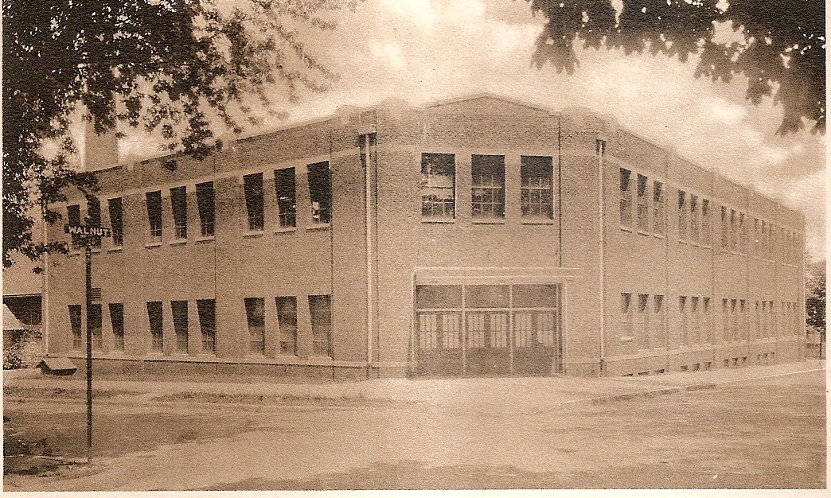

**TIGER CUBS IN THE 1980s (1987-88)**

The latter half of the 1980s saw tragedy in the world – the explosion of the space shuttle Challenger, the nuclear accident at the Soviet power station Chernobyl, the Pan-Am 747 exploding from a terrorist bomb and crashing in Lockerbie Scotland, and the 7.1 magnitude San Francisco earthquake. But not all the news were one of sadness. The Berlin Wall was opened to the free world. The people of Romania overthrew their communist government. The Czechoslovakian Parliament ended communist domination in their country. And President Ronald Reagan was succeeded by George H.W. Bush.

The 1987-88 school year saw the Tiger Cubs claim ten Sectional titles (nine individual and one team) and two Regional Championships (one individual and one team). Carrie Nealon claimed the first two Sectional titles in girls swimming as she continued her dominance in the 200 yard and 500 yard freestyle events. She won her fourth consecutive Sectional title in the 200 yard freestyle with a winning time of 2:28.84. But she was not satisfied. She then won her fourth consecutive Sectional Championship in the 500 yard freestyle with a winning time of 5:25.77. These two Sectional Championships made Carrie Nealon the first and only Tiger Cub athlete in school history to claim four consecutive individual Sectional Championships in two different events!!

The wrestling squad added three individual Sectional titles and one Regional Championship to the Tiger Cub resume. Rob Osborn claimed the 112 lb. title. Bill Daugherty won the 152 lb. championship, and Ray Hoover the heavyweight title. Bill Daugherty also added the 152 lb. Regional Championship to his resume.

The track program claimed four Sectional Championships – two in girls and two in boys. Charlene Brown won the 100 meter dash in 12.7, and the 200 meter dash in 27.1. Wes Trout claimed the 400 meter dash title with a winning time of 50.8. The 1600 meter relay squad of J. Buis, J. Tucker, B. Berish, and W. Trout captured Sectional honors with a winning time of 3:28.07

The boys basketball team entered the 1988 sectionals with the hope of claiming the first Sectional title since 1969. The Cubs squeaked by Rockville in their opener 67 to 65 in overtime. The Cubs returned the next night to win the Sectional title with a 86 to 74 victory over South Putnam. Traveling to Terre Haute the next Saturday the Tiger Cubs defeated Northview 70 to 64 and Shakamak 56 to 49 to claim the Tiger Cubs first Regional Championship since 1968. The Semi-State was next and the Cubs won another exciting game in overtime 69 to 65 over Evansville Central to advance to the Elite Eight. Unfortunately, the Cubs hope of a Final Four appearance ended that evening as they dropped a hard fought battle to the Damon Bailey led Bedford North Lawrence Stars 62 to 47.

Ten Sectional Championships and two Regional Championships -- not a bad year for the 1987-88 Greencastle Tiger Cubs!!

**GHS STATE CHAMPIONS**

(through 1988)

1925 - Andrew Ray Sears - Mile Run

1926 - Andrew Ray Sears - Mile Run

1927 - Andrew Ray Sears - Half-Mile Run

1927 – Andrew Ray Sears – Mile Run

1962 – Steve Norris – High Hump

1981 – Lisa Allen – 800 Meter Run

**LOOKING BACK & LOOKING FORWARD**

As we’ve entered a new year it’s time to take a look at just what has been accomplished in 2019, and what we hope to accomplish in 2020. In 2019 we added four new board members – Jon Blue, Paul Gould, Scott Monnett, and Mary Lou Blue. Unfortunately, we also lost three board members – Steve Fenwick, Judy Mooney, and Judy Cantonwine Miller. We had another successful All-Class Reunion Dinner where we recognized the 2019 scholarship recipients. We made tremendous progress (thanks to Terri McKee) in fulfilling the necessary requirements for full-fledge membership in Scholarship America’s Dollars for Scholars. We became incorporated by the state of Indiana. And we changed our name from Greencastle High School Alumni Association to Greencastle Alumni Dollars for Scholars, Inc. We participated along with the alumni associations of Cloverdale, North Putnam, and South Putnam in the first annual Farm to Fork dinner. And most importantly, we saw the increase of approximately $50,000 in our scholarship fund through the Putnam County Community Foundation. Yes, 2019 was a very good year!

Our goals for 2020 include becoming a full-fledge member of Dollars for Scholars. We are submitting the final paper work within the next few days. We will be hosting the All-Class Reunion Dinner in June. We are participating in the Farm to Fork Dinner in September. Another major goal is to increase the number of board members. Our ultimate goal is to have at least fifteen board members. We hope to organize and update our “history” files – issues of Tiger Tales, The Ink Pot, etc. And we hope to see our Foundation Balance increase to at least $500,000. As this increases our earnings increase. And our money available for scholarships increases as we only use the returns from the investments for our scholarships. You can help us reach some of these goals through joining or renewing your membership, donating to the scholarship fund, and/or considering becoming a board member.

SAVE THE DATE

**SATURDAY**

**JUNE 20, 2020**

**ALL-CLASS REUNION**

**DINNER**

**SEE YOU THERE!!!!!**

**SO I GOT MY CONCEALED GUN PERMIT**

(from Facebook)

So I got my concealed gun permit yesterday and went over to the local Bass Pro Shop to get a small 9mm pistol for home protection.

When I was ready to pay for the gun and bullets, the cashier said “Strip down, facing me.”

Making a mental note to complain to the NRA about the gun control wackos running amok, I did just as she had instructed.

When the hysterical shrieking and alarms finally subsided, I found out she was referring to how I should place my credit card in the credit card reader!

I’ve been asked to shop elsewhere in the future. They need to make their instructions to seniors a little clearer.

I still don’t think I look that bad.

**GREENCASTLE FIRE DEPARTMENT**

**1917 POSTCARD**

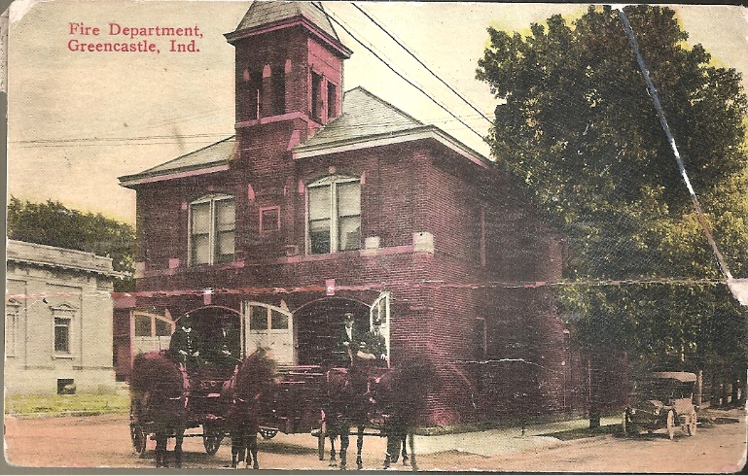

SAVE THE DATE

**SATURDAY**

**SEPTEMBER 19, 2020**

**FARM TO FORK DOLLARS FOR SCHOLARS IN PUTNAM COUNTY DINNER**

SPONSORED BY THE GREENCASTLE, CLOVERDALE, NORTH PUTNAM, AND SOUTH PUTNAM ALUMNI ASSOCIATIONS

**SCHOOL NICKNAMES**

In last spring’s issue of **Tiger Tales** there was an article by Alison Spencer written in 1986 about school nicknames. So here is a list of present and former Putnam County high schools and their nicknames with one exception – New Maysville.

Bainbridge Pointers

Belle Union Panthers

Clinton Center Yellow Jackets

Cloverdale Clovers

Fillmore Cardinals

Greencastle Tiger Cubs

New Maysville ?????????

North Putnam Cougars

Putnamville Bulldogs

Reelsville Indians

Roachdale Hawks

Russellville Bees

South Putnam Eagles

**2020 GREENCASTLE ALUMNI DIRECTORS**

Suzy Gould Schneider ’64 765-720-2822

(Co-President)

Ron Blotch ’65 (Co-President) 317-989-5601

Jon Blue ’69 (Vice-President) 765-721-1539

Dawn York Barger (Secretary) 765-247-8222

Terri Sutherlin McKee ’74 765-653-5620

(Treasurer)

Scott Monnett ‘95 352-283-3421

Paul Gould ’58 765-301-9266

Mary Lou Blue 630-750-9185

A LITTLE MORE OF

**THIS AND** **THAT**

Greencastle Community School Corporation Superintendent Jeffrey Hubble has announced he will retire at the end of the 2019-20 school year.

The **Dollars for Scholars in Putnam** **County** **Farm** **to** **Fork** **Dinner**, sponsored by the alumni associations of Greencastle, Cloverdale, North Putnam, and South Putnam, was very successful. Our own Terri McKee was responsible for decorating the facility. And the decorations were outstanding! The event is a fund raiser for the four sponsoring alumni associations. The proceeds were divided evenly among the four participating groups. Each school received over $2500 for their scholarship fund. In addition, the 100+ Men Who Care of Putnam County donated $10,500 to the group. Consequently, the Putnam County Farm to Fork Dinner raised over $5000 for each alumni association. Your alumni board would like to thank each and every person who sponsored and/or attended the event! And we would like to give a shout out to the 100+ Men Who Care of Putnam County for their generous donation. The generosity of the people of Putnam County says a lot about Putnam County and the businesses and people who reside there! THANK YOU!!!!

The second annual **Dollars for Scholars in Putnam** **County** **Farm** **to** **Fork** **Dinner** will be Saturday September 19, 2020. Our association will provide the speaker (former scholarship winner) for the event. We hope to see you there!

Once we have attained full-fledge status in Dollars for Scholars, our next task will be to create a new website. Once that is completed, we will publish the address.

Please help us keep current concerning any changes in your name, address, phone number, and/or email address. You can do this by email:

[mtmckee@frontier.com](mailto:mtmckee@frontier.com) or [suzy.schneider@talktotucker.com](mailto:suzy.schneider@talktotucker.com) or by phone at the numbers listed elsewhere on this page.

**THE INK POT**

**May 13, 1960**

TRUE CONFESSIONS

Peggy and Becky confess to rolling the windows down in Mr. Novak’s car the night of the game between the county coaches and all-stars.

Warren Tipton confesses that he really wasn’t sick on Career Day last year.

Joyce Reeves confesses that she really did try to out-do Mary Beth Norton.

Al Trusler confesses that he was the one who took the hands off the clock.

Barbara Allee confesses that she had a secret crush on Ronnie Allee for a few months this year.

Marcella Haltom confesses that the second semester she just couldn’t keep her mind on her work.

Reed Williams confesses to borrowing pictures from the Minaret staff and forgetting to return them.

Dick Frederick confesses that he is only 4’8” – his height is only an optical illusion.

Carole Nelson confesses that she eats more ice cream at Fleenor’s than she sells.

David Haines confesses to a secret crush on a certain girl in his journalism class this year.

**THOUGHT OF THE DAY**

“It is assuredly better to go laughing than crying through the rough journey of life.”

George Washington

**SCHOLARSHIP INFO**

As of September 30, 2019

Founded: 1994

First Donor: Norman Handy

First Scholarship Recipient: Jon Blue

Foundation Balance: $427,003.57

Number of Scholarships Awarded: 168

Amount of Scholarships Awarded: $166,200.00

**VISITING PASTOR**

(from Facebook)

A new pastor was visiting in the homes of his parishioners. At one house it seemed obvious that someone was at home but no answer came to his repeated knocks at the door. Therefore, he took out a business card and wrote ‘Revelation 3:20’ on the back of it and stuck it in the door.

When the offering was processed at the next worship service, he found that his card had been returned. Added to it was this cryptic message, ‘Genesis 3:10’. Reaching for his bible to check out the citation, he broke up in gales of laughter. Revelation 3:20 begins ‘Behold, I stand at the door and knock.’ Genesis 3:10 reads, ‘I heard your voice in the garden and I was afraid for I was naked.’

**DID YOU KNOW**

* that Franklin Rule Shamel was born in Greencastle in 1912? He was an American pro basketball player. He appeared in three games for the Cincinnati Comellas in the National Basketball League during the 1937-38 season.
* that Donald Trump was born in Greencastle? Yes, that’s right. Donald Trump was born in Greencastle! That is Donald Lynn “Skip” Trump was born in Greencastle in 1945. He is an oncologist who is the executive director and chief executive officer of the Inova Schar Cancer Institute in Falls Church, Virginia.
* that in March 2011 Greencastle was one of two cities selected as a “Stellar Community” by the state of Indiana?

**GHS STATE RUNNER-UPS**

(through 1988)

1931 - Boys Basketball

1933 - Boys Basketball

1964 - Elliott Williams - High Jump

**THE INK POT**

**May 18, 1956**

SEVENTH GRADE NEWS

Some of the couples going to the mixer are:

Karen Vote – Bobby Irwin

Sara Hanna – Larry Giddings

Bobby Jo Steele – John Compton

Rita Nichols – Teddy Whitaker

Charlotte Erdmann – Ronnie Pingleton

Judy Elmore – Marvin Ogle

Wanda Smithers – Billy Mahoney

Jo Ellen Hickman – Billy Lewis

Kay Johnson – Bob Fletcher

Malinda Williams – Mike Haines

**THE INK POT**

**October 2, 1959**

TOP TUNES

* GHS students met their “Waterloo” when they heard “Bells, Bells, Bells.”
* “The Shape I’m In” is Charley Buckles’ favorite song.
* I hear that Dave A. and Deanna O. are still on a “Sea Cruise” on the “Sea of Love.”
* Jerry Clearwaters says “I’ve Been There” and it’s “Lavender Blue.”
* I guess Cindy F. has been hearing a “Broken Hearted Melody” lately. Has he found someone “Sweeter Than You?”
* I hear Barbara A.’s favorite song is “Danny Boy.” I wonder why?
* Gary K. used to tell Patty M. “My heart is an Open Book.” Who turned the page?
* I hear Reed W. has a job working with “Mr. Kleen” in his “Mad Pad.”

**THOUGHT OF THE WEEK**

It requires strength to stand up for yourself. It requires even greater strength to stand up for others. - Robert Moore - Massachusetts

**DID YOU KNOW**

* that according to the National Register of Historical Places there are twenty historical sites in Greencastle and the surrounding communities? They are:

The Appleyard Farm (Alexander C. Stevenson Farm)

The Boulders house

Brick Chapel United Methodist Church

Courthouse Square Historic District

Delta Kappa Epsilon Fraternity house

East College of DePauw University

Forest Hill Cemetery

Richard M. Hazelett house (“Sunny Hill”)

Alfred Hirt House

McKim Observatory, DePauw University

F.P. Nelson house (“The Towers”)

Old Greencastle Historic District

Lycurgus Stoner House

William C. Van Arsdel house (“The Elms”)

Samuel Brown house (“The Brick”), Roachdale

Melville F. McHaffie Farm (“Schulyer Arnold Seed Farm”), Stilesville

James Edington Montgomery O’Hair house, Brick Chapel

Putnam County Bridge No. 159 (“Reelsville Bridge”)

Putnamville Presbyterian Church (“Putnamville Methodist Church)

Also, according to the National Register of Historical Places there are three historical neighborhoods in Greencastle, They are:

Old Greencastle

Eastern Enlargement

Northwood Neighborhood

* that there are several houses, buildings, bridges, etc. in the Greencastle and Putnam County that are supposedly haunted?

**YOUR ALUMNI BOARD WOULD LIKE TO WISH EACH AND EVERY ONE OF YOU A VERY HAPPY, HEALTHY, AND PROSPEROUS NEW YEAR!!!!**

Greencastle Alumni Dollars for Scholars, Inc.

formerly known as GHS Alumni Association

Join or Renew Now!

Joining or renewing your Greencastle Alumni Membership will allow you to benefit in a variety of ways...

* You will receive the Tiger Tales newsletter up to 3 times per year
* Receive current news about the association and upcoming events
* Maybe you just want to reminisce or contact former classmates
* Support the awarding of scholarships to GHS graduates

The GHS Alumni Association was created in 1995 for the purpose of supporting Greencastle High School and operating a Scholarship Fund for our graduates. We currently use a number of fundraising events and activities to add to our scholarship fund including the All Class Reunion Dinner held June 20, 2020, as well as the Farm to Fork Dollars for Scholars in Putnam County Dinner to be held September 19, 2020.

**Membership is only $10 per person per year. To join or renew, complete this application form and mail it to us with your $10 dues payment. Another option is a one-year free membership with a $25 contribution to the Greencastle Alumni Dollars for Scholars, Inc. Scholarship Fund. All contributions may be designated**

**"In Honor of” _______________ or "In Memory of” _____________________ for anyone that you choose.**

Please Print

 JOIN RENEW

**_______________________________________________________________________________ _____________**

Name (include Middle Initial and/or Maiden Name) Class Year

**_______________________________________________________________________________ _____________**

Name (for use by Couples please include Middle Initial and/or Maiden Name) Class Year

**_________________________________________________________________________________________________**

Address City State Zip

**_____________________________________ _____________________________________________________**

Phone **Email Address**

**Receive Tiger Tales via email? Yes _______ No ____________**

Total Enclosed $_____________ Mail to. **Greencastle Alumni Dollars for Scholars, Inc.**

**P.O. Box 846**

Referred By: __________________ **Greencastle, Indiana 46135**

* Contribution to Greencastle Alumni Dollars for Scholars, Inc. Scholarship Fund
* **In Honor of ___________________________or In Memory of _________________________________**

